**WordCount.java (contains driver, mapper and reducer classes)**

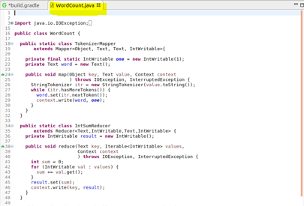

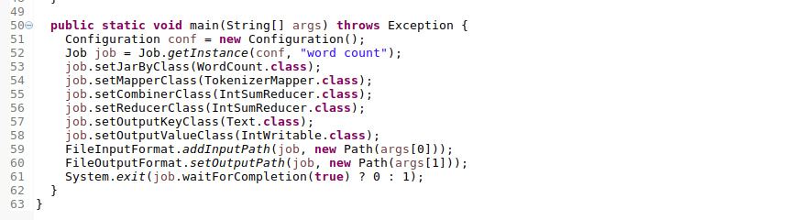

**build.gradle**

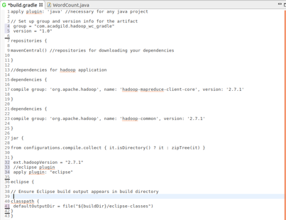

**Input dataset**

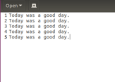

**gradle build**

**using command >**

**$ grade build**

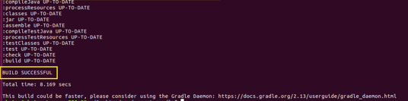

**jar file is generated :**









**Running jar file :**

**using command >**

$ Hadoop jar word_count_gradle-1.0.jar wordcount /sample.txt gradle_output

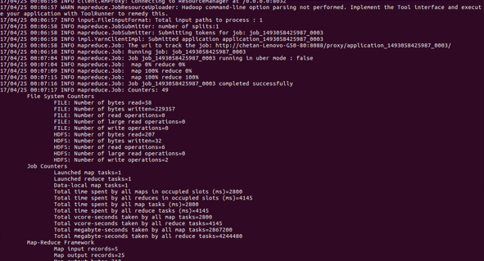

**Output :**



