**PROBLEM STATEMENT:**

**Use reduce side join to join the two datasets and find what kind of problems are prevalent and in which state?**

**PROGRAM:**

**DRIVER CLASS**

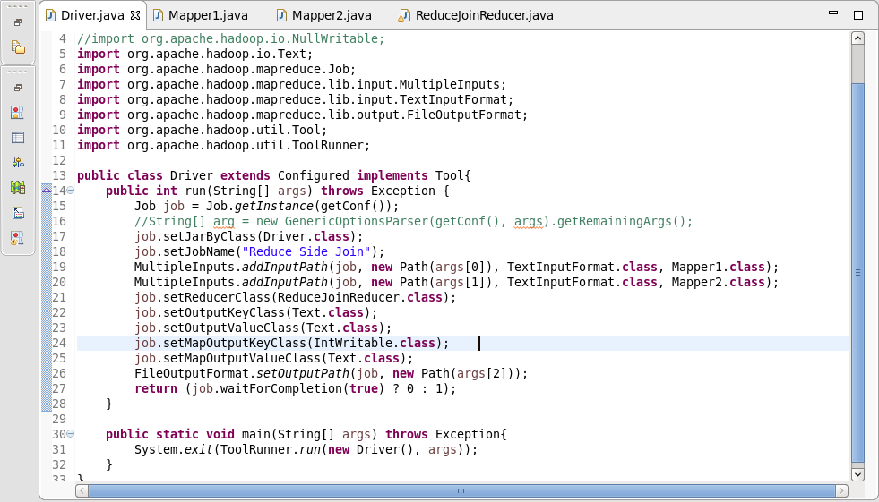

**MAPPER1 CLASS**

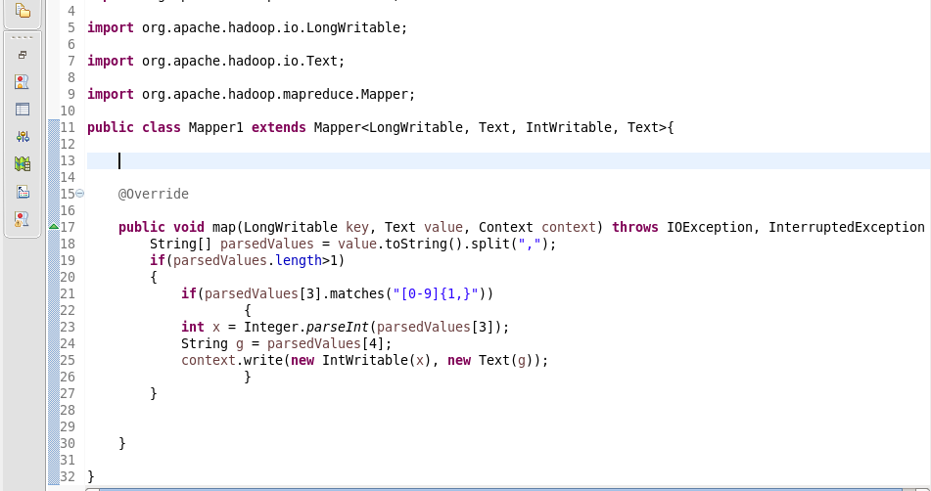

**MAPPER2 CLASS**

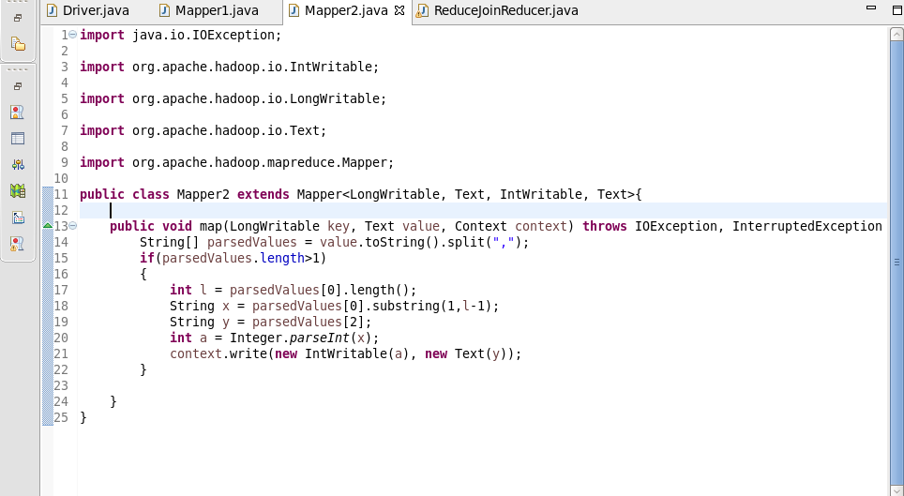

**REDUCER CLASS**

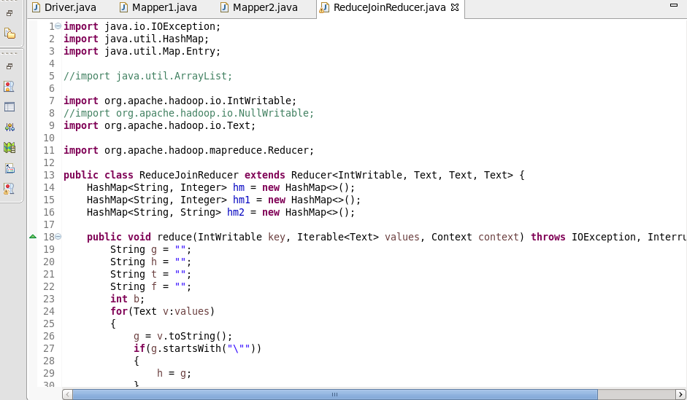

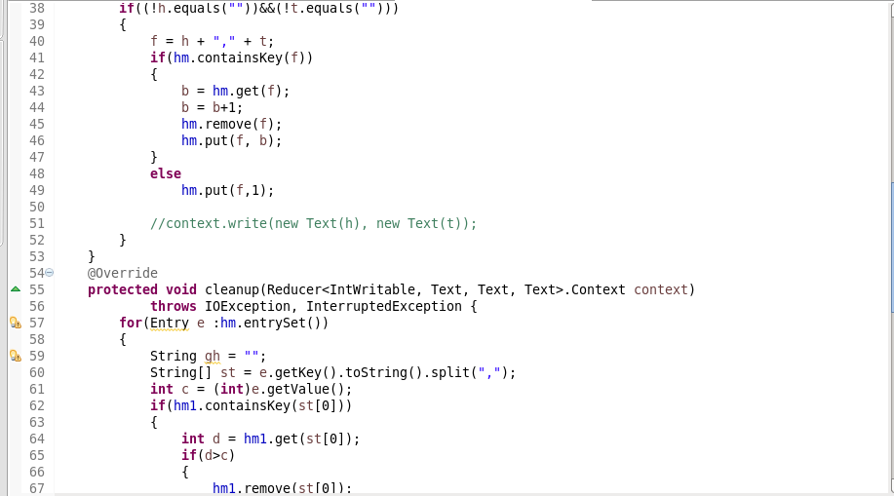  
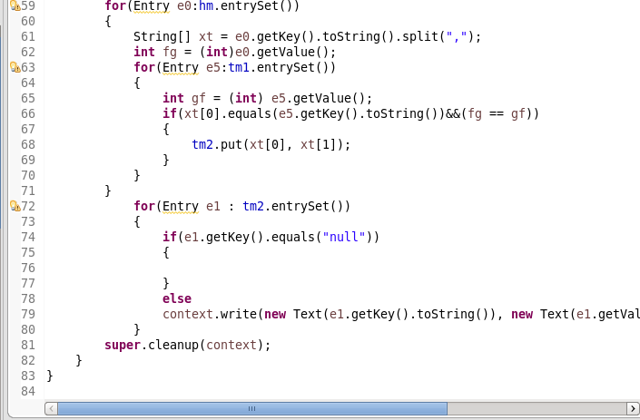

**Running jar file:**

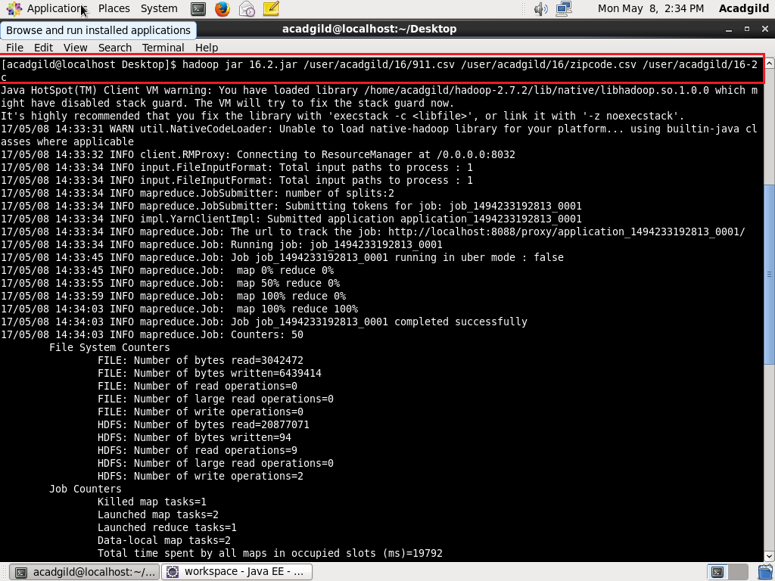

**OUTPUT:**

