Execute Session 16 - Assignment 1 (Machine and Sensor data analysis) using Reduce side join and compare which join is faster in normal conditions.

Driver class:

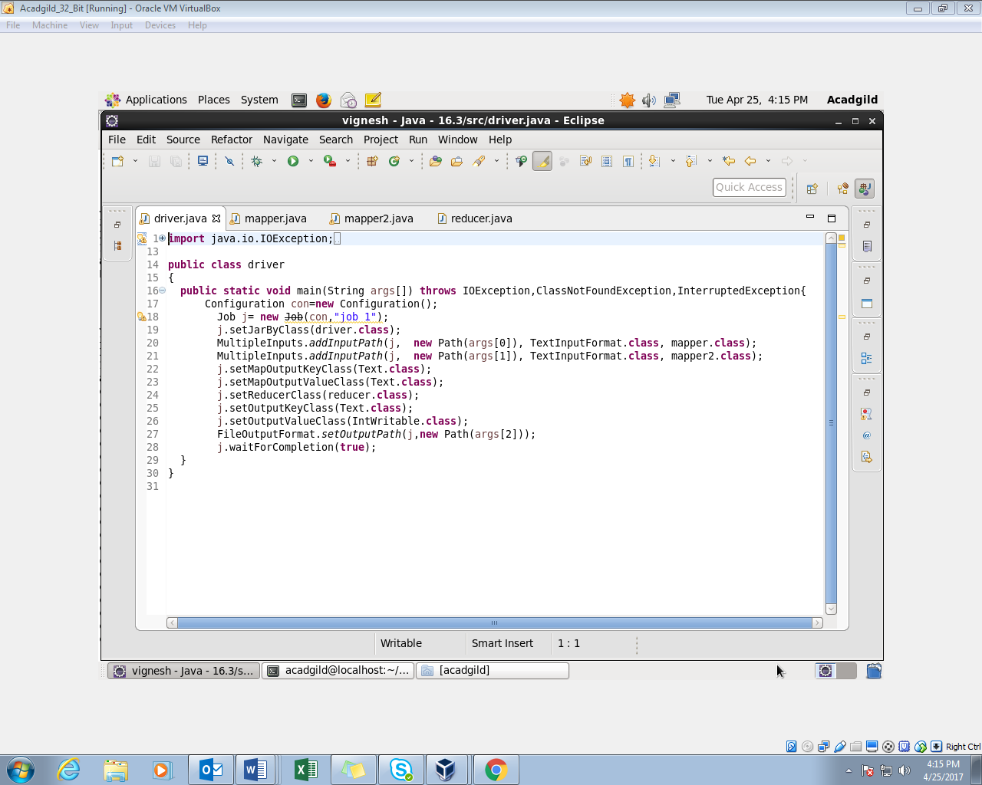

1mapper class: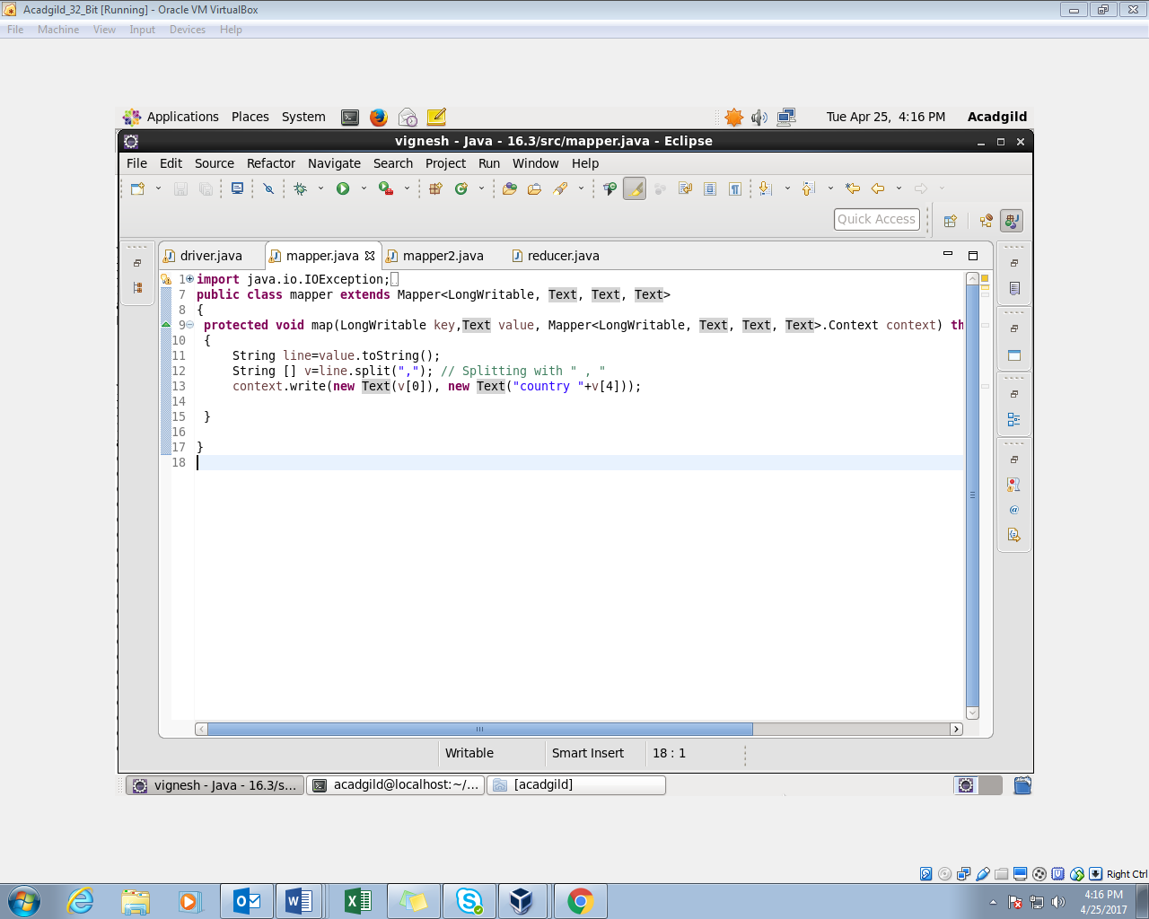

2Mapper class:

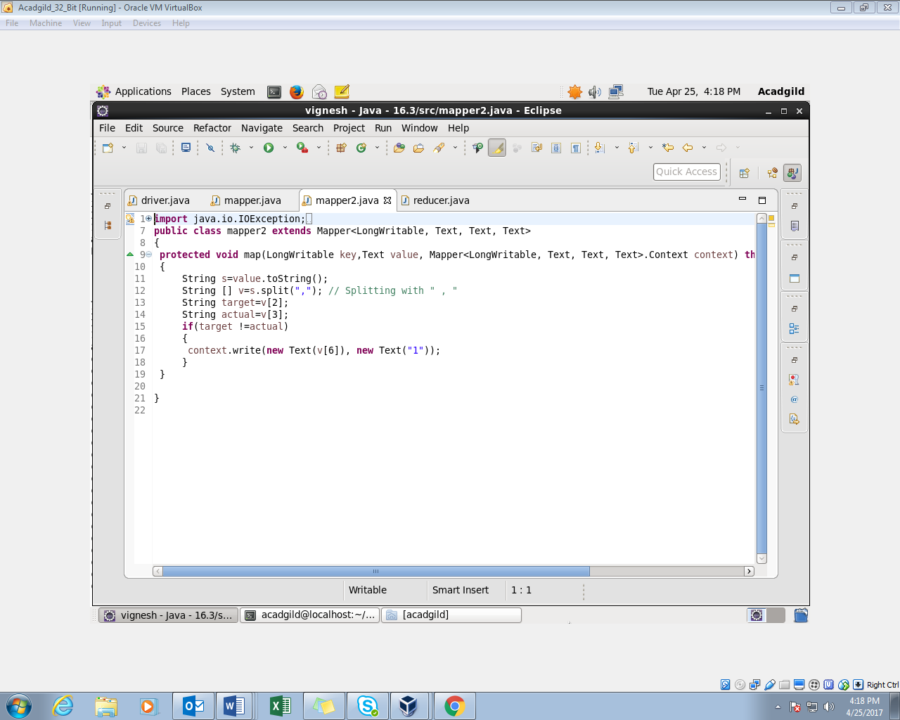

Reducer class:

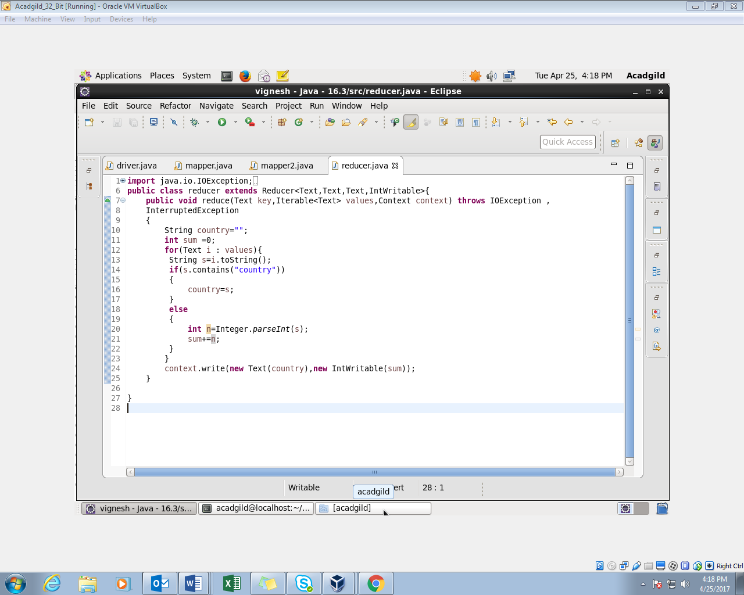

Output:

