**PROBLEM STATEMENT:**

**Write the map reduce program use map side join to join the two datsets and find what kind of problems are prevalent and in which state?**

**PROGRAM:**

**DRIVER CLASS:**

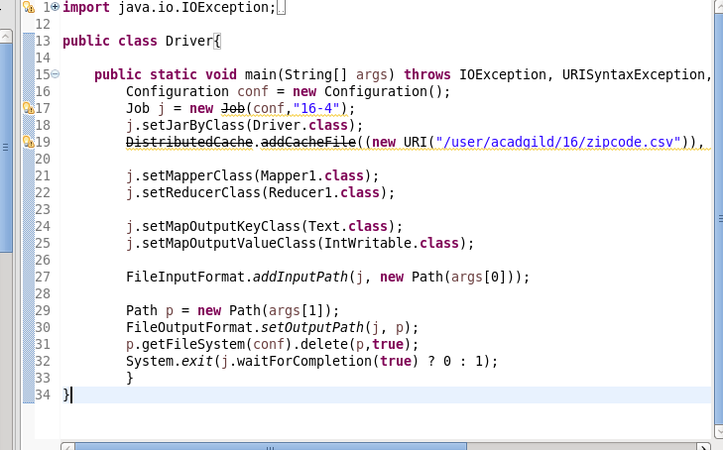

**MAPPER CLASS**

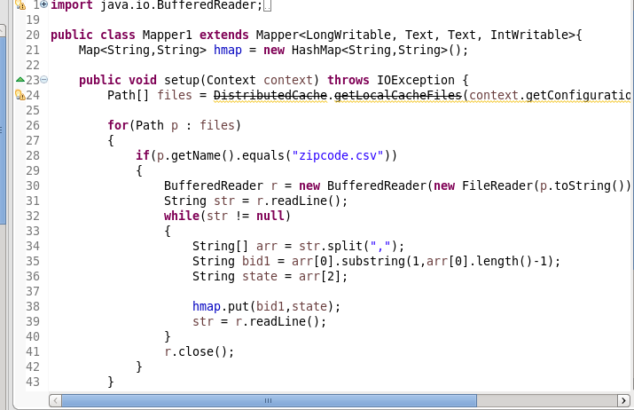

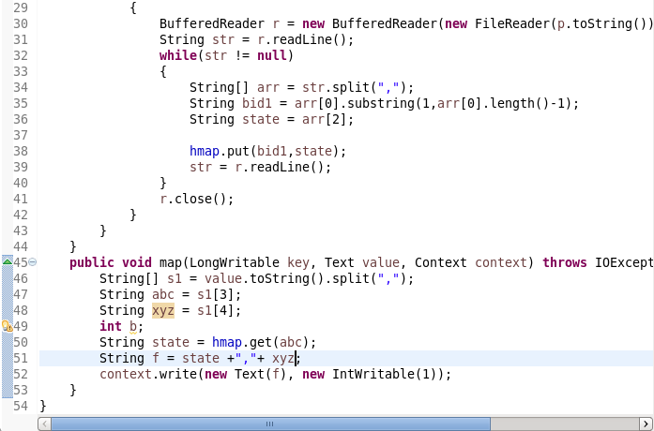

**REDUCER** **CLASS**

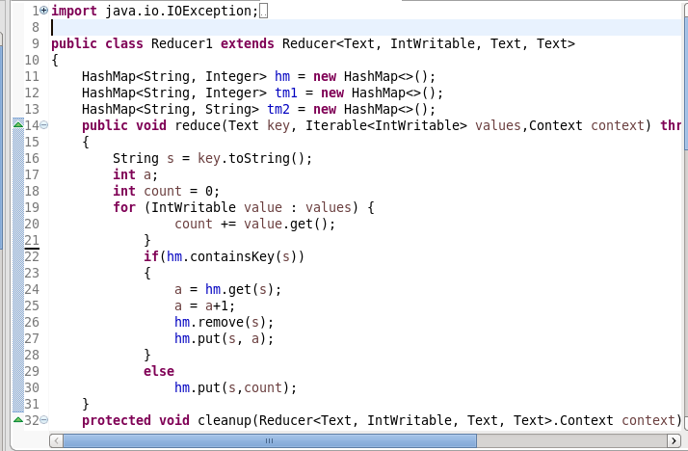

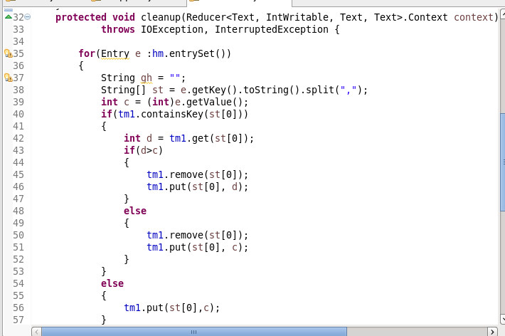

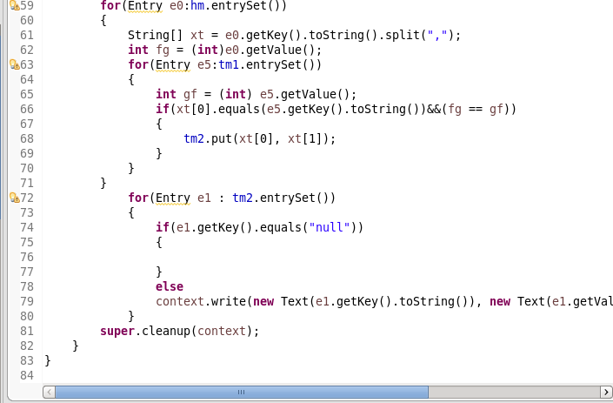

**Running jar file:**

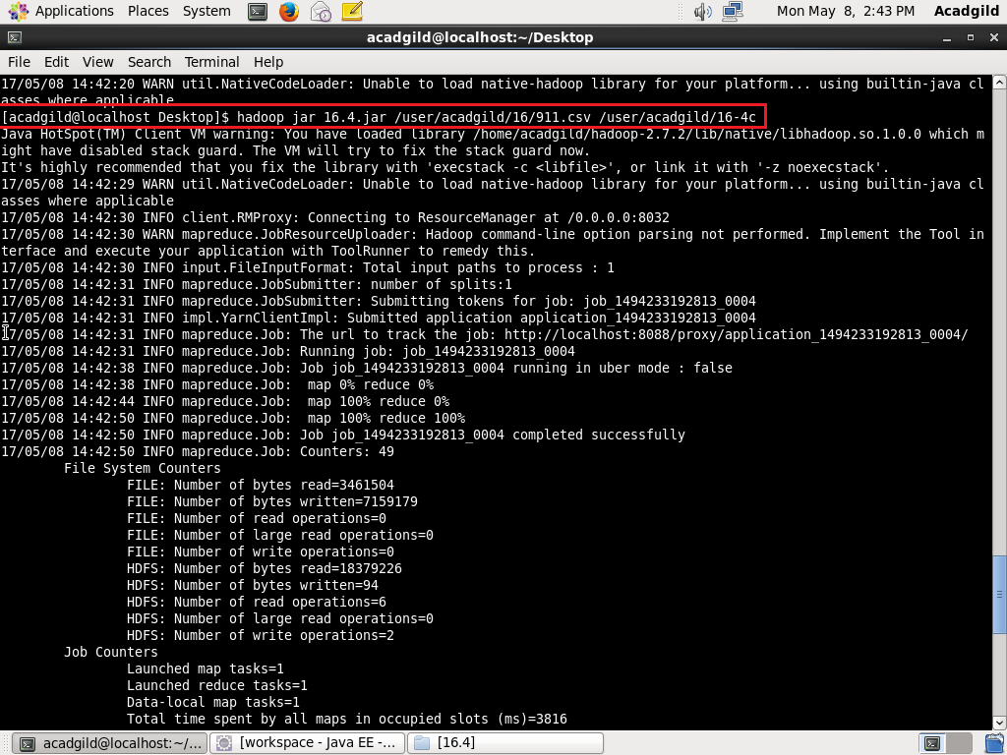

**OUTPUT:**

