Write a program that accepts the job_id as argument and returns a custom counter and a system counter (total records input to the map tasks) associated with that job.

Driver class:

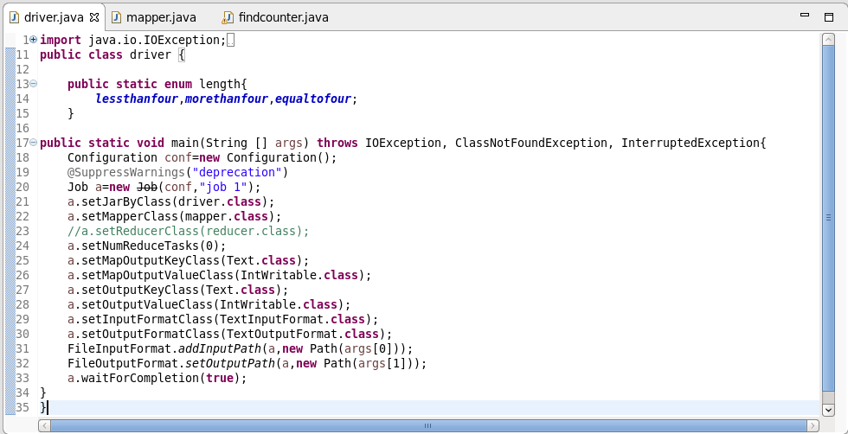

Mapper class:

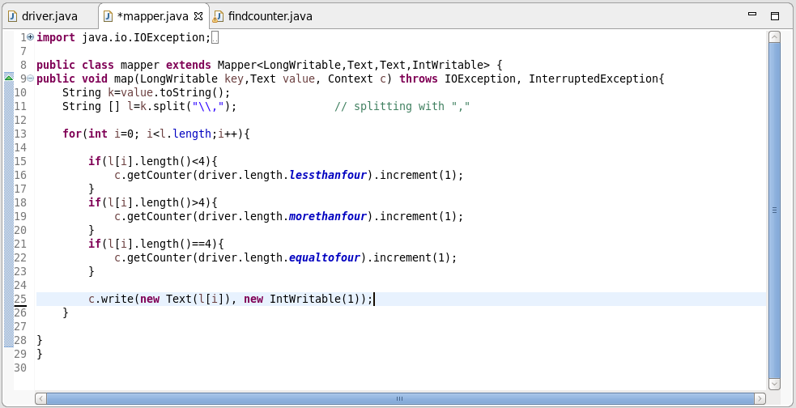

Findcounter class:

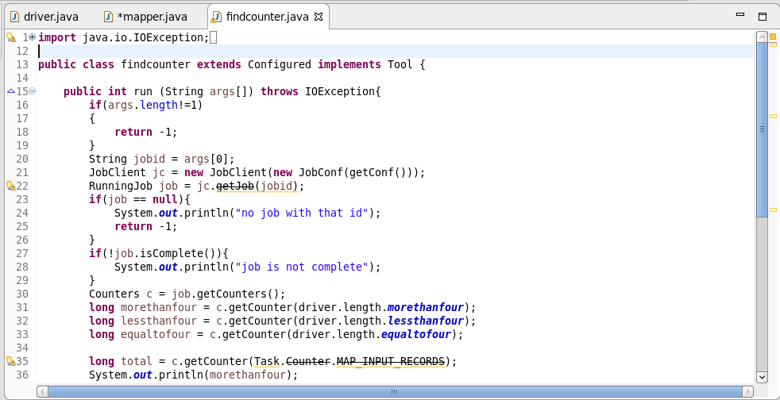

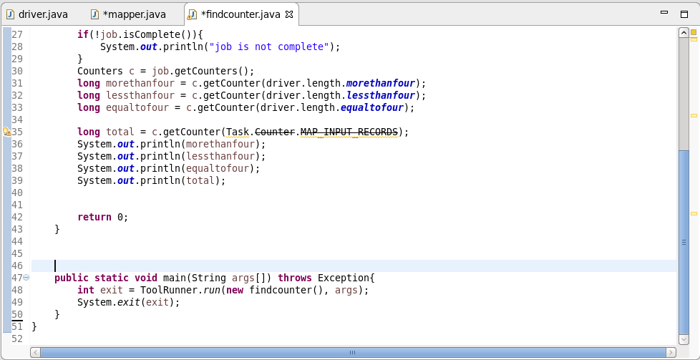

Logic:

* If the length of the word is greater than 4, variable ‘more than four ‘ will increment with 1.
* If the length of the word is less than 4, the variable ‘ less than four ‘ will increment with 1.
* If the length of the word is equal to 4, ‘ equal to four ‘ gets increment with 1.
* While running jar file with driver as main class and arguments as input text file and output path, we will get the first output .
* While running jar file with job id as argument, we will get the second output

First output :

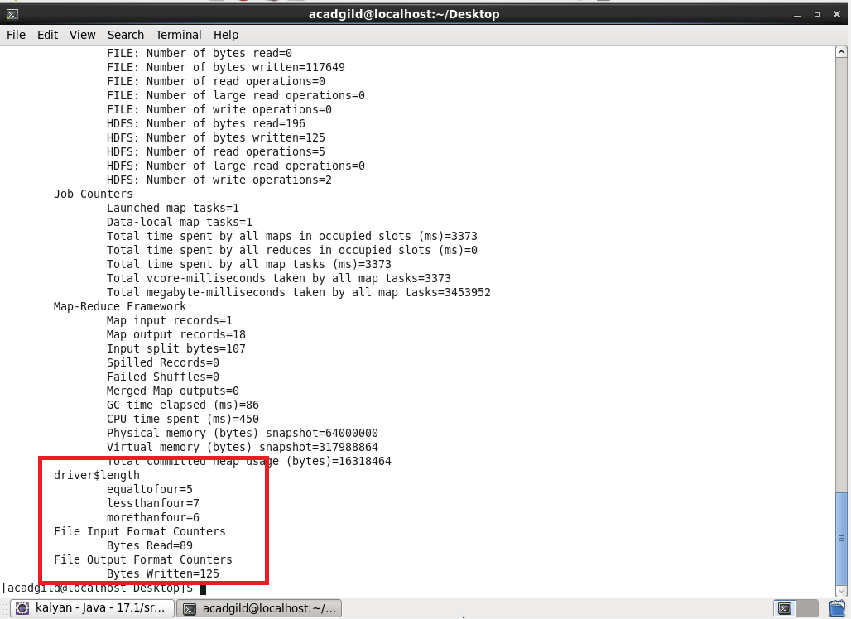

Second output**:**