Write a map reduce program to design a custom counter to count number of people are affected with 'PULMONARY' disease and 'BRONCHITIS & ASTHMA' in the state 'CA'.

The dataset description is as follows

DRG Definition: varchar

Provider Id :integer Provider

Name :varchar

Provider Street Address : varchar

Provider City : varchar

Provider State : varchar

Provider Zip Code : integer

Hospital Referral Region Description : varchar

Total Discharges : integer

Average Covered Charges : float

Average Total Payments : float

Average Medicare Payments : float

Driver Class:

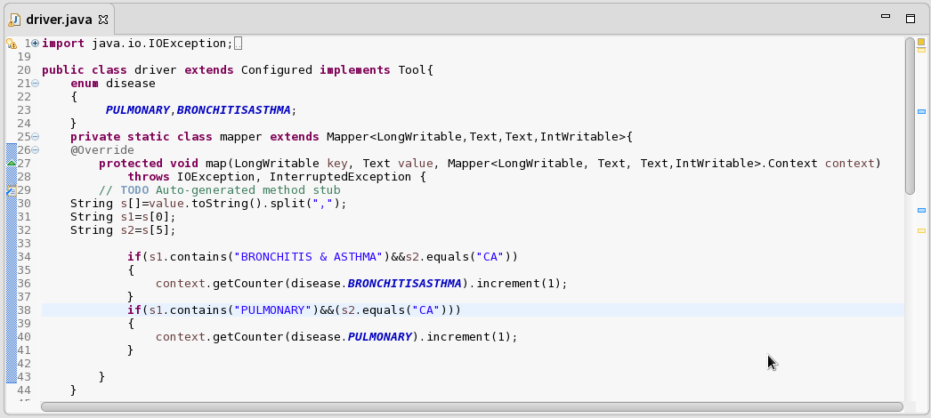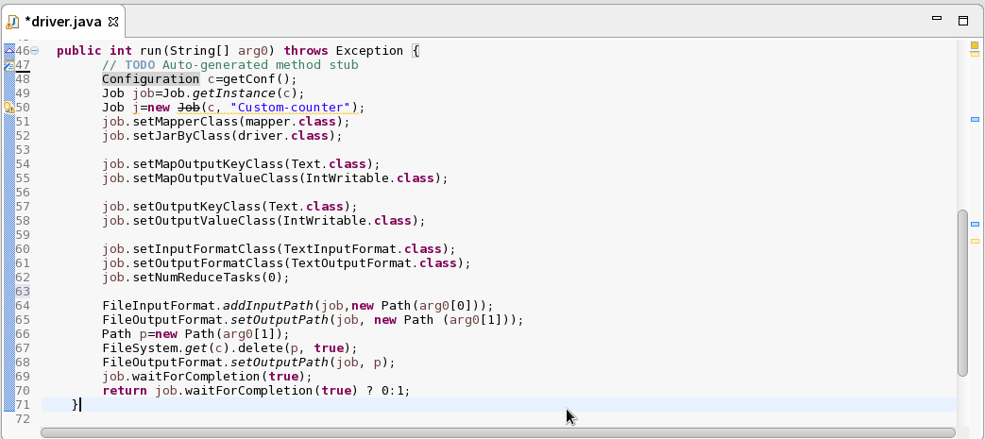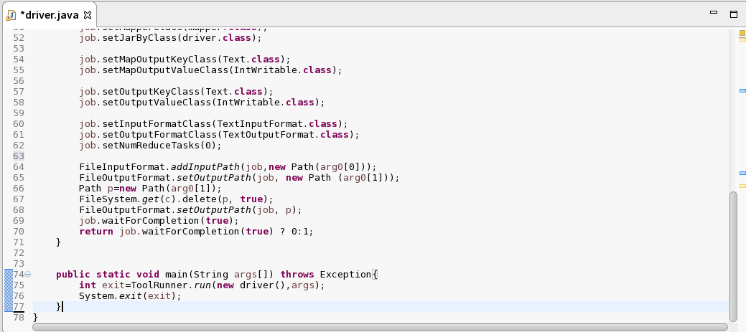

Output:

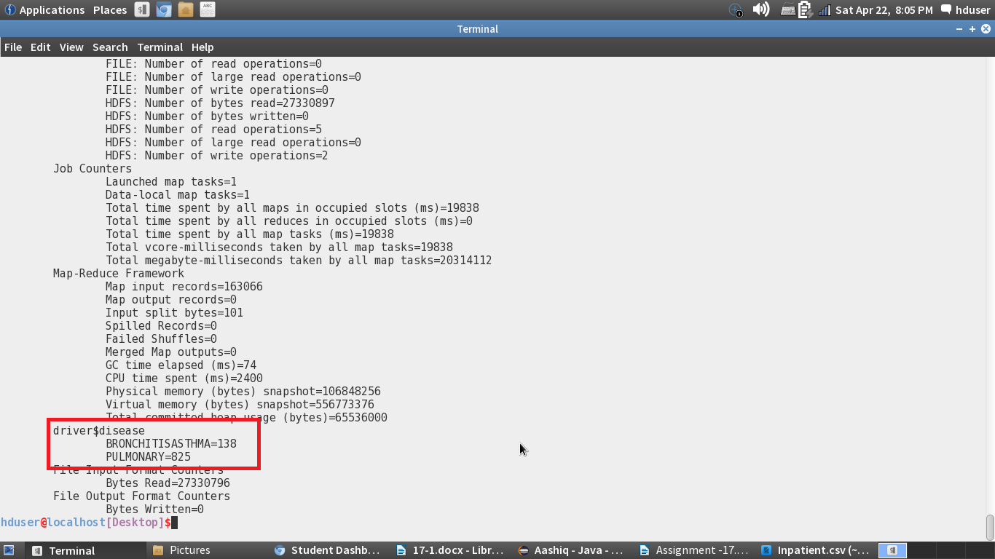

Job History Server:

