Merge the small files in hadoop by following the below blog.

I had listed all the files inside the directory merging.

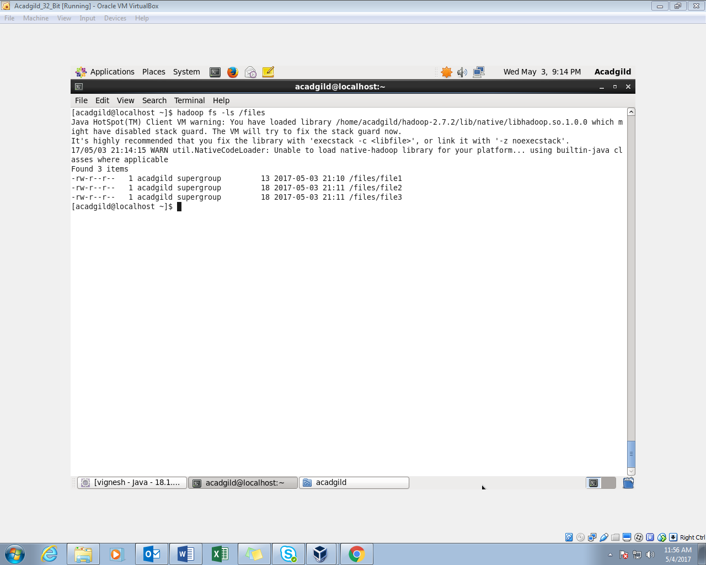

I had opened the contents of the file using cat command

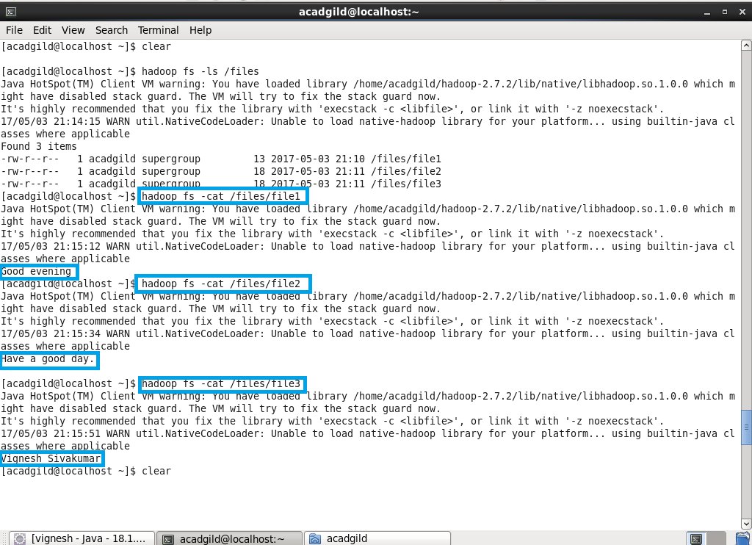

Using getmerge command, contents of all the 3 files will be merged to form a new file called mergedop.txt which will be in local system.

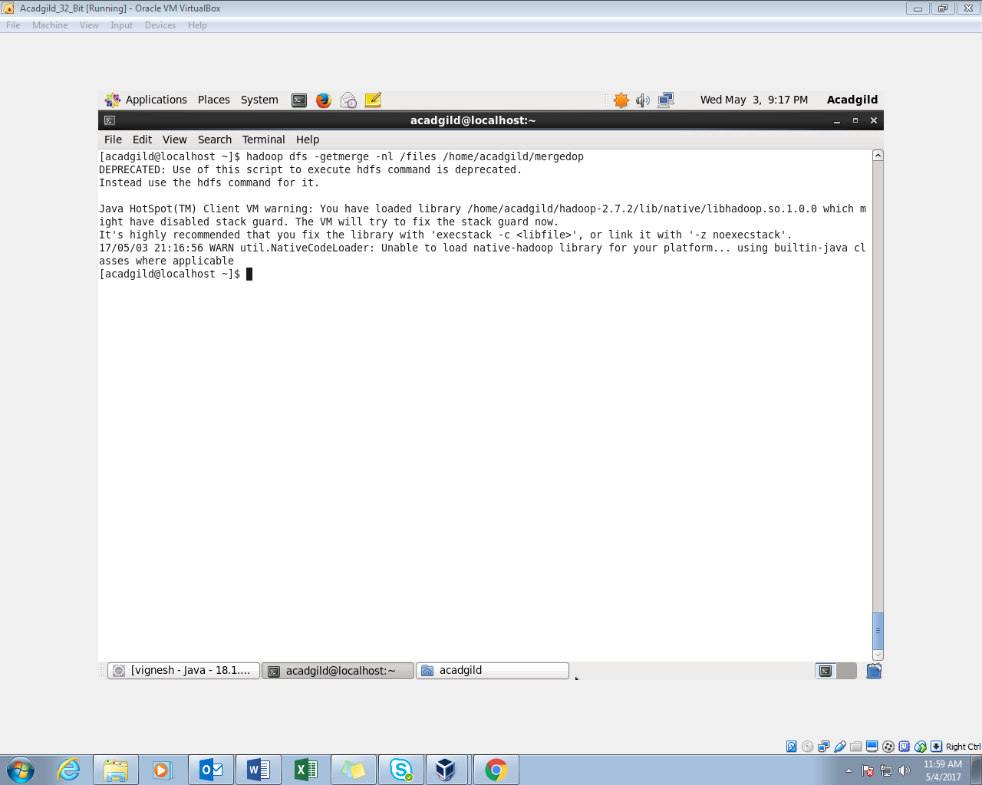

Reading the mergedtext.txt using cat command

