**19.2 Convert XML File into Json File Format. You can consider below example XML, save it in the hdfs cluster and then to convert into Json File Format.**

**The following xml file has to be converted into JSon File format**

**INPUT FILE:**

***I’ve stored it as Sample.xml in hdfs***

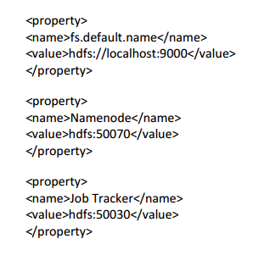

**Java code:**

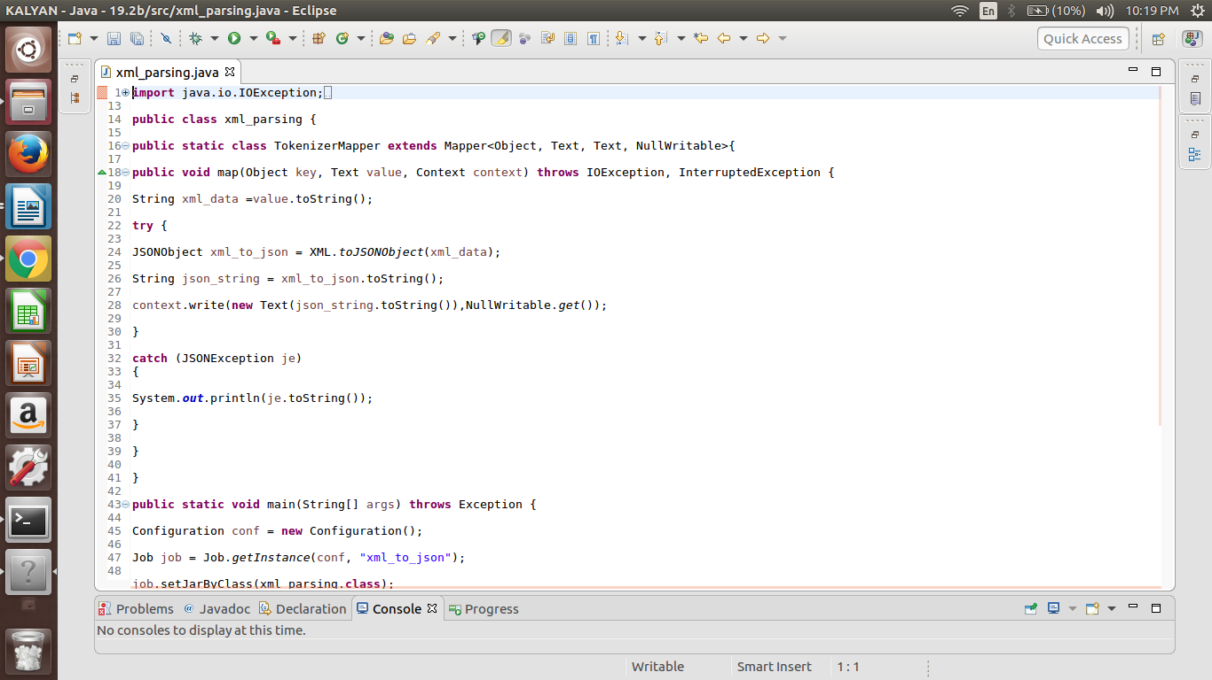

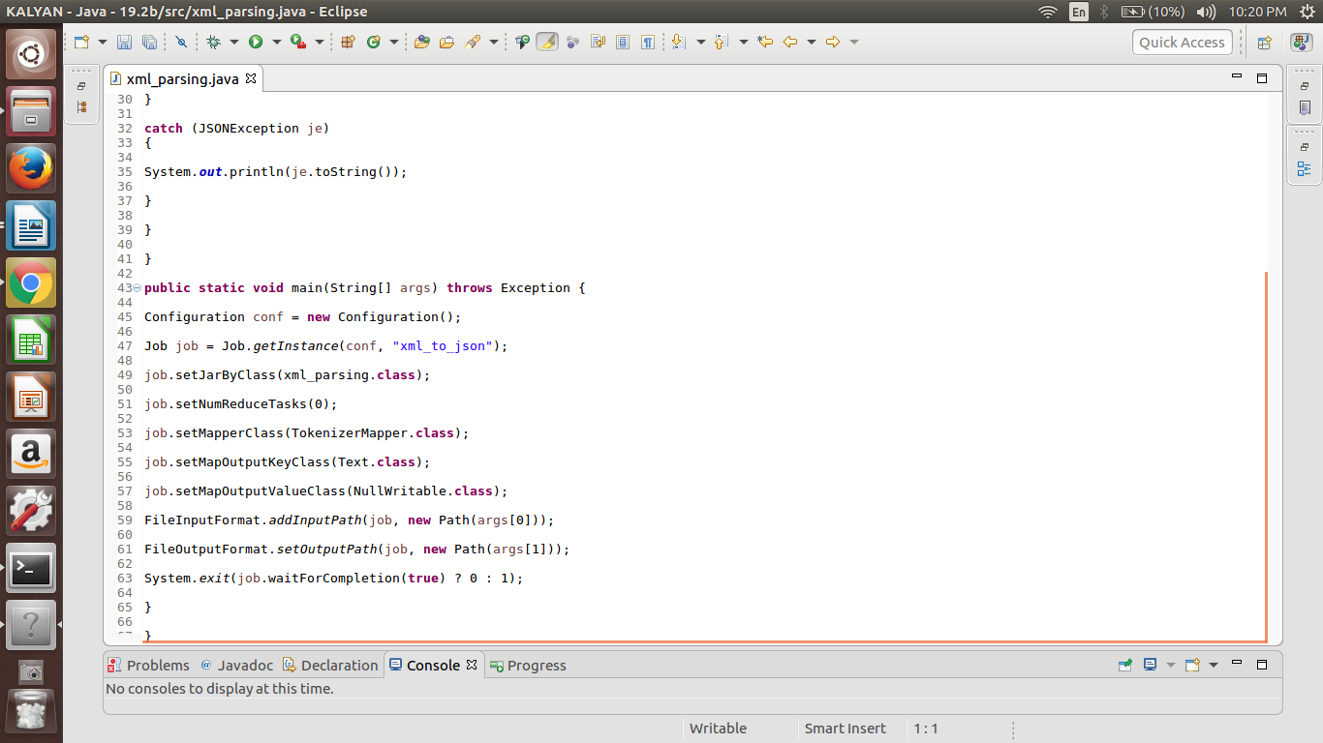

**RUNNING JAR:**

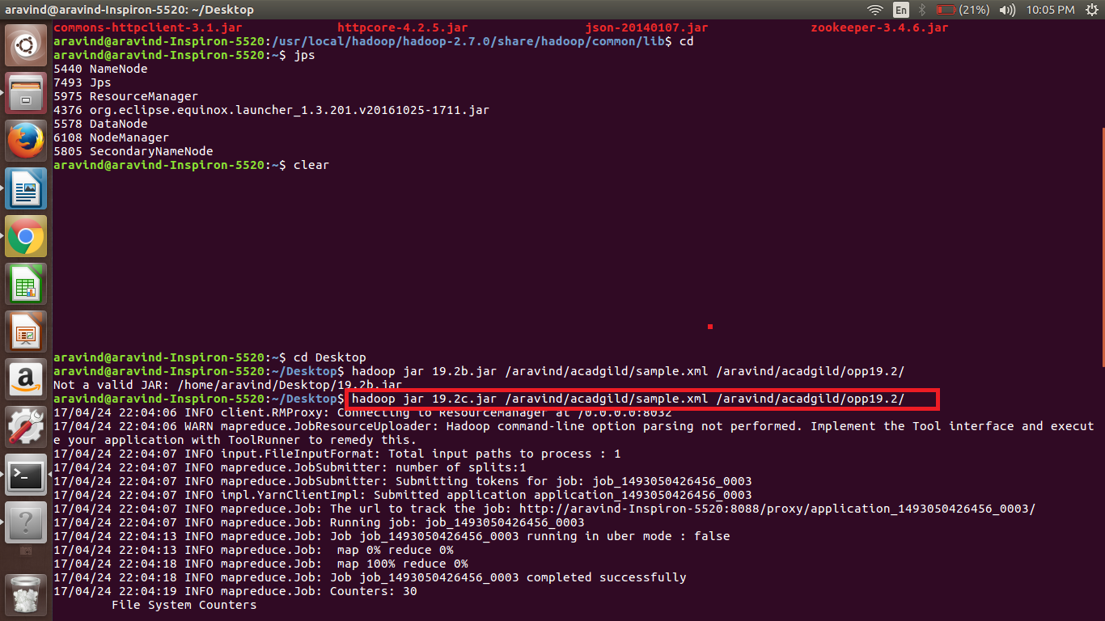

**OUTPUT:**

