Enhance the MapReduce program of Task 8 (refer session 19, assignment 3) to use multiple reducers for sorting. The driver should accept three additional values: the minimum units sold, the maximum units sold and number of reducers to use. Use units sold as key and company as value. Write a custom partitioner to divide the keys on the basis of range. Take minimum to be 0 and maximum to be 10. Divide them across 2 reducers.

Since I was asked for minimum and maximum units sold, I had used 2 reducers. One reducer is for the companies who have made maximum sales(6-10) another one is for the companies who made minimum sales(0-5).

In the composite key, I had taken company and sales into account and ordered it by

Descending order using compareTo() method.

Since partitioner is used, companies who sold TV’s more than 5 (6-10) will go to a reducer and companies who sold TV’s less than 6 (0-5) will go to another reducer.

Driver class:

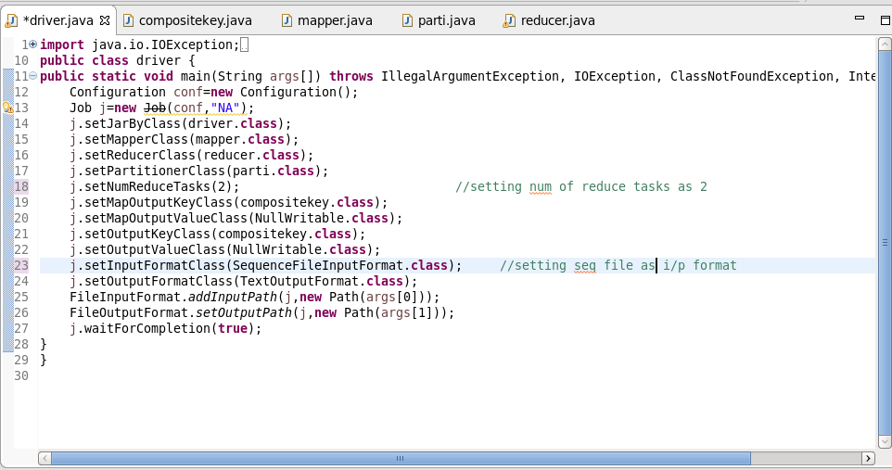

Mapper class:

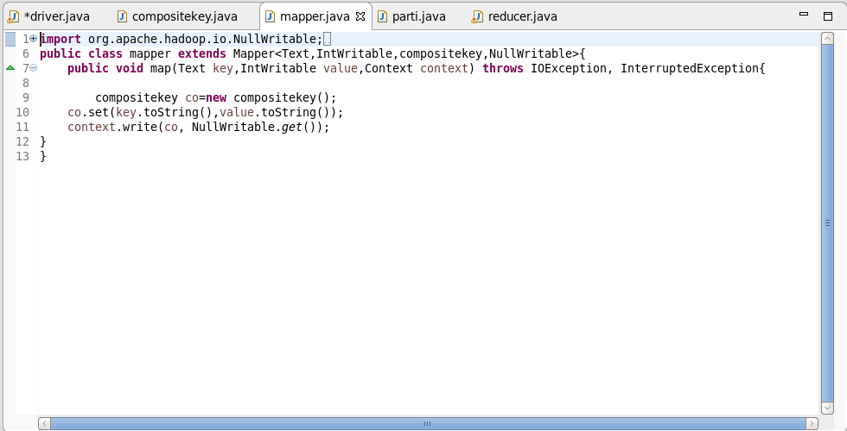

Compositekey class:

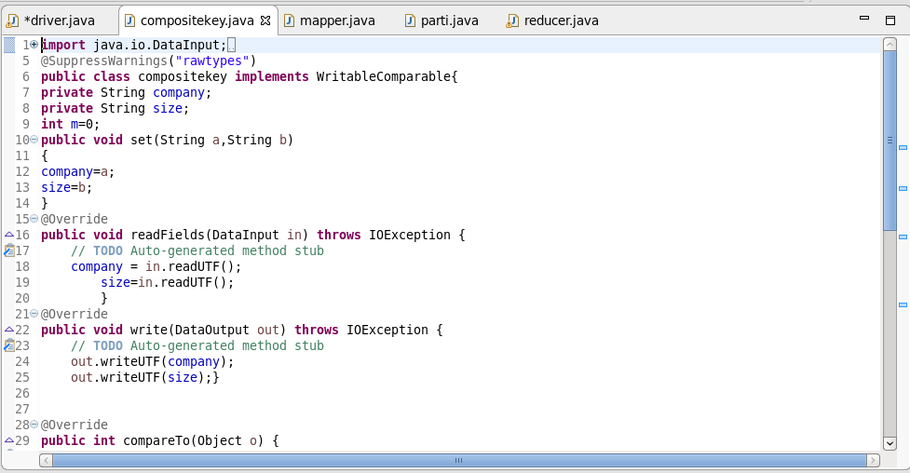

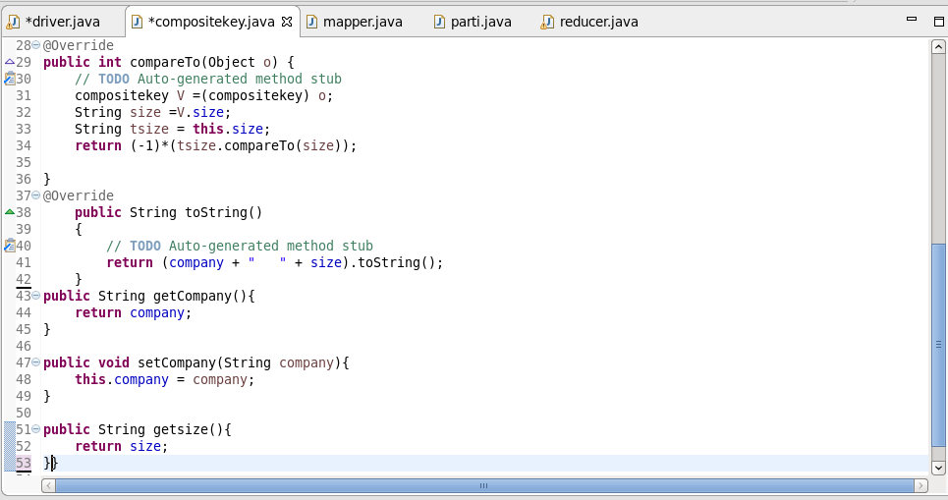

Partitioner class:

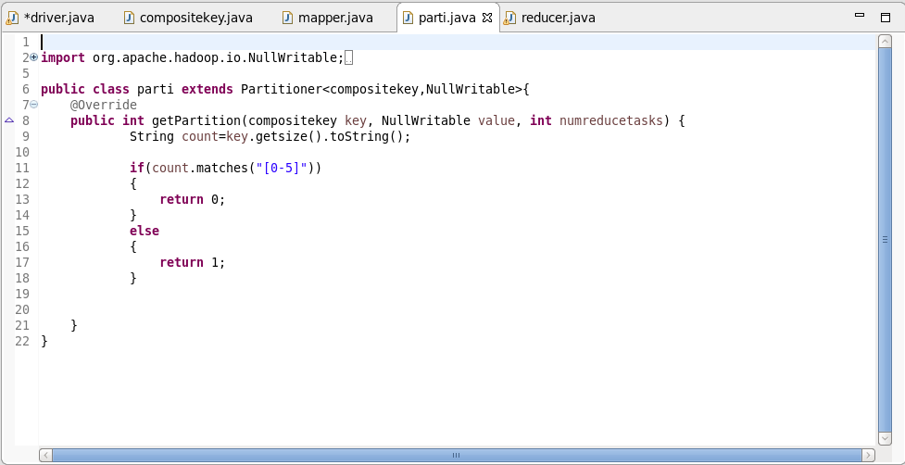

Reducer class:

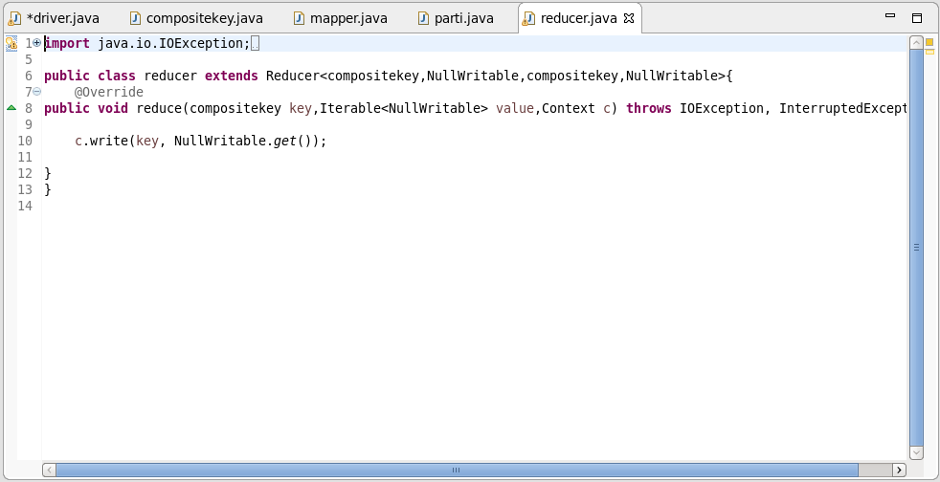

Output:

