Write a mapreduce program to use CombineFileInputFormat. Pass a directory containing multiple small files. The program should be able to pick multiple files in a single mapper.

Driver class:

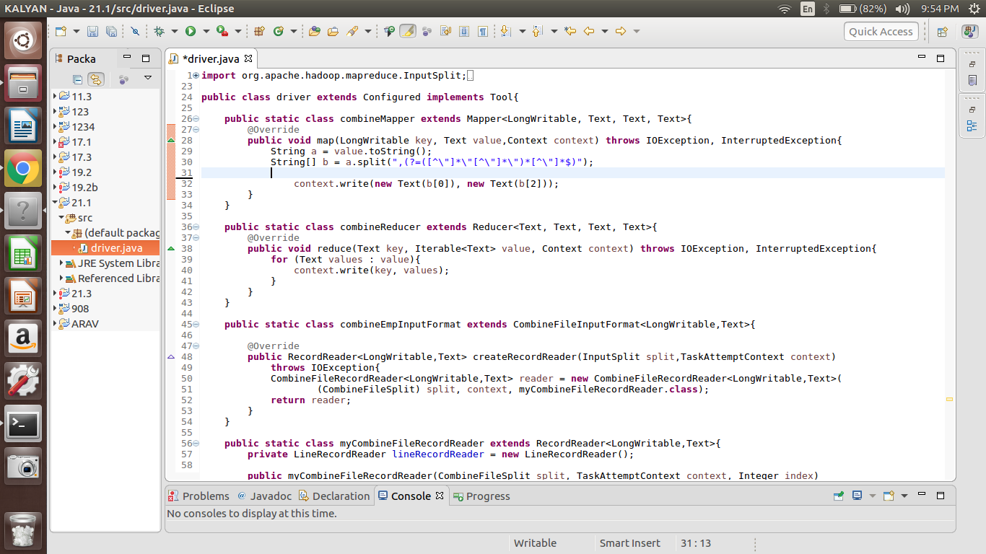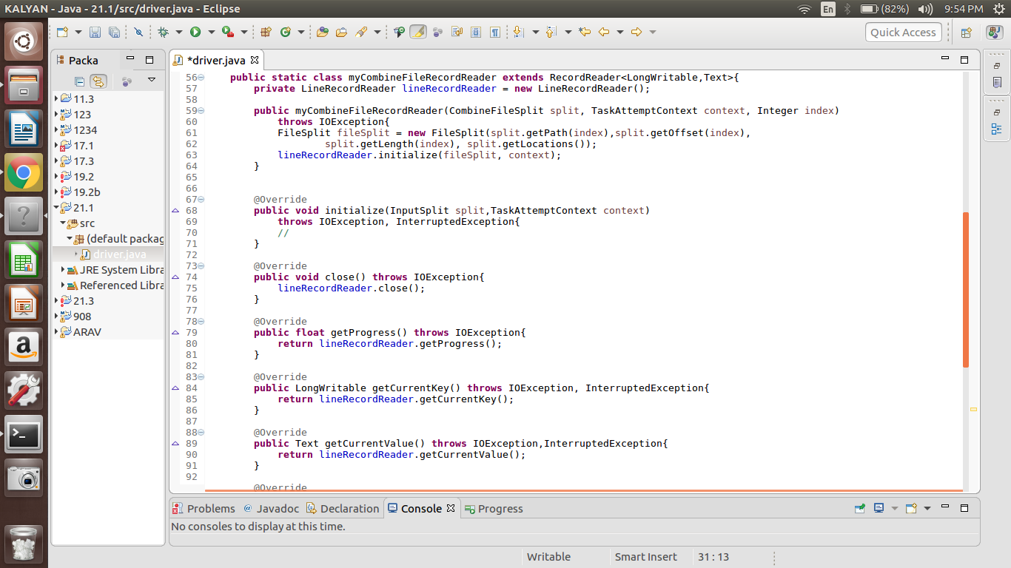

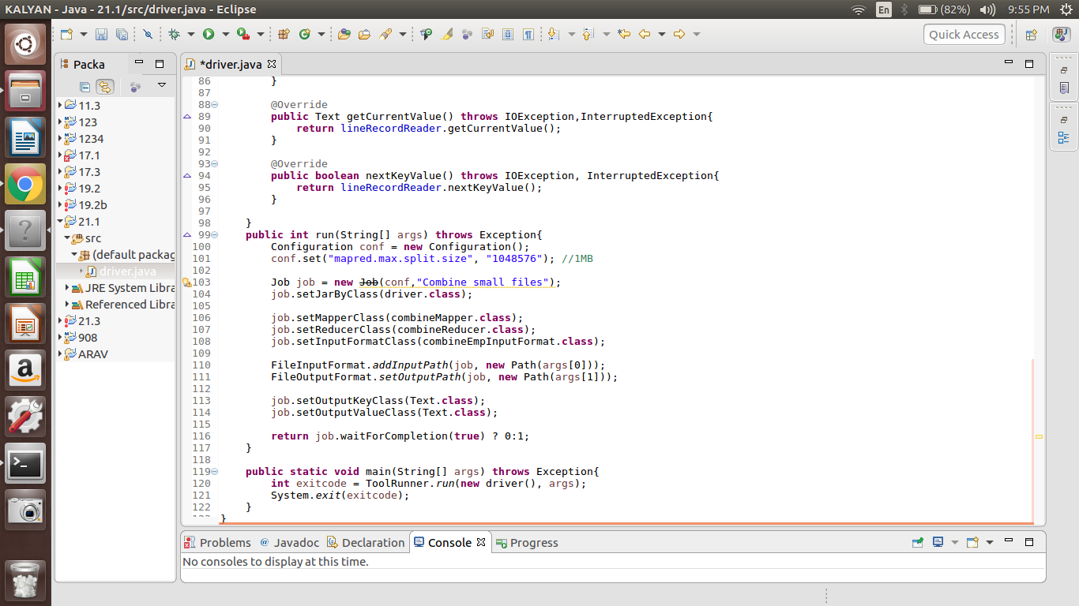

Output:

