Create a database named 'custom'.

Create a table named temperature_data inside custom having below fields: 1. date (mm-ddyyyy) format 2. zip code 3. temperature The table will be loaded from comma-delimited file.

Load the dataset.txt (which is ',' delimited) in the table.

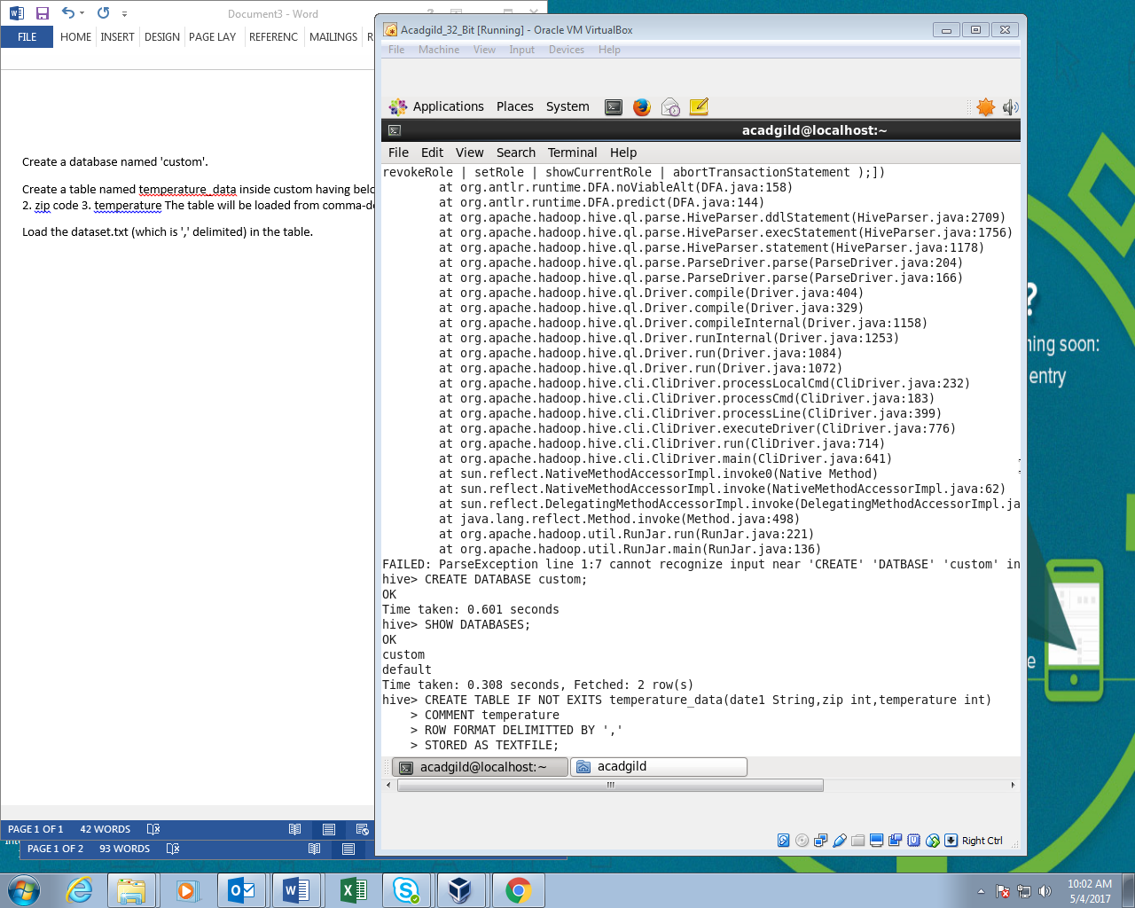

First i had Created database named custom.

Then I used custom database to store my table.

I had created the table named temperature_data where it contains date,zip and temperature.

It is delimited using comma operator.

And I stored it as a textfile.

