Write a hive query find the average age of male and female persons died in the titanic tragedy 2

First I created the table named tiranica_data and respective columns, then I stored it as a text field.

Then using count function I counted number of male and female died by using group by function.

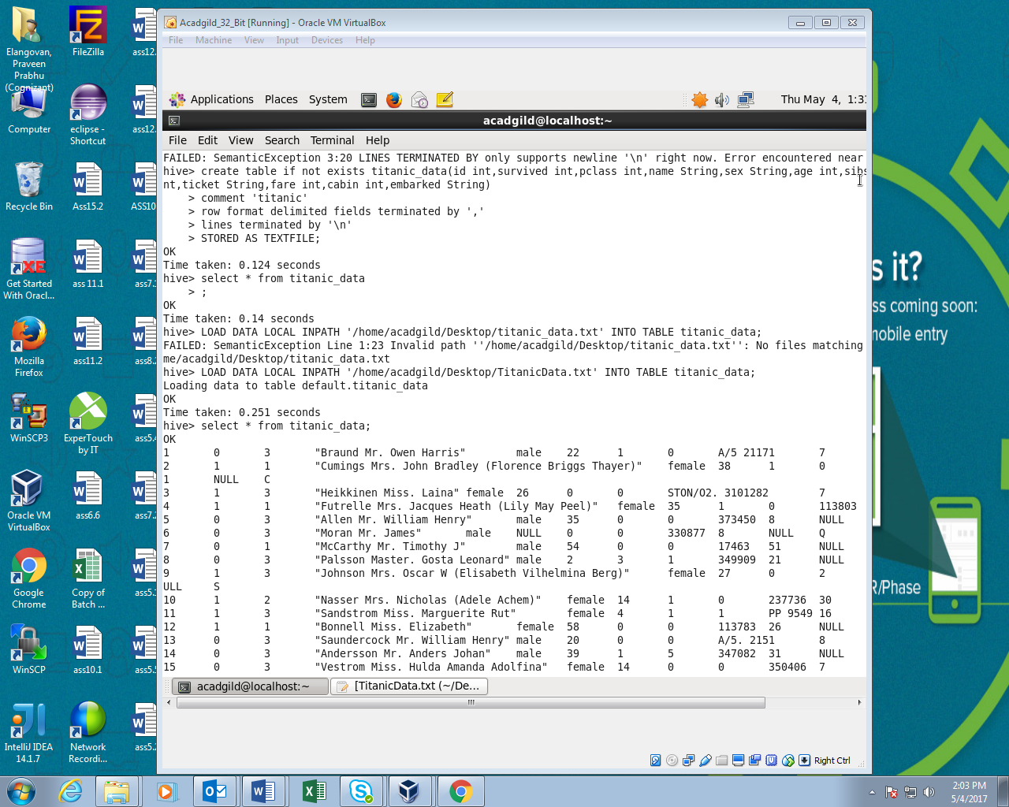

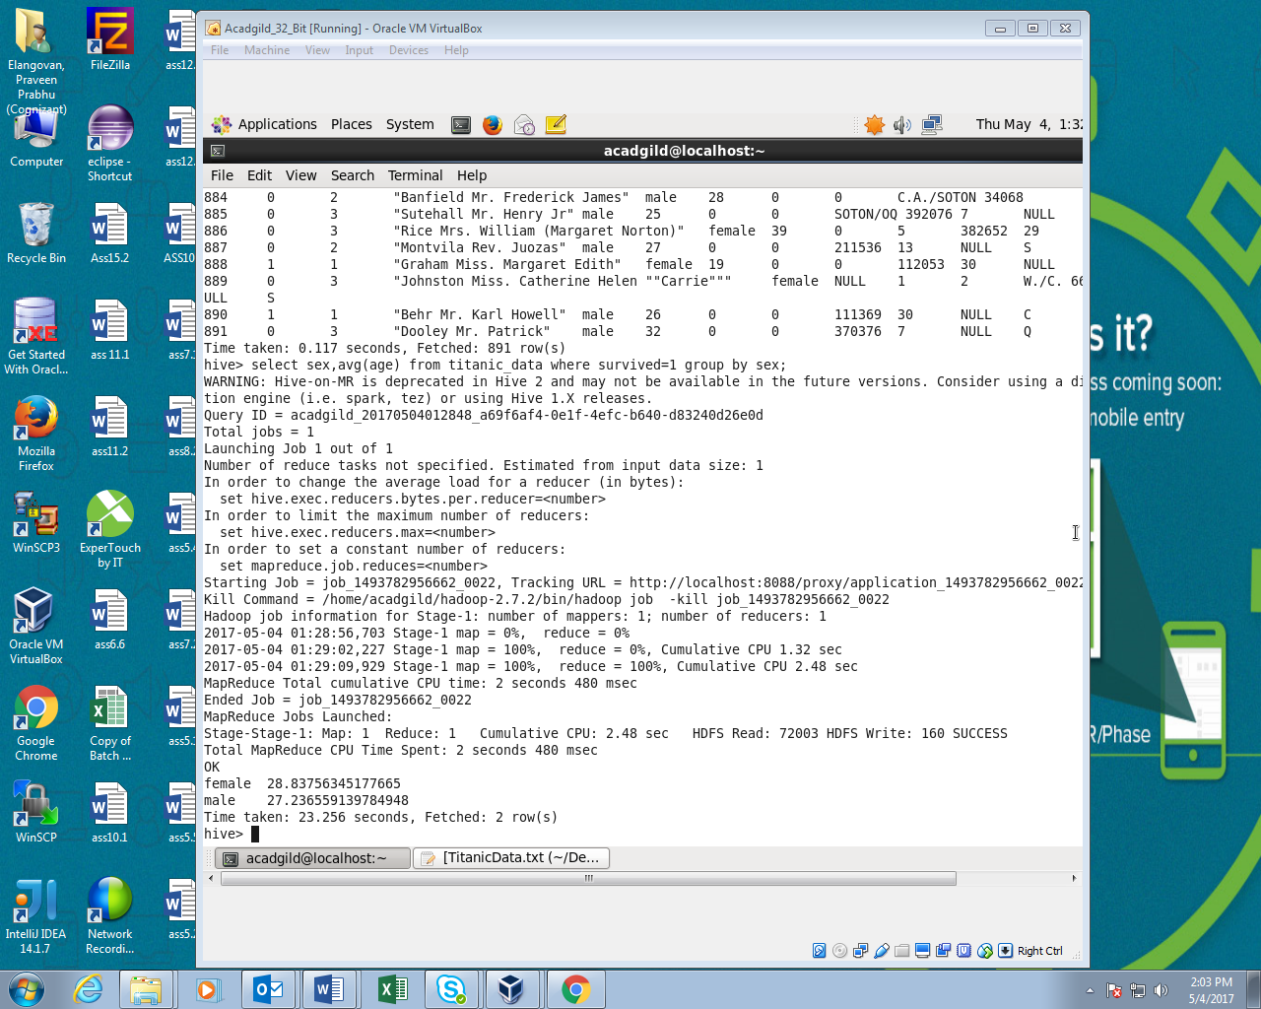

Write a hive query to find the number of people died and survived in each class.

In this I has counted the people survived based on the passenger class ‘0’ indicates the passenger who survived and ‘1’ indicates the passenger who was died.

