**Create a hive table and load the dataset into the table and evaluate the below problem statements**

**CREATING THE TABLE AND LOADING THE DATA INSIDE THE TABLE**

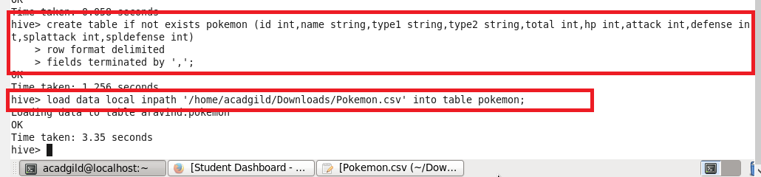

1. ***Find out the average HP (Hit points) of all the Pokémons***

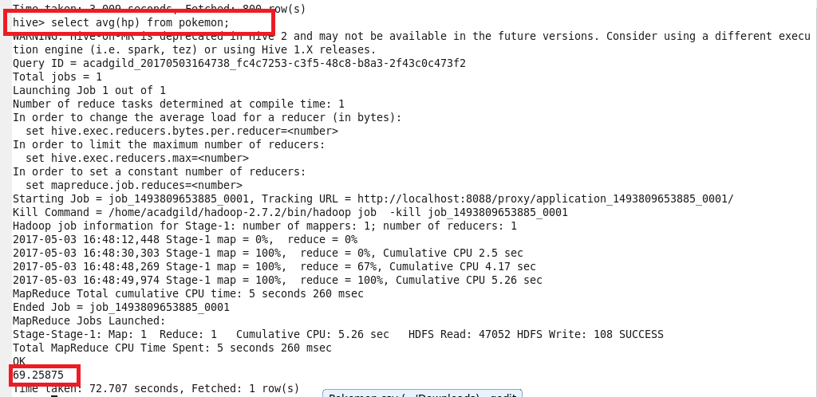

***Find out the average Defense of all the pokemon***

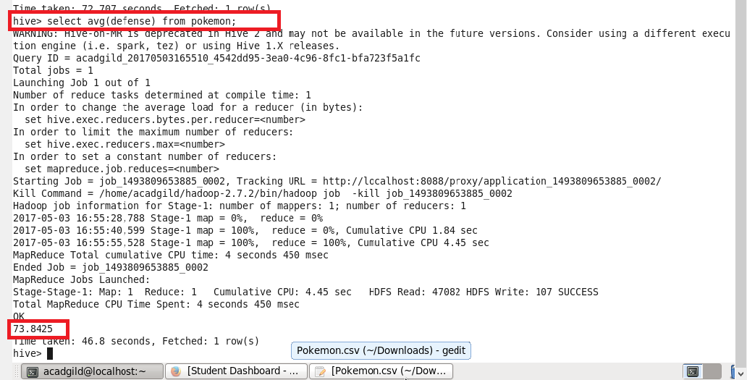

1. ***Find out the average Sp.Atk of all the pokemons***

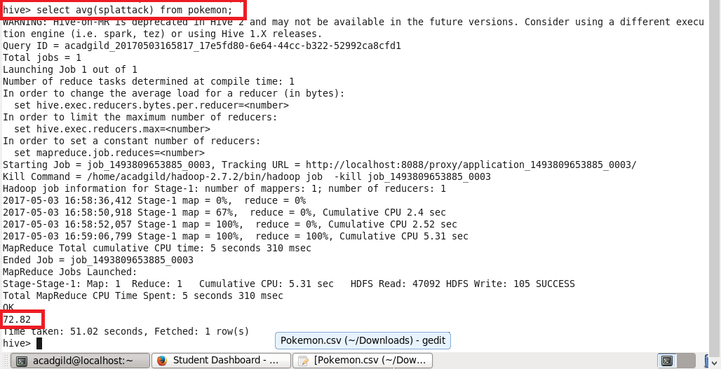

1. ***Find out the average sp.Def of all the pokemons***

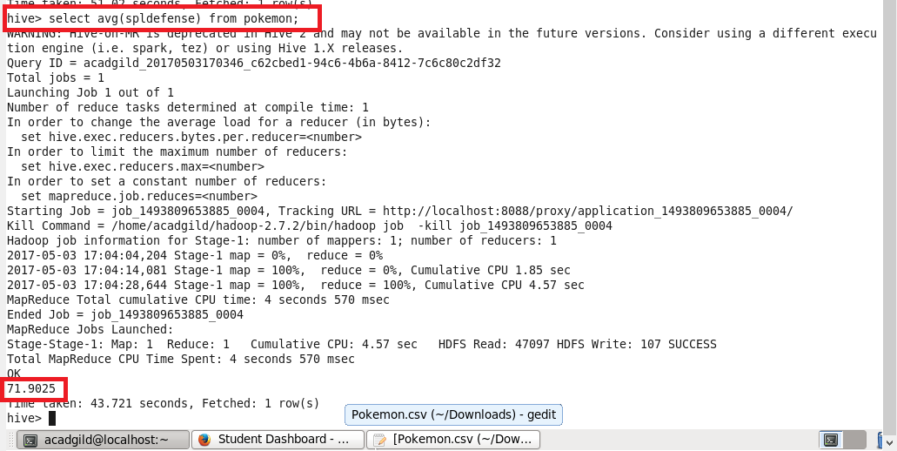

1. ***Find out the average Speed of all the pokemons***

