1.Write a hive query to find the minimum temperature observed in a given weather station in a particular year.

First I was created the table name weather and load the dataset into the table.

By using the min function I found the miminum temperature of the particular station using group by function.

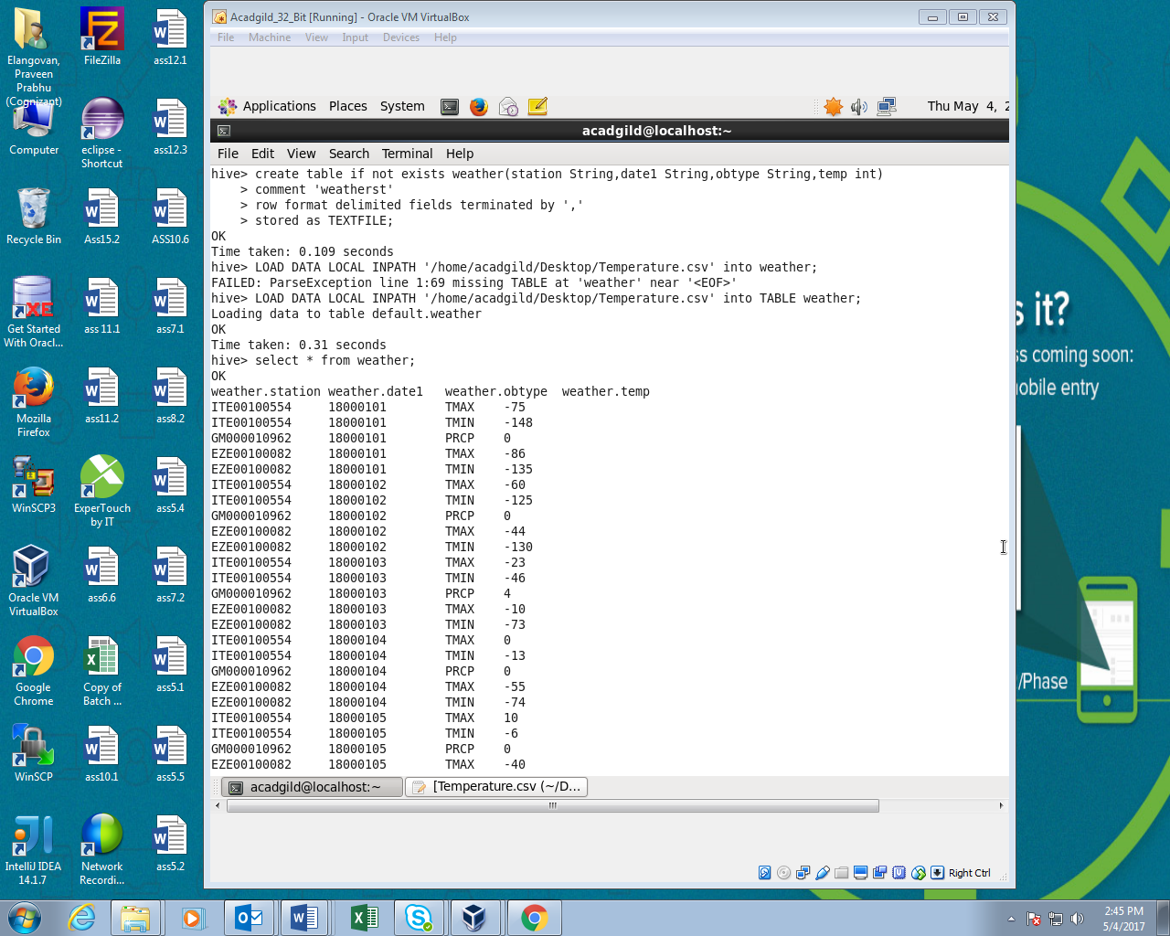

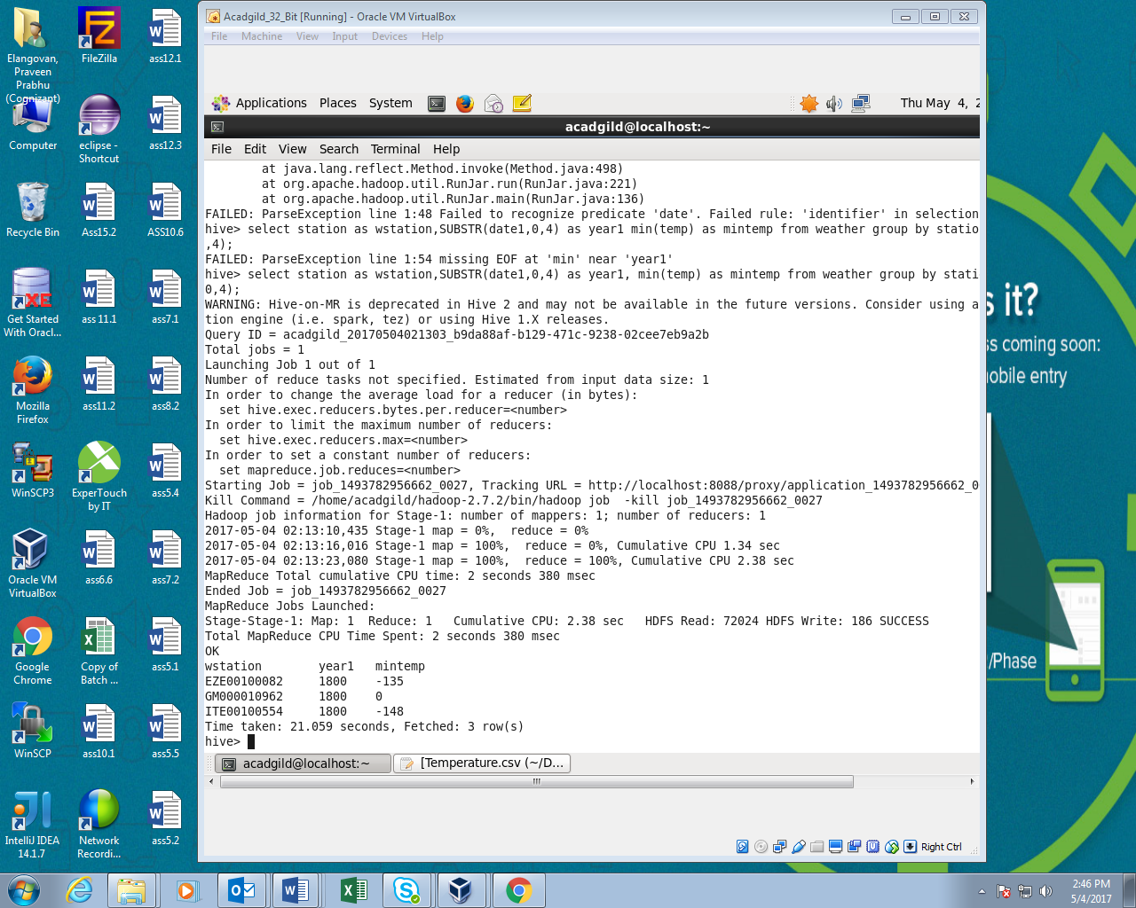

2. Write a hive query to find the maximum temperature observed in a given weather station in a particular year.

This is similar to the first question instead of min function we should use max to find the maximum temperature of the particular station of the particular year.

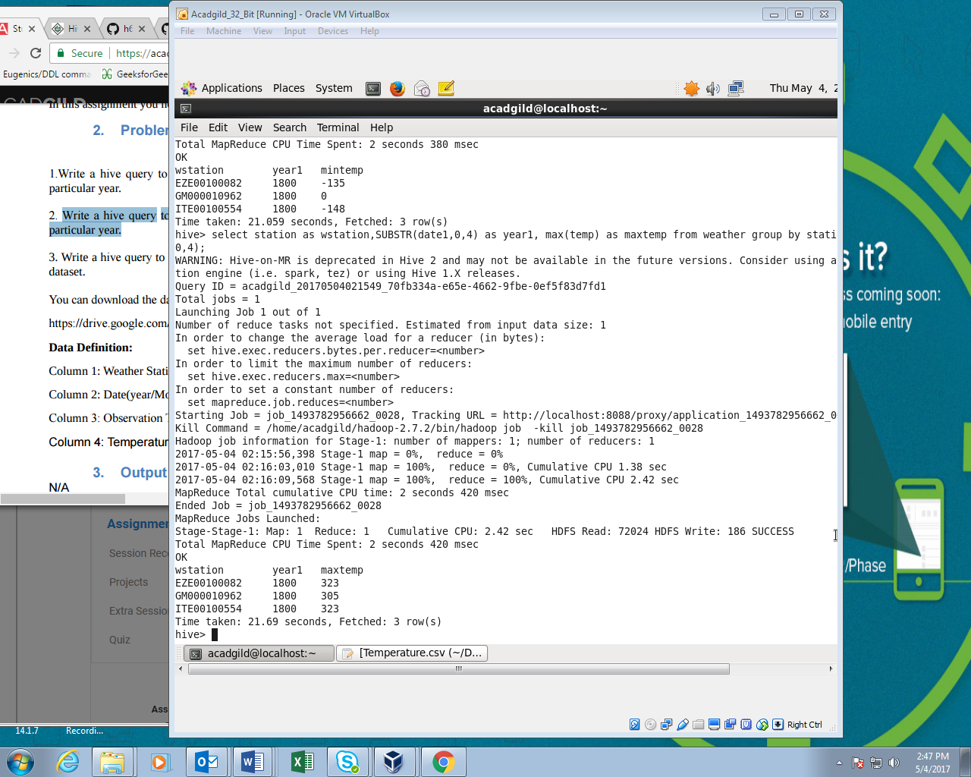

3. Write a hive query to find the number of readings given by each weather station according to the dataset

In this I had count all the station and finally using group by function I found the number of readings for the each station.

