**Get a list of employees who receive a salary less than 100, compared to their immediate employee with higher salary in the same unit.**

**QUERY:**

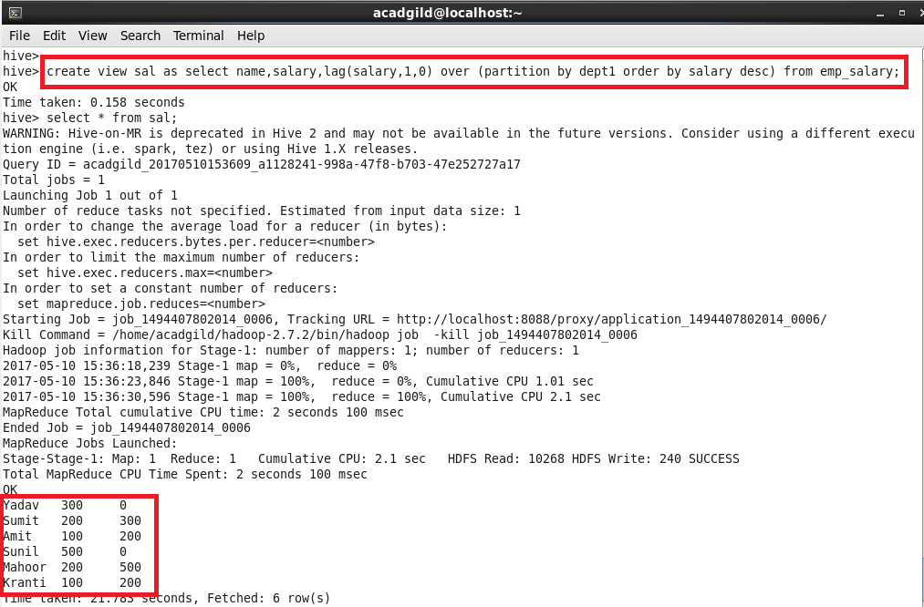

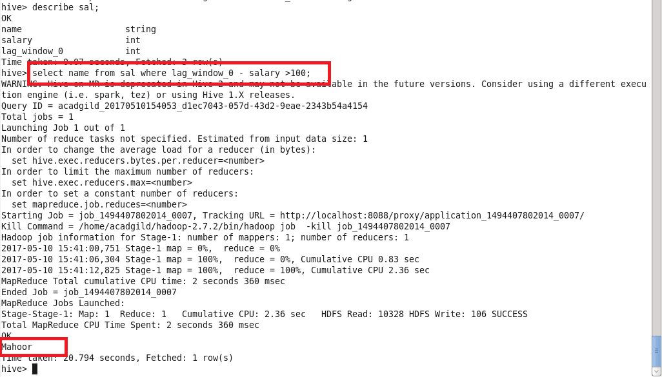

**List of all employees who draw higher salary than the average salary of that department.**

**Query:**