1. Write a hive query to find the top 20 destination people travel the most

I had created the table travel where I stored the travel_data.

Since there are many categories of travelers I added all the categories to get the total count and sorted it by descending and limited to 20.

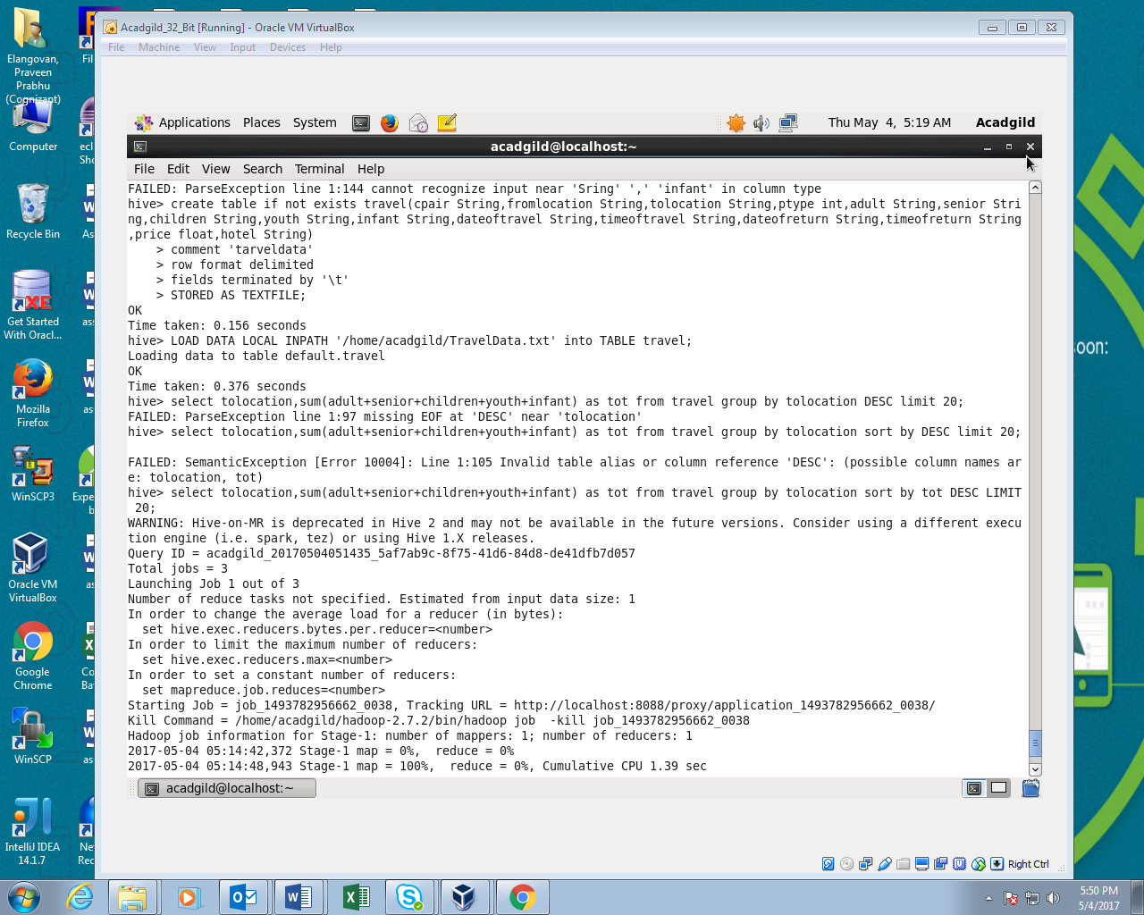

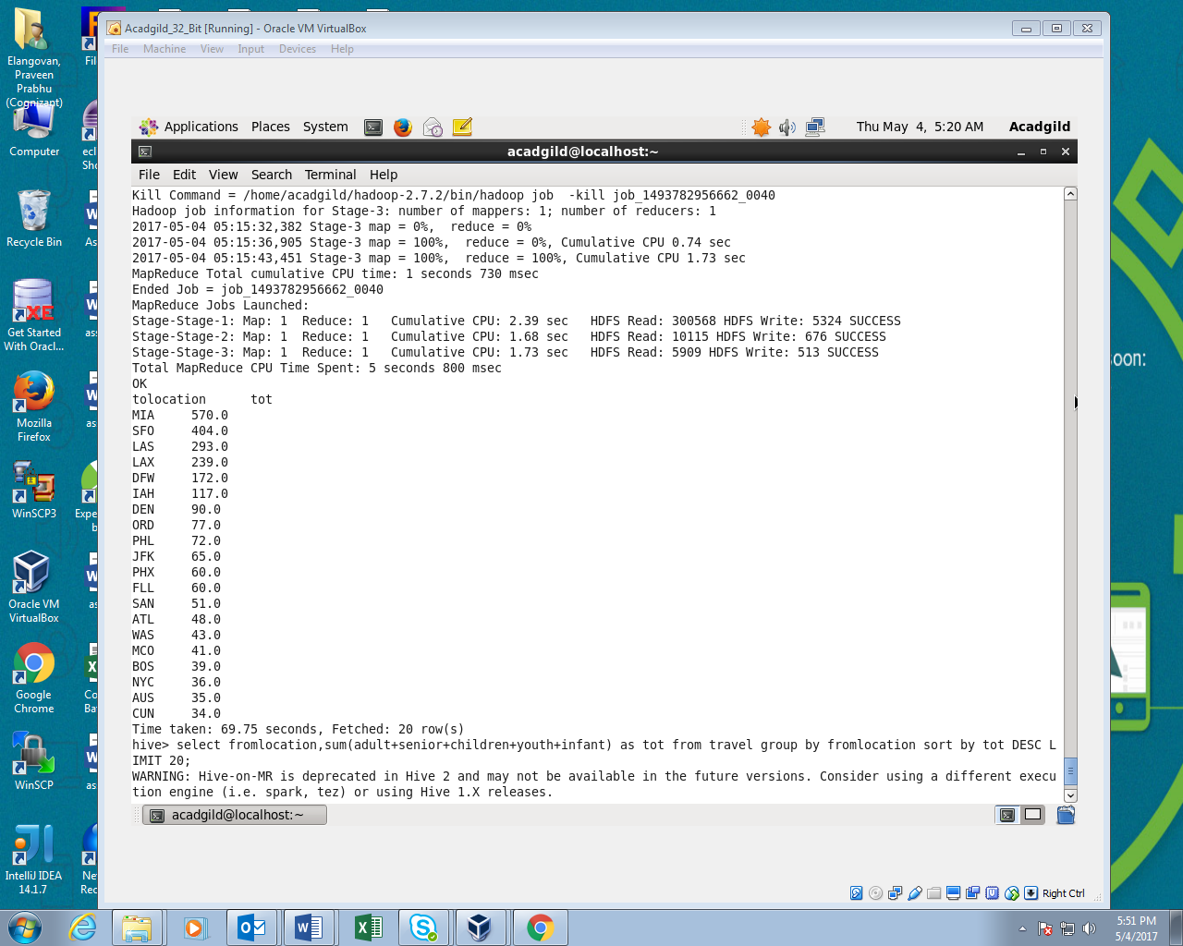

2.Write a hive query to find the top 20 locations from where people travel the most

This is same as the first instead of to location we have to find from where people travels most so in place of to location we should use from location and sorted it by descending and limited to 20.

