**Implement view in hive by following the steps in the below blog**

**Already I’ve created a table emp_salary with id,name,salary,dept as contents.**

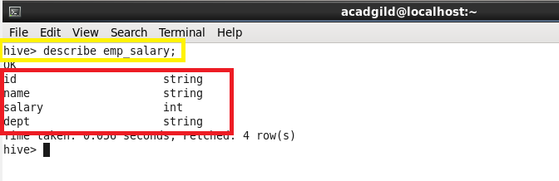

**Now I’m creating a view and loaded the contents of emp_salary into it.**

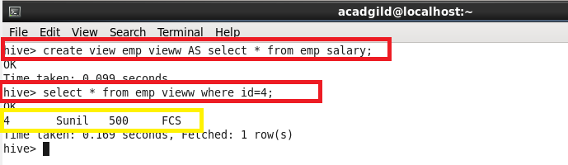

The main reason for having a view of a table is to simplify some of the complexities of a larger table into a more Flat structure. For instance, if you have a table that has 100 columns, but you are only interested in 5, you could create a View with those 5 columns.

Retrieved the data using select statement from the view