What are ACID properties and Explain Transactions in Hive.

ACID stands for Atomicity, Consistency, Isolation, and Durability.

**Atomicity:**

Atomicity means, a transaction should complete successfully or else it should fail completely i.e. it should not be left partially.

**Consistency:**

Consistency ensures that any transaction will bring the database from one valid state to another state.

**Isolation:**

Isolation states that every transaction should be independent of each other i.e. one transaction should not affect another.

**Durability:**

Durability states that if a transaction is completed, it should be preserved in the database even if the machine state is lost or a system failure might occur.

These ACID properties are essential for a transaction and every transaction should ensure that these properties are met.

**Transactions in Hive**

Transactions in Hive are introduced in Hive 0.13, but they only partially fulfill the ACID properties like atomicity, consistency, durability, at the partition level. Here, Isolation can be provided by turning on one of the locking mechanisms available with zookeeper or in memory.

But in Hive 0.14, new API’s have been added to completely fulfill the ACID properties while performing any transaction.

Transactions are provided at the row-level in Hive 0.14. The different row-level transactions available in Hive 0.14 are as follows:

1. Insert
2. Delete
3. Update

There are numerous limitations with the present transactions available in Hive 0.14. ORC is the file format supported by Hive transaction. It is now essential to have ORC file format for performing transactions in Hive. The table needs to be bucketed in order to support transactions.

Transactions in hive:

Setting configurations in hive shell:

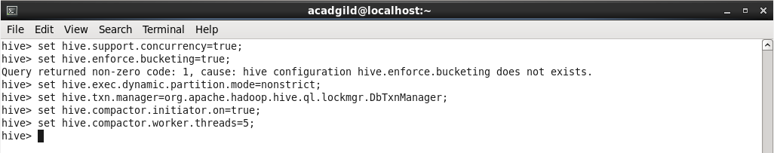

Creating table and inserting data into it.

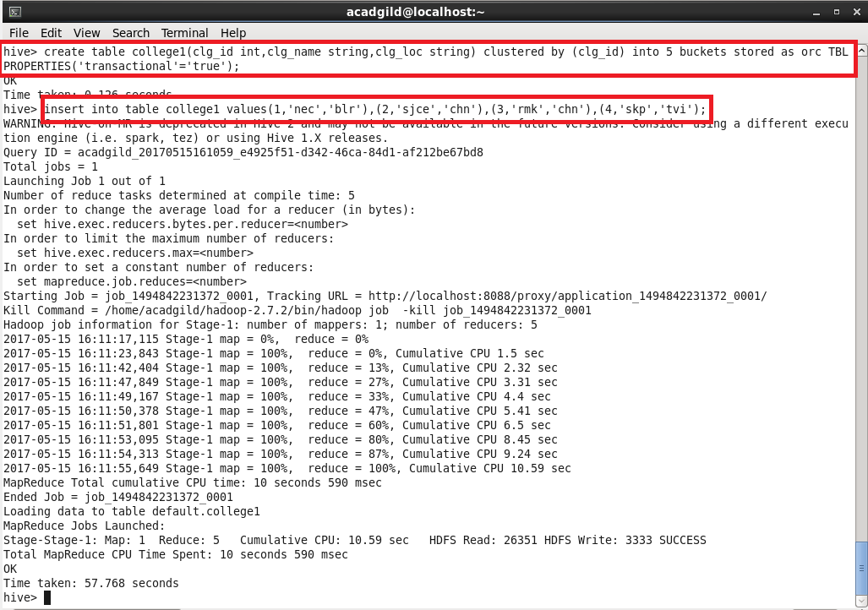

Showing the table with inserted values.

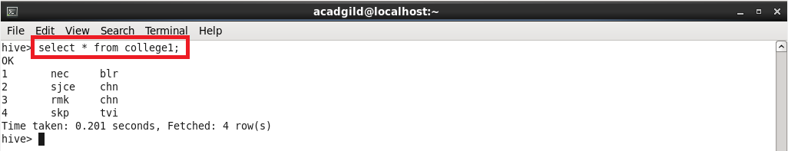

Inserting the same values again does the append operation.

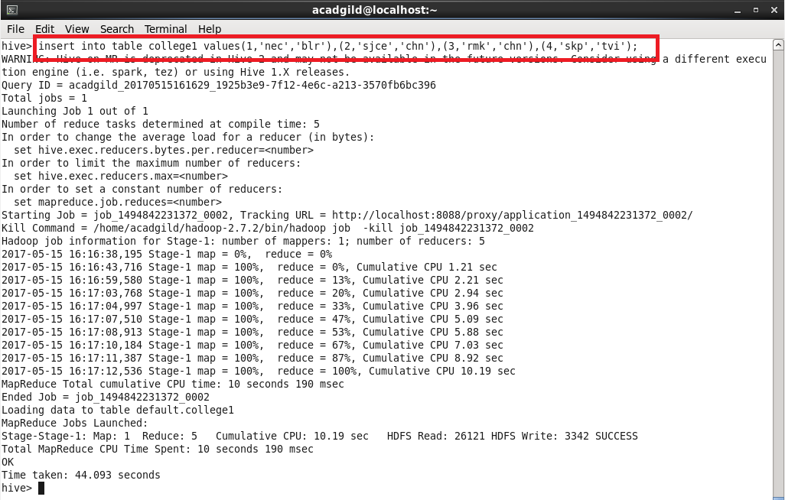

Showing the appended data

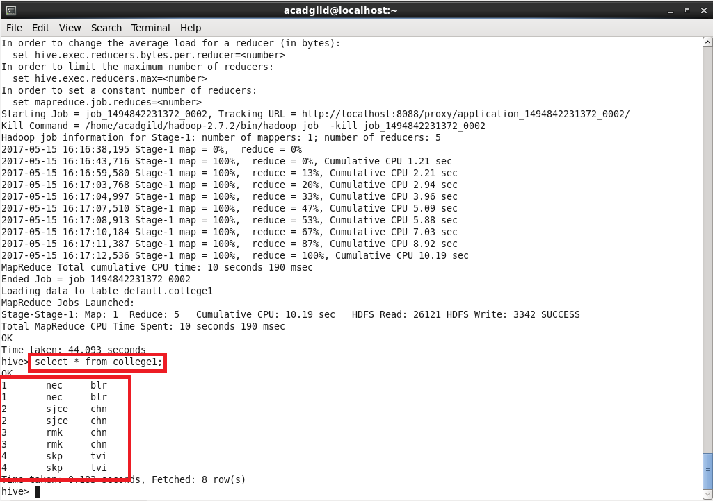

Performing update operation in the rows of the table

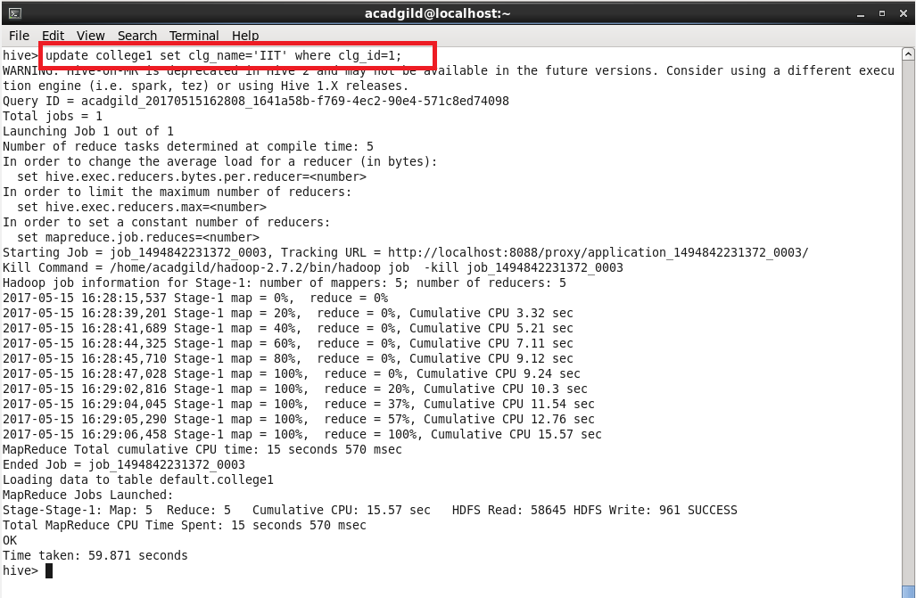

Showing the updated table:

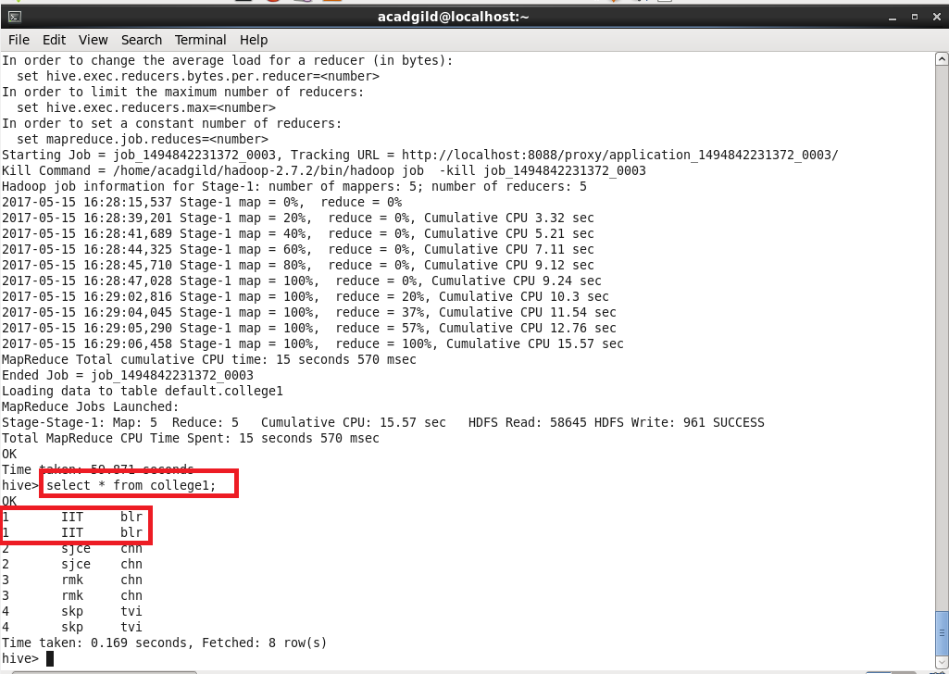

Performing delete operation:

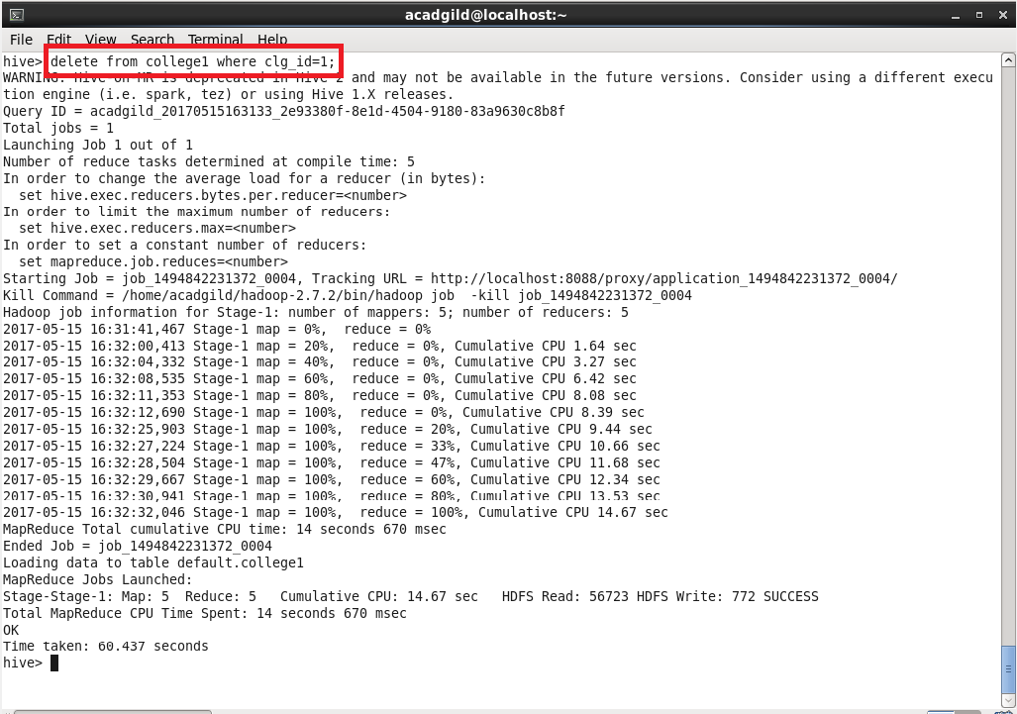

Showing the updated table with deleted rows:

