Get a list of employees who receive a salary less than 100, compared to their immediate employee with higher salary in the same unit.

**Query:**

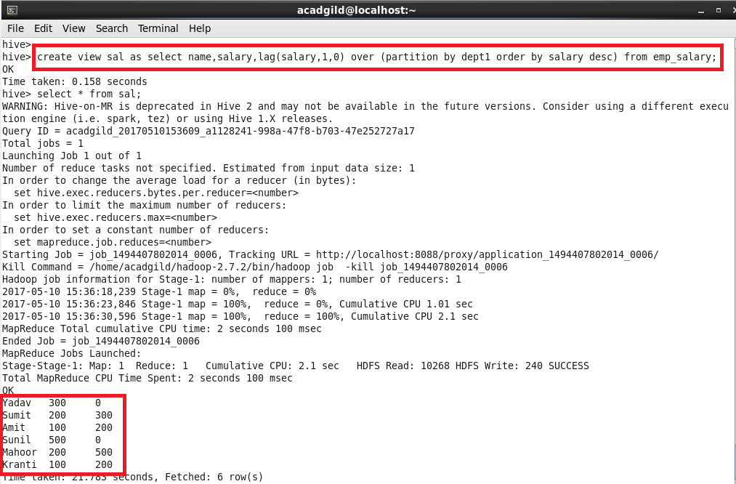

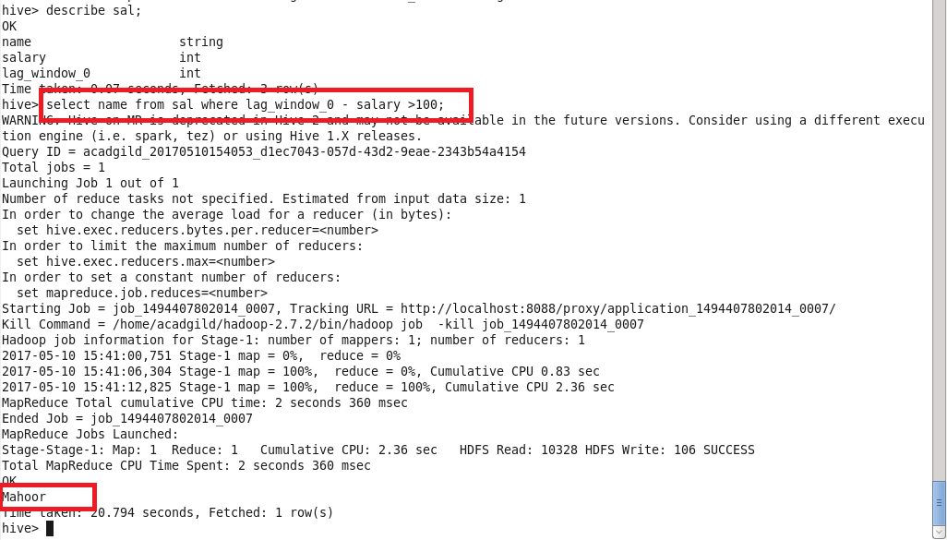

List of all employees who draw higher salary than the average salary of that department.

**Query:**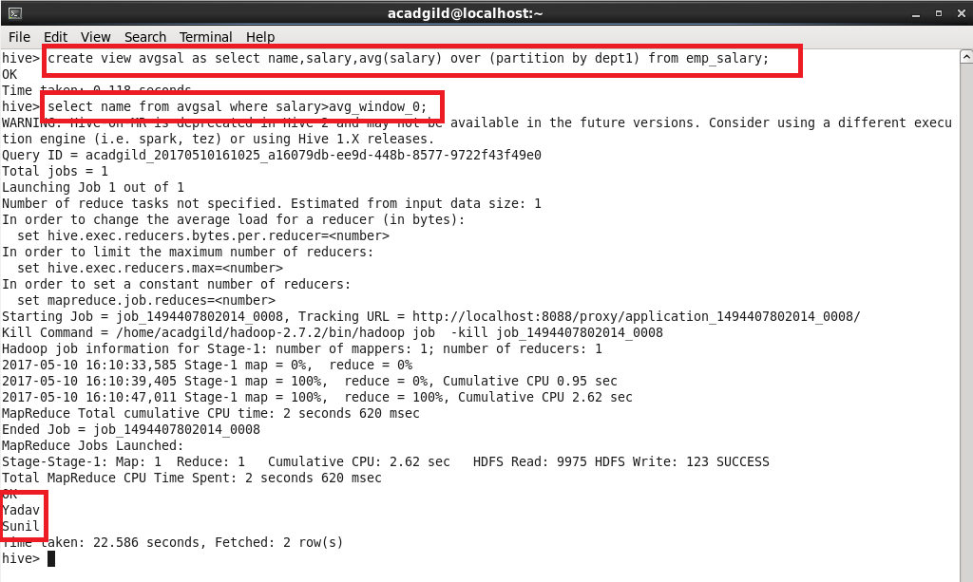

**Sequence file format:**

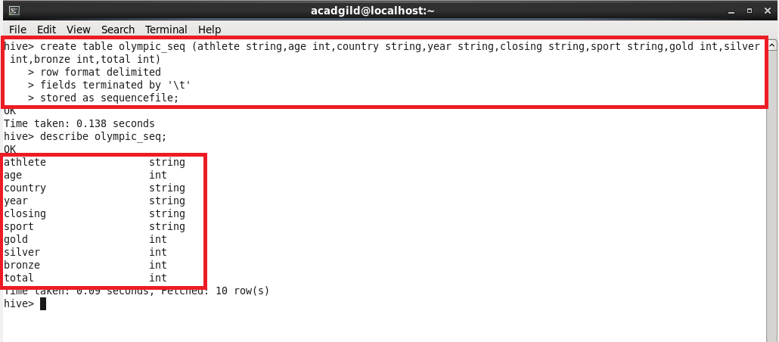

Query:

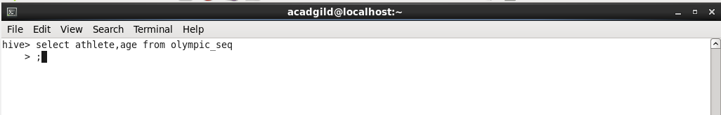

Sample output**:**

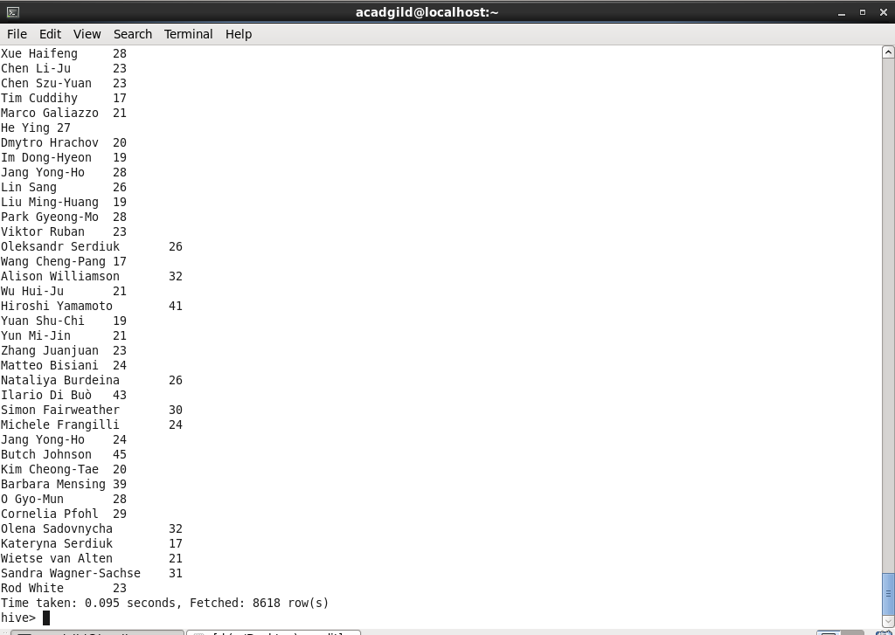

**RCFILE:**

Creating a table and storing it as rc file

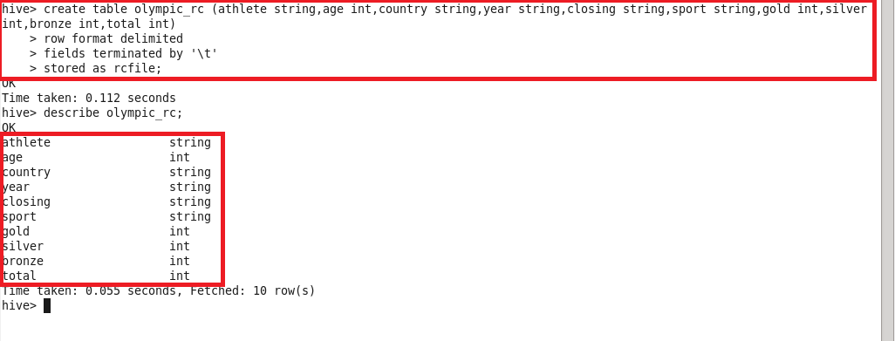

Inserting into the table:

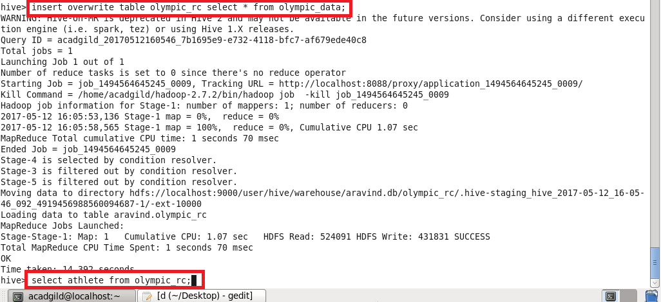

Sample Output:



**ORC FILE:**

Creating a table and storing it as orc file**.**

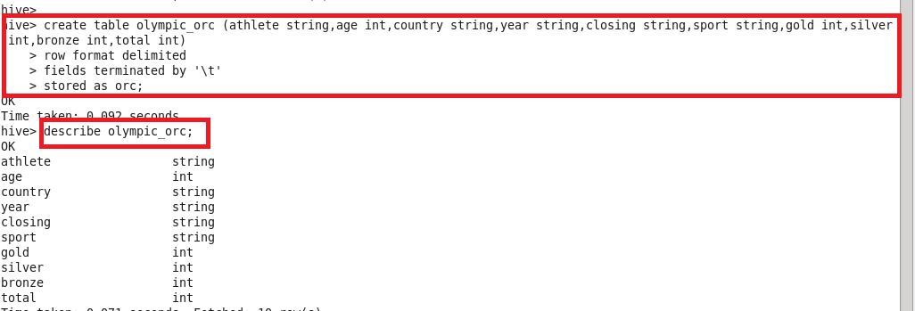

Inserting into the table:

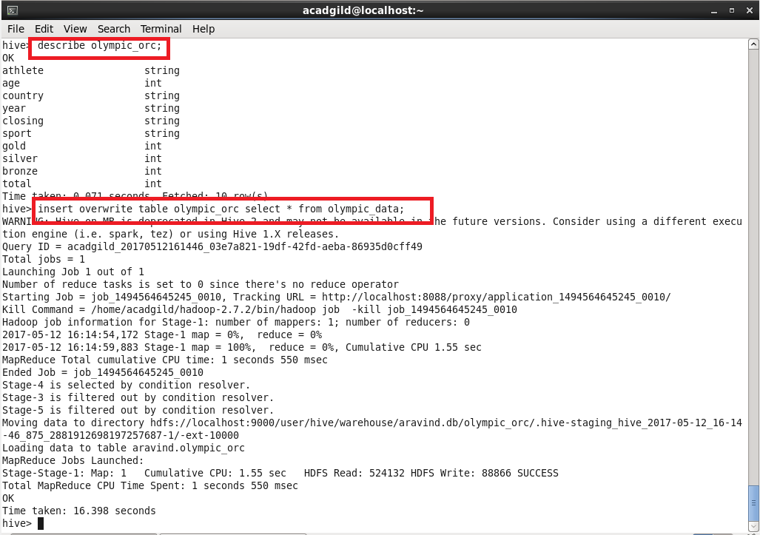

Query:

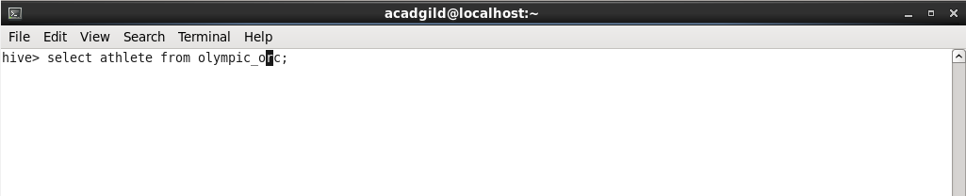

Sample Output:

