Write a hive UDAF to find the largest integer in a column. Use your own dataset for the above problem statement and attach the steps performed, codes used with the result.

Writing java code to find largest integer in the column

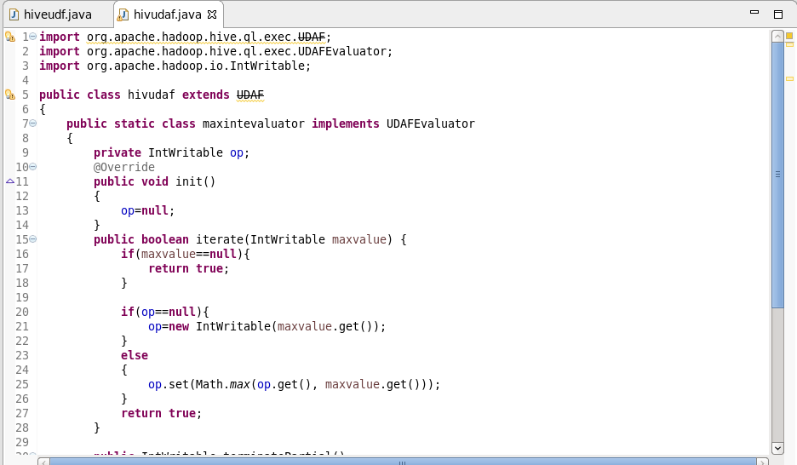

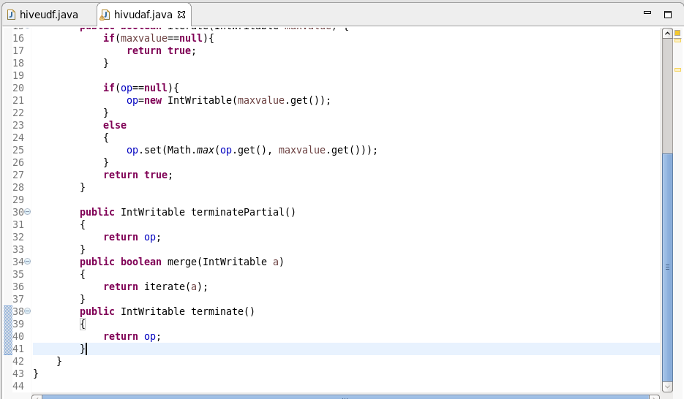

Adding jar to the hive shell

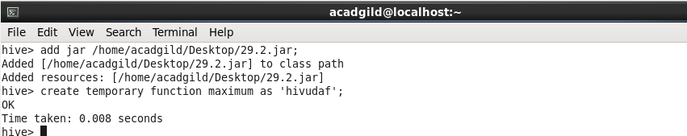

I am using customer table to find maximum salary

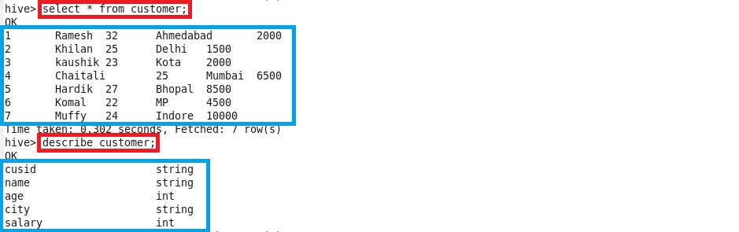

Using maximum temporary udf function

