Use Hbase shell for performing the following operations ● Create the table customer with two column families ● Personal details and order details as column families. Create a unique number as row key (ssn/Aadhar no.,etc) Insert at least 10 records to each column Insert following values for personal details column family Name, age, city, state ● Insert following values for order details column family ● Order no., order quantity, and order amount ● Use put command to insert the values for each record. Use get command, to retrieve all the records of single customer.

**Creating table with customer’s personal and order details:**

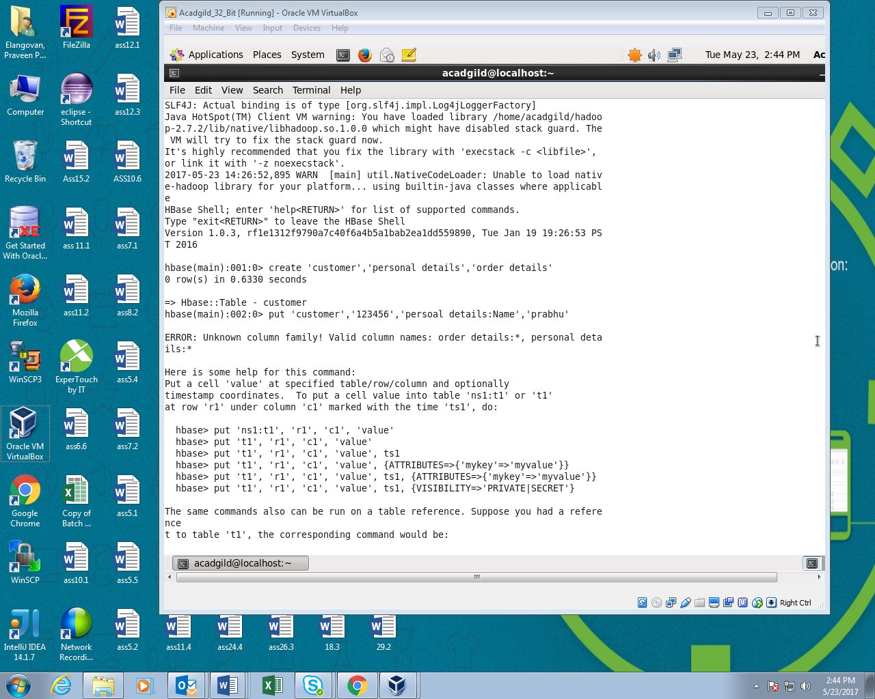

**Inserting details into personal details using put command:**

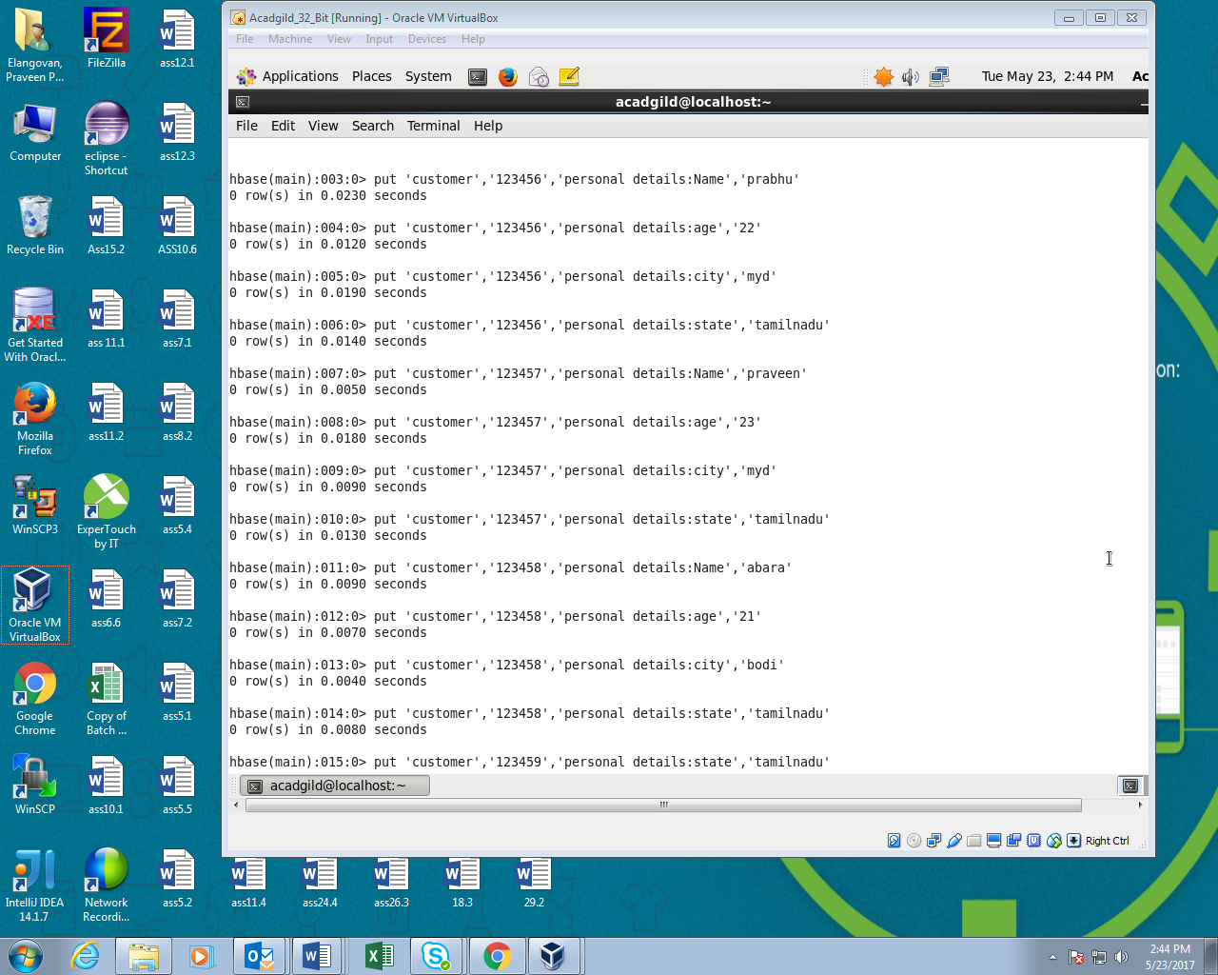

**Inserting details into order details using put command:**

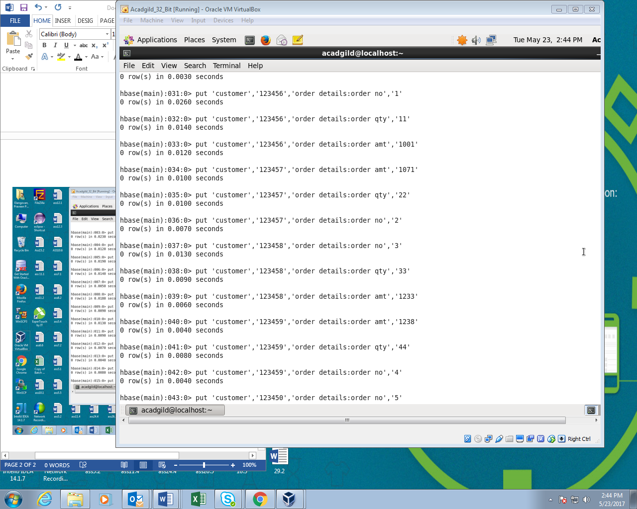

**Using get command retrieving the required details:**

