● Write a Java client API to perform following operations:

● Use HBaseAdmin class and create the table named company with one column family name details.

● Create the method name insert and use put class to insert records to company table

Creating Table:

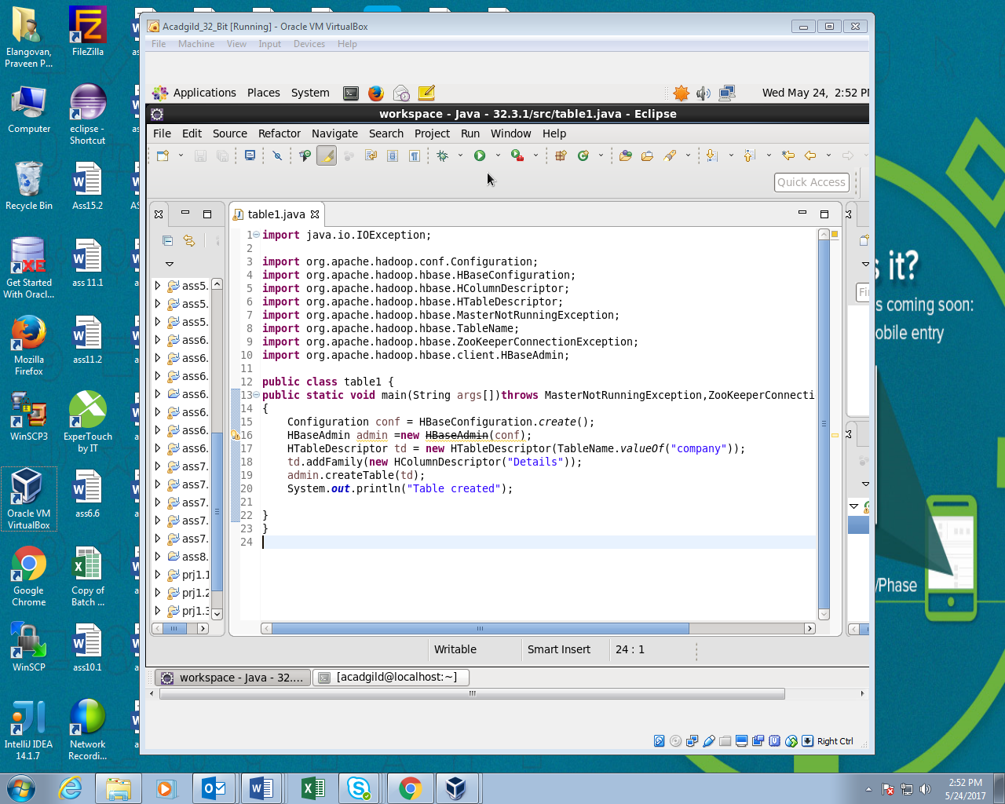

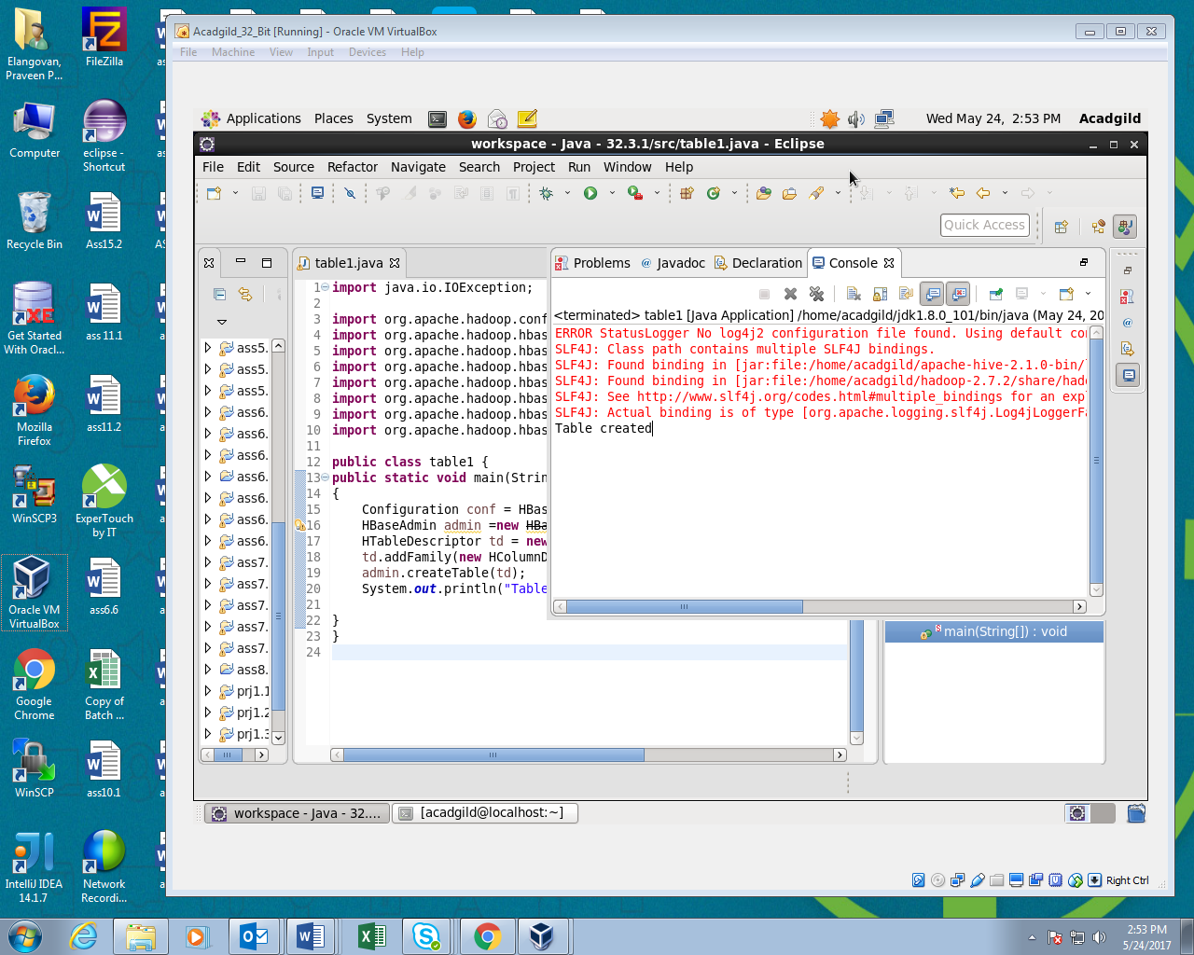

Inserting Data:

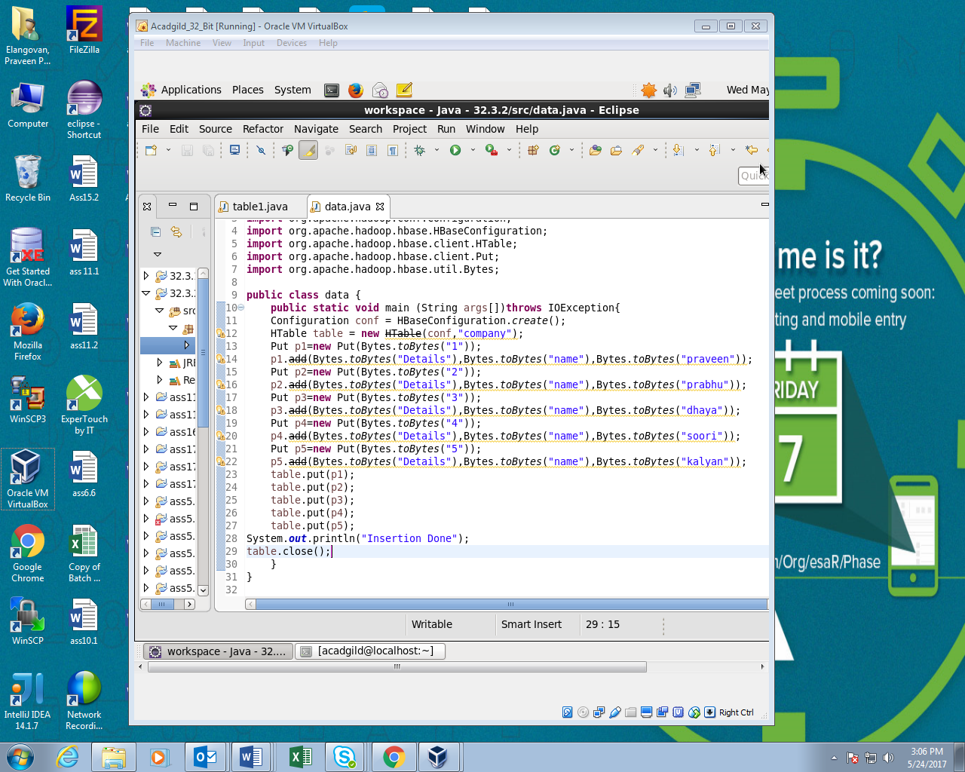

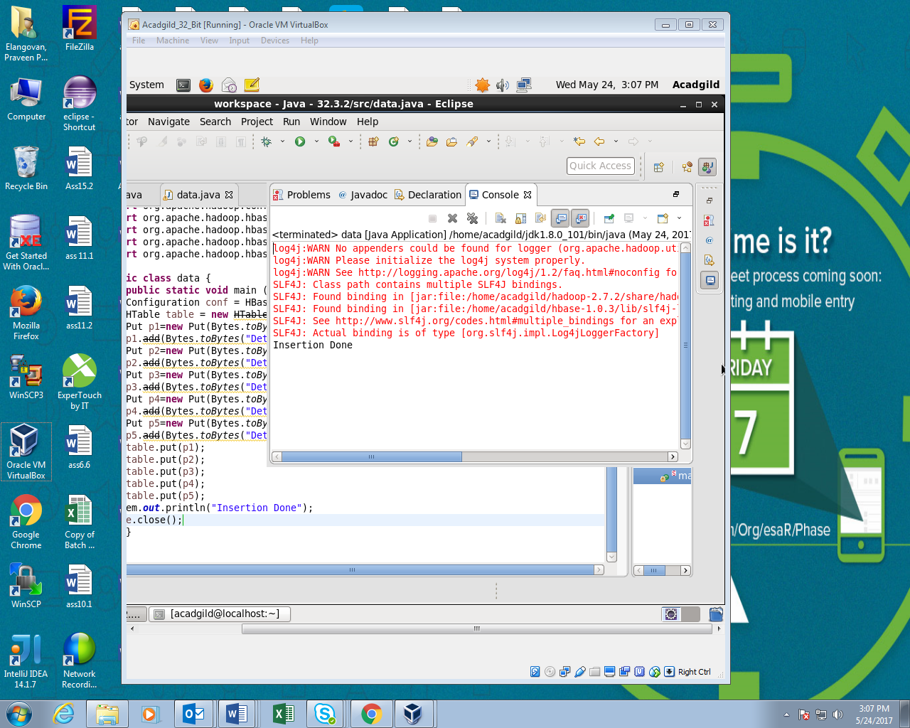

After Insertion:

