**● Integrate Hbase with Hive**

**Load Data (Bulk Load) from Hive table to Hbase Table**

**Explain the procedures and code implemented with screenshots.**

**Note: Candidates should Load their own data into Hbase table.**



We are creating an external table in hive ,so that it can be accessed by other application,since we need to integrate with hbase we are providing the table a key and the other columns with serde properties to make it easy access to hbase 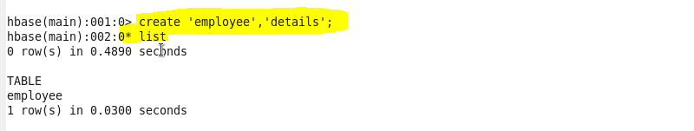

We are creating a table in hbase with a column family ‘details’****

Now to load the external table,we are creating another table and we are inserting the dataset into it

Now we will insert the dataset into external table from this table

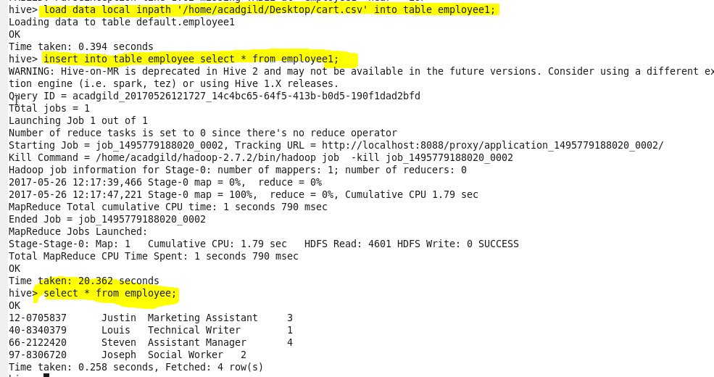

When we upload the content tp hive external table you can see that in hbase also the dataset is also uploaded