● Integrate Hbase with Pig

● Load Data (Bulk Load) from HDFS to Hbase Table using Pig.

● Explain the procedures and code implemented with screenshots.

● Note: Candidates should Load their own data into Hbase table.

So in this question we need to integrate hbase with pig

At first we are transferring the dataset into hdfs



So the content would be moved from local system to Hadoop

Then to transfer the content to hbase,we are creating a table ‘student’ with a column family ‘details’

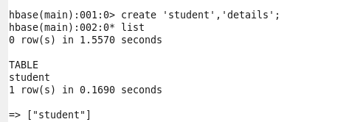

Then we are loading the data set into pig ,



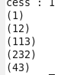

Now to transfer the content ,first we have to transfer some jar files oh hbase to pigpath



Now we can transfer the content to hbase

