1) Write a MapReduce program to filter out the invalid records. The output of this program will act as input for subsequent tasks. Map only job will fit for this context.

Driver:

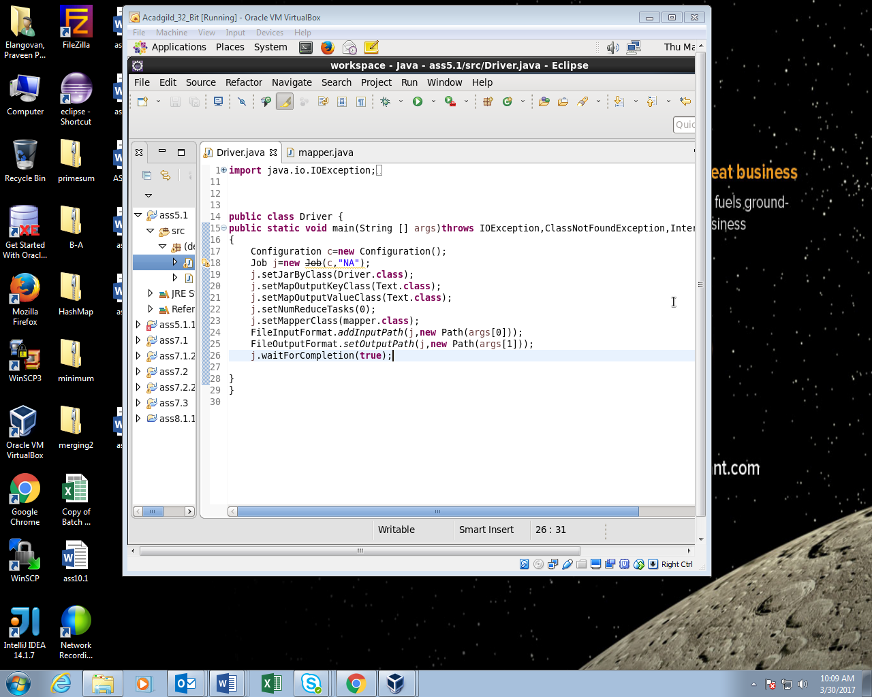

Mapper:

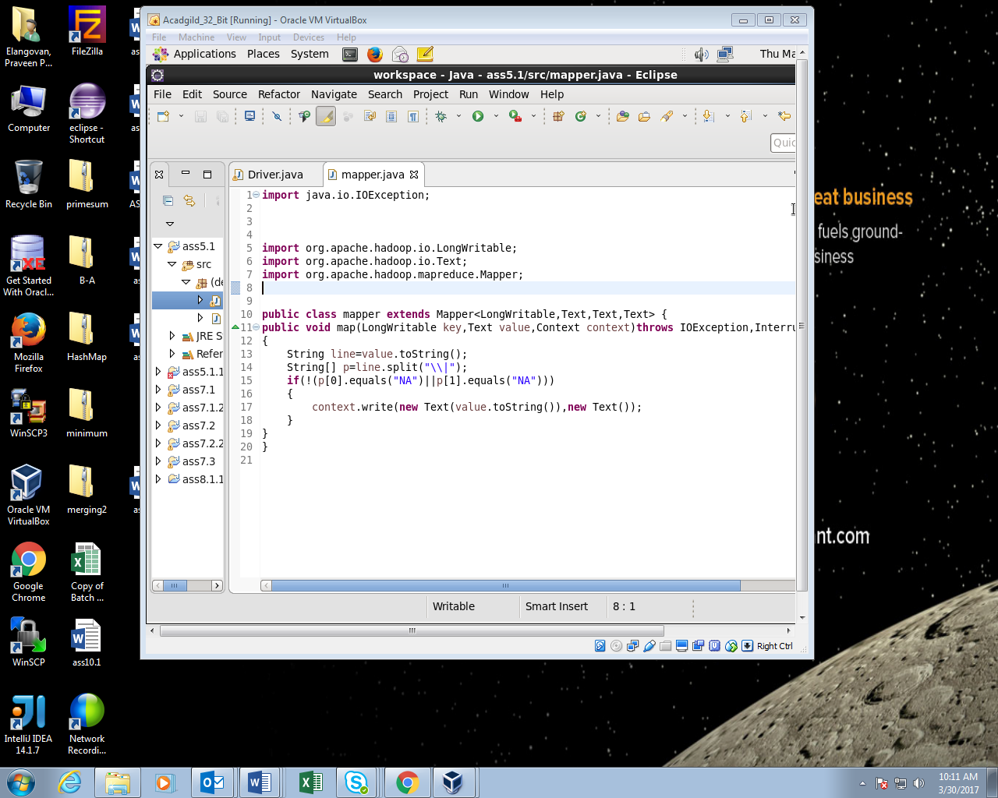

Running JAR file:

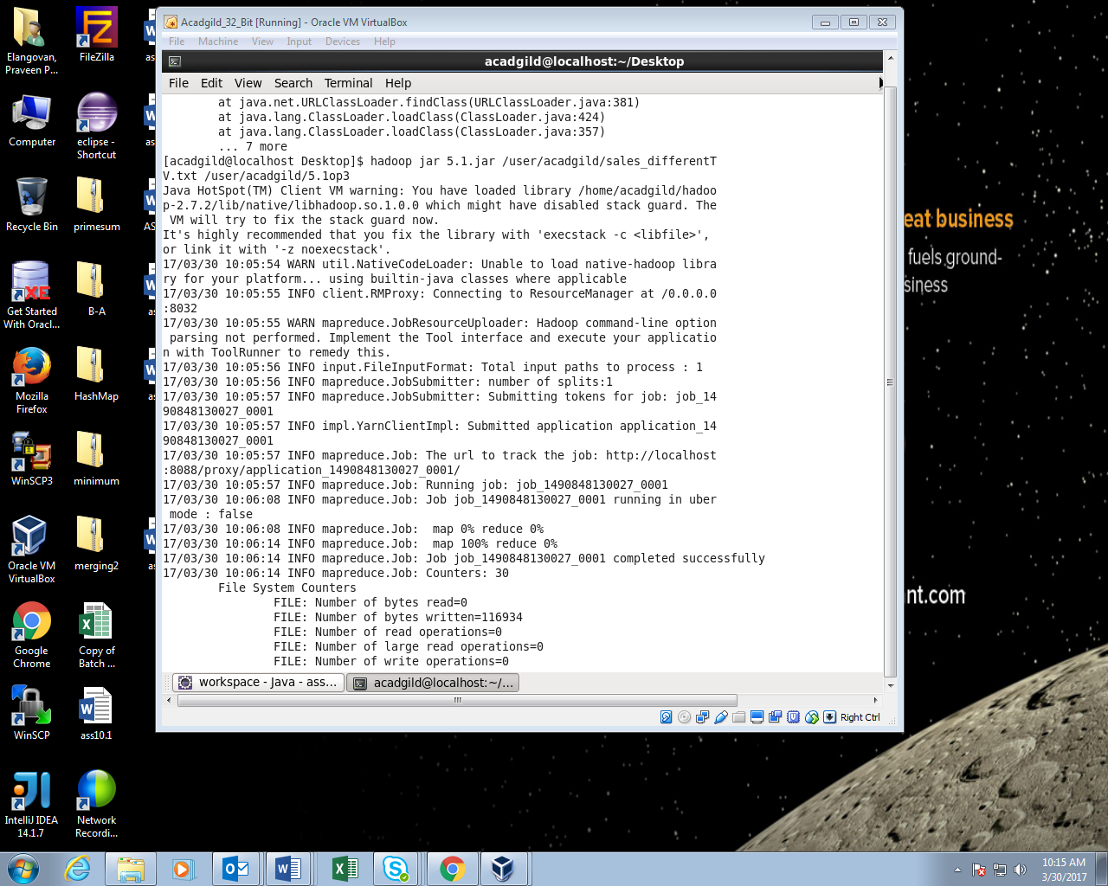

Output:

