[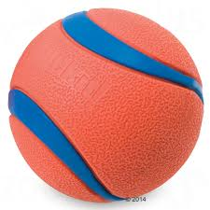](https://www.google.com/url?sa=i&rct=j&q=&esrc=s&source=images&cd=&cad=rja&uact=8&ved=2ahUKEwj_28TX0c7eAhUMYo8KHb8sAuwQjRx6BAgBEAU&url=https://www.bitiba.nl/shop/honden/spel_sport/werpen/ballen/522069&psig=AOvVaw2EorAzBGOW8pPV255fEW-5&ust=1542104593472005) [](https://www.google.com/url?sa=i&rct=j&q=&esrc=s&source=images&cd=&cad=rja&uact=8&ved=2ahUKEwjG49Xt9c7eAhUGLI8KHQJAAZsQjRx6BAgBEAU&url=https://en.wiktionary.org/wiki/aeroplane&psig=AOvVaw2iy_OOVwOTw2OET_7Zg0Px&ust=1542113494915816)

[](https://www.google.com/url?sa=i&rct=j&q=&esrc=s&source=images&cd=&cad=rja&uact=8&ved=2ahUKEwjFnvq04NDeAhWPHXAKHWTPD08QjRx6BAgBEAU&url=https://www.pinterest.com/pin/329466528973054163/&psig=AOvVaw0hFgx8BiN6dmWicYBKNlqV&ust=1542177325532250) [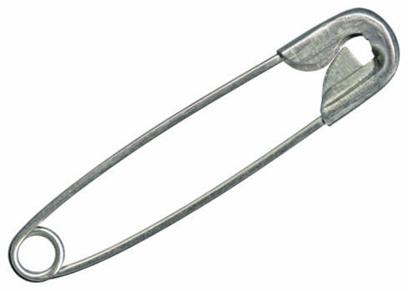](http://www.google.com/url?sa=i&rct=j&q=&esrc=s&source=images&cd=&cad=rja&uact=8&ved=2ahUKEwipu7X_0c7eAhUB148KHbLkBwwQjRx6BAgBEAU&url=http://www.kcur.org/post/safety-pin-controversy-rages-shawnee-mission-school-district&psig=AOvVaw1UBS12NS-j1vZOnMEh88zS&ust=1542104743892715)

[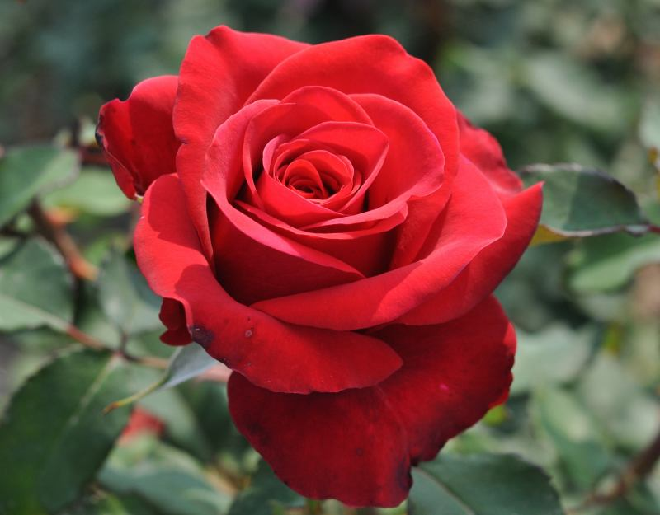](http://www.google.com/url?sa=i&rct=j&q=&esrc=s&source=images&cd=&cad=rja&uact=8&ved=&url=http://haldhartimes.in/%E0%A4%97%E0%A5%81%E0%A4%B2%E0%A4%BE%E0%A4%AC-%E0%A4%95%E0%A5%87-%E0%A4%94%E0%A4%B7%E0%A4%A7%E0%A5%80%E0%A4%AF-%E0%A4%A8%E0%A5%81%E0%A4%B8%E0%A5%8D%E0%A4%96%E0%A5%87/&psig=AOvVaw0YDLxFUNe64UAIcolGDlEj&ust=1542113338617821) [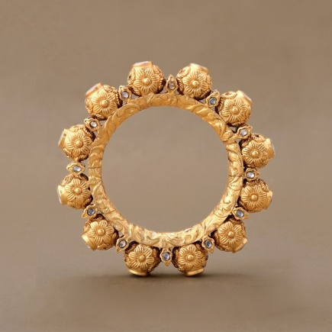](https://www.google.com/url?sa=i&rct=j&q=&esrc=s&source=images&cd=&cad=rja&uact=8&ved=2ahUKEwiCxc3A9s7eAhURSY8KHflQDekQjRx6BAgBEAU&url=https://www.symetree.com/xx.html&psig=AOvVaw0d_fVvDpGZfJFaBka7vu8h&ust=1542114520478859)

[](http://www.google.com/url?sa=i&rct=j&q=&esrc=s&source=images&cd=&cad=rja&uact=8&ved=2ahUKEwjdrIzBwNHeAhUS4o8KHReCDBwQjRx6BAgBEAU&url=http://www.psdgraphics.com/graphics/red-plastic-button-psd/&psig=AOvVaw3SaRab9NfhGgFruMX2czZM&ust=1542203104361675) [](http://www.google.com/url?sa=i&rct=j&q=&esrc=s&source=images&cd=&cad=rja&uact=8&ved=2ahUKEwiijMbdytHeAhUOknAKHUvlCJUQjRx6BAgBEAU&url=http://designatprinting.com/umbrella-clipart/clipart-open-umbrella-2400-2360-15/&psig=AOvVaw26KFYklu_WHjySGg9ztisg&ust=1542205853088261)

[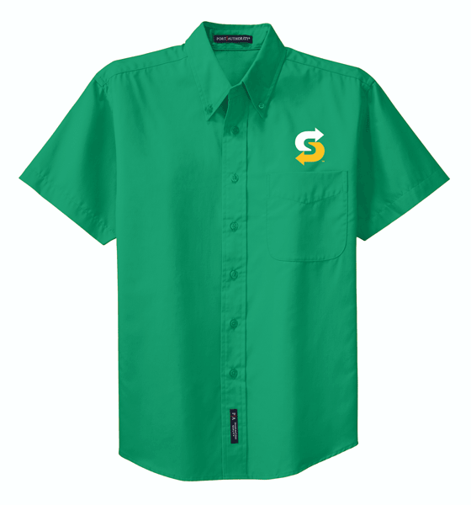](http://www.google.com/url?sa=i&rct=j&q=&esrc=s&source=images&cd=&cad=rja&uact=8&ved=2ahUKEwjmtbqoq87eAhXFKo8KHVCABKQQjRx6BAgBEAU&url=http://www.outrageousapparelonline.com/choice-mark-tall-mens-short-sleeve-easy-care-shirt&psig=AOvVaw0-NMlg0r4qVeRSU-zccNwy&ust=1542094363888960) [](https://www.google.com/url?sa=i&rct=j&q=&esrc=s&source=images&cd=&cad=rja&uact=8&ved=2ahUKEwjRj_6k987eAhWHYo8KHTBwC4cQjRx6BAgBEAU&url=https://medium.com/@adamemanon/meet-the-butterfly-a7616125e274&psig=AOvVaw3CYQjLs9jufKa-AeaW7ApK&ust=1542114727008666)

[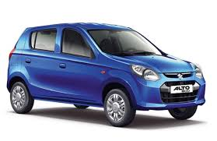](https://www.google.com/url?sa=i&rct=j&q=&esrc=s&source=images&cd=&cad=rja&uact=8&ved=2ahUKEwjinZKqjM_eAhXFP48KHfzmD9AQjRx6BAgBEAU&url=https://www.businesstoday.in/photos/in-the-news/top-10-cars-under-5-lakhs-alto-800-k10-swift-tiago-kwid-grand-i10-wagon-r-figo/1105.html&psig=AOvVaw0H93VWI6XggwuXnF1lNnDi&ust=1542120372206777) [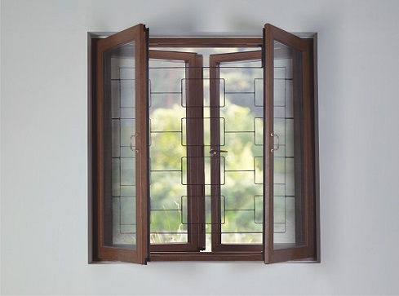](https://www.google.com/url?sa=i&rct=j&q=&esrc=s&source=images&cd=&cad=rja&uact=8&ved=2ahUKEwjv56mt1M7eAhWJvI8KHZp-CbUQjRx6BAgBEAU&url=https://www.quora.com/What-are-some-ideas-for-window-grills&psig=AOvVaw3zKzfGPw0aPH5KkcA0-w7Y&ust=1542105371488809)

[](https://www.google.com/url?sa=i&rct=j&q=&esrc=s&source=images&cd=&cad=rja&uact=8&ved=2ahUKEwiXyuKfsNPeAhUBE4gKHegPBp0QjRx6BAgBEAU&url=https://thecrayoninitiative.org/&psig=AOvVaw28zc5Om4YKpJ9tDMavvQGh&ust=1542267468026785) [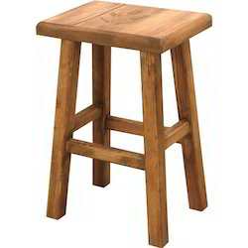](http://www.google.com/url?sa=i&rct=j&q=&esrc=s&source=images&cd=&cad=rja&uact=8&ved=2ahUKEwiGldmx-tPeAhUBOY8KHbf2Bw0QjRx6BAgBEAU&url=http://www.classroomfurniture.in/wooden-stools.html&psig=AOvVaw2xjtyL4UOFo6G4epIfL48u&ust=1542287381513524)

[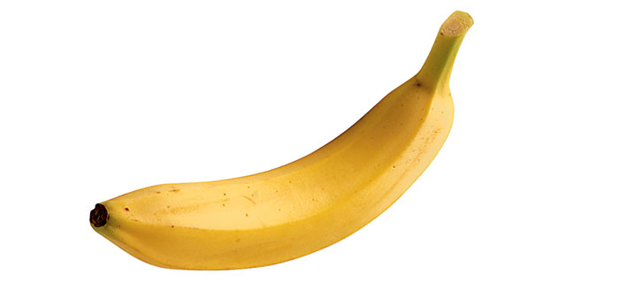](https://www.google.com/url?sa=i&rct=j&q=&esrc=s&source=images&cd=&cad=rja&uact=8&ved=2ahUKEwiCv5znsNPeAhXYdt4KHZAxBfMQjRx6BAgBEAU&url=https://www.bbcgoodfood.com/glossary/banana&psig=AOvVaw0B4ICcZl4p3zlFo4PPz2LK&ust=1542267622307793) [](https://www.google.com/url?sa=i&rct=j&q=&esrc=s&source=images&cd=&cad=rja&uact=8&ved=2ahUKEwj86p7j3tDeAhUTZt4KHYa4Bl4QjRx6BAgBEAU&url=https://www.akc.org/dog-breeds/best-dogs-for-kids/&psig=AOvVaw3gapCwgaxbsmyYu1js8CUq&ust=1542176891535202)

[](https://www.google.com/url?sa=i&rct=j&q=&esrc=s&source=images&cd=&cad=rja&uact=8&ved=&url=https://fontanapharmacy.com/products/Balloon-12%22-Teal-10pk.html&psig=AOvVaw2RCn0lb5RiKkE_3nL1BA4e&ust=1542115032455685) [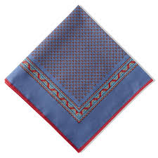](https://www.google.com/url?sa=i&rct=j&q=&esrc=s&source=images&cd=&cad=rja&uact=8&ved=2ahUKEwjhtOiox9PeAhUHfnAKHR-7BFYQjRx6BAgBEAU&url=https://www.pediwear.co.uk/pediwear-collection/products/6317.php&psig=AOvVaw2a0p4jxeXYgT9fHkHHKzsN&ust=1542273637732830)

[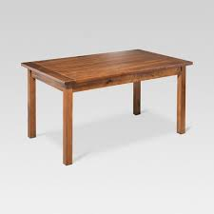](https://www.google.com/url?sa=i&rct=j&q=&esrc=s&source=images&cd=&cad=rja&uact=8&ved=2ahUKEwjoh4Oazc7eAhXMvo8KHfTcDq0QjRx6BAgBEAU&url=https://www.target.com/p/farm-60-dining-table-honey-threshold-153/-/A-15587335&psig=AOvVaw2sHlmLRpz50Jlc4iXz0HaV&ust=1542103408215338) [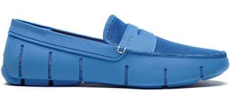](https://www.google.com/url?sa=i&rct=j&q=&esrc=s&source=images&cd=&ved=2ahUKEwiJ9tvd9s7eAhVFvI8KHbHiAbgQjRx6BAgBEAU&url=https://www.islandtrends.com/swims-mens-penny-loafer-boat-shoes-regatta-blue-19882&psig=AOvVaw3rUHYekdGOhi1HfICoGLr3&ust=1542114588231916)

[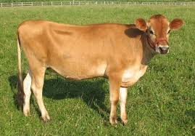](https://www.google.com/url?sa=i&rct=j&q=&esrc=s&source=images&cd=&cad=rja&uact=8&ved=&url=https://www.quora.com/Is-A1-milk-from-non-Indian-breed-cows-injurious-to-health-while-A2-milk-from-desi-Indian-breed-cows-is-good-for-health&psig=AOvVaw3jTJ0fzp6kQC5XvQ1nUs-r&ust=1542105093241724) [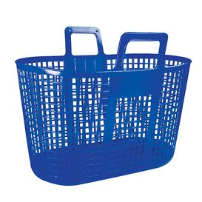](https://www.google.com/url?sa=i&rct=j&q=&esrc=s&source=images&cd=&cad=rja&uact=8&ved=&url=https://www.amazon.co.uk/SP-Berner-Flexible-Shopping-Basket/dp/B00BL2TS3G&psig=AOvVaw1dP26Kt0s1d0yvbMkJGy3v&ust=1542103152151466)

[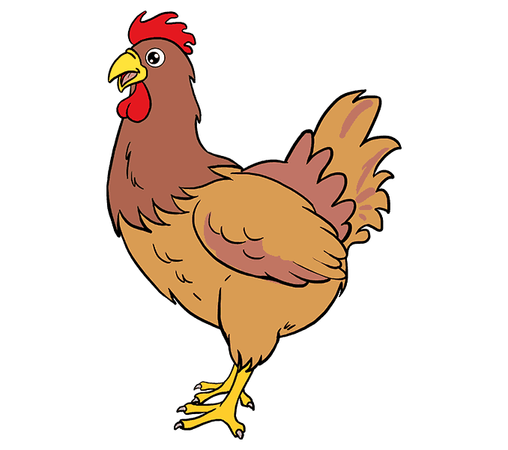](https://www.google.com/url?sa=i&rct=j&q=&esrc=s&source=images&cd=&cad=rja&uact=8&ved=2ahUKEwi1n8SusNHeAhXHknAKHdsnC70QjRx6BAgBEAU&url=https://easydrawingguides.com/how-to-draw-a-chicken/&psig=AOvVaw3zCqUQBDhKktpytMOWTsnW&ust=1542198792223036) [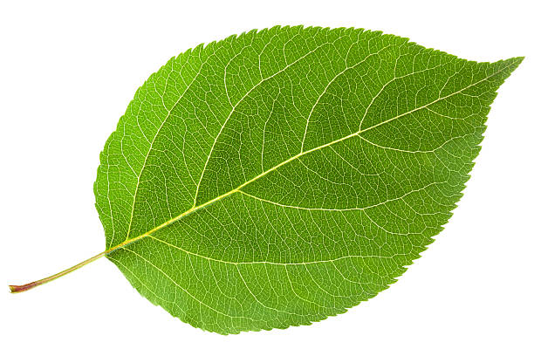](https://www.google.com/url?sa=i&rct=j&q=&esrc=s&source=images&cd=&cad=rja&uact=8&ved=2ahUKEwjb5PS48s7eAhVFRo8KHYZ9CBkQjRx6BAgBEAU&url=https://www.reddit.com/r/notinteresting/comments/7vwun4/this_leaf_is_green_because_of_chlorophyll/&psig=AOvVaw3EWoIKQMeLPWLEx3JE5BD8&ust=1542113431428951)

[](http://www.google.com/url?sa=i&rct=j&q=&esrc=s&source=images&cd=&cad=rja&uact=8&ved=2ahUKEwiw_IuEyNPeAhVI_GEKHS8mAAUQjRx6BAgBEAU&url=http://time.com/3936846/powerful-books-list/&psig=AOvVaw3yAZq8CxRoIDh8S-TMkhu6&ust=1542273863948336) [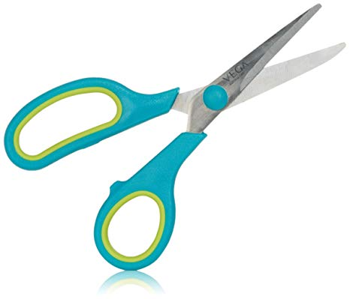](https://www.google.com/url?sa=i&rct=j&q=&esrc=s&source=images&cd=&cad=rja&uact=8&ved=2ahUKEwiDm7PrrtHeAhUIso8KHclMCqoQjRx6BAgBEAU&url=https://www.amazon.in/Vega-Small-General-Cutting-Scissor/dp/B00BOLFYV4&psig=AOvVaw2B1s3UvBrf_YUk2CMMlQwe&ust=1542198311826432)

[](http://www.google.com/url?sa=i&rct=j&q=&esrc=s&source=images&cd=&cad=rja&uact=8&ved=2ahUKEwju_MjDyNPeAhXMdN4KHUrXCWAQjRx6BAgBEAU&url=http://www.transparentpng.com/details/beautiful-colorful-simple-transparent_2923.html&psig=AOvVaw0sEVZJJfIGVCbiup_58xOD&ust=1542273991518148) [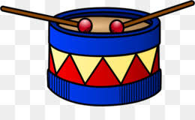](https://www.google.com/url?sa=i&rct=j&q=&esrc=s&source=images&cd=&cad=rja&uact=8&ved=2ahUKEwjlwZ_oyNPeAhVQZt4KHYiUBFgQjRx6BAgBEAU&url=https://www.kissclipart.com/free/drum-sticks,2.html&psig=AOvVaw378mJfz3VA3fHMKOeKTS1q&ust=1542274065549150)

[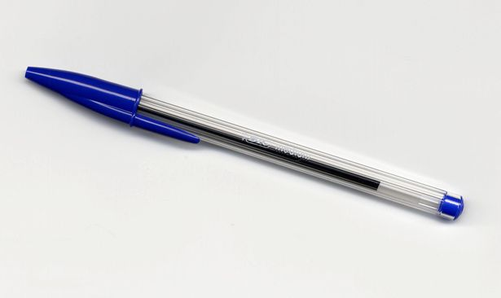](https://www.google.com/url?sa=i&rct=j&q=&esrc=s&source=images&cd=&cad=rja&uact=8&ved=2ahUKEwiX9KyhydPeAhXLc94KHRgtCkEQjRx6BAgBEAU&url=https://www.reddit.com/r/CFA/comments/6djzvk/level_3_what_kind_of_pen/&psig=AOvVaw3znmtRX0eofStIbXadIbCm&ust=1542274186603691) [](http://www.google.com/url?sa=i&rct=j&q=&esrc=s&source=images&cd=&ved=&url=http://mentalfloss.com/article/80011/7-short-facts-about-munchkin-cats&psig=AOvVaw19JNrYaUcc6xRvyrq53DZN&ust=1542176927317884)

[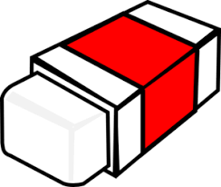](http://www.google.com/url?sa=i&rct=j&q=&esrc=s&source=images&cd=&cad=rja&uact=8&ved=&url=http://www.clker.com/clipart-eraser-3.html&psig=AOvVaw0NdMORcwwmUhg17UeGAM6F&ust=1542274276866714) [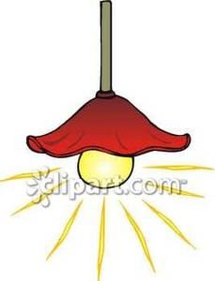](http://www.google.com/url?sa=i&rct=j&q=&esrc=s&source=images&cd=&cad=rja&uact=8&ved=2ahUKEwjTurf6xNHeAhVSiHAKHaHPDVYQjRx6BAgBEAU&url=http://www.picturesof.net/pages/090313-003800-049009.html&psig=AOvVaw2DJJwGiEZy3Q1se9saCfRB&ust=1542204325408569)

 [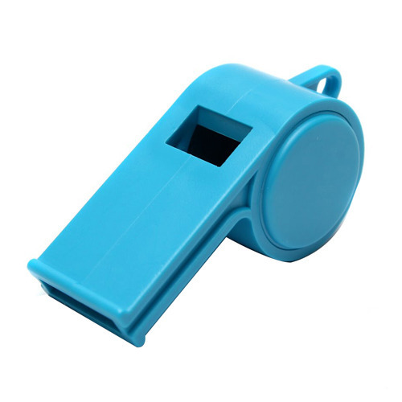](https://www.google.com/url?sa=i&rct=j&q=&esrc=s&source=images&cd=&cad=rja&uact=8&ved=2ahUKEwiwjoey-c7eAhVBrI8KHQQOAP8QjRx6BAgBEAU&url=https://dir.indiamart.com/impcat/whistle.html&psig=AOvVaw1_xTAE-Ck1MwS2DlUJZQon&ust=1542115309366079)

[](https://www.google.com/url?sa=i&rct=j&q=&esrc=s&source=images&cd=&cad=rja&uact=8&ved=2ahUKEwjA79LmytPeAhWNMN4KHRFuAxAQjRx6BAgBEAU&url=https://www.thebigduck.us/&psig=AOvVaw09yZ9TS1alFLANKKxEPphY&ust=1542274603918057) [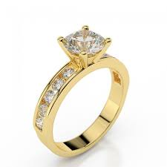](https://www.google.com/url?sa=i&rct=j&q=&esrc=s&source=images&cd=&cad=rja&uact=8&ved=2ahUKEwipm_Hp-c7eAhWLLI8KHdtdAqMQjRx6BAgBEAU&url=https://www.brillianteers.com/diamond-ring-sidestones-enchantment-yellowgold-14k1-3.html&psig=AOvVaw0ycj98cU6qhvteLgHeMK2J&ust=1542115398280299)

[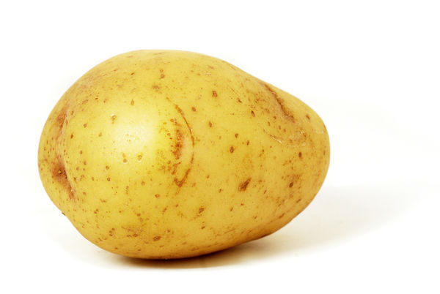](https://www.google.com/url?sa=i&rct=j&q=&esrc=s&source=images&cd=&cad=rja&uact=8&ved=2ahUKEwiU-vTuw9HeAhUGro8KHWzCAE8QjRx6BAgBEAU&url=https://github.com/drtshock/Potato&psig=AOvVaw31ve6UNNzkL3Z74RcqNVJV&ust=1542204028994424) [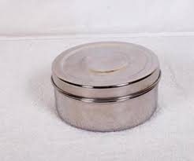](http://www.google.com/url?sa=i&rct=j&q=&esrc=s&source=images&cd=&cad=rja&uact=8&ved=2ahUKEwjF89aj0tPeAhUMfnAKHfimDf0QjRx6BAgBEAU&url=http://www.hotdishes.net/Indian_kitchen_Appliances/stainless_steel_lunch_carrier/Round_Shape_Food_Carriers/Round_Shape_food_Container/&psig=AOvVaw0UUUfOW2hHBJv-gMJjXgwz&ust=1542276601015120)

[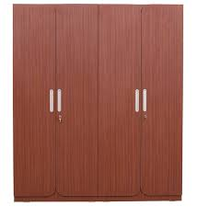](http://www.google.com/url?sa=i&rct=j&q=&esrc=s&source=images&cd=&cad=rja&uact=8&ved=2ahUKEwjI4LTSy87eAhUL4o8KHYyOBlEQjRx6BAgBEAU&url=http://www.rawatfurniture.com/shop/rawat-turin-4-doors-wardrobe-in-saphelli-colour/&psig=AOvVaw0uMZrmK3ZtxBVbupKbKMOi&ust=1542102987277114) [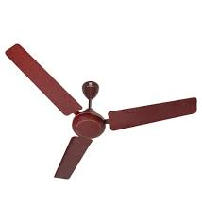](https://www.google.com/url?sa=i&rct=j&q=&esrc=s&source=images&cd=&cad=rja&uact=8&ved=2ahUKEwj-qLTy0c7eAhXMpY8KHakZBWcQjRx6BAgBEAU&url=https://www.pepperfry.com/standard-by-havells-zinger-1200-mm-brown-ceiling-fan-1548294.html&psig=AOvVaw0Dt55u6ZY1DvTSBQy6GLb0&ust=1542104687071591)

[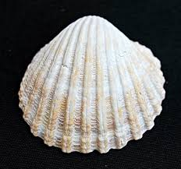](https://www.google.com/url?sa=i&rct=j&q=&esrc=s&source=images&cd=&cad=rja&uact=8&ved=2ahUKEwjDk-ubwNHeAhUCTo8KHRJ4BX0QjRx6BAgBEAU&url=https://www.etsy.com/listing/470588498/raw-seashell-set-50-shells-natural-sea&psig=AOvVaw3ORsr4bicMBp9BtSHaDpLC&ust=1542201900325238) [](https://www.google.com/url?sa=i&rct=j&q=&esrc=s&source=images&cd=&cad=rja&uact=8&ved=2ahUKEwicyM-kwtHeAhUMwI8KHZ2rDlUQjRx6BAgBEAU&url=https://world.taobao.com/product/%E6%97%A5%E6%AD%A6%E5%88%80.htm&psig=AOvVaw2ySwZk8Zjead4gpINI5gS8&ust=1542203225880183)

[](https://www.google.com/url?sa=i&rct=j&q=&esrc=s&source=images&cd=&cad=rja&uact=8&ved=2ahUKEwiMvJL9xtHeAhVKpY8KHdGrBEsQjRx6BAgBEAU&url=https://www.freeiconspng.com/images/birthday-candles-png&psig=AOvVaw3egE42wplFKeFHF5Jdkm1O&ust=1542204862072764) [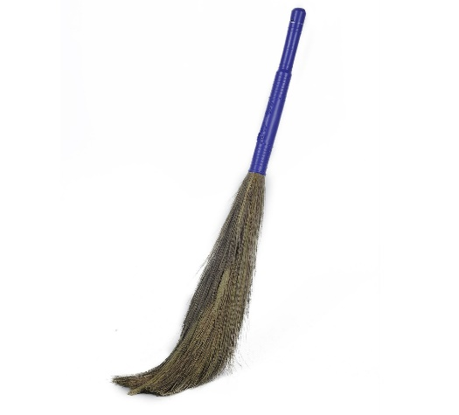](https://www.google.com/url?sa=i&rct=j&q=&esrc=s&source=images&cd=&cad=rja&uact=8&ved=&url=https://www.amazon.in/Gala-132769-Laxmi-Grass-Broom/dp/B00M6P5Q5G&psig=AOvVaw0RjybcRYVW86whpO9Shr7l&ust=1542203671882062)

[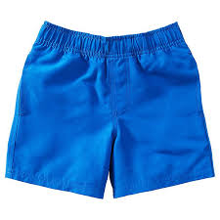](https://www.google.com/url?sa=i&rct=j&q=&esrc=s&source=images&cd=&cad=rja&uact=8&ved=2ahUKEwjb6umm0dHeAhUYXisKHfReBEsQjRx6BAgBEAU&url=https://www.target.com.au/p/unisex-school-microfiber-shorts/59616801&psig=AOvVaw3tgr6ZTsDwHzEAVdjK_Gzm&ust=1542207610664877) [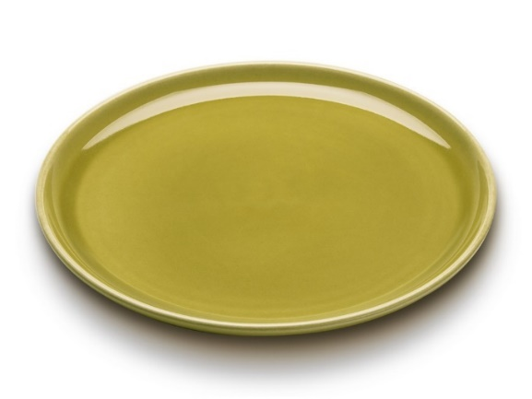](https://www.google.com/url?sa=i&rct=j&q=&esrc=s&source=images&cd=&cad=rja&uact=8&ved=2ahUKEwiJ9cSQ-M7eAhUHrY8KHSvAAnsQjRx6BAgBEAU&url=https://bauerpottery.com/american-modern-dinner-plate.html&psig=AOvVaw3bJ03iQwEvGMJkLIZ2vrea&ust=1542114965881152)

[](https://www.google.com/url?sa=i&rct=j&q=&esrc=s&source=images&cd=&cad=rja&uact=8&ved=2ahUKEwjd34PKu9HeAhUQeisKHXVPDO8QjRx6BAgBEAU&url=https://venezianocoffee.com.au/shop/inker-coffee-cups/inker-coffee-cups-and-saucers-ocean-blue/&psig=AOvVaw29U_I5lvVXCu9rkbWJ7aT9&ust=1542201801704672) [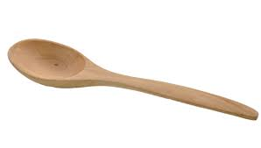](https://www.google.com/url?sa=i&rct=j&q=&esrc=s&source=images&cd=&cad=rja&uact=8&ved=2ahUKEwjh54WLydHeAhVCN48KHTxiDEoQjRx6BAgBEAU&url=https://melbournechapter.net/explore/transparent-spoon-large/&psig=AOvVaw0JBWxmp0b_eI7Xna4byxBE&ust=1542205407609884)

[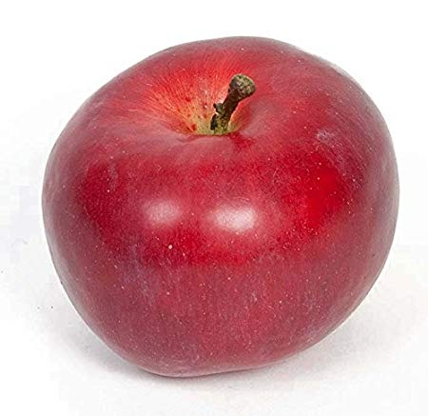](https://www.amazon.co.uk/Props4shows-Fake-Red-Apple/dp/B01CPA6ZJC) [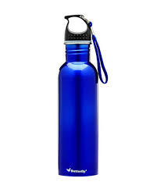](http://www.google.com/url?sa=i&rct=j&q=&esrc=s&source=images&cd=&cad=rja&uact=8&ved=&url=http://staging.homeneedsonline.com/butterfly-stainless-steel-eco-750-ml-water-bottle-set-of-2.html&psig=AOvVaw2nlWmw_xwE5Ckk_ckuLBcl&ust=1542094443293950)

[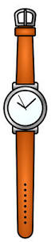](http://www.google.com/url?sa=i&rct=j&q=&esrc=s&source=images&cd=&cad=rja&uact=8&ved=2ahUKEwihtZOg09PeAhXSMd4KHYugCsAQjRx6BAgBEAU&url=http://clipart-library.com/watches-cliparts.html&psig=AOvVaw2-_dkJZE3qs6EgUHNUxN3P&ust=1542276871637255) [](https://www.google.com/url?sa=i&rct=j&q=&esrc=s&source=images&cd=&cad=rja&uact=8&ved=&url=https://www.fotosearch.com/CSP991/k11920024/&psig=AOvVaw0NMriRvq7wPRqosDji3RA6&ust=1542204945965638)

[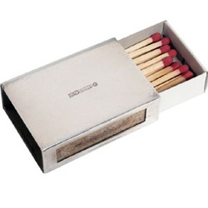](https://www.google.com/url?sa=i&rct=j&q=&esrc=s&source=images&cd=&cad=rja&uact=8&ved=2ahUKEwjqzcKuyNHeAhWMso8KHQ2yBlIQjRx6BAgBEAU&url=https://www.indiamart.com/shivimpex/match-boxes.html&psig=AOvVaw1Yg4k9r2b6XsjyAzTBaROm&ust=1542205235598902) [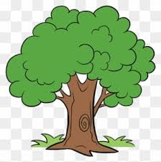](https://www.google.com/url?sa=i&rct=j&q=&esrc=s&source=images&cd=&cad=rja&uact=8&ved=2ahUKEwjE0pShi8_eAhVMK48KHTlACiYQjRx6BAgBEAU&url=https://www.clipartmax.com/middle/m2H7i8i8A0G6Z5A0_tree-drawing-tree-with-colorful-leaves/&psig=AOvVaw1nysQTfz4Fl_yogokEoPX5&ust=1542120109613788)

[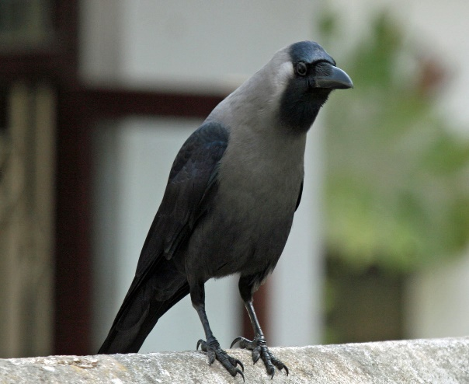](http://www.google.com/url?sa=i&rct=j&q=&esrc=s&source=images&cd=&cad=rja&uact=8&ved=2ahUKEwjbmMnn09PeAhUKMt4KHet0ATAQjRx6BAgBEAU&url=http://safari-ecology.blogspot.com/2013/05/indian-house-crows-and-invasive-aliens.html&psig=AOvVaw1FRMCiI4VAE49kJ9ZTZJ7O&ust=1542277029400211) [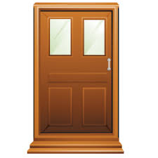](http://www.google.com/url?sa=i&rct=j&q=&esrc=s&source=images&cd=&cad=rja&uact=8&ved=2ahUKEwjM_uCA7NPeAhUOFHIKHdO1B0sQjRx6BAgBEAU&url=http://laoblogger.com/cartoon-half-open-door-clipart.html&psig=AOvVaw1nvEI_UGw8IZPeKIiaHvI8&ust=1542283520210132)

[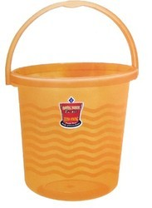](http://www.google.com/url?sa=i&rct=j&q=&esrc=s&source=images&cd=&cad=rja&uact=8&ved=2ahUKEwiM_q3X99XeAhWTf30KHZuUBtIQjRx6BAgBEAU&url=http://www.royaltouchplastic.co.in/plastic-bucket-manufacturer.html&psig=AOvVaw2HujHfTSZt2jhVl3RjiYqn&ust=1542355341175669) [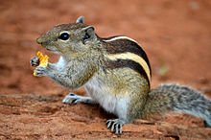](https://www.google.com/url?sa=i&rct=j&q=&esrc=s&source=images&cd=&cad=rja&uact=8&ved=&url=https://en.wikipedia.org/wiki/Indian_palm_squirrel&psig=AOvVaw30z2sSE_j9LDLOJNA2MgpQ&ust=1542177106683487)

[](https://www.google.com/url?sa=i&rct=j&q=&esrc=s&source=images&cd=&cad=rja&uact=8&ved=2ahUKEwjh-ueTx9HeAhUMPY8KHXgJAVIQjRx6BAgBEAU&url=https://www.amazon.in/Godrej-Locks-Navtal-Levers-Hardened/dp/B00GJD9S9G&psig=AOvVaw1s9zMewMyE7Byqg9ZMDgxe&ust=1542204911079974) [](https://www.google.com/url?sa=i&rct=j&q=&esrc=s&source=images&cd=&cad=rja&uact=8&ved=&url=https://pt.pngtree.com/freepng/watercolor-toothpaste_3025389.html&psig=AOvVaw3kYtOXnIxxGmeLUnyC4_z5&ust=1542205684860965)

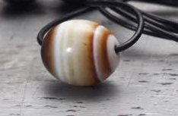 [](https://www.google.com/url?sa=i&rct=j&q=&esrc=s&source=images&cd=&cad=rja&uact=8&ved=2ahUKEwirsuGW7tPeAhWQXCsKHZwEClUQjRx6BAgBEAU&url=https://ecohuertosescolares.eu/file/pizarrapng&psig=AOvVaw2pkjnrQDkYnZeg9iIxQ2MR&ust=1542284091126835)

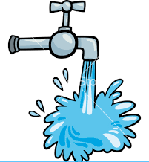 [](http://www.google.com/url?sa=i&rct=j&q=&esrc=s&source=images&cd=&cad=rja&uact=8&ved=2ahUKEwi1gb7V-dXeAhXQinAKHTMIAsoQjRx6BAgBEAU&url=http://www.clker.com/clipart-red-candy.html&psig=AOvVaw0eU39MUWXh0QlsuD6wz84E&ust=1542355910381326)

[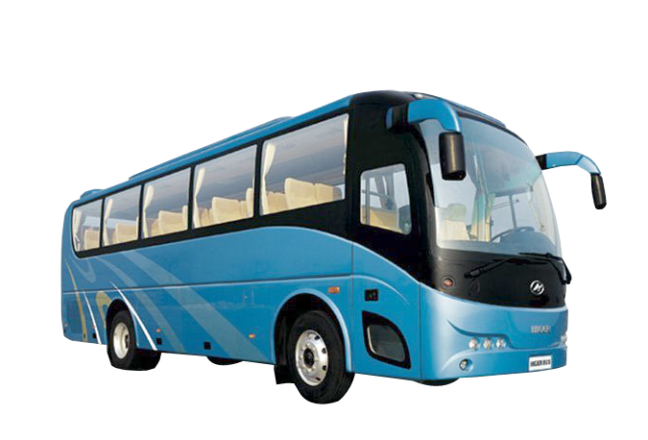](https://www.google.com/url?sa=i&rct=j&q=&esrc=s&source=images&cd=&cad=rja&uact=8&ved=&url=https://fairdinkumtours.rezdy.com/235781/contract-lr-or-hr-bus-charter-driving-monday-to-saturday&psig=AOvVaw346Cfbrma2hJSOtL3RYpOj&ust=1542207489213651) [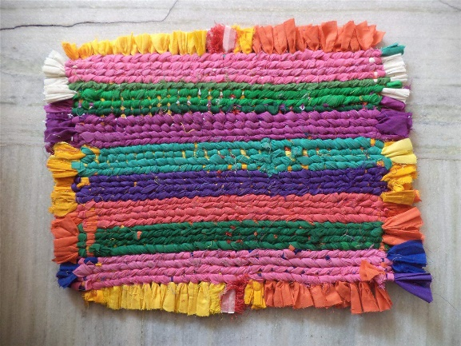](http://forum.embroideryshristi.com/tips-and-tricks/how-to-make-a-door-mat-from-old-wasted-clothes/)

[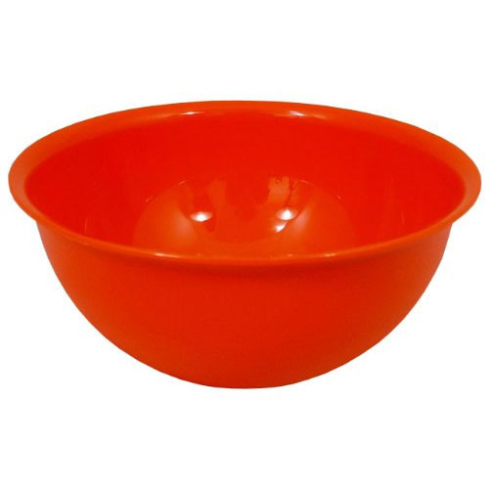](https://www.google.com/url?sa=i&rct=j&q=&esrc=s&source=images&cd=&cad=rja&uact=8&ved=&url=https://www.indiamart.com/proddetail/plastic-rice-bowl-13175072933.html&psig=AOvVaw2R0dUNX1i-HmQBGAv-glC6&ust=1542284620315985) [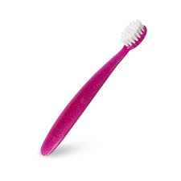](https://www.google.com/url?sa=i&rct=j&q=&esrc=s&source=images&cd=&cad=rja&uact=8&ved=2ahUKEwiC9pOsytHeAhUG148KHWv8A8sQjRx6BAgBEAU&url=https://madebyradius.com/products/totz&psig=AOvVaw1_vdoa7BaNzdEwjW1qJtfA&ust=1542205739129389)

[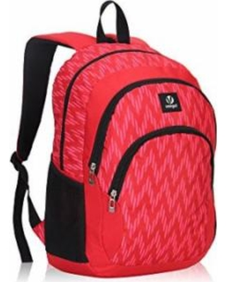](https://www.google.com/url?sa=i&rct=j&q=&esrc=s&source=images&cd=&cad=rja&uact=8&ved=2ahUKEwjC0pnR8NPeAhUGT30KHf5NCkUQjRx6BAgBEAU&url=https://www.parenting.com/shop/veegul-veegul-cool-backpack-kids-sturdy-schoolbags-back-to-school-backpack-for-boys-girls-pe450897521ea1842def9d610fbe595c8.html&psig=AOvVaw2RjCFLtDKsa9wHtMYFtygE&ust=1542284737038716) 