# **DevOps Free Bootcamp DAY – 3**

Linux File System Overview

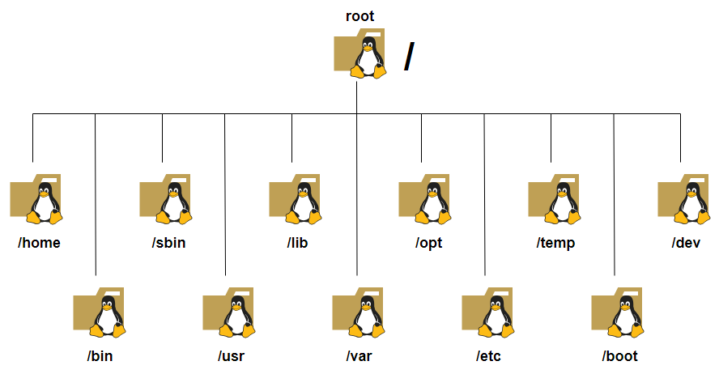

* / - is a root directory and the Linux file system hierarchy base begins at the root (/) and everything starts with the root directory (/).
* /home – Contains home directories for all non root users and home directory is the default current directory.
* /bin – Contains binaries and exucutable programs for most essential user commands
* /sbin - Contains binaries and exucutable programs for most essential user commands
* /usr - Contains binaries and exucutable programs for most essential user commands
* /lib - Contains binaries and exucutable programs for most essential user commands
* /var - Contains binaries and exucutable programs for most essential user commands
* /opt - Contains binaries and exucutable programs for most essential user commands
* /etc - Contains binaries and exucutable programs for most essential user commands
* /tmp - Contains binaries and exucutable programs for most essential user commands
* /boot - Contains binaries and exucutable programs for most essential user commands
* /dev - Contains binaries and exucutable programs for most essential user commands

##### 1. File and Directory Management

1. ls - List files and directories.
2. 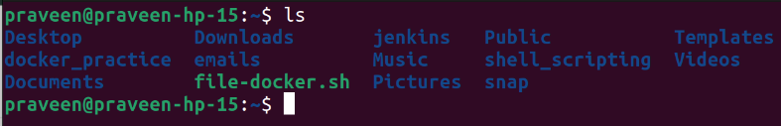pwd – Print the current working directory.

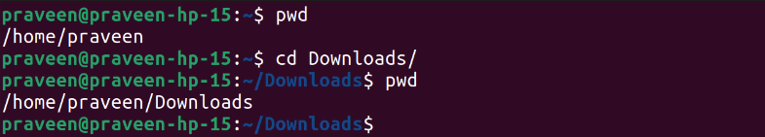

1. – Print the current working directory.