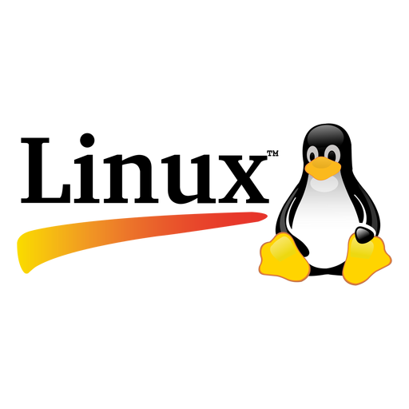
DevOps Free Bootcamp DAY – 3

Basics of Linux Commands

1. File and Directory Management
- ls - List files and directories.
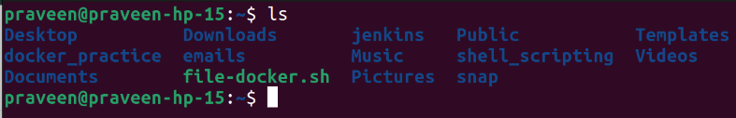
- pwd – Print the current working directory.
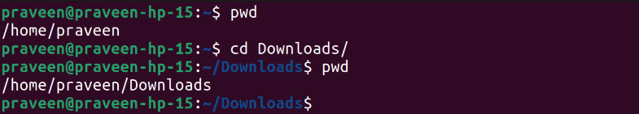
- – Print the current working directory.

