Use this project

<https://github.com/gaya3chandran1/tf-ci>

To pass aws credentials use cloudbees awscredentials plugin

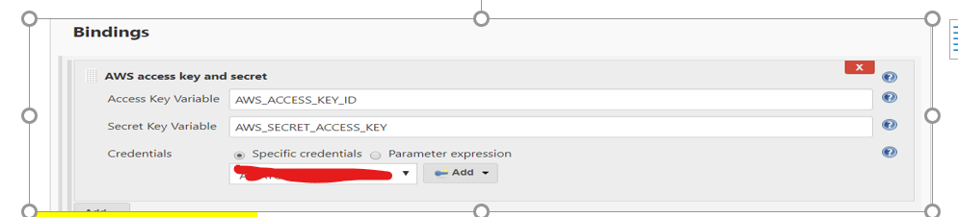

Setup webhook for polling

<http://IP:8080/>github-hook/

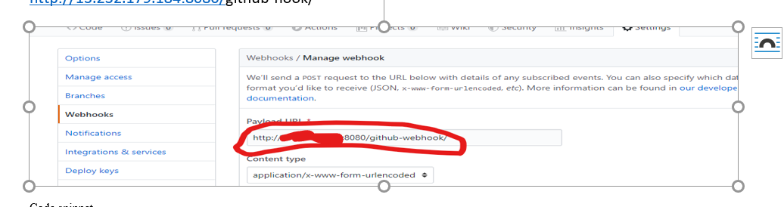

Code snippet

Here both terraform and Jenkins are installed with ec2access and to start Jenkins sudo id was used. Jenkins doesn’t have sudo access.

cd projects/A

pwd

whoami

export PATH=$PATH:/usr/local/bin/

#terraform -v

terraform init

terraform plan -out ec2.out

#terraform apply -auto-approve

#terraform destroy -auto-approve

Clone the project

Invoke the following in shell according to requirement

For CI use polling in Jenkins

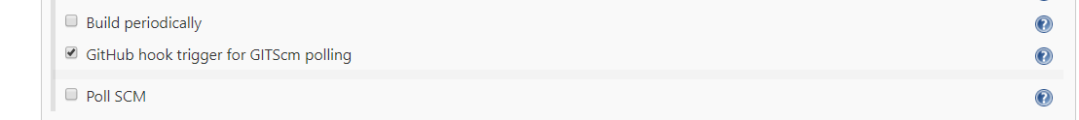

For CD use

Terraform destroy command