Requirement 1:

* Need to Calcute the difference between in & out time
* 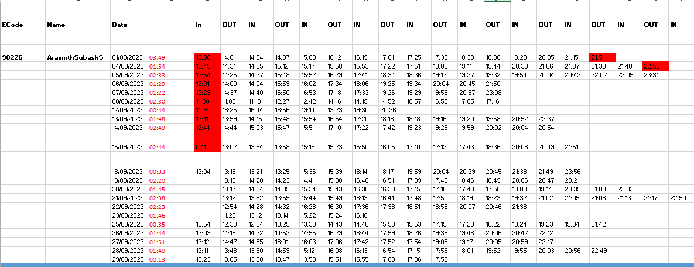First in and last out time to be calculated (E.g.: 18-10-23 In time 10:00 – out time: 19:00 = 09:00:00)
* Omit the first in & last out of the particular day and calculate the break time and need summation of it as well.
* Cut off time for the second shift out time would be 4:45 am

Requirement 2:

* In and out time will be in one excel sheet
* Monthly report will be kept in same location.
* In & out time to be overwrite to all the monthly report based on filtering the employee id & data.