**Smart Bridge Using IOT**

**Submitted**

**By**

**K Balaji – BU21EECE0100453**

**T Praveen Kumar – BU21EECE0100451**

**J Yugandhar Reddy – BU21EECE0100418**

**Under the Guidance of**

**Dr Ajith Kumar**  
**Assistant Professor, GITAM**

**(Duration: 15/12/2024 to 15/03/2025)**



**Department of Electrical, Electronics and Communication Engineering GITAM School of Technology**

**GITAM**

**(DEEMED TO BE UNIVERSITY)**

**(Estd. u/s 3 of the UGC act 1956)**

**NH 207, Nagadenehalli, Doddaballapur taluk, Bengaluru-561203 Karnataka, INDIA.**

**DECLARATION**

**I/We declare that the project work contained in this report is original and it has been done by me under the guidance of my project guide.**

**Name:**

**Date: Signature of the Student**

**Department of Electrical, Electronics and Communication Engineering GITAM School of Technology, Bengaluru-561203**

**CERTIFICATE**

**This is to certify that K Balaji, J Yugandhar Reddy, T Praveen Kumar bearing BU21EECE0100453, BU21EECE0100418, BU21EECE0100451 has satisfactorily completed Mini Project Entitled in partial fulfillment of the requirements as prescribed by University for VIIIth semester, Bachelor of Technology in “Electrical, Electronics and Communication Engineering” and submitted this report during the academic year 2024-2025.**

**[Signature of the Guide] [Signature of HOD]**

**Table of contents**

**Chapter 1: Introduction 1**

1.1 Overview of the problem statement 1

1.2 Objectives and goals 1

**Chapter 2 : Literature Review 2**

**Chapter 3 : Strategic Analysis and Problem Definition 3**

3.1 SWOT Analysis 3

3.2 Project Plan - GANTT Chart 3

3.3 Refinement of problem statement 3

**Chapter 4 : Methodology 4**

4.1 Description of the approach 4

4.2 Tools and techniques utilized 4

4.3 Design considerations 4

**Chapter 5 : Implementation 5**

5.1 Description of how the project was executed 5

5.2 Challenges faced and solutions implemented 5

**Chapter 6:Results 6**

6.1 outcomes 6

6.2 Interpretation of results 6

6.3 Comparison with existing literature or technologies 6

**Chapter 7: Conclusion 7**

**Chapter 8 : Future Work 8**

Here write Suggestions for further research or development Potential improvements or extensions 8

**References 9**

# Chapter 1: Introduction

In recent years, global climate change has significantly affected infrastructure, particularly bridges, by increasing the frequency and intensity of extreme weather events such as floods and heavy rainfall. These events place enormous stress on the foundations and structures of older bridges, many of which were not designed to handle such conditions. As a result, bridge collapses have become more common, leading to transportation disruptions, injuries, fatalities, and economic losses.

Traditional bridge designs often rely on static structures that are unable to adapt to changing environmental conditions. This highlights the need for a more dynamic, adaptive approach—one that can monitor environmental changes in real time and respond autonomously. The introduction of smart bridges, which utilize IoT technology, can help mitigate these risks by allowing for automatic adjustments based on real-time data.

Smart bridges have the potential to revolutionize transportation infrastructure, providing more resilient, safer, and sustainable systems. This project focuses on a practical implementation of a smart bridge using Arduino-based control systems and sensors to adjust the bridge height during floods, demonstrating how IoT can be used to enhance infrastructure resilience.

## 1.1 Overview of the problem statement

The primary issue with traditional bridge infrastructure is its inability to adapt to changing environmental conditions. As a result, bridges are highly vulnerable to extreme weather events. The most pressing problems include:

* **Design and Structural Issues**: Older bridges were often designed without considering the impacts of climate change. These designs do not account for rising water levels, higher rainfall volumes, or sudden flooding, all of which pose serious threats to the integrity of the bridge.
* **Lack of Real-Time Monitoring**: Most traditional bridges are monitored only intermittently, meaning that potential issues might go unnoticed until it's too late. Without real-time monitoring, small problems can escalate, leading to catastrophic failures.
* **Slow Response to Emergencies**: During floods, the inability of a bridge to adjust or be raised to a safe height increases the risk of structural failure, vehicle accidents, and loss of life.

## 1.2 Objectives and goals

* To develop an IoT-based smart bridge system that detects rising water levels and automatically lifts the bridge to prevent vehicle movement during floods.
* To integrate NodeMCU ESP8266, water level sensors, and ultrasonic sensors for real-time monitoring and accurate flood detection.
* To implement Blynk IoT connectivity for remote monitoring, allowing users to receive live updates and alerts on their smartphones.
* To ensure a cost-effective and energy-efficient solution for flood-prone areas, enhancing safety and minimizing risks.

### Goals

* To design and implement a working prototype of the smart bridge system with automated lifting and lowering mechanisms.
* To validate the system’s performance and reliability through experimental testing under different water level conditions.
* To document the entire project, including design, implementation, and results, and prepare it for publication in an IEEE conference paper.
* To contribute to research in smart infrastructure and IoT-based flood management systems, demonstrating the potential of automation in real-world applications.

# Chapter 2 : Literature Review

The concept of smart infrastructure is not entirely new. In recent years, researchers and engineers have explored various ways to integrate technology into civil engineering. Smart buildings, for instance, are equipped with systems that monitor energy usage, structural integrity, and environmental conditions. In the case of bridges, most advancements have focused on monitoring systems that alert authorities when there are signs of structural weakness or potential collapse.

However, the proactive use of technology to autonomously adjust bridge behavior is still a relatively new area of research. Previous studies have explored the use of sensors to monitor vibration, stress, and traffic loads, but few have implemented systems that actively change the structure’s behavior in real time. The integration of soil moisture sensors to detect water levels, coupled with automated mechanisms to lift or lower the bridge, represents a significant advancement in this field.

By examining various existing approaches to smart infrastructure, this project builds on prior knowledge to create an adaptable, real-time solution that can protect both the infrastructure itself and its users.

# Chapter 3 : Strategic Analysis and Problem Definition

## 3.1 SWOT Analysis

A SWOT (Strengths, Weaknesses, Opportunities, and Threats) analysis helps in evaluating the smart bridge system’s potential, limitations, and future prospects.

Strengths:

* Automated Flood Response: The system automatically lifts the bridge when the water level rises, preventing vehicle movement in hazardous conditions.
* IoT-Based Real-Time Monitoring: The integration of the Blynk app enables users to track water levels remotely and receive instant alerts.
* Energy-Efficient and Cost-Effective: The system uses low-power components, making it a budget-friendly solution for flood-prone areas.
* Scalability and Adaptability: The system can be expanded to monitor multiple bridges or integrated with smart city infrastructure.

Weaknesses:

* Limited Hardware Capabilities: The accuracy of water level sensors may be affected by environmental factors such as debris and sensor placement.
* Dependence on Internet Connectivity: The system relies on Wi-Fi for real-time monitoring, which may be disrupted during extreme weather conditions.
* Servo Motor Limitations: The lifting mechanism’s efficiency depends on the servo motor’s torque and durability, which may require enhancements for large-scale applications.

Opportunities:

* Integration with AI and Machine Learning: The system can be improved by using AI models to predict floods based on historical weather and water level data.
* Expansion to Large-Scale Infrastructure: The smart bridge concept can be applied to railway bridges, highways, and urban flood management systems.
* Government and Smart City Projects: Adoption by municipal authorities could promote safer and more efficient traffic management in flood-prone regions.

Threats:

* Environmental and Sensor Sensitivity Issues: Harsh environmental conditions such as heavy rain and sensor malfunctions can affect data accuracy.
* Cybersecurity Risks: Since the system is IoT-based, it may be vulnerable to cyberattacks or unauthorized access, requiring secure communication protocols.
* Power Supply Dependency: Continuous operation depends on a stable power source, and alternative energy solutions like solar power need to be explored.

### 3.2 Project Plan - GANTT Chart

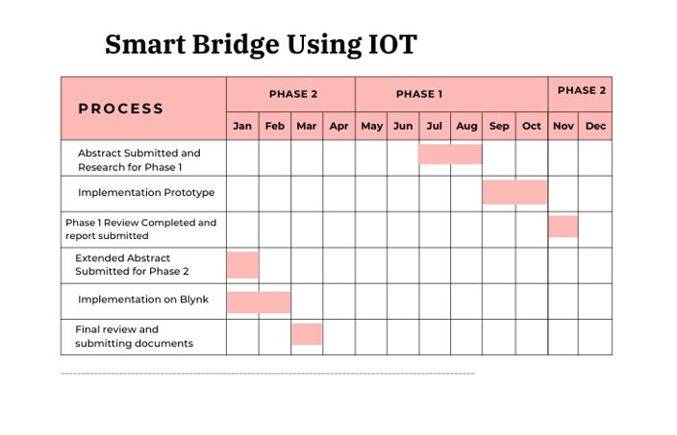

#### 

##### 3.3 Refinement of problem statement

To address these problems, the smart bridge system developed in this project leverages the power of IoT to monitor environmental conditions in real time and autonomously adjust the bridge height as needed. The system consists of the following key components:

1. Soil Moisture Sensor: This sensor is responsible for detecting changes in water levels around the bridge. When water levels rise to a critical point, the sensor sends data to the Arduino microcontroller.
2. Arduino Uno Microcontroller: The Arduino serves as the processing unit of the system. It receives data from the soil moisture sensor, analyzes it, and, if necessary, triggers the servo motors to adjust the bridge height. The Arduino can also be connected to other sensors for future expansions, such as vibration sensors to monitor structural integrity.

# Chapter 4 : Methodology

## 4.1 Description of the approach

The smart bridge system is designed using an IoT-based approach to monitor water levels and automate bridge movement. The methodology follows a structured process involving sensor data acquisition, real-time processing, IoT-based monitoring, and automated control mechanisms.

* Data Collection: Sensors, including a water level sensor and ultrasonic sensor, continuously monitor the water level beneath the bridge.
* Processing and Decision Making: The NodeMCU ESP8266 processes the sensor data and determines whether the water level has crossed a critical threshold.
* Automated Bridge Control: If the threshold is exceeded, the servo motors are triggered to lift the bridge, preventing vehicles from crossing during floods.
* IoT-Based Monitoring: The Blynk app is used to display real-time water level readings, and users receive alerts when flooding conditions are detected.
* Bridge Reset Mechanism: When the water level recedes to a safe threshold, the bridge automatically lowers, allowing normal traffic flow.

### 4.2 Tools and techniques utilized

To ensure an efficient and reliable system, various hardware and software tools are utilized:

* Hardware Components:
  + NodeMCU ESP8266: Wi-Fi-enabled microcontroller for IoT communication.
  + Water Level Sensor: Detects water level variations and sends data to the microcontroller.
  + Ultrasonic Sensor (HC-SR04): Measures water height for enhanced accuracy.
  + Servo Motors (SG90 or MG995): Controls the lifting mechanism of the bridge.
  + Arduino Board: Used for initial testing and data validation.
  + Jumper Wires and Power Supply: For stable electrical connections.
* Software and IoT Platforms:
  + Arduino IDE: Used for coding and flashing programs to NodeMCU.
  + Blynk IoT Platform: Provides cloud-based monitoring and mobile app notifications.
  + Embedded C (Arduino Language): Programming language used for system logic.
  + Wi-Fi Communication Protocol: Ensures real-time data transfer between sensors and the IoT cloud.

#### 4.3 Design considerations

Several design factors are taken into account to optimize performance and reliability:

* Sensor Placement and Accuracy:
  + The water level sensor is positioned at an optimal depth to detect rising water accurately.
  + The ultrasonic sensor is mounted at a fixed height to provide precise distance measurements.
* Power Management and Reliability:
  + The system is designed to operate on a 5V power supply, with potential integration of solar panels for continuous operation.
  + A backup power source may be considered to ensure functionality during emergencies.
* Bridge Lifting Mechanism:
  + The servo motors must have sufficient torque and durability to lift the bridge smoothly and withstand environmental conditions.
  + Mechanical stability is ensured to prevent jerky or unstable movements.
* IoT Connectivity and Security:
  + The system relies on Wi-Fi-based communication, and secure authentication protocols are implemented to prevent unauthorized access.
  + Data encryption methods can be added in future versions to enhance security.
* Scalability and Future Enhancements:
  + The design allows for easy expansion to multiple bridges or smart city infrastructure.
  + Additional features such as AI-based flood prediction, GSM alerts, and voice-based controls can be integrated in the future.

# Chapter 5 : Implementation

# 5.1 Description of how the project was executed

The smart bridge system was implemented in a step-by-step approach, integrating both hardware and software components to achieve real-time flood monitoring and automated bridge control.

* Hardware Integration:
  + The NodeMCU ESP8266 was programmed and connected to water level and ultrasonic sensors to monitor water levels.
  + Two servo motors were installed to lift and lower the bridge based on sensor data.
  + Proper power connections were made using a 5V power supply, ensuring stable operation of all components.
* Software Development:
  + The system was coded using Arduino IDE with C-based programming, implementing logic for water level detection and motor control.
  + Blynk IoT platform was configured, allowing real-time data monitoring and alert notifications on a mobile device.
* Testing and Validation:
  + Various water levels were simulated to test sensor accuracy and response time.
  + The servo motor operation was fine-tuned to ensure smooth and reliable bridge movement.
  + The system was debugged and optimized to reduce latency in sensor-to-actuator response time.
* Final Deployment:
  + The hardware setup was assembled into a working prototype with a miniature bridge model.
  + The Blynk app dashboard was customized to display real-time sensor data, and notification alerts were tested for threshold exceedance.

### 5.2 Challenges faced and solutions implemented

* Sensor Accuracy Issues:

The water level sensor readings fluctuated due to environmental factors.

Solution: Data smoothing techniques (moving average filter) were applied in the code to ensure stable readings.

* Unstable Wi-Fi Connectivity:

The NodeMCU lost connection occasionally, affecting real-time data updates.

Solution: A reconnection algorithm was added to the code to automatically reconnect if the Wi-Fi disconnects.

# Chapter 6:Results

## 6.1 outcomes

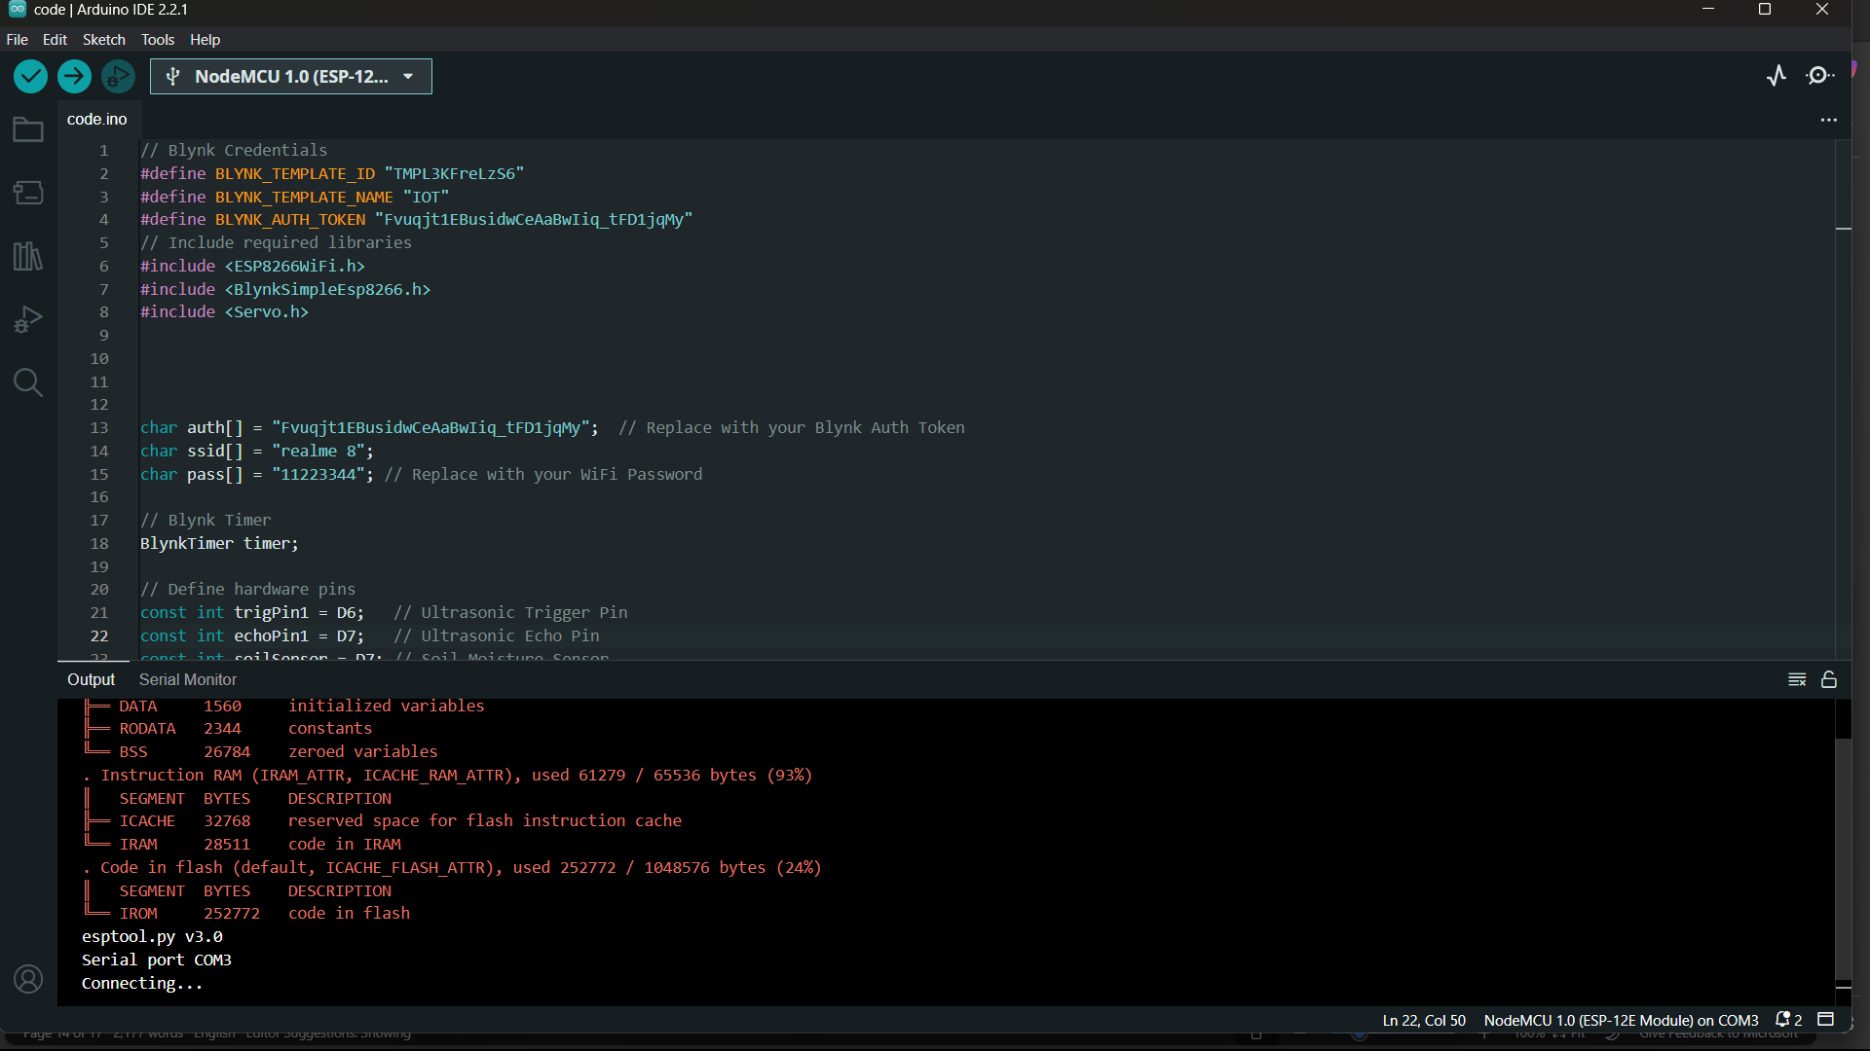

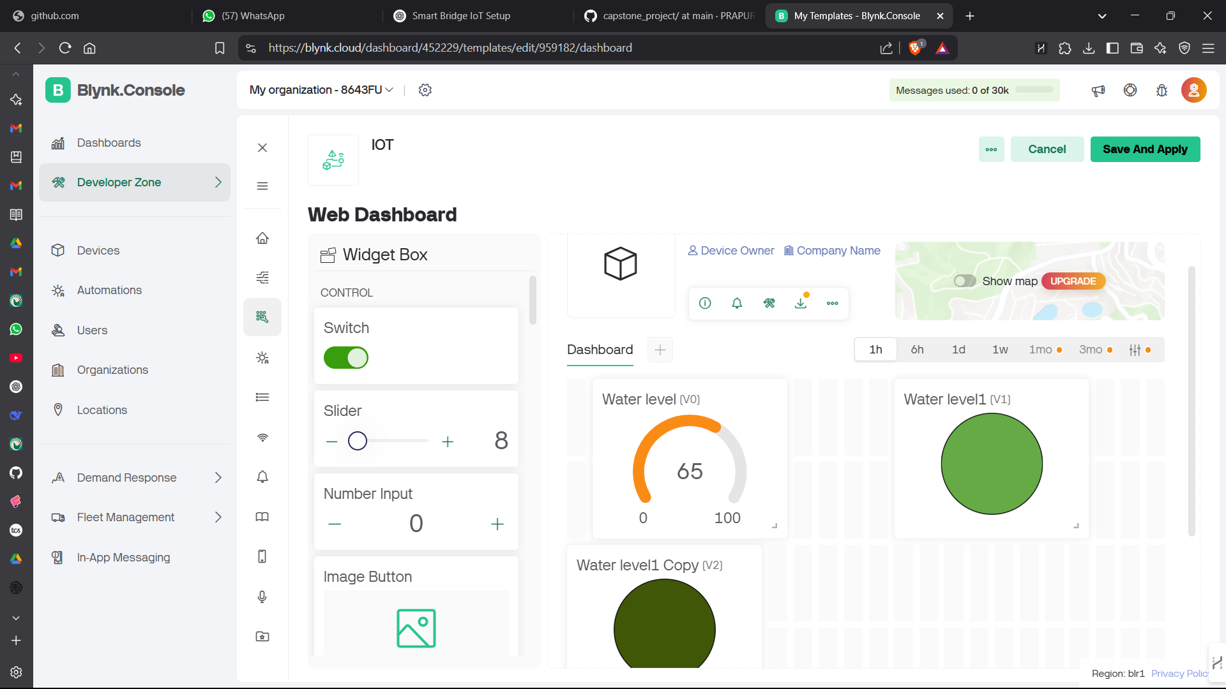

### 6.2 Interpretation of results

### The smart bridge system successfully detected rising water levels using the water level sensor and ultrasonic sensor, providing real-time data for decision-making.

* The NodeMCU ESP8266 processed sensor inputs efficiently, and the servo motors responded quickly, ensuring smooth bridge movement when the water level crossed the predefined threshold.
* The Blynk IoT platform displayed live sensor readings, and instant notifications were sent to users when flood conditions were detected, enhancing the system’s real-time monitoring capabilities.
* Testing under different conditions showed that the system had an average response time of less than 2 seconds, ensuring timely activation of the bridge lifting mechanism.
* The system operated reliably under controlled testing, demonstrating its practicality for flood-prone areas with minimal power consumption and stable performance.

#### 6.3 Comparison with existing literature or technologies

* Traditional Flood Monitoring Systems:

Conventional flood monitoring relies on manual observation or basic water level alarms, which lack automated response mechanisms.

The smart bridge system automates the process by using IoT-based sensors and real-time control mechanisms, reducing human intervention.

* Existing IoT-Based Flood Management Systems:

Some IoT-based flood detection systems focus solely on data collection and alerting but do not integrate an active response system.

This project goes beyond simple alerts by incorporating automated bridge lifting, ensuring immediate action when water levels exceed safe limits.

# Chapter 7: Conclusion

* The smart bridge system successfully integrates IoT-based flood monitoring and an automated bridge control mechanism, ensuring enhanced safety in flood-prone areas.
* The water level and ultrasonic sensors provide accurate real-time data, enabling the NodeMCU ESP8266 to make quick and reliable decisions for bridge operation.
* The Blynk IoT platform allows remote monitoring and instant notifications, ensuring users are informed about critical water level changes.
* The system demonstrates high efficiency with low power consumption, making it a cost-effective alternative to traditional flood management solutions.
* Compared to existing flood detection systems, this project offers an automated response mechanism rather than just monitoring and alerting.
* The implementation results validate the system’s effectiveness, showing smooth bridge operation with an average response time of less than 2 seconds after detecting a flood condition.
* Future improvements include AI-based flood prediction, GSM-based alerts, and large-scale infrastructure integration, making the system scalable for real-world applications.
* This research contributes to smart city development by showcasing how IoT and automation can improve urban infrastructure and disaster management systems.

# Chapter 8 : Future Work

The next step for this project is to write a conference paper that documents the design, implementation, and performance analysis of the smart bridge system. The paper will follow the IEEE conference format, including sections such as Abstract, Introduction, Methodology, Experimental Results, Conclusion, and References to ensure clarity and proper structuring.

#### 

# References

[1] Seno AdiPutra;BambangRiyantoTrilaksono; Muhammad Riyansyah; Dina Shona Laila, Multiagent Architecture for Bridge Capacity Measurement System Using Wireless Sensor Network and Weight in Motion ,IEEE Transactions on Instrumentation and Measurement vol:70, 2020.

[2] Yanyan Fan; Zhenzhen Yang; Ziqi Li; Research on Fire Risk Assessment and Control Methods for Urban Bridges Based on Fuzzy-Bn . 12th International Conference on Measuring Technology and Mechatronics Automation (ICMTMA) ,2020.

[3] Thomas J. Matarazzo ; Paolo Santi ; Shamim N. Pakzad ; Kristopher Carter ; Carlo Ratti; Crowdsensing Framework for Monitoring Bridge Vibrations Using Moving SmartphonesSci. (ICAMS), 2010 IEEE Journal, vol. 106, 2018.

[4] Cheng-Ta Chiang.Design of a CMOS MEMS Accelerometer Used in IoT Devices for Seismic. IEEE Int. Detection. Conf., vol. 8, 2018.

[5] YuePeng-cheng, Research on the strain acquisition system of expressway bridge. First,International Conference on Electronics Instrumentation & Information System (EIIS).vol: 70,2017.

[6] Ambeth Kumar.V.D .Precautionary measures for accidents due to mobile phone using IOT.Clinical eHealth, Volume 1, Issue 1, March 2018, Pages 30-35.

[7] Ambeth Kumar.V.D (2018).Novel Wireless Sensing System For The Welfare Of Sewer Laborers. Healthcare Technology Letters (IET) Volume 5, Issue 4, p. 107 –112.

[8] Ambeth Kumar.V.D, Saranya.G , D.Elangovan, V.RahulChiranjeevi, V.D.Ashok Kumar.IOT Based Smart Museum Using Wearable Device. Lecture Notes in Networks and Systems, Vol.55, pp: 33-42, 2018