**NAME:PRAVEEN V**

**ROLL NO.:241901082**

# Exercise 11

**CUSTOMISE SWITCH WITH NETWORK MODULES USING CISCO PACKET TRACER**

**Aim:**

To **customize a switch** by adding **network modules** in Cisco Packet Tracer and verify extended connectivity options.

**Introduction:**

In Cisco devices, **network modules** are removable or pluggable components that expand the functionality of switches or routers.   
By adding modules, we can:

* Increase the number of Ethernet ports.
* Add fiber optic (Gigabit) or FastEthernet interfaces.
* Support new technologies like wireless or WAN connections.

Cisco Packet Tracer allows us to **virtually add or remove** these modules to simulate real-world hardware customization.

**Algorithm:**

**1.**Start Packet Tracer and place a Router 2811 on the workspace.

2.  Power off the router (Physical tab).

  3.Remove cover plates from empty module slots.

  4.Insert network modules (e.g., NM-1T, NM-1E) into empty slots.

  5.Power on the router.

  6.Check new interfaces appear (FastEthernet, Serial, Ethernet).

  7.Place PCs (PC0, PC1) near the router.

  8.Connect PCs to router interfaces using Copper Straight-Through cables.

  9.Configure router interfaces:

* Assign IP address
* Enable interface (no shutdown)

  10.ConfigurePCs:

* Assign IP address in same subnet
* Set default gateway as router interface IP

 11**.** Test connectivity:

* Ping router from PCs
* Ping PC1 from PC0 and vice versa

**Topology**:

**Output**:

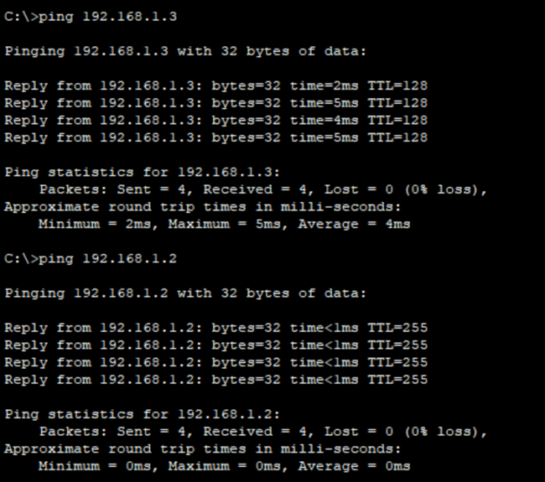

**Result**:

The switch was successfully customized by adding a network module, and the newly added ports functioned correctly for connecting PCs in Cisco Packet Tracer.