**NAME:PRAVEEN V**

**ROLL NO.:241901082**

# Exercise 15

**DEMONSTRATE NETWORK FORENSICS USING PCAPXRAY TOOLS**

**Introduction:**

Network forensics involves capturing, analyzing, and investigating network traffic to detect malicious activities or anomalies. PcapXray is a tool that visualizes packet capture (PCAP) files, showing hosts, connections, web/Tor traffic, and potentially malicious activities in a network. It helps investigators quickly identify suspicious traffic flows and extract relevant payloads for deeper analysis.

**Aim:**

To analyze captured network traffic using PcapXray and identify hosts, traffic patterns, and suspicious network activities for forensic investigation.

**Algorithm:**

1. Install prerequisites:
   * Install Python 3, pip, Graphviz, Tkinter, and required libraries.
   * Clone the PcapXray repository and install dependencies using pip install -r requirements.txt.
2. Prepare input:
   * Obtain a .pcap file containing network traffic to be analyzed.
   * Ensure the PCAP is from a safe/testing source for learning purposes.
3. Launch PcapXray:
   * Open main.py in the repository using Python.
   * Load the selected .pcap file via the GUI.
4. Analyze traffic**:**
   * Observe the network graph of hosts (nodes) and connections (edges).
   * Filter traffic based on Web, Tor, Malicious, DNS, or ICMP.
   * Click on nodes/edges to view traffic details, HTTP requests, or extracted payloads.
5. Record observations:
   * Note suspicious hosts, unusual ports, or Tor traffic.
   * Check extracted files or payloads for anomalies.
   * Optionally, cross-verify suspicious IPs with WHOIS or threat intelligence sources.
6. Document results:
   * Capture screenshots of network diagrams and significant flows.
   * Summarize the suspicious activities identified during analysis.

**Output:**

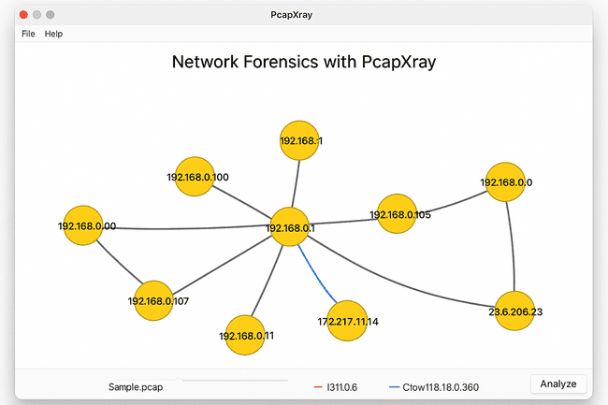

* Graphical visualization of network hosts and flows.
* Reports listing:
  + Host IPs
  + Connection types
  + Protocols used
  + Extracted payloads
  + Flags for Tor/malicious traffic
* Optional JSON or text files summarizing traffic analysis.

**Result :**

* Hosts with the most connections were identified as central nodes.
* Web traffic, Tor traffic, and DNS requests were visualized clearly.
* Suspicious or unusual traffic flows were highlighted for further investigation.
* Payload extraction revealed potential files or URLs of interest.
* PcapXray provided a clear, interactive overview of network activity, making it easier to identify anomalies or malicious patterns compared to raw packet inspection in Wireshark.