NAME: PRAVEEN V

ROLL NO.:241901082

# Exercise 4

DEVELOP A CUSTOMISED PING COMMAND TO SERVER

AIM:

To develop a Python program using the socket module that tests server connectivity

(similar to the ping command) and measures the minimum, maximum, and average round-

trip time (RTT) for multiple connection attempts.

ALGORITHM:

1. Import socket and time modules.

2. Set host, port, and number of ping attempts (count).

3. For each attempt:

o Create a socket and record start time.

o Connect to the server and record end time.

o Calculate RTT = (end - start) × 1000 ms.

o Print RTT or “Request timed out” if connection fails.

4. After all attempts, compute and display min, max, and average RTT values.

CODE:

import socket

import time

host = ”google.com”;

port = 80 # HTTP port

count = 4 # number of pings

for i in range(count):

try:

s = socket.socket()

start = time.time()

s.connect((host, port))

end = time.time()

s.close()

print(f”Reply from {host}: time={(end-start)*1000:.2f} ms”)

except Exception:

print(”Request timed out”)

Customized Ping Program to Measure Min, Max, and Average RTT

import socket, time

host = ”google.com”;

port = 80

count = 4

times = []

for i in range(count):

try:

s = socket.socket()

start = time.time()

s.connect((host, port))

end = time.time()

s.close()

rtt = (end - start) * 1000

times.append(rtt)

print(f&quot;Reply from {host}: time={rtt:.2f} ms&quot;)

except:

print(&quot;Request timed out&quot;)

if times:

print(“\nMin RTT =”, min(times), “ms”)

print(“Max RTT =”, max(times), “ms”)

print(“Avg RTT =”, sum(times)/len(times), “ms”)

OUTPUT:

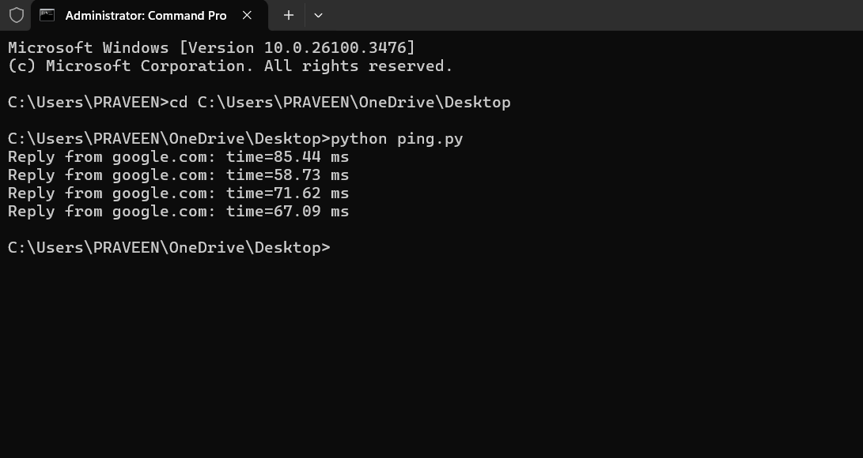

**RESULT:**

Thus, the program has successfully performed ping operation to google.com

,extracted RTT values from the response and computed min ,max ,and average RTT