NAME:PRAVEEN V

DATE:15.09.25 ROLL NO.:241901082

# Exercise 7

NMAP TO DISCOVER LIVE HOSTS USING ARP SCAN, ICMP SCAN, AND TCP/UDP PING

IN TRY HACK ME PLATFORM

AIM:

In this module, we focus on discussing live hosts on a network using Nmap. Finding which systems are online is crucial before scanning ports or services to save time and avoid unnecessary network traffic. This forms the foundation for effective network mapping and security auditing.

TASK 1: INTRODUCTION

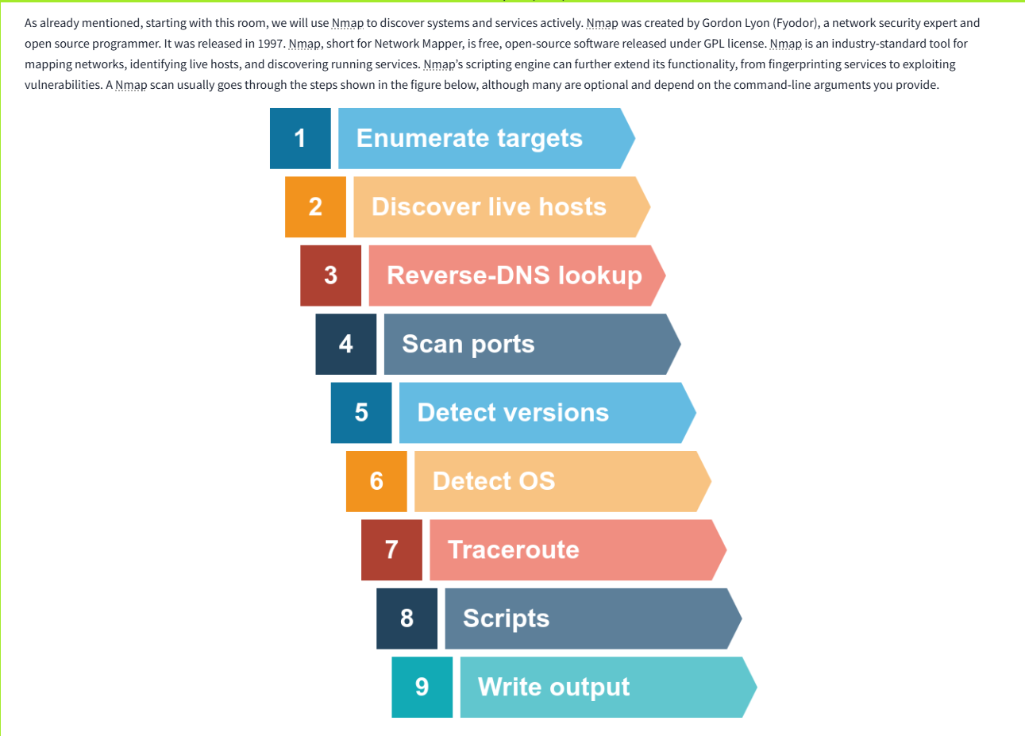

TASK 2: SUBNETWORKS

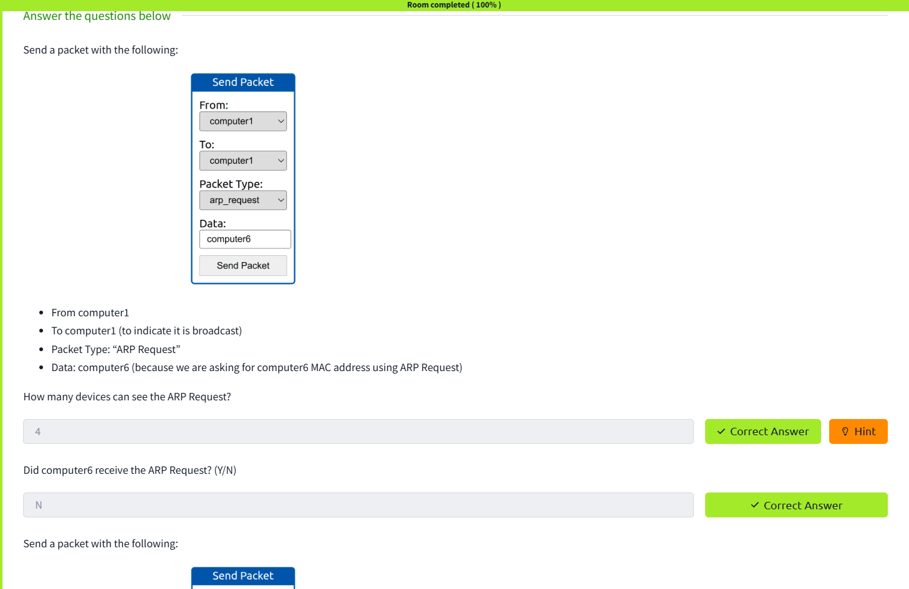

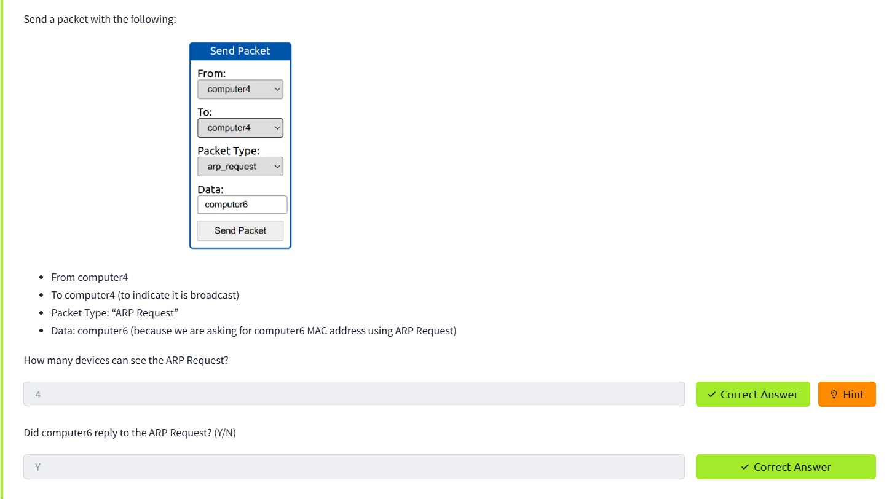

TASK 3: ENUMERATING TARGETS

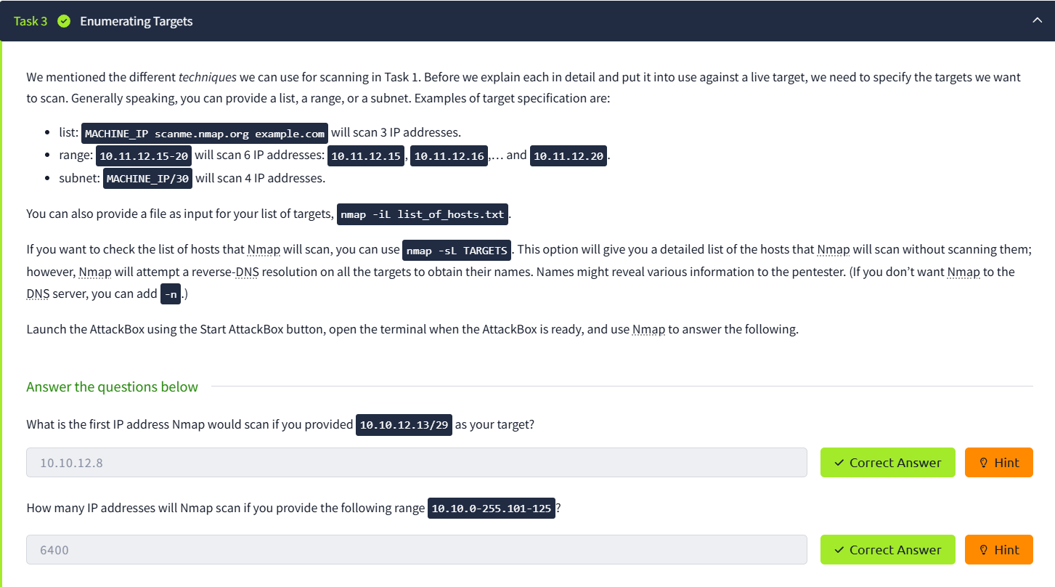

TASK 4: DISCOVERING LIVE HOSTS

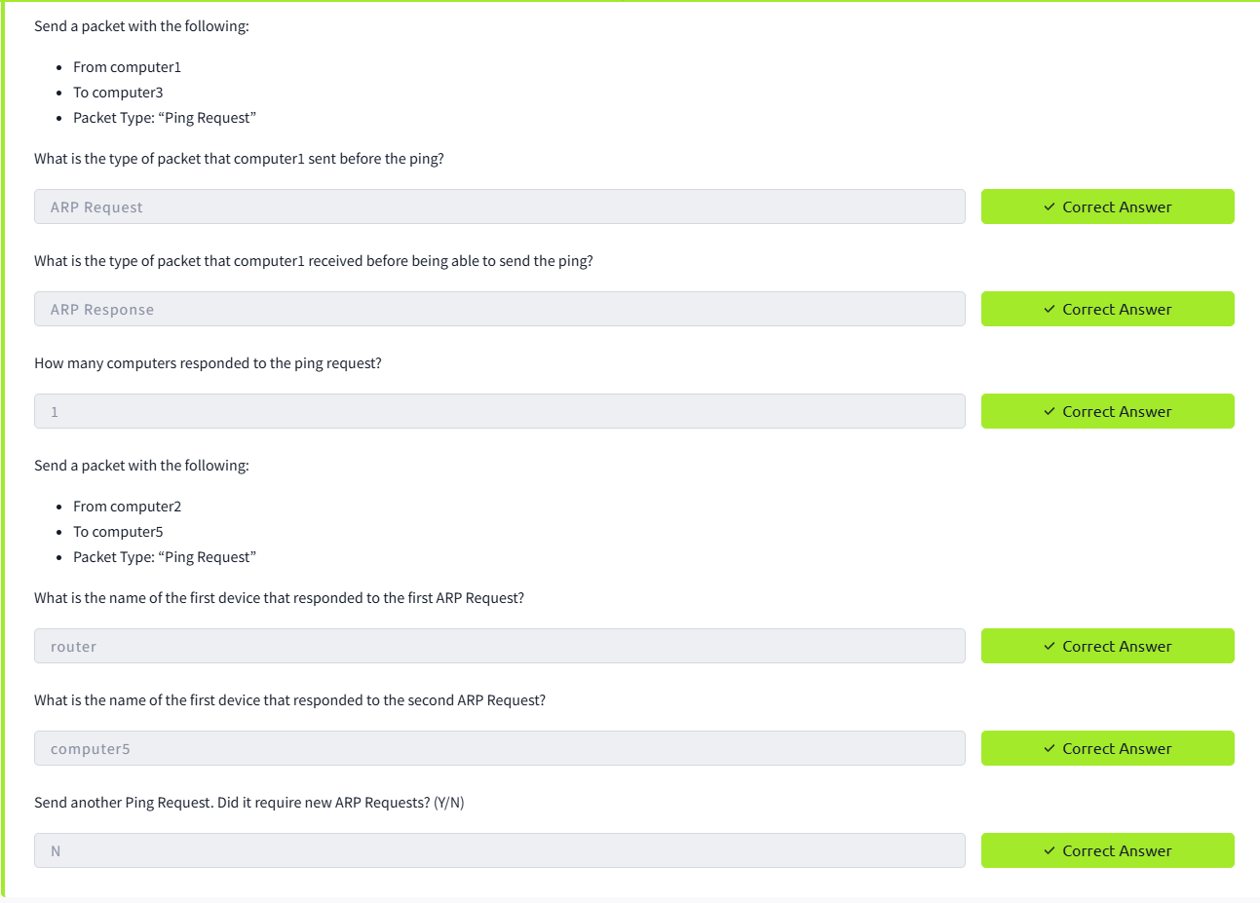

TASK 5: NMAP HOST DISCOVERY USING ARP

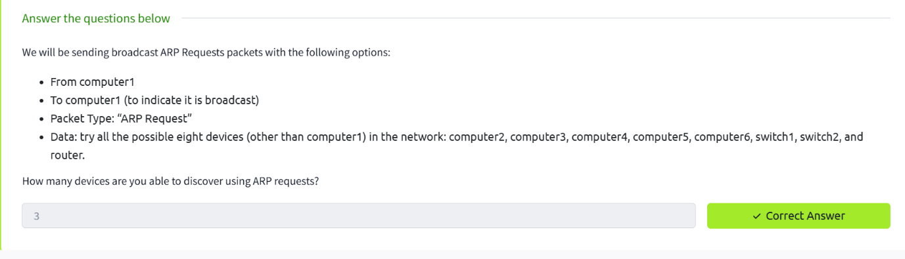

TASK 6: NMAP HOST DISCOVERY USING ICMP

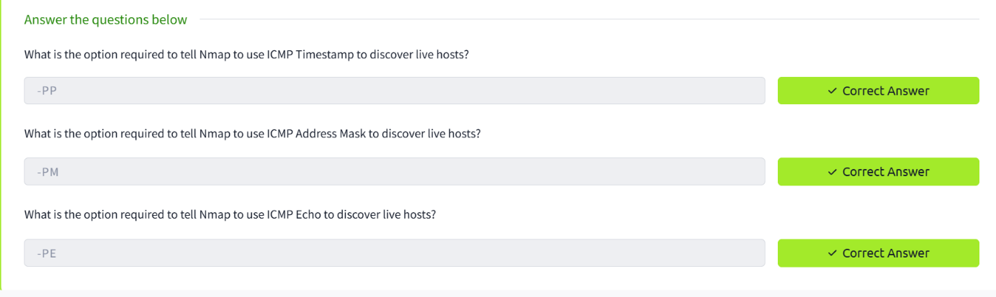

TASK 7: NMAP HOST DISCOVERY USING TCP AND UDP 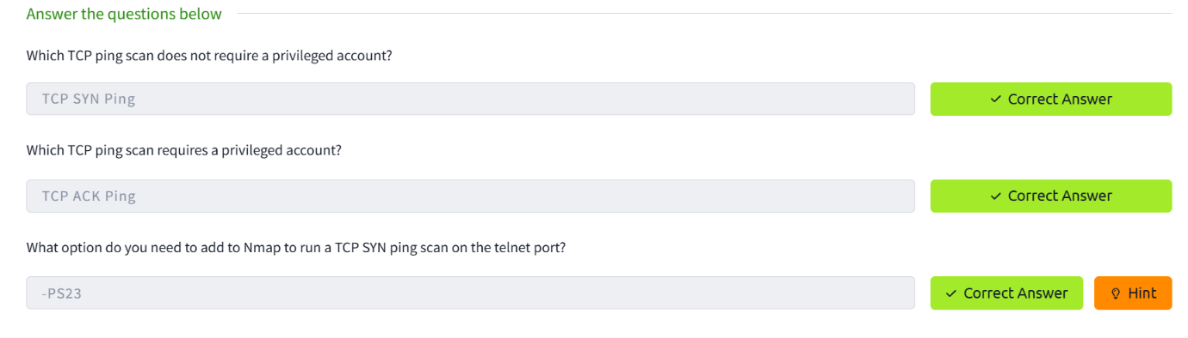

TASK 8: USING REVERSE DNS LOOKUP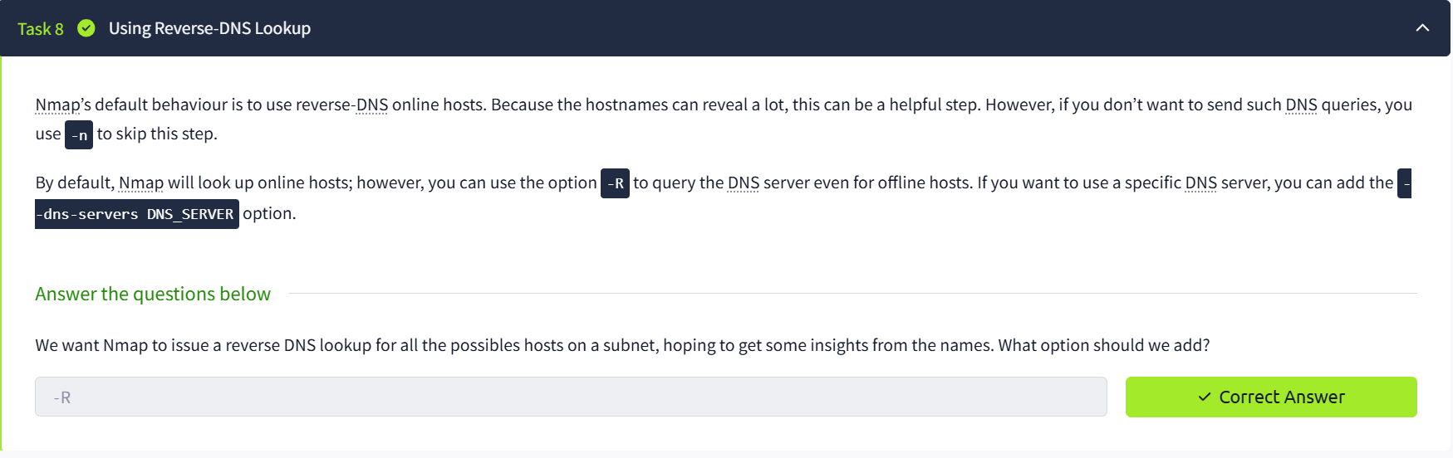

TASK 9: SUMMARY

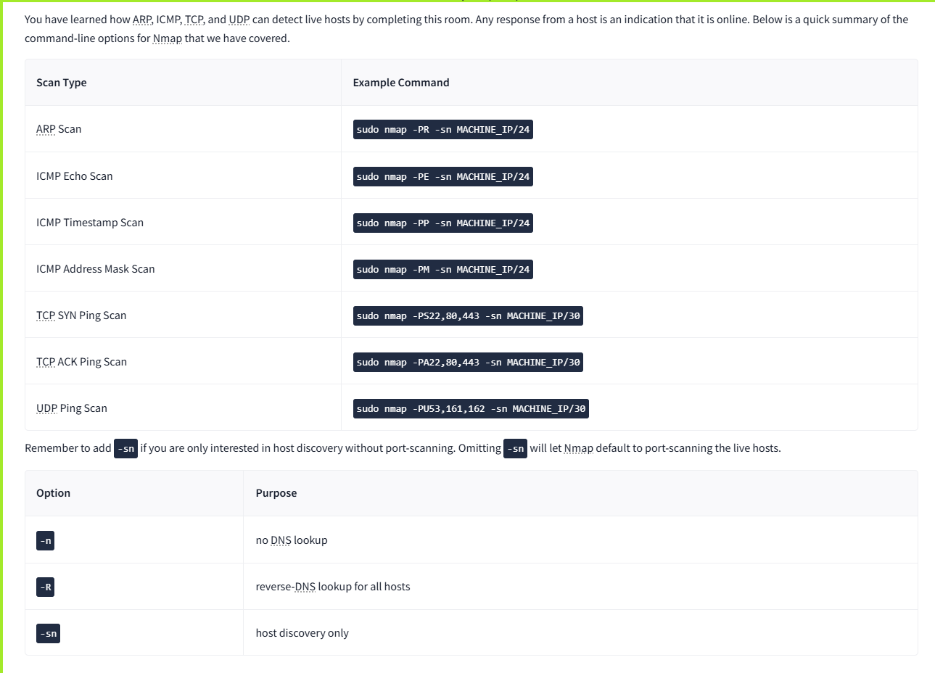

RESULT:

Nmap detects live hosts using ARP, ICMP, TCP SYN/ACK, and UDP. DNS lookups are run by default, but the -n, -R, and --dns-servers options control resolution.