**NAME : PRAVEEN V**

**ROLL NO.: 241901082**

# Exercise 8

**BUILDING AN ANONYMOUS FTP SCANNER USING FTPLIB MODULE**

**INTRODUCTION:**

Anonymous FTP servers allow logging in with the username anonymous (often using an email as password). A basic anonymous FTP scanner tries to connect to FTP servers (port 21) and attempts an anonymous login to check whether anonymous access is allowed.

**AIM:**

Create a small Python script that checks one or more hosts for FTP service and reports whether anonymous login is permitted.

**ALGORITHM:**

1. For each target host: try a TCP connection to port 21 (quick reachability check).
2. If reachable, open an ftplib.FTP connection and attempt login('anonymous', 'anonymous@').
3. Record and print whether anonymous login succeeded, was refused, or connection failed.
4. Repeat for all targets.

**CODE**:

import ftplib   
def anonymousLogin(hostname):   
    try:   
        ftp = ftplib.FTP(hostname)   
        response = ftp.login('anonymous', 'anonymous')   
        print(response)   
        if "230 Anonymous access granted" in response:   
            print('\n[*] ' + str(hostname) +' FTP Anonymous Login Succeeded.')   
            print(ftp.getwelcome())   
            ftp.dir()   
    except Exception as e:   
        print(str(e))   
        print('\n[-] ' + str(hostname) +' FTP Anonymous Login Failed.')   
hostname = 'ftp.be.debian.org'   
anonymousLogin(hostname)

**OUTPUT**:

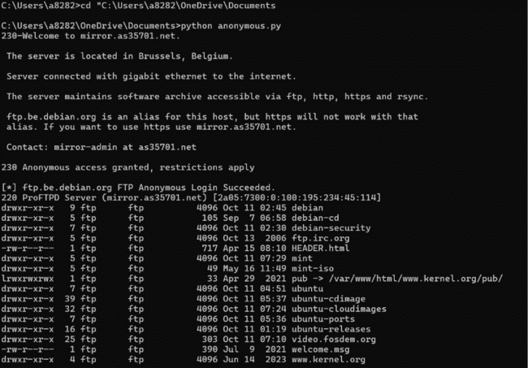

**RESULT**:

The anonymous FTP scanner successfully attempted connections to target hosts  and tried to log in using the anonymous account.