NAME : PRAVEEN V

ROLL NO.: 241901082

# Exercise 5

DEVELOP A SIMPLE CALCULATOR USING XML-RPC

INTRODUCTION:

An XML-RPC calculator exposes arithmetic functions (add, sub, mul, div, pow) over HTTP so a client can call them remotely using the XML-RPC protocol.

AIM:

Build a simple XML-RPC server that provides calculator functions and a client that calls them.

ALGORITHM:

1. Create an XML-RPC server that registers calculator functions.

2. Start the server on localhost and a chosen port.

3. Client connects to server URL and calls functions with arguments.

4. Server executes the function and returns result. Client prints it.

CODE:

SERVER:

from xmlrpc.server import SimpleXMLRPCServer

def add(a,b):

return a+b

def sub(a,b):

return a-b

def mul(a,b):

return a*b

def div(a,b):

return a/b

def mod(a,b):

return a%b

server=SimpleXMLRPCServer(("localhost",8000))

print("Listening on port 8000...")

server.register_function(add,"add")

server.register_function(sub,"sub")

server.register_function(mul,"mul")

server.register_function(div,"div")

server.register_function(mod,"mod")

server.serve_forever()

CLIENT:

import xmlrpc.client

proxy=xmlrpc.client.ServerProxy("http://localhost:8000/")

for i in range(5):

a=int(input("Enter a number:"))

b=int(input("Enter b number:"))

print("addition of given number is %d "%((proxy.add(a,b))))

print("sub of given number is %d "%((proxy.sub(a,b))))

print("multiplication of given number is %d "%((proxy.mul(a,b))))

print("division of given number is %d "%((proxy.div(a,b))))

print("mod of given number is %d "%((proxy.mod(a,b))))

OUTPUT:

SERVER:

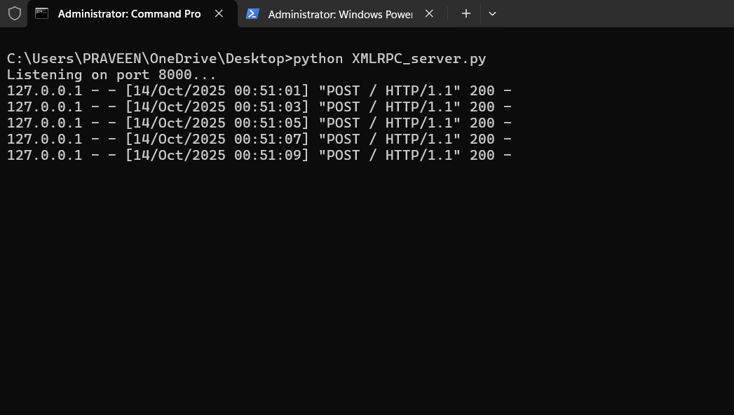

CLIENT:

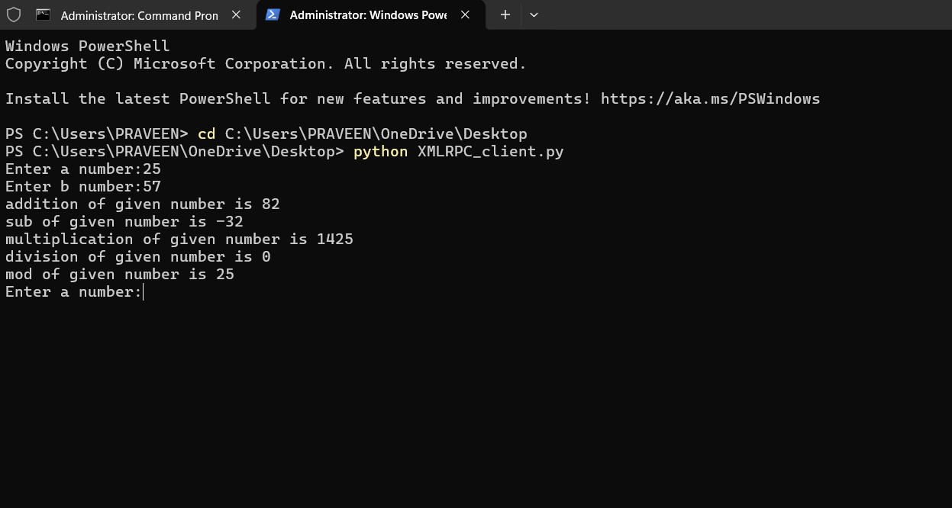

RESULT:

The XML-RPC calculator server successfully provided remote arithmetic functions. The client connected to the server and received correct results for addition, subtraction, multiplication, division, and modulo.