SAN JOSESTATEUNIVERSITY

CharlesW.DavidsonCollege of Engineering

DEPARTMENT OF ELECTRICAL ENGINEERING

**EE271 – Advanced Digital System Design and Synthesis**

Fall 2014 Final Project Report

A Simple 8-bit Scalar Processor

|  |  |  |  |
| --- | --- | --- | --- |
| **Name** | Praveen Waliitagi | **Email** | [Praveen.waliitagi@sjsu.edu](mailto:Praveen.waliitagi@sjsu.edu) |
| **SJSUID** | 010059257 | **Phone** | 6694009013 |

Table of Contents

Executive Summary: 3

I. GeneralProject Information 3

Table I.1: List of EDA Tools Used 3

Table I.2: List of Libraries Used 3

Table I.3: List of Verilog Modules (both design and test modules) 3

II. The Design Overview 6

Table II.1: Number of Clock Cycles Required for Each Instruction 8

II.2: Experiments to obtain optimum number of clock cycles 8

III. RTL-LevelSimulations/Tests for Each Instruction 9

IV. RTL-Level Simulations/Tests of Whole Design (processor) 13

IV.1 Test Program, Machine Codes, and Test Data 13

Table IV.1: Memory Code Address (in Hex), Test Instruction, and Machine Code (in Hex) 13

Table IV.2: Initial Test Data Stored atMemory Addresses (in Hex) 14

IV.2 Test Results 14

V. Synthesis and Optimizations of Whole Design (processor) 15

Table V.1: Synthesis Constraints and Results 15

V.III Relationship between Area Power and operating clock frequency 16

VI. Gate-Level Simulations/Tests of Whole Design (processor) 17

VII. Conclusion 18

VIII. References 18

Appendix A 19

A.1.1 RTL simulation command 19

A.2.1 Synthesis_script 19

Completed Verilog Source Codes and Test benches 22

Reports and Circuits from EDA Tools 46

C.1 Reports (contents) from RTL (Pre-synthesis) Simulations (VCS or NCVERILOG) 46

C.2 Reports (contents) from Netlist (Post-synthesis) Simulations (VCS or NCVERILOG) 48

C.3 Reports (contents) from Synthesis (Design Compiler) 52

C.3.1 Area Report 52

C.3.2 Power Report 53

C.3.3 Timing Report 54

C.4 Screenshot Circuits from Synthesis (Design Compiler) 61

C.4.1 TopLevel Schematic of the design 61

C.4.2 Controller Schematic 61

C.4.3 Data_Block Schematic 62

# Executive Summary:

In this Project an 8 bit Scalar processor is designed and implemented in verilog HDL. RTL level simulations and Gate level simulations were carried out to test the functionality of the processor. After successful completion of RTL level simulations, synthesis was performed using design compiler to obtain gate level netlist. Timing analysis was done using “update_timing” and “report_timing” commands in design_compiler. Synthesis was performed by setting various values for design constraints to obtain a better tradeoff between area, power and speed. Simulation and synthesis test results are described in detail in this project report.

# I. GeneralProject Information

## Table I.1: List of EDA Tools Used

|  |  |  |  |  |
| --- | --- | --- | --- | --- |
| **Name** | **Company** | **Used for** | **Free? (Y/N)** | **Software Documents** |
| VCS | Synopsys | Simulation & test | No |  |
| NCSIM | Cadence | Simulation & test | No |  |
| Design Vision | Synopsys | Synthesis | No |  |

## Table I.2: List of Libraries Used

|  |  |  |  |
| --- | --- | --- | --- |
| **Library file name** | **Company** | **Used with**  (EDA tool) | **The libraries are at**  (directories on eecad systems) |
| tc240c.db_BCCOM25 | Toshiba | Synopsys | /apps/toshiba/sjsu/synopsys/tc240c/ |
| tc240c.db_WCCOM25 | Toshiba | Synopsys | /apps/toshiba/sjsu/synopsys/tc240c/ |
|  |  |  |  |

## Table I.3: List of Verilog Modules (both design and test modules)

|  |  |  |  |  |
| --- | --- | --- | --- | --- |
| **Module Name** | **Input Ports** | **Output Ports** | **BiDirectional** | **Short Description** |
| s8sp | clk;  reset; | add;  wrt;  rd; | dat; | Top level design of the processor |
| Data_block | clk;  reset;  load_ar;  ar_on_addr;  ar_2_data;  load_dr;  dr_2_data;  load_lsb_gr;  load_msb_gr;  gr_2_data;  load_ar_2_pr;  inc_pr;  pr_2_data;  pr_on_addr;  load_ir;  ir_2_data;  sub_nadd;  add_oprnd1_sel;  add_oprnd2_sel;  alu_2_data;  flag_2_data; | addr_bus;  ir_code; | data_bus; | Data Handling Block where all the data manipulations occur. This block contains all the registers and ALU. |
| sys_controller | clk;  reset;  ctrl_ir_code; | rd_mem;  wr_mem;  ctrl_load_ar;  ctrl_ar_on_addr;  ctrl_ar_2_data;  ctrl_load_dr;  ctrl_dr_2_data;  ctrl_load_lsb_gr;  ctrl_load_msb_gr;  ctrl_gr_2_data;  ctrl_load_ar_2_pr;  ctrl_inc_pr;  ctrl_pr_2_data;  ctrl_pr_on_addr;  ctrl_load_ir;  ctrl_ir_2_data;  ctrl_alu_2_data;  ctrl_sub_nadd;  ctrl_add_oprnd1_sel;  ctrl_add_oprnd2_sel;  ctrl_flag_2_data; |  | Controller block sends control signals to data block for data manipulations. This Block reads the instruction from the instruction code register and then sends the control signals accordingly. |
| program_cnt_reg | clk;  reset;  inc_pr;  load_ar_2_pr;  data_on_pr; | pr_on_bus; |  | Program counter register which Points to the location in the memory from where next instruction is to be fetched |
| data_reg | clk;  reset;  data_on_dr;  load_dr | dr_on_data; |  | Data Register Block used data manipulation. |
| gen_reg | clk;  reset;  load_lsb_gr;  load_msb_gr;  data_on_gr; | gr_on_data; |  | General Register Block used data manipulation. |
| addr_reg | clk;  reset;  data_on_ar;  load_ar | ar_on_bus; |  | Address Register used to hold the memory address and it can also be used for data manupulations |
| local_ir_reg | clk;  reset;  load_ir;  data_on_ir; | ir_out; |  | Instruction register used to hold the instruction fetched from memory. |
| flag_reg | clk;  reset;  alu_2_data;  alu_data; | flag_reg; |  | Flag Register which holds the status of various arithmetic operations. |
| **Module Name** | **Input Ports** | **Output Ports** | **BiDirectional** | **Short Description** |
| alu_block | reg_in1;  reg_in2;  sub_nadd; | alu_out; |  | Top level block of Arithmetic Logic Unit used to per Addition and subtraction |
| CLA8bit | in1;  in2;  cin; | sum;  cout; |  | 8 Bit carry Look ahead adder. Formed by instantiating two 4 bit Carry lookahead circuit. |
| CLA_N_bit | in1;  in2;  cin; | sum;  cout; |  | Generic N bit Carry Lookahead adder module. |
| **Testbench Module** | | | | |
| **TB_name** | **Wire** | **Reg** |  | **Description** |
| tb_s8sp | add;  wrt;  rd;  dat; | Clk;  Reset;  Out_data;  mem |  | Generic Testbench which can be used to test both RTL and Netlist. |

# 

# II. The Design Overview

The RTL level design of small 8 bit scalar processor has data processing unit and control unit.

**DATA PROCESSING UNIT:** consists of all the registers and ALU block. As per the design specification we have the following set of registers 1. Address register (AR) which holds the memory address from where the data has to be read/write. 2. Data register (DR) which is used for data manipulations. 3. Genral register (GR) which is used to load the data read from the memory. 4. Program counter (PC) register which holds the memory address from where the next instruction has to be fetched. 5. Flag register (FR) which holds the conditions of arithmetic operations. All these registers except the flag registers are multiplexed at the input of ALU so that they can be used as source or destination in the instruction code. The ALU unit consists of a generic N bit carry look-ahead adder circuit. This generic adder is parameterized to two 4 bit carry look-ahead adder circuit to form 8 bit CLA circuit. This adder circuit is intern used for subtraction by using the necessary EXOR logic. There is also an internal instruction code register (IR) which holds the instruction fetched from the memory.

**CONTROL UNIT:**  Controller unit of the 8 bit scalar processor has 4 states namely reset, fetch, decode, and execute. In reset state all the registers and control signals values are set to zero. In fetch state all the signals necessary to fetch the instruction from the memory are asserted and PC value is incremented by one so as to be ready to fetch the next instruction from memory. In decode state IR value is read and then the state moves to execute. In execution phase based on the kind of instruction necessary control signals are asserted in order to perform the necessary operation. Memory is implemented in testbench.

**Figure II.1**: Overall Processor Block Diagram

Simplified processor block diagram is as shown below. Data block contains all the register modules and the ALU. Controller block contains a state machine which sequences the operation based on the fetched instruction. Memory is implemented in the testbench and is not part of the design

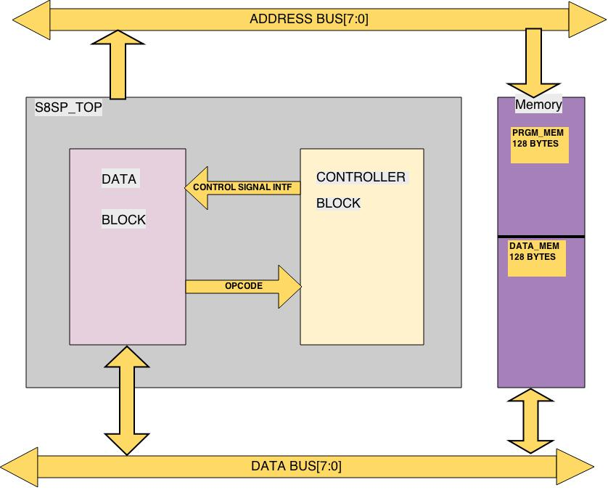

**Figure II.1**: Overall Processor Block Diagram

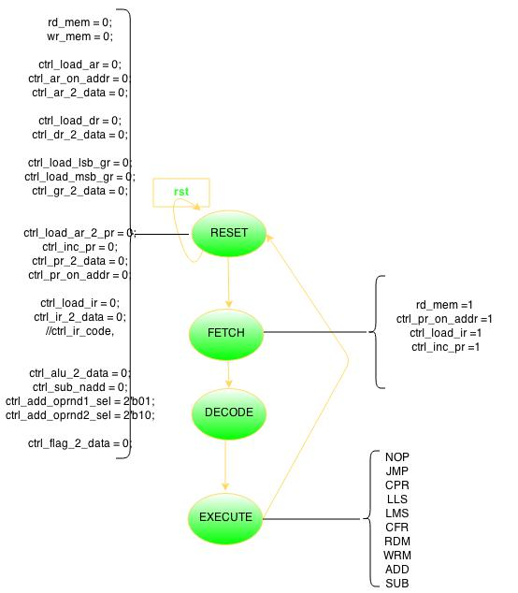

**Figure II.2**: Overall State Transition Diagram

## Table II.1: Number of Clock Cycles Required for Each Instruction

|  |  |  |  |  |  |
| --- | --- | --- | --- | --- | --- |
| **Instruction** | **# of Clock Cycles** | **Instruction** | **# of Clock Cycles** | **Instruction** | **# of Clock Cycles** |
| NOP | 1 | LMS | 1 | ADD | 2 |
| JMP | 1 | CFR | 1 | SUB | 2 |
| CPR | 1 | RDM | 2 |  |  |
| LLS | 1 | WRM | 2 |  |  |

## II.2: Experiments to obtain optimum number of clock cycles

To get the best results for Arithmetic instructions ALU block was designed and tested independently. Single 4 bit carry-look-ahead (CLA) adder circuit was designed and cascaded to obtain an 8 bit CLA circuit. Synthesis of 8 bit CLA circuit was carried out and timing analysis was done to obtain the maximum delay in the circuit. This 8 bit CLA adder circuit was used for SUB instruction by using an additional EXOR logic for the 1st carry-in and to one of the inputs.

To get the best results for RDM and WRM instructions synchronous and asynchronous memory was implemented in test bench. Since memory was part of the test bench and is not synthesized asynchronous memory was used to get the faster response.

# III. RTL-LevelSimulations/Tests for Each Instruction

In the below waveform JMP instruction is executed in which AR register value is loaded into PR so as to fetch the next instruction from the JMP address. Corresponding control signals are shown in the waveform.

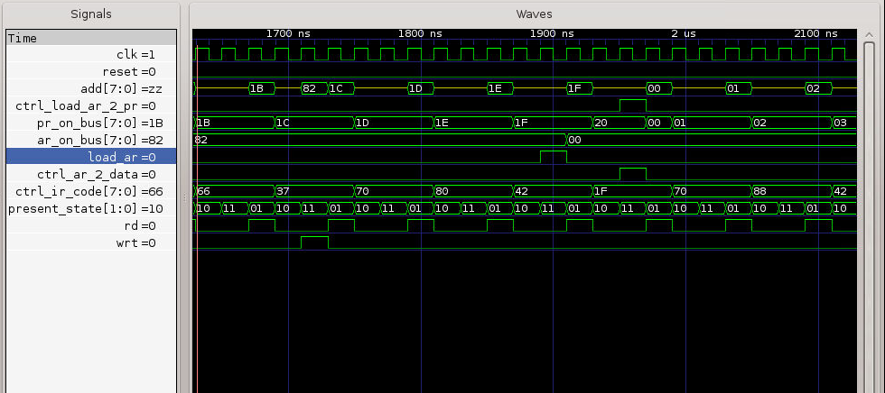

**Figure III.1**: Test Result for **JMP** Instruction

Waveform below shows copy of GR register to AR register. gr_2_data signal is asserted and load_ar signal is asserted.

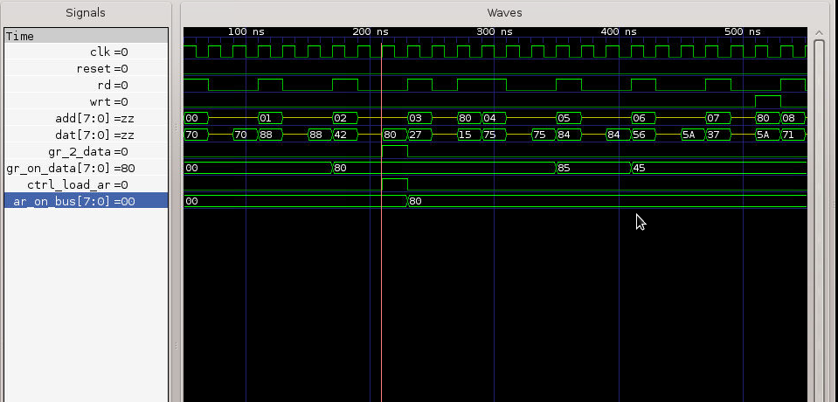

**Figure III.2**: Test Result for **CPR** Instruction

In the below waveform Last four significant bits of GR register is loaded with a value on the data bus. Ctrl_load_lsb_gr is asserted to 1.

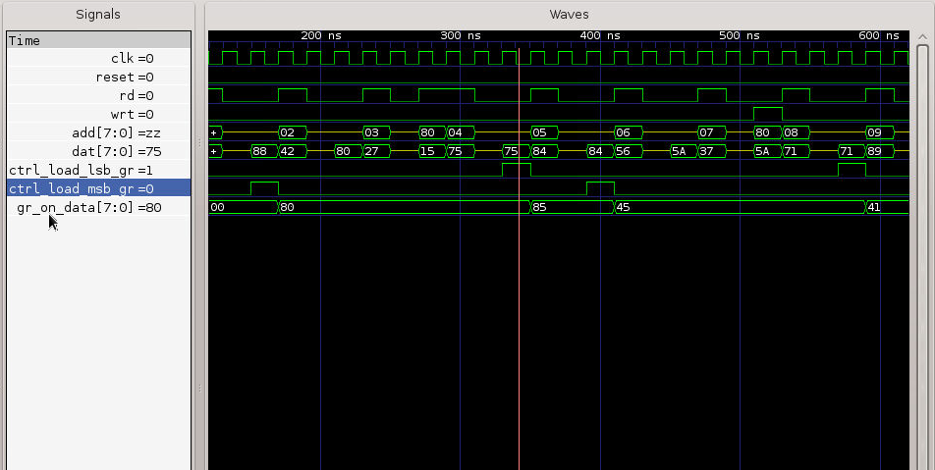

**Figure III.3**: Test Result for **LLS** Instruction

In the below waveform four most significant bits of GR register is loaded with a value on the data bus. Ctrl_load_msb_gr is asserted to 1.



**Figure III.4**: Test Result for **LMS** Instruction

In the below waveform, contents of the flag register are copied to least significant bits of general register. control signals ctrl_flag_2_data and ctrl_load_lsb_gr are set to 1.

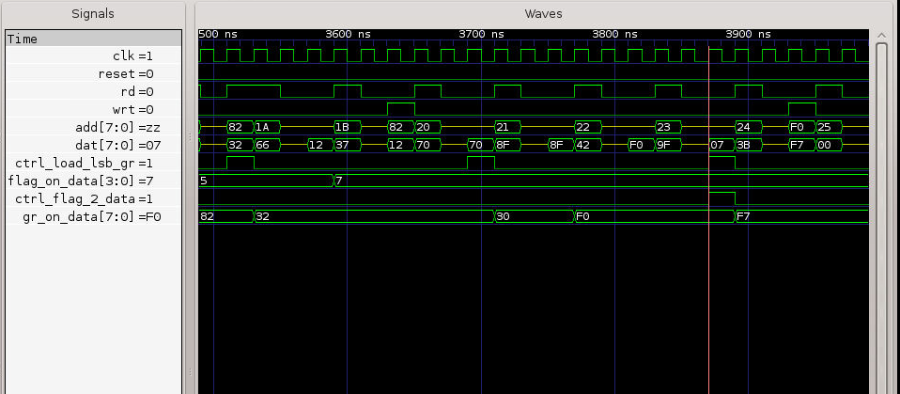

**Figure III.5**: Test Result for **CFR** Instruction

Below waveform shows AR register value loaded onto address bus to fetch the data from that memory address and also ctrl_load_dr set to one to load the fetched value onto DR register.

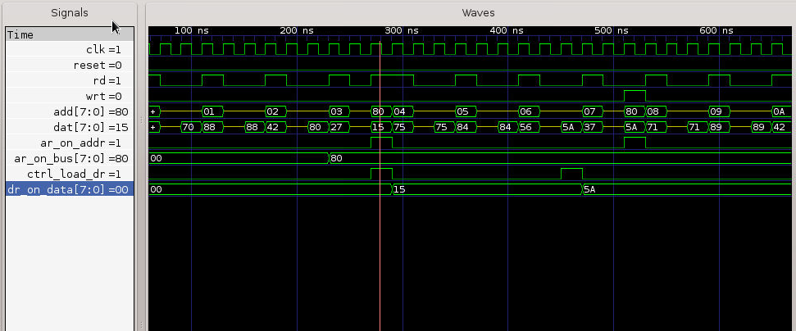

**Figure III.6**: Test Result for **RDM** Instruction

Below waveform shows AR register value loaded onto address bus to write the data from DR register onto the memory address of AR.

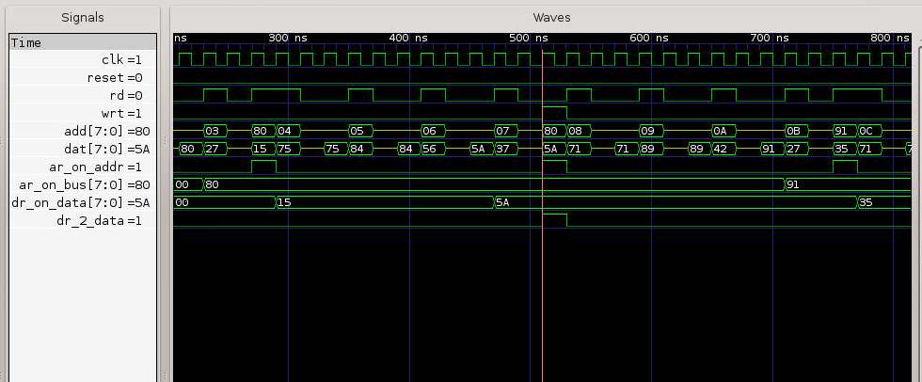

**Figure III.7**: Test Result for **WRM** Instruction

Below waveform shows Addition of contents of DR and GR register and the result getting stored in DR register.

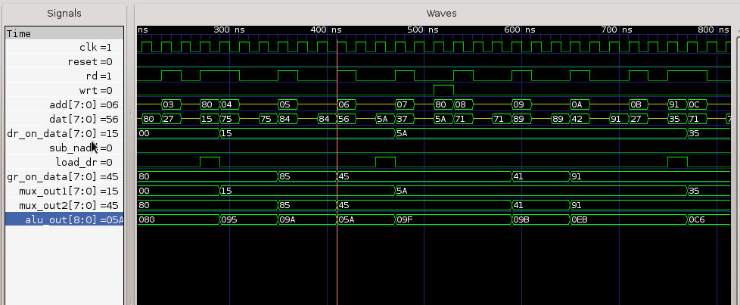

**Figure III.8**: Test Result for **ADD** Instruction

Below waveform shows subtraction of contents of DR and GR register and the result getting stored in DR register. 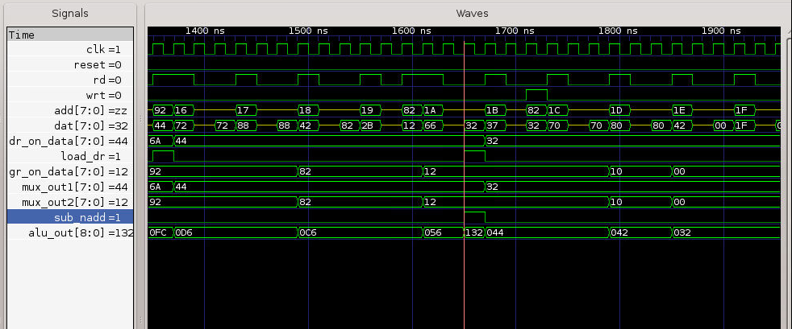

**Figure III.9**: Test Result for **SUB** Instruction

# IV. RTL-Level Simulations/Tests of Whole Design (processor)

## IV.1 Test Program, Machine Codes, and Test Data

## Table IV.1: Memory Code Address (in Hex), Test Instruction, and Machine Code (in Hex)

|  |  |  |
| --- | --- | --- |
| **Memory Address** | **Instruction** | **Machine Code** |
| 00 | LLS 0 | 70 |
| 01 | LMS 8 | 88 |
| 02 | CPR AR GR | 42 |
| 03 | RDM DR | 27 |
| 04 | LLS 5 | 75 |
| 05 | LMS 4 | 84 |
| 06 | ADD DR GR | 56 |
| 07 | WRM DR | 37 |
| 08 | LLS 1 | 71 |
| 09 | LMS 9 | 89 |
| 0A | CPR AR GR | 42 |
| 0B | RDM DR | 27 |
| 0C | LLS 1 | 71 |
| 0D | LMS 8 | 88 |
| 0E | CPR AR GR | 42 |
| 0F | RDM GR | 2B |
| 10 | ADD DR GR | 56 |
| 11 | WRM DR | 37 |
| 12 | LLS 2 | 72 |
| 13 | LMS 9 | 89 |
| 14 | CPR AR GR | 42 |
| 15 | RDM DR | 27 |
| 16 | LLS 2 | 72 |
| 17 | LMS 8 | 88 |
| 18 | CPR AR GR | 42 |
| 19 | RDM GR | 2B |
| 1A | SUB DR GR | 66 |
| 1B | WRM DR | 37 |
| 1C | LLS 0 | 70 |
| 1D | LMS F | 8F |
| 1E | CPR AR GR | 42 |
| 1F | CFR | 9F |
| 20 | WRM GR | 3B |
| 21 | LLS 0 | 70 |
| 22 | LMS 0 | 80 |
| 23 | CPR AR GR | 42 |
| 24 | JMP | 1F |
|  |  |  |
|  |  |  |

## Table IV.2: Initial Test Data Stored atMemory Addresses (in Hex)

|  |  |  |  |
| --- | --- | --- | --- |
| **Memory Address** | **Data** | **Memory Address** | **Data** |
| 80 | 15 | 92 | 44 |
| 81 | 35 | 82 | 12 |
| 91 | 35 |  |  |

## IV.2 Test Results

Chronologic VCS simulator copyright 1991-2014

Contains Synopsys proprietary information.

Compiler version I-2014.03-2; Runtime version I-2014.03-2; Dec 7 22:12 2014

0 mem[80]=15 mem[81]=35 mem[82]=12

510 mem[80]=5a mem[81]=35 mem[82]=12

1110 mem[80]=5a mem[81]=6a mem[82]=12

1710 mem[80]=5a mem[81]=6a mem[82]=32

2430 mem[80]=9f mem[81]=6a mem[82]=32

3030 mem[80]=9f mem[81]=9f mem[82]=32

3630 mem[80]=9f mem[81]=9f mem[82]=12

$finish called from file "/home/wa/wali9257/ee271/s8sp/implementation/rtl_vcs/../../s8sp_tb/tb_s8sp.v", line 128.

$finish at simulation time 4000000

V C S S i m u l a t i o n R e p o r t

Time: 4000000 ps

CPU Time: 0.140 seconds; Data structure size: 0.0Mb

Sun Dec 7 22:12:54 2014

# V. Synthesis and Optimizations of Whole Design (processor)

## Table V.1: Synthesis Constraints and Results

**Table V.II**: Variation in Area and Power with the change in clock period (Constant Area)

|  |  |  |  |  |  |
| --- | --- | --- | --- | --- | --- |
| **Trial**  **No**. | **Constraint settings** | | **Synthesis results** | | |
| **MAX_AREA** | **CLOCK(ns)** | **SLACK** | **AREA** | **POWER(mW)** |
| **1** | 500 | 5.0 | 0.05 | 1122.0 | 1.9644 |
| **2** | 500 | 4.0 | 0.05 | 1126.0 | 2.9748 |
| **3** | 500 | 3.0 | 0.02 | 1108.5 | 3.9498 |
| **4** | 500 | 2.0 | 0.02 | 1165.0 | 5.9353 |
| **5** | 500 | 1.8 | 0.01 | 1179.0 | 6.5928 |
| **6** | 500 | 1.7 | 0.00 | 1179.5 | 9.4142 |

**Table V.II**: Variation in Area and Power with the change in Area (Constant clock period)

|  |  |  |  |  |  |
| --- | --- | --- | --- | --- | --- |
| **Trial**  **No**. | **Constraint settings** | | **Synthesis results** | | |
| **AREA** | **CLOCK(ns)** | **SLACK** | **AREA(sq.nm)** | **POWER(mW)** |
| **1** | 300 | 2.0 | 0.02 | 1165 | 5.9353 |
| **2** | 400 | 2.0 | 0.02 | 1165 | 5.9353 |
| **3** | 1000 | 2.0 | 0.19 | 1165 | 5.9353 |
| **4** | 2000 | 2.0 | 0.13 | 1203 | 6.0221 |
| **5** | 3000 | 2.0 | 0.19 | 1165 | 5.9353 |

**Figure V.1**: Power versus Clock of the Final Design

**Figure V.1**: Area versus Clock of the Final Design

## V.III Relationship between Area Power and operating clock frequency

Various synthesis runs were carried out to obtain a better tradeoff between area, power and timing. I analyzed the total area consumed and total power consumed by the design for different values of the operating clock frequency. From Table V.I and V.II we can see that as the operating clock frequency increases area and power consumption of the design increases. For my design the best operating clock frequency obtained is 588 MHz (1.7ns).

# VI. Gate-Level Simulations/Tests of Whole Design (processor)

Chronologic VCS simulator copyright 1991-2014

Contains Synopsys proprietary information.

Compiler version I-2014.03-2; Runtime version I-2014.03-2; Dec 7 23:16 2014

VCD+ Writer I-2014.03-2 Copyright (c) 1991-2014 by Synopsys Inc.

The file '/home/wa/wali9257/ee271/s8sp/implementation/netlist_vcs/inter.vpd' was opened successfully.

dve> run

0 mem[80]=15 mem[81]=25 mem[82]=54

198 mem[80]=zZ mem[81]=25 mem[82]=54

198 mem[80]=4a mem[81]=25 mem[82]=54

438 mem[80]=4a mem[81]=zZ mem[82]=54

438 mem[80]=4a mem[81]=5a mem[82]=54

678 mem[80]=4a mem[81]=5a mem[82]=zZ

678 mem[80]=4a mem[81]=5a mem[82]=f0

1086 mem[80]=zZ mem[81]=5a mem[82]=f0

1086 mem[80]=8f mem[81]=5a mem[82]=f0

1326 mem[80]=8f mem[81]=zZ mem[82]=f0

1326 mem[80]=8f mem[81]=8f mem[82]=f0

1566 mem[80]=8f mem[81]=8f mem[82]=zZ

1566 mem[80]=8f mem[81]=8f mem[82]=54

1974 mem[80]=zZ mem[81]=8f mem[82]=54

1974 mem[80]=d4 mem[81]=8f mem[82]=54

$finish called from file "tb_s8sp.v", line 128.

$finish at simulation time 2000000

Simulation complete, time is 2000000 ps.

V C S S i m u l a t i o n R e p o r t

Time: 2000000 ps

CPU Time: 0.040 seconds; Data structure size: 0.2Mb

Sun Dec 7 23:17:17 2014

# VII. Conclusion

Successfully designed and implemented a simple 8 bit scalar processor. To obtain a faster response for arithmetic instructions a Carry look ahead adder circuit was designed and tested independently and then integrated into the processor design. In order for effective utilization of resources the same carry look ahead adder circuit was used for subtraction with some additional combinational logic. Synthesis trails were carried out to obtain the better tradeoff between area power and speed. Maximum operating clock frequency of the processor obtained is 588Mhz. From synthesis trails it was known that as operating clock frequency increases power consumption and area utilized by the circuit increases.

# VIII. References

* Dr. Thuy Le, EE271 Fall 2014 class notes.
* Dr. Thuy Le, project handout material.
* Synopsys DC Synthesis tutorial.
* Verilog HDL: A Guide to Digital Design and Synthesis, Second Edition - Samir Palnitkar
* Advanced Digital Design with the Verilog HDL (2nd Edition)- Michael ciletti

# Appendix A

**A.1** Scripts and/or Commands Used for Simulation and Synthesis

### A.1.1 RTL simulation command

vcs -RPP /home/wa/wali9257/ee271/s8sp/data_block/reg_blocks/addr_reg.v /home/wa/wali9257/ee271/s8sp/data_block/reg_blocks/data_reg.v /home/wa/wali9257/ee271/s8sp/data_block/reg_blocks/flag_reg.v /home/wa/wali9257/ee271/s8sp/data_block/reg_blocks/gen_reg.v /home/wa/wali9257/ee271/s8sp/data_block/reg_blocks/local_ir_reg.v /home/wa/wali9257/ee271/s8sp/data_block/reg_blocks/program_cnt_reg.v /home/wa/wali9257/ee271/s8sp/data_block/alu_block/alu_block.v /home/wa/wali9257/ee271/s8sp/data_block/alu_block/CLA8bit.v /home/wa/wali9257/ee271/s8sp/data_block/alu_block/CLA_N_bit.v /home/wa/wali9257/ee271/s8sp/data_block/data_block_top/data_block.v /home/wa/wali9257/ee271/s8sp/ctrl_block/sys_controller.v /home/wa/wali9257/ee271/s8sp/s8sp_top/s8sp.v /home/wa/wali9257/ee271/s8sp/implementation/rtl_vcs/../../s8sp_tb/tb_s8sp.v

### 

### A.2.1 Synthesis_script

dc_shell -xg -f synthesis.script

set link_library {/apps/toshiba/sjsu/synopsys/tc240c/tc240c.db_BCCOM25 /apps/toshiba/sjsu/synopsys/tc240c/tc240c.db_WCCOM25 }

set target_library {/apps/toshiba/sjsu/synopsys/tc240c/tc240c.db_BCCOM25 /apps/toshiba/sjsu/synopsys/tc240c/tc240c.db_WCCOM25 }

set synthetic_library {dw_foundation.sldb standard.sldb}

set_min_library /apps/toshiba/sjsu/synopsys/tc240c/tc240c.db_WCCOM25 -min_version /apps/toshiba/sjsu/synopsys/tc240c/tc240c.db_BCCOM25

analyze -f verilog /home/wa/wali9257/ee271/s8sp/data_block/reg_blocks/addr_reg.v

analyze -f verilog /home/wa/wali9257/ee271/s8sp/data_block/reg_blocks/data_reg.v

analyze -f verilog /home/wa/wali9257/ee271/s8sp/data_block/reg_blocks/flag_reg.v

analyze -f verilog /home/wa/wali9257/ee271/s8sp/data_block/reg_blocks/gen_reg.v

analyze -f verilog /home/wa/wali9257/ee271/s8sp/data_block/reg_blocks/local_ir_reg.v

analyze -f verilog /home/wa/wali9257/ee271/s8sp/data_block/reg_blocks/program_cnt_reg.v

analyze -f verilog /home/wa/wali9257/ee271/s8sp/data_block/alu_block/CLA_N_bit.v

analyze -f verilog /home/wa/wali9257/ee271/s8sp/data_block/alu_block/CLA8bit.v

analyze -f verilog /home/wa/wali9257/ee271/s8sp/data_block/alu_block/alu_block.v

analyze -f verilog /home/wa/wali9257/ee271/s8sp/data_block/data_block_top/data_block.v

analyze -f verilog /home/wa/wali9257/ee271/s8sp/ctrl_block/sys_controller.v

analyze -f verilog /home/wa/wali9257/ee271/s8sp/s8sp_top/s8sp.v

elaborate s8sp

current_design s8sp

uniquify -reference CLA_N_bit

link

#set_flatten -design s8sp

#set_flatten -design alu_block

#ungroup -all

check_design > reports/design_report

#create_clock clk -name clk -period 2.800000

create_clock clk -name clk -period 2

set_propagated_clock clk

set_clock_uncertainty .25 clk

set_max_delay 1 -from [all_inputs]

set_max_delay 1 -to [all_outputs]

#set_max_delay 2 -to sum

#set_load 160 sum

set_max_area 1000

#compile -map_effort high -ungroup_all

compile -map_effort high

report_cell > reports/cell_report

report_net > reports/net_report

update_timing

report_timing -max_paths 10 -group clk > reports/timing_report

report_area > reports/area_report

report_power > reports/power_report

write -hierarchy -format verilog -output reports/s8sp_netlist.v

#write -format verilog -output reports/s8sp_netlist.v

quit

Appendix B

# Completed Verilog Source Codes and Test benches

**Top Level Module of the Design**

//////////////////////////////////////////////////////////////////////////////////

// Company: San Jose State University

// Engineer:

//

// Create Date: 02:05:08 10/28/2014

// Design Name: Simple 8 bit Scalar Processor

// Module Name: s8sp

// Project Name:

// Target Devices:

// Tool versions:

// Description:

//

// Dependencies:

//

// Revision:

// Revision 0.01 - File Created

// Additional Comments:

//

//////////////////////////////////////////////////////////////////////////////////

module s8sp(clk,reset,add,dat,wrt,rd );

input clk;

input reset;

output[7:0] add;

inout [7:0] dat;

output wrt;

output rd;

//For AR Connections from Controller to Data_block

wire load_ar;

wire ar_on_addr;

wire ar_2_data;

//For DR Connections from Controller to Data_block

wire load_dr;

wire dr_2_data;

//For GR Connections from Controller to Data_block

wire load_lsb_gr;

wire load_msb_gr;

wire gr_2_data;

//For PR Connections from Controller to Data_block

wire load_ar_2_pr;

wire inc_pr;

wire pr_2_data;

wire pr_on_addr;

//For IR Connections from Controller to Data_block

wire load_ir;

wire ir_2_data;

wire [7:0] ir_code;

//For ALU Connections from Controller to Data_block

wire sub_nadd;

wire alu_2_data;

wire [1:0] add_oprnd1_sel;

wire [1:0] add_oprnd2_sel;

//For Flag connections

wire flag_2_data;

data_block u1_data_block_instantiation (

//System Signals

.clk (clk),

.reset (reset),

//System Bus

.data_bus (dat),

.addr_bus (add),

//AR related signals

.load_ar(load_ar),

.ar_on_addr(ar_on_addr),

.ar_2_data(ar_2_data),

//DR related signals

.load_dr(load_dr),

.dr_2_data(dr_2_data),

//GR related signals

.load_lsb_gr(load_lsb_gr),

.load_msb_gr(load_msb_gr),

.gr_2_data(gr_2_data),

//PR related signals

.load_ar_2_pr(load_ar_2_pr),

.inc_pr(inc_pr),

.pr_2_data(pr_2_data),

.pr_on_addr(pr_on_addr),

//Internal IR related signals

.load_ir(load_ir),

.ir_2_data(ir_2_data),

.ir_code(ir_code), //used by controller for decoding instructions

//ALU related signals

.sub_nadd(sub_nadd),

.add_oprnd1_sel(add_oprnd1_sel),

.add_oprnd2_sel(add_oprnd2_sel),

.alu_2_data (alu_2_data),

//FLAG related signals

.flag_2_data (flag_2_data)

);

//--------------------------------------------------------------

sys_controller u1_sys_controller_inst (

//System related signals

.clk (clk),

.reset (reset),

.rd_mem (rd),

.wr_mem (wrt),

//AR related signals

.ctrl_load_ar(load_ar),

.ctrl_ar_on_addr(ar_on_addr),

.ctrl_ar_2_data(ar_2_data),

//DR related signals

.ctrl_load_dr(load_dr),

.ctrl_dr_2_data(dr_2_data),

//GR related signals

.ctrl_load_lsb_gr(load_lsb_gr),

.ctrl_load_msb_gr(load_msb_gr),

.ctrl_gr_2_data(gr_2_data),

//PR related signals

.ctrl_load_ar_2_pr(load_ar_2_pr),

.ctrl_inc_pr(inc_pr),

.ctrl_pr_2_data(pr_2_data),

.ctrl_pr_on_addr(pr_on_addr),

//Internal IR related signals

.ctrl_load_ir(load_ir),

.ctrl_ir_2_data(ir_2_data),

.ctrl_ir_code(ir_code),

//ALU related signals

.ctrl_alu_2_data(alu_2_data),

.ctrl_sub_nadd(sub_nadd),

.ctrl_add_oprnd1_sel(add_oprnd1_sel),

.ctrl_add_oprnd2_sel(add_oprnd2_sel),

//FLAG related signals

.ctrl_flag_2_data (flag_2_data)

);

endmodule

**Controller module of the design**

//////////////////////////////////////////////////////////////////////////////////

// Company: San Jose State University

// Engineer:

//

// Create Date: 21:49:57 10/27/2014

// Design Name: System Controller

// Module Name: sys_controller

// Project Name: S8SP

// Target Devices:

// Tool versions:

// Description:

//

// Dependencies:

//

// Revision:

// Revision 0.01 - File Created

// Additional Comments:

//

//////////////////////////////////////////////////////////////////////////////////

module sys_controller( clk,reset,rd_mem,wr_mem,ctrl_load_ar,ctrl_ar_on_addr,ctrl_ar_2_data,ctrl_load_dr,ctrl_dr_2_data,

ctrl_load_lsb_gr,ctrl_load_msb_gr,ctrl_gr_2_data,ctrl_load_ar_2_pr,ctrl_inc_pr,ctrl_pr_2_data,ctrl_pr_on_addr,ctrl_load_ir,

ctrl_ir_2_data,ctrl_ir_code,ctrl_alu_2_data,ctrl_sub_nadd,ctrl_add_oprnd1_sel,ctrl_add_oprnd2_sel,ctrl_flag_2_data );

//System related signals

input clk;

input reset;

output reg rd_mem;

output reg wr_mem;

//AR related signals

output reg ctrl_load_ar;

output reg ctrl_ar_on_addr;

output reg ctrl_ar_2_data;

//DR related signals

output reg ctrl_load_dr;

output reg ctrl_dr_2_data;

//GR related signals

output reg ctrl_load_lsb_gr;

output reg ctrl_load_msb_gr;

output reg ctrl_gr_2_data;

//PR related signals

output reg ctrl_load_ar_2_pr;

output reg ctrl_inc_pr;

output reg ctrl_pr_2_data;

output reg ctrl_pr_on_addr;

//Internal IR related signals

output reg ctrl_load_ir;

output reg ctrl_ir_2_data;

input [7:0] ctrl_ir_code;

//ALU related signals

output reg ctrl_alu_2_data;

output reg ctrl_sub_nadd;

output reg [1:0] ctrl_add_oprnd1_sel;

output reg [1:0] ctrl_add_oprnd2_sel;

//FLAG related signals

output reg ctrl_flag_2_data;

//State Assignment

parameter RST = 2'b00;

parameter FETCH = 2'b01;

parameter DECODE = 2'b10;

parameter EXECUTE = 2'b11;

//Register Assignment

parameter AR = 2'b00;

parameter DR = 2'b01;

parameter GR = 2'b10;

parameter PR = 2'b11;

//Instruction opcodes

parameter NOP = 4'b0000;

parameter JMP = 4'b0001;

parameter RDM = 4'b0010;

parameter WRM = 4'b0011;

parameter CPR = 4'b0100;

parameter ADD = 4'b0101;

parameter SUB = 4'b0110;

parameter LLS = 4'b0111;

parameter LMS = 4'b1000;

parameter CFR = 4'b1001;

reg [1:0] present_state;

reg [1:0] next_state;

always @(posedge clk)

begin

if(reset)

present_state <= 2'b00;

else

present_state <= next_state;

end

always @(present_state or reset or ctrl_ir_code)

begin

rd_mem = 0;

wr_mem = 0;

ctrl_load_ar = 0;

ctrl_ar_on_addr = 0;

ctrl_ar_2_data = 0;

ctrl_load_dr = 0;

ctrl_dr_2_data = 0;

ctrl_load_lsb_gr = 0;

ctrl_load_msb_gr = 0;

ctrl_gr_2_data = 0;

ctrl_load_ar_2_pr = 0;

ctrl_inc_pr = 0;

ctrl_pr_2_data = 0;

ctrl_pr_on_addr = 0;

ctrl_load_ir = 0;

ctrl_ir_2_data = 0;

//ctrl_ir_code,

ctrl_alu_2_data = 0;

ctrl_sub_nadd = 0;

ctrl_add_oprnd1_sel = 2'b01;

ctrl_add_oprnd2_sel = 2'b10;

ctrl_flag_2_data = 0;

case (present_state)

RST : begin

next_state = reset? RST : FETCH;

end

FETCH : begin

next_state = DECODE;

rd_mem = 1;

ctrl_pr_on_addr = 1;

ctrl_load_ir = 1;

ctrl_inc_pr = 1;

end

DECODE : begin

next_state = EXECUTE;

end

EXECUTE : begin

next_state = FETCH;

case (ctrl_ir_code [7:4]) //synopsys full_case

NOP : ;

JMP : begin

ctrl_load_ar_2_pr = 1;

ctrl_ar_2_data = 1;

end

RDM : begin

rd_mem = 1;

ctrl_ar_on_addr = 1;

case (ctrl_ir_code [3:2])

AR : ctrl_load_ar = 1;

DR : ctrl_load_dr = 1;

GR : begin ctrl_load_lsb_gr = 1;

ctrl_load_msb_gr = 1;

end

PR : ctrl_load_ar_2_pr = 1;

endcase

end

WRM : begin

wr_mem = 1;

ctrl_ar_on_addr = 1;

case (ctrl_ir_code [3:2])

AR : ctrl_ar_2_data = 1;

DR : ctrl_dr_2_data = 1;

GR : ctrl_gr_2_data = 1;

PR : ctrl_pr_2_data = 1;

endcase

end

CPR : begin

case (ctrl_ir_code [3:0])

4'b0000 : ;

4'b0001 : begin ctrl_dr_2_data = 1; ctrl_load_ar = 1; end

4'b0010 : begin ctrl_gr_2_data = 1; ctrl_load_ar = 1; end

4'b0011 : begin ctrl_pr_2_data = 1; ctrl_load_ar = 1; end

//---------------------------------------------------------

4'b0100 : begin ctrl_ar_2_data = 1; ctrl_load_dr = 1; end

4'b0101 : ;

4'b0110 : begin ctrl_gr_2_data = 1; ctrl_load_dr = 1; end

4'b0111 : begin ctrl_pr_2_data = 1; ctrl_load_dr = 1; end

//----------------------------------------------------------

//-----------------------------------------------------------

4'b1000 : begin ctrl_ar_2_data = 1; ctrl_load_lsb_gr = 1; ctrl_load_msb_gr = 1; end

4'b1001 : begin ctrl_dr_2_data = 1; ctrl_load_lsb_gr = 1; ctrl_load_msb_gr = 1; end

4'b1010 : ;

4'b1011 : begin ctrl_pr_2_data = 1; ctrl_load_lsb_gr = 1; ctrl_load_msb_gr = 1; end

//----------------------------------------------------------------

//----------------------------------------------------------------

4'b1100 : begin ctrl_ar_2_data = 1; ctrl_load_ar_2_pr = 1; end

4'b1101 : begin ctrl_dr_2_data = 1; ctrl_load_ar_2_pr = 1; end

4'b1110 : begin ctrl_gr_2_data = 1; ctrl_load_ar_2_pr = 1; end

4'b1111 : ;

endcase

end

ADD : begin ctrl_sub_nadd = 0;

ctrl_add_oprnd1_sel = ctrl_ir_code [3:2];

ctrl_add_oprnd2_sel = ctrl_ir_code [1:0];

ctrl_alu_2_data = 1;

case (ctrl_ir_code [3:2])

AR : ctrl_load_ar = 1;

DR : ctrl_load_dr = 1;

GR : begin ctrl_load_lsb_gr = 1;

ctrl_load_msb_gr = 1;

end

PR : ctrl_load_ar_2_pr = 1;

endcase

end

SUB : begin ctrl_sub_nadd = 1;

ctrl_add_oprnd1_sel = ctrl_ir_code [3:2];

ctrl_add_oprnd2_sel = ctrl_ir_code [1:0];

ctrl_alu_2_data = 1;

case (ctrl_ir_code [3:2])

AR : ctrl_load_ar = 1;

DR : ctrl_load_dr = 1;

GR : begin ctrl_load_lsb_gr = 1;

ctrl_load_msb_gr = 1;

end

PR : ctrl_load_ar_2_pr = 1;

endcase

end

LLS : begin ctrl_ir_2_data = 1; ctrl_load_lsb_gr = 1; end

LMS : begin ctrl_ir_2_data = 1; ctrl_load_msb_gr = 1; end

CFR : begin ctrl_flag_2_data = 1;

ctrl_load_lsb_gr = 1; end

default : next_state = RST ;

endcase //endcase of EXECUTE block

end //end of EXECUTE begin block

endcase

end

endmodule

---------------------------------------------------------------------------------------------------------------------

**Data Handling Block**

`timescale 1ns / 1ps

//////////////////////////////////////////////////////////////////////////////////

// Company: San Jose State University

// Engineer:

//

// Create Date: 13:57:22 10/26/2014

// Design Name:

// Module Name: data_block

// Project Name: S8SP

// Target Devices:

// Tool versions:

// Description:

//

// Dependencies:

//

// Revision:

// Revision 0.01 - File Created

// Additional Comments:

//

//////////////////////////////////////////////////////////////////////////////////

module data_block(clk,reset,data_bus,addr_bus,load_ar,ar_on_addr,ar_2_data,load_dr,dr_2_data,

load_lsb_gr,load_msb_gr,gr_2_data,load_ar_2_pr,inc_pr,pr_2_data,pr_on_addr,load_ir,ir_2_data,

ir_code,sub_nadd,add_oprnd1_sel,add_oprnd2_sel,alu_2_data,flag_2_data);

//System Bus

inout [7:0] data_bus;

output [7:0] addr_bus;

//System Signals

input clk;

input reset;

//AR related signals

input load_ar;

input ar_on_addr;

input ar_2_data;

//DR related signals

input load_dr;

input dr_2_data;

//GR related signals

input load_lsb_gr;

input load_msb_gr;

input gr_2_data;

//PR related signals

input load_ar_2_pr;

input inc_pr;

input pr_2_data;

input pr_on_addr;

//Internal IR related signals

input load_ir;

input ir_2_data;

output [7:0] ir_code; //used by controller for decoding instructions

//ALU related signals

input sub_nadd;

input [1:0] add_oprnd1_sel;

input [1:0] add_oprnd2_sel;

input alu_2_data;

//Flag_reg related signals

input flag_2_data;

wire [7:0] pr_on_bus;

wire [7:0] dr_on_data;

wire [7:0] gr_on_data;

wire [7:0] ar_on_bus;

wire [8:0] alu_out;

wire [7:0] ir_out;

wire [3:0] flag_on_data;

reg [7:0] mux_out1;

reg [7:0] mux_out2;

program_cnt_reg u1_pr_instance (

.clk (clk),

.reset (reset),

.inc_pr (inc_pr),

.pr_on_bus (pr_on_bus),

.load_ar_2_pr (load_ar_2_pr),

.data_on_pr (data_bus)

);

data_reg u1_dr_instance (

.clk (clk),

.reset (reset),

.data_on_dr (data_bus),

.dr_on_data (dr_on_data),

.load_dr (load_dr)

);

gen_reg u1_gr_instance (

.clk (clk),

.reset (reset),

.load_lsb_gr (load_lsb_gr),

.load_msb_gr (load_msb_gr),

.data_on_gr (data_bus),

.gr_on_data (gr_on_data)

);

addr_reg u1_ar_instance (

.clk (clk),

.reset (reset),

.data_on_ar (data_bus),

.ar_on_bus (ar_on_bus),

.load_ar (load_ar)

);

local_ir_reg u1_ir_instance (

.clk (clk),

.reset (reset),

.load_ir (load_ir),

.ir_out (ir_out),

.data_on_ir (data_bus)

);

alu_block u1_alu_instance (

.reg_in1 (mux_out1),

.reg_in2 (mux_out2),

//.clk (clk),

//.reset (reset),

.sub_nadd (sub_nadd),

.alu_out (alu_out)

);

flag_reg u1_flag_reg_instance (

.clk (clk),

.reset (reset),

.alu_2_data (alu_2_data),

.alu_data (alu_out),

.flag_reg (flag_on_data)

);

always @(*)

begin : mux_block1

case (add_oprnd1_sel)

2'b00 : mux_out1 = ar_on_bus;

2'b01 : mux_out1 = dr_on_data;

2'b10 : mux_out1 = gr_on_data;

2'b11 : mux_out1 = pr_on_bus;

endcase

end

always @(*)

begin : mux_block2

case (add_oprnd2_sel)

2'b00 : mux_out2 = ar_on_bus;

2'b01 : mux_out2 = dr_on_data;

2'b10 : mux_out2 = gr_on_data;

2'b11 : mux_out2 = pr_on_bus;

endcase

end

assign addr_bus = ar_on_addr ? ar_on_bus : 8'bzzzz_zzzz;

assign addr_bus = pr_on_addr ? pr_on_bus : 8'bzzzz_zzzz;

assign data_bus = pr_2_data ? pr_on_bus : 8'bzzzz_zzzz;

assign data_bus = dr_2_data ? dr_on_data : 8'bzzzz_zzzz;

assign data_bus = gr_2_data ? gr_on_data : 8'bzzzz_zzzz;

assign data_bus = ar_2_data ? ar_on_bus : 8'bzzzz_zzzz;

assign data_bus = alu_2_data ? alu_out[7:0] : 8'bzzzz_zzzz;

assign data_bus = flag_2_data ?{4'b0000,flag_on_data} : 8'bzzzz_zzzz;

assign data_bus = ir_2_data ? ir_out : 8'bzzzz_zzzz;

assign ir_code = ir_out;

endmodule

---------------------------------------------------------------------------------------------------------------------

**ALU Block**

//////////////////////////////////////////////////////////////////////////////////

// Company: San Jose State University

// Engineer:

//

// Create Date: 14:22:43 10/27/2014

// Design Name:

// Module Name: alu_block

// Project Name:

// Target Devices:

// Tool versions:

// Description:

//

// Dependencies:

//

// Revision:

// Revision 0.01 - File Created

// Additional Comments: This block needs some more enhancemt. Need to add 4 flag register

//

//////////////////////////////////////////////////////////////////////////////////

module alu_block(reg_in1,reg_in2,sub_nadd,alu_out);

input [7:0] reg_in1;

input [7:0] reg_in2;

input sub_nadd;

output [8:0] alu_out;

//reg [8:0] alu_out;

wire [7:0] xor_out;

genvar i;

generate

for (i=0; i<8; i=i+1)

begin : SUB_BLOCK

xor xor_u1 (xor_out[i], reg_in2[i], sub_nadd);

end

endgenerate

CLA8bit cla8bit_u1 (.in1(reg_in1), .in2(xor_out), .sum(alu_out[7:0]), .cin(sub_nadd), .cout(alu_out[8]));

endmodule

//////////////////////////////////////////////////////////////////////////////////

// Company:

// Engineer:

//

// Create Date: 21:41:48 11/07/2014

// Design Name:

// Module Name: CLA8bit

// Project Name:

// Target Devices:

// Tool versions:

// Description:

//

// Dependencies:

//

// Revision:

// Revision 0.01 - File Created

// Additional Comments:

//

//////////////////////////////////////////////////////////////////////////////////

module CLA8bit (in1,in2,sum,cin,cout);

input [7:0] in1,in2;

input cin;

output [7:0] sum;

output cout;

wire cnxt;

CLA_N_bit #4 cla_inst0 (.in1(in1[3:0]),.in2(in2[3:0]),.sum(sum[3:0]),.cin(cin),.cout(cnxt));

CLA_N_bit #4 cla_inst2 (.in1(in1[7:4]),.in2(in2[7:4]),.sum(sum[7:4]),.cin(cnxt),.cout(cout));

endmodule

module CLA_N_bit (in1,in2,sum,cin,cout);

parameter N=4;

input [N-1 :0 ] in1,in2;

input cin;

output [N-1 : 0] sum;

output cout;

reg [N : 0] c;

integer i;

always @(*)

begin

c[0] = cin;

for (i=0; i<N; i=i+1) begin:CARRY_BLK

c[i+1] = (in1[i] & in2[i]) | ((in1[i] ^ in2[i]) & c[i]);

end

end

genvar j;

generate

for( j=0; j<N; j=j+1) begin:SUM_BLK

xor u1 (sum[j],c[j],in1[j],in2[j]);

end

endgenerate

assign cout = c[N];

endmodule

-----------------------------------------------------------------------------------------------------------------

**Register_Modules**

//////////////////////////////////////////////////////////////////////////////////

// Company: San Jose State University

// Engineer:

//

// Create Date: 00:18:50 10/27/2014

// Design Name: Address_Register Block

// Module Name: addr_reg

// Project Name:

// Target Devices:

// Tool versions:

// Description:

//

// Dependencies:

//

// Revision:

// Revision 0.01 - File Created

// Additional Comments:

//

//////////////////////////////////////////////////////////////////////////////////

module addr_reg(clk,reset,data_on_ar,ar_on_bus,load_ar);

input clk;

input reset;

input load_ar;

input [7:0] data_on_ar;

output [7:0] ar_on_bus;

reg [7:0] ar_on_bus;

always @(posedge clk)

begin

if(reset)

ar_on_bus <= 8'd0;

else

begin

if(load_ar)

ar_on_bus <= data_on_ar;

end

end

endmodule

//////////////////////////////////////////////////////////////////////////////////

// Company: San Jose State University

// Engineer:

//

// Create Date: 21:18:20 10/26/2014

// Design Name:

// Module Name: data_reg

// Project Name: S8SP

// Target Devices:

// Tool versions:

// Description:

//

// Dependencies:

//

// Revision:

// Revision 0.01 - File Created

// Additional Comments:

//

//////////////////////////////////////////////////////////////////////////////////

module data_reg(clk,reset,data_on_dr,dr_on_data,load_dr);

input clk;

input reset;

input load_dr;

input [7:0] data_on_dr;

output [7:0] dr_on_data;

reg [7:0] dr_on_data;

always @(posedge clk)

begin: DR_Block

if(reset)

dr_on_data <= 8'd0;

else

begin

if(load_dr)

dr_on_data <= data_on_dr;

end

end

endmodule

//////////////////////////////////////////////////////////////////////////////////

// Company:

// Engineer:

//

// Create Date: 13:43:48 11/08/2014

// Design Name:

// Module Name: flag_reg

// Project Name:

// Target Devices:

// Tool versions:

// Description:

//

// Dependencies:

//

// Revision:

// Revision 0.01 - File Created

// Additional Comments:

//

//////////////////////////////////////////////////////////////////////////////////

module flag_reg(clk,reset,alu_2_data,alu_data,flag_reg);

input clk;

input reset;

input alu_2_data;

input [8:0] alu_data;

output [3:0] flag_reg;

reg [3:0] flag_reg;

always @(posedge clk)

begin

if(reset)

flag_reg <= 4'b0000;

else if(alu_2_data)

begin

flag_reg[3] <= ~|alu_data;

flag_reg[2] <= (alu_data[7]^alu_data[8]);

flag_reg[1] <= alu_data[8];

flag_reg[0] <= alu_data[7]^alu_data[8];

end

else

flag_reg <= flag_reg;

end

endmodule

//////////////////////////////////////////////////////////////////////////////////

// Company: San Jose State University

// Engineer:

//

// Create Date: 21:33:15 10/26/2014

// Design Name: Genral Register Block

// Module Name: gen_reg

// Project Name:

// Target Devices:

// Tool versions:

// Description:

//

// Dependencies:

//

// Revision:

// Revision 0.01 - File Created

// Additional Comments:

//

//////////////////////////////////////////////////////////////////////////////////

module gen_reg(clk,reset,load_lsb_gr,load_msb_gr,data_on_gr,gr_on_data );

input clk;

input reset;

input load_lsb_gr;

input load_msb_gr;

input [7:0] data_on_gr;

output [7:0] gr_on_data;

reg [7:0] gr_on_data;

always @(posedge clk)

begin : Genral_Register_Block

if( reset)

gr_on_data <= 8'd0;

else

begin

if(load_lsb_gr && !load_msb_gr)

gr_on_data[3:0] <= data_on_gr[3:0];

else if(load_msb_gr && !load_lsb_gr)

gr_on_data[7:4] <= data_on_gr[3:0];

else if(load_msb_gr && load_lsb_gr)

gr_on_data <= data_on_gr;

end

end

endmodule

//////////////////////////////////////////////////////////////////////////////////

// Company:

// Engineer:

//

// Create Date: 00:34:33 10/27/2014

// Design Name:

// Module Name: local_ir_reg

// Project Name:

// Target Devices:

// Tool versions:

// Description:

//

// Dependencies:

//

// Revision:

// Revision 0.01 - File Created

// Additional Comments:

//

//////////////////////////////////////////////////////////////////////////////////

module local_ir_reg(clk,reset,load_ir,ir_out,data_on_ir);

input clk;

input reset;

input load_ir;

input [7:0] data_on_ir;

output [7:0] ir_out;

reg [7:0] ir_out;

always @(posedge clk)

begin

if(reset)

ir_out <= 8'd0;

else

begin

if(load_ir)

ir_out <= data_on_ir;

end

end

endmodule

//////////////////////////////////////////////////////////////////////////////////

// Company:

// Engineer:

//

// Create Date: 14:45:15 10/26/2014

// Design Name:

// Module Name: program_cnt_reg

// Project Name:

// Target Devices:

// Tool versions:

// Description:

//

// Dependencies:

//

// Revision:

// Revision 0.01 - File Created

// Additional Comments:

//

//////////////////////////////////////////////////////////////////////////////////

module program_cnt_reg(clk,reset,inc_pr,pr_on_bus,load_ar_2_pr,data_on_pr);

input clk;

input reset;

input inc_pr;

input load_ar_2_pr;

input [7:0] data_on_pr;

output [7:0] pr_on_bus;

reg [7:0] pr_on_bus;

always @(posedge clk)

begin : PR_Block

if (reset)

pr_on_bus <= 8'd0;

else

begin

if(load_ar_2_pr)

pr_on_bus <= data_on_pr;

else if( inc_pr)

pr_on_bus <= pr_on_bus+1;

end

end

endmodule

**---------------------------------------------------------------------------------------------------------------------**

**TestBench Used to test the design module**

**`timescale 1ns / 1ps**

////////////////////////////////////////////////////////////////////////////////

// Company:

// Engineer:

//

// Create Date: 03:28:58 11/03/2014

// Design Name: s8sp

// Module Name: D:/xilinx_location/S8SP/tb_s8sp.v

// Project Name: S8SP

// Target Device:

// Tool versions:

// Description:

//

// Verilog Test Fixture created by ISE for module: s8sp

//

// Dependencies:

//

// Revision:

// Revision 0.01 - File Created

// Additional Comments:

//

////////////////////////////////////////////////////////////////////////////////

`define clk_period_by2 10

module tb_s8sp;

// Inputs

reg clk;

reg reset;

// Outputs

wire [7:0] add;

wire wrt;

wire rd;

// Bidirs

wire [7:0] dat;

reg [7:0] out_data;

//wire [7:0] out_data;

reg [7:0] mem [0:255];

// Instantiate the Unit Under Test (UUT)

s8sp uut (

.clk(clk),

.reset(reset),

.add(add),

.dat(dat),

.wrt(wrt),

.rd(rd)

);

//Memory Initialisation

initial

begin

$readmemh ( "mem.txt", mem, 8'h00, 8'hff );

end

initial begin

// Initialize Inputs

clk = 0;

reset = 1;

end

always # `clk_period_by2 clk = ~clk;

initial begin

#40 reset = 0;

end

// Read memory block

always @(rd or add)

begin

if(rd)

out_data = mem[add];

end

//Write memory block

always @(wrt or add or dat)

begin

if( wrt )

mem[add] = dat;

end

assign dat = rd ? out_data : 8'bzzzz_zzzz;

initial begin

$dumpfile("s8sp_wave.vcd");

$dumpvars(0,uut);

end

initial #4000 $finish;

initial

begin

$monitor("%d \t mem[80]=%h \t mem[81]=%h \t mem[82]=%h \t", $time,mem[128],mem[129],mem[130]);

end

endmodule

**Mem.txt file is as below**

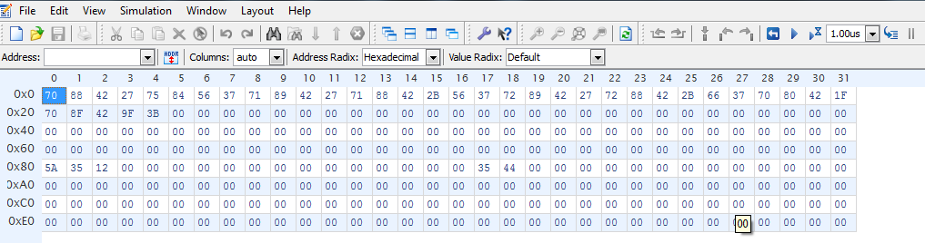

Appendix C

# Reports and Circuits from EDA Tools

## C.1 Reports (contents) from RTL (Pre-synthesis) Simulations (VCS or NCVERILOG)

Note-[VIRSIM_GONE] Virsim not supported

Virsim is no longer supported as warned in earlier VCS releases.

DVE has replaced Virsim as the default Debug GUI since VCS 2006.06 release.

The Virsim vcs switches -RI, -RIG, and -RPP are also no longer supported.

Please invoke DVE as follows:

Interactive Mode compile time: >vcs <other options> -R -gui

Interactive Mode run time: >simv <other optoins> -gui

Post Process Mode >dve &

Contact Synopsys VCS Support for more details: vcs_support@synopsys.com .

Chronologic VCS (TM)

Version I-2014.03-2 -- Sun Dec 7 22:12:04 2014

Copyright (c) 1991-2014 by Synopsys Inc.

ALL RIGHTS RESERVED

This program is proprietary and confidential information of Synopsys Inc.

and may be used and disclosed only as authorized in a license agreement

controlling such use and disclosure.

Parsing design file '/home/wa/wali9257/ee271/s8sp/data_block/reg_blocks/addr_reg.v'

Parsing design file '/home/wa/wali9257/ee271/s8sp/data_block/reg_blocks/data_reg.v'

Parsing design file '/home/wa/wali9257/ee271/s8sp/data_block/reg_blocks/flag_reg.v'

Parsing design file '/home/wa/wali9257/ee271/s8sp/data_block/reg_blocks/gen_reg.v'

Parsing design file '/home/wa/wali9257/ee271/s8sp/data_block/reg_blocks/local_ir_reg.v'

Parsing design file '/home/wa/wali9257/ee271/s8sp/data_block/reg_blocks/program_cnt_reg.v'

Parsing design file '/home/wa/wali9257/ee271/s8sp/data_block/alu_block/alu_block.v'

Parsing design file '/home/wa/wali9257/ee271/s8sp/data_block/alu_block/CLA8bit.v'

Parsing design file '/home/wa/wali9257/ee271/s8sp/data_block/alu_block/CLA_N_bit.v'

Parsing design file '/home/wa/wali9257/ee271/s8sp/data_block/data_block_top/data_block.v'

Parsing design file '/home/wa/wali9257/ee271/s8sp/ctrl_block/sys_controller.v'

Parsing design file '/home/wa/wali9257/ee271/s8sp/s8sp_top/s8sp.v'

Parsing design file '/home/wa/wali9257/ee271/s8sp/implementation/rtl_vcs/../../s8sp_tb/tb_s8sp.v'

Top Level Modules:

tb_s8sp

TimeScale is 1 ns / 1 ps

Starting vcs inline pass...

2 modules and 0 UDP read.

However, due to incremental compilation, no re-compilation is necessary.

rm -f _csrc*.so linux_scvhdl_*.so pre_vcsobj_*.so share_vcsobj_*.so

ld -m elf_i386 -shared -o .//../simv.daidir//_csrc0.so SIM_l.o 5NrI_d.o 5NrIB_d.o

ld -m elf_i386 -shared -o .//../simv.daidir//pre_vcsobj_1_1.so --whole-archive pre_vcsobj_1_1.a --no-whole-archive

if [ -x ../simv ]; then chmod -x ../simv; fi

g++ -o ../simv -m32 -m32 -Wl,-rpath-link=./ -Wl,-rpath='$ORIGIN'/simv.daidir/ -Wl,-rpath='$ORIGIN'/simv.daidir//scsim.db.dir _csrc0.so pre_vcsobj_1_1.so rmapats_mop.o rmapats.o rmar.o /apps/synopsys/VCSMX_NEW/linux/lib/libzerosoft_rt_stubs.so /apps/synopsys/VCSMX_NEW/linux/lib/libvirsim.so /apps/synopsys/VCSMX_NEW/linux/lib/librterrorinf.so /apps/synopsys/VCSMX_NEW/linux/lib/libsnpsmalloc.so /apps/synopsys/VCSMX_NEW/linux/lib/libvcsnew.so /apps/synopsys/VCSMX_NEW/linux/lib/libuclinative.so -Wl,-whole-archive /apps/synopsys/VCSMX_NEW/linux/lib/libvcsucli.so -Wl,-no-whole-archive /apps/synopsys/VCSMX_NEW/linux/lib/vcs_save_restore_new.o /apps/synopsys/VCSMX_NEW/linux/lib/ctype-stubs_32.a -ldl -lc -lm -lpthread -ldl

../simv up to date

CPU time: .067 seconds to compile + .011 seconds to elab + .072 seconds to link

-----------------------------------------------------------------------------

Chronologic VCS simulator copyright 1991-2014

Contains Synopsys proprietary information.

Compiler version I-2014.03-2; Runtime version I-2014.03-2; Dec 7 22:12 2014

0 mem[80]=15 mem[81]=35 mem[82]=12

510 mem[80]=5a mem[81]=35 mem[82]=12

1110 mem[80]=5a mem[81]=6a mem[82]=12

1710 mem[80]=5a mem[81]=6a mem[82]=32

2430 mem[80]=9f mem[81]=6a mem[82]=32

3030 mem[80]=9f mem[81]=9f mem[82]=32

3630 mem[80]=9f mem[81]=9f mem[82]=12

$finish called from file "/home/wa/wali9257/ee271/s8sp/implementation/rtl_vcs/../../s8sp_tb/tb_s8sp.v", line 128.

$finish at simulation time 4000000

V C S S i m u l a t i o n R e p o r t

Time: 4000000 ps

CPU Time: 0.140 seconds; Data structure size: 0.0Mb

Sun Dec 7 22:12:54 2014

**---------------------------------------------------------------------------------------------------------------------**

## C.2 Reports (contents) from Netlist (Post-synthesis) Simulations (VCS or NCVERILOG)

Chronologic VCS (TM)

Version I-2014.03-2 -- Sun Dec 7 23:21:23 2014

Copyright (c) 1991-2014 by Synopsys Inc.

ALL RIGHTS RESERVED

This program is proprietary and confidential information of Synopsys Inc.

and may be used and disclosed only as authorized in a license agreement

controlling such use and disclosure.

Parsing design file 's8sp_netlist.v'

Parsing design file 'tb_s8sp.v'

Parsing library directory file '/apps/toshiba/sjsu/verilog/tc240c/CAN2X1.tsbvlibp'

Parsing library directory file '/apps/toshiba/sjsu/verilog/tc240c/CAN2XL.tsbvlibp'

Parsing library directory file '/apps/toshiba/sjsu/verilog/tc240c/CAN3X2.tsbvlibp'

Parsing library directory file '/apps/toshiba/sjsu/verilog/tc240c/CAN3XL.tsbvlibp'

Parsing library directory file '/apps/toshiba/sjsu/verilog/tc240c/CANR11X1.tsbvlibp'

Parsing library directory file '/apps/toshiba/sjsu/verilog/tc240c/CANR11XL.tsbvlibp'

Parsing library directory file '/apps/toshiba/sjsu/verilog/tc240c/CANR1X1.tsbvlibp'

Parsing library directory file '/apps/toshiba/sjsu/verilog/tc240c/CANR1X2.tsbvlibp'

Parsing library directory file '/apps/toshiba/sjsu/verilog/tc240c/CANR1XL.tsbvlibp'

Parsing library directory file '/apps/toshiba/sjsu/verilog/tc240c/CANR2X1.tsbvlibp'

Parsing library directory file '/apps/toshiba/sjsu/verilog/tc240c/CANR2X2.tsbvlibp'

Parsing library directory file '/apps/toshiba/sjsu/verilog/tc240c/CANR2XL.tsbvlibp'

Parsing library directory file '/apps/toshiba/sjsu/verilog/tc240c/CAOR2X1.tsbvlibp'

Parsing library directory file '/apps/toshiba/sjsu/verilog/tc240c/CDLY1XL.tsbvlibp'

Parsing library directory file '/apps/toshiba/sjsu/verilog/tc240c/CENX1.tsbvlibp'

Parsing library directory file '/apps/toshiba/sjsu/verilog/tc240c/CENX2.tsbvlibp'

Parsing library directory file '/apps/toshiba/sjsu/verilog/tc240c/CENXL.tsbvlibp'

Parsing library directory file '/apps/toshiba/sjsu/verilog/tc240c/CEO3XL.tsbvlibp'

Parsing library directory file '/apps/toshiba/sjsu/verilog/tc240c/CEOX1.tsbvlibp'

Parsing library directory file '/apps/toshiba/sjsu/verilog/tc240c/CEOX2.tsbvlibp'

Parsing library directory file '/apps/toshiba/sjsu/verilog/tc240c/CEOXL.tsbvlibp'

Parsing library directory file '/apps/toshiba/sjsu/verilog/tc240c/CFD1QX1.tsbvlibp'

Parsing library directory file '/apps/toshiba/sjsu/verilog/tc240c/CFD1QX2.tsbvlibp'

Parsing library directory file '/apps/toshiba/sjsu/verilog/tc240c/CFD1QX4.tsbvlibp'

Parsing library directory file '/apps/toshiba/sjsu/verilog/tc240c/CFD1QXL.tsbvlibp'

Parsing library directory file '/apps/toshiba/sjsu/verilog/tc240c/CHA1X1.tsbvlibp'

Parsing library directory file '/apps/toshiba/sjsu/verilog/tc240c/CHA1XL.tsbvlibp'

Parsing library directory file '/apps/toshiba/sjsu/verilog/tc240c/CIVDX1.tsbvlibp'

Parsing library directory file '/apps/toshiba/sjsu/verilog/tc240c/CIVDX2.tsbvlibp'

Parsing library directory file '/apps/toshiba/sjsu/verilog/tc240c/CIVDXL.tsbvlibp'

Parsing library directory file '/apps/toshiba/sjsu/verilog/tc240c/CIVX1.tsbvlibp'

Parsing library directory file '/apps/toshiba/sjsu/verilog/tc240c/CIVX16.tsbvlibp'

Parsing library directory file '/apps/toshiba/sjsu/verilog/tc240c/CIVX2.tsbvlibp'

Parsing library directory file '/apps/toshiba/sjsu/verilog/tc240c/CIVX20.tsbvlibp'

Parsing library directory file '/apps/toshiba/sjsu/verilog/tc240c/CIVX3.tsbvlibp'

Parsing library directory file '/apps/toshiba/sjsu/verilog/tc240c/CIVX4.tsbvlibp'

Parsing library directory file '/apps/toshiba/sjsu/verilog/tc240c/CIVX8.tsbvlibp'

Parsing library directory file '/apps/toshiba/sjsu/verilog/tc240c/CIVXL.tsbvlibp'

Parsing library directory file '/apps/toshiba/sjsu/verilog/tc240c/CMXI2X1.tsbvlibp'

Parsing library directory file '/apps/toshiba/sjsu/verilog/tc240c/CMXI2X2.tsbvlibp'

Parsing library directory file '/apps/toshiba/sjsu/verilog/tc240c/CND2IX1.tsbvlibp'

Parsing library directory file '/apps/toshiba/sjsu/verilog/tc240c/CND2IX2.tsbvlibp'

Parsing library directory file '/apps/toshiba/sjsu/verilog/tc240c/CND2IX4.tsbvlibp'

Parsing library directory file '/apps/toshiba/sjsu/verilog/tc240c/CND2IXL.tsbvlibp'

Parsing library directory file '/apps/toshiba/sjsu/verilog/tc240c/CND2X1.tsbvlibp'

Parsing library directory file '/apps/toshiba/sjsu/verilog/tc240c/CND2X2.tsbvlibp'

Parsing library directory file '/apps/toshiba/sjsu/verilog/tc240c/CND2X4.tsbvlibp'

Parsing library directory file '/apps/toshiba/sjsu/verilog/tc240c/CND2XL.tsbvlibp'

Parsing library directory file '/apps/toshiba/sjsu/verilog/tc240c/CND3X1.tsbvlibp'

Parsing library directory file '/apps/toshiba/sjsu/verilog/tc240c/CND3X2.tsbvlibp'

Parsing library directory file '/apps/toshiba/sjsu/verilog/tc240c/CND3XL.tsbvlibp'

Parsing library directory file '/apps/toshiba/sjsu/verilog/tc240c/CND4X1.tsbvlibp'

Parsing library directory file '/apps/toshiba/sjsu/verilog/tc240c/CND4X2.tsbvlibp'

Parsing library directory file '/apps/toshiba/sjsu/verilog/tc240c/CNIVX1.tsbvlibp'

Parsing library directory file '/apps/toshiba/sjsu/verilog/tc240c/CNIVX4.tsbvlibp'

Parsing library directory file '/apps/toshiba/sjsu/verilog/tc240c/CNIVXL.tsbvlibp'

Parsing library directory file '/apps/toshiba/sjsu/verilog/tc240c/CNR2IX1.tsbvlibp'

Parsing library directory file '/apps/toshiba/sjsu/verilog/tc240c/CNR2IX2.tsbvlibp'

Parsing library directory file '/apps/toshiba/sjsu/verilog/tc240c/CNR2IX4.tsbvlibp'

Parsing library directory file '/apps/toshiba/sjsu/verilog/tc240c/CNR2IXL.tsbvlibp'

Parsing library directory file '/apps/toshiba/sjsu/verilog/tc240c/CNR2X1.tsbvlibp'

Parsing library directory file '/apps/toshiba/sjsu/verilog/tc240c/CNR2X2.tsbvlibp'

Parsing library directory file '/apps/toshiba/sjsu/verilog/tc240c/CNR2X4.tsbvlibp'

Parsing library directory file '/apps/toshiba/sjsu/verilog/tc240c/CNR2XL.tsbvlibp'

Parsing library directory file '/apps/toshiba/sjsu/verilog/tc240c/CNR3X1.tsbvlibp'

Parsing library directory file '/apps/toshiba/sjsu/verilog/tc240c/CNR3X4.tsbvlibp'

Parsing library directory file '/apps/toshiba/sjsu/verilog/tc240c/COND11X1.tsbvlibp'

Parsing library directory file '/apps/toshiba/sjsu/verilog/tc240c/COND1X1.tsbvlibp'

Parsing library directory file '/apps/toshiba/sjsu/verilog/tc240c/COND1XL.tsbvlibp'

Parsing library directory file '/apps/toshiba/sjsu/verilog/tc240c/COND2X1.tsbvlibp'

Parsing library directory file '/apps/toshiba/sjsu/verilog/tc240c/COND2X2.tsbvlibp'

Parsing library directory file '/apps/toshiba/sjsu/verilog/tc240c/COND2XL.tsbvlibp'

Parsing library directory file '/apps/toshiba/sjsu/verilog/tc240c/COND3X1.tsbvlibp'

Parsing library directory file '/apps/toshiba/sjsu/verilog/tc240c/COND3XL.tsbvlibp'

Parsing library directory file '/apps/toshiba/sjsu/verilog/tc240c/COND4CX1.tsbvlibp'

Parsing library directory file '/apps/toshiba/sjsu/verilog/tc240c/COND4CXL.tsbvlibp'

Parsing library directory file '/apps/toshiba/sjsu/verilog/tc240c/COR2X1.tsbvlibp'

Parsing library directory file '/apps/toshiba/sjsu/verilog/tc240c/COR2X2.tsbvlibp'

Parsing library directory file '/apps/toshiba/sjsu/verilog/tc240c/COR2XL.tsbvlibp'

Parsing library directory file '/apps/toshiba/sjsu/verilog/tc240c/CTSX2.tsbvlibp'

Parsing library directory file '/apps/toshiba/sjsu/verilog/tc240c/CTSX3.tsbvlibp'

Parsing library directory file '/apps/toshiba/sjsu/verilog/tc240c/CTSXL.tsbvlibp'

Parsing library directory file '/apps/toshiba/sjsu/verilog/tc240c/TMUX21INVprim.tsbvlibp'

Parsing library directory file '/apps/toshiba/sjsu/verilog/tc240c/tsbCFD1QX1.tsbvlibp'

Parsing library directory file '/apps/toshiba/sjsu/verilog/tc240c/tsbCFD1QX2.tsbvlibp'

Parsing library directory file '/apps/toshiba/sjsu/verilog/tc240c/tsbCFD1QX4.tsbvlibp'

Parsing library directory file '/apps/toshiba/sjsu/verilog/tc240c/tsbCFD1QXL.tsbvlibp'

Parsing library directory file '/apps/toshiba/sjsu/verilog/tc240c/TFDPNOprim.tsbvlibp'

Top Level Modules:

tb_s8sp

TimeScale is 1 ns / 1 ps

Starting vcs inline pass...

49 modules and 2 UDPs read.

However, due to incremental compilation, no re-compilation is necessary.

rm -f _csrc*.so linux_scvhdl_*.so pre_vcsobj_*.so share_vcsobj_*.so

ld -m elf_i386 -shared -o .//../simv.daidir//_csrc0.so SIM_l.o 5NrI_d.o 5NrIB_d.o

ld -m elf_i386 -shared -o .//../simv.daidir//pre_vcsobj_1_1.so --whole-archive pre_vcsobj_1_1.a --no-whole-archive

if [ -x ../simv ]; then chmod -x ../simv; fi

g++ -o ../simv -m32 -m32 -Wl,-rpath-link=./ -Wl,-rpath='$ORIGIN'/simv.daidir/ -Wl,-rpath='$ORIGIN'/simv.daidir//scsim.db.dir _csrc0.so pre_vcsobj_1_1.so rmapats_mop.o rmapats.o rmar.o /apps/synopsys/VCSMX_NEW/linux/lib/libzerosoft_rt_stubs.so /apps/synopsys/VCSMX_NEW/linux/lib/libvirsim.so /apps/synopsys/VCSMX_NEW/linux/lib/librterrorinf.so /apps/synopsys/VCSMX_NEW/linux/lib/libsnpsmalloc.so /apps/synopsys/VCSMX_NEW/linux/lib/libvcsnew.so /apps/synopsys/VCSMX_NEW/linux/lib/libuclinative.so -Wl,-whole-archive /apps/synopsys/VCSMX_NEW/linux/lib/libvcsucli.so -Wl,-no-whole-archive /apps/synopsys/VCSMX_NEW/linux/lib/vcs_save_restore_new.o /apps/synopsys/VCSMX_NEW/linux/lib/ctype-stubs_32.a -ldl -lm -lc -lpthread -ldl

../simv up to date

CPU time: .191 seconds to compile + .012 seconds to elab + .098 seconds to link + 2.477 seconds in simulation

Chronologic VCS simulator copyright 1991-2014

Contains Synopsys proprietary information.

Compiler version I-2014.03-2; Runtime version I-2014.03-2; Dec 7 23:16 2014

VCD+ Writer I-2014.03-2 Copyright (c) 1991-2014 by Synopsys Inc.

The file '/home/wa/wali9257/ee271/s8sp/implementation/netlist_vcs/inter.vpd' was opened successfully.

dve> run

0 mem[80]=05 mem[81]=25 mem[82]=54

198 mem[80]=zZ mem[81]=25 mem[82]=54

198 mem[80]=4a mem[81]=25 mem[82]=54

438 mem[80]=4a mem[81]=zZ mem[82]=54

438 mem[80]=4a mem[81]=5a mem[82]=54

678 mem[80]=4a mem[81]=5a mem[82]=zZ

678 mem[80]=4a mem[81]=5a mem[82]=f0

1086 mem[80]=zZ mem[81]=5a mem[82]=f0

1086 mem[80]=8f mem[81]=5a mem[82]=f0

1326 mem[80]=8f mem[81]=zZ mem[82]=f0

1326 mem[80]=8f mem[81]=8f mem[82]=f0

1566 mem[80]=8f mem[81]=8f mem[82]=zZ

1566 mem[80]=8f mem[81]=8f mem[82]=54

1974 mem[80]=zZ mem[81]=8f mem[82]=54

1974 mem[80]=d4 mem[81]=8f mem[82]=54

$finish called from file "tb_s8sp.v", line 128.

$finish at simulation time 2000000

Simulation complete, time is 2000000 ps.

V C S S i m u l a t i o n R e p o r t

Time: 2000000 ps

CPU Time: 0.040 seconds; Data structure size: 0.2Mb

Sun Dec 7 23:17:17 2014

## C.3 Reports (contents) from Synthesis (Design Compiler)

### C.3.1 Area Report

****************************************

Report : area

Design : s8sp

Version: C-2009.06-SP5

Date : Sun Dec 7 23:43:24 2014

****************************************

Library(s) Used:

tc240c (File: /apps/toshiba/sjsu/synopsys/tc240c/tc240c.db_WCCOM25)

Number of ports: 20

Number of nets: 49

Number of cells: 2

Number of references: 2

Combinational area: 863.500000

Noncombinational area: 464.500000

Net Interconnect area: undefined (No wire load specified)

Total cell area: 1328.000000

Total area: undefined

1

### C.3.2 Power Report

Loading db file '/apps/toshiba/sjsu/synopsys/tc240c/tc240c.db_WCCOM25'

Loading db file '/apps/toshiba/sjsu/synopsys/tc240c/tc240c.db_BCCOM25'

Warning: Main library 'tc240c' does not specify the following unit required for power: 'Leakage Power'. (PWR-424)

Information: Propagating switching activity (low effort zero delay simulation). (PWR-6)

****************************************

Report : power

-analysis_effort low

Design : s8sp

Version: C-2009.06-SP5

Date : Sun Dec 7 23:43:25 2014

****************************************

Library(s) Used:

tc240c (File: /apps/toshiba/sjsu/synopsys/tc240c/tc240c.db_WCCOM25)

Operating Conditions: WCCOM25 Library: tc240c

Wire Load Model Mode: top

Global Operating Voltage = 2.3

Power-specific unit information :

Voltage Units = 1V

Capacitance Units = 1.000000ff

Time Units = 1ns

Dynamic Power Units = 1uW (derived from V,C,T units)

Leakage Power Units = Unitless

Cell Internal Power = 1.8601 mW (95%)

Net Switching Power = 100.8653 uW (5%)

---------

Total Dynamic Power = 1.9610 mW (100%)

Cell Leakage Power = 0.0000

1

-----------------------------------------------------------------------------

### C.3.3 Timing Report

****************************************

Report : timing

-path full

-delay max

-group clk

-max_paths 10

Design : s8sp

Version: C-2009.06-SP5

Date : Sun Dec 7 23:43:24 2014

****************************************

Operating Conditions: WCCOM25 Library: tc240c

Wire Load Model Mode: top

Startpoint: reset (input port)

Endpoint: u1_data_block_instantiation/u1_ir_instance/ir_out_reg[4]

(rising edge-triggered flip-flop clocked by clk)

Path Group: clk

Path Type: max

Point Incr Path

--------------------------------------------------------------------------

input external delay 0.00 0.00 f

reset (in) 0.00 0.00 f

u1_data_block_instantiation/reset (data_block) 0.00 0.00 f

u1_data_block_instantiation/u1_ir_instance/reset (local_ir_reg)

0.00 0.00 f

u1_data_block_instantiation/u1_ir_instance/U2/Z (CIVX16)

0.04 0.04 r

u1_data_block_instantiation/u1_ir_instance/U3/Z (CND2X2)

0.11 0.15 f

u1_data_block_instantiation/u1_ir_instance/U5/Z (CND2X1)

0.07 0.22 r

u1_data_block_instantiation/u1_ir_instance/U4/Z (COND1XL)

0.17 0.38 f

u1_data_block_instantiation/u1_ir_instance/ir_out_reg[4]/D (CFD1QX4)

0.00 0.38 f

data arrival time 0.38

max_delay 1.00 1.00

clock uncertainty -0.25 0.75

library setup time -0.36 0.39

data required time 0.39

--------------------------------------------------------------------------

data required time 0.39

data arrival time -0.38

--------------------------------------------------------------------------

slack (MET) 0.00

Startpoint: reset (input port)

Endpoint: u1_data_block_instantiation/u1_gr_instance/gr_on_data_reg[6]

(rising edge-triggered flip-flop clocked by clk)

Path Group: clk

Path Type: max

Point Incr Path

--------------------------------------------------------------------------

input external delay 0.00 0.00 r

reset (in) 0.00 0.00 r

u1_data_block_instantiation/reset (data_block) 0.00 0.00 r

u1_data_block_instantiation/u1_gr_instance/reset (gen_reg)

0.00 0.00 r

u1_data_block_instantiation/u1_gr_instance/U11/Z (CIVX3)

0.04 0.04 f

u1_data_block_instantiation/u1_gr_instance/U26/Z (CND3XL)

0.14 0.18 r

u1_data_block_instantiation/u1_gr_instance/U32/Z (COND3X1)

0.21 0.39 f

u1_data_block_instantiation/u1_gr_instance/gr_on_data_reg[6]/D (CFD1QX2)

0.00 0.39 f

data arrival time 0.39

max_delay 1.00 1.00

clock uncertainty -0.25 0.75

library setup time -0.36 0.39

data required time 0.39

--------------------------------------------------------------------------

data required time 0.39

data arrival time -0.39

--------------------------------------------------------------------------

slack (MET) 0.00

Startpoint: dat[3] (input port)

Endpoint: u1_data_block_instantiation/u1_gr_instance/gr_on_data_reg[3]

(rising edge-triggered flip-flop clocked by clk)

Path Group: clk

Path Type: max

Point Incr Path

--------------------------------------------------------------------------

input external delay 0.00 0.00 f

dat[3] (inout) 0.00 0.00 f

u1_data_block_instantiation/data_bus[3] (data_block)

0.00 0.00 f

u1_data_block_instantiation/u1_gr_instance/data_on_gr[3] (gen_reg)

0.00 0.00 f

u1_data_block_instantiation/u1_gr_instance/U13/Z1 (CIVDX1)

0.12 0.12 f

u1_data_block_instantiation/u1_gr_instance/U20/Z (CAOR2X1)

0.28 0.40 f

u1_data_block_instantiation/u1_gr_instance/gr_on_data_reg[3]/D (CFD1QX2)

0.00 0.40 f

data arrival time 0.40

max_delay 1.00 1.00

clock uncertainty -0.25 0.75

library setup time -0.35 0.40

data required time 0.40

--------------------------------------------------------------------------

data required time 0.40

data arrival time -0.40

--------------------------------------------------------------------------

slack (MET) 0.00

Startpoint: reset (input port)

Endpoint: u1_data_block_instantiation/u1_gr_instance/gr_on_data_reg[4]

(rising edge-triggered flip-flop clocked by clk)

Path Group: clk

Path Type: max

Point Incr Path

--------------------------------------------------------------------------

input external delay 0.00 0.00 f

reset (in) 0.00 0.00 f

u1_data_block_instantiation/reset (data_block) 0.00 0.00 f

u1_data_block_instantiation/u1_gr_instance/reset (gen_reg)

0.00 0.00 f

u1_data_block_instantiation/u1_gr_instance/U18/Z (COR2X1)

0.24 0.24 f

u1_data_block_instantiation/u1_gr_instance/U30/Z (COND3X1)

0.17 0.42 r

u1_data_block_instantiation/u1_gr_instance/gr_on_data_reg[4]/D (CFD1QX1)

0.00 0.42 r

data arrival time 0.42

max_delay 1.00 1.00

clock uncertainty -0.25 0.75

library setup time -0.33 0.42

data required time 0.42

--------------------------------------------------------------------------

data required time 0.42

data arrival time -0.42

--------------------------------------------------------------------------

slack (MET) 0.00

Startpoint: reset (input port)

Endpoint: u1_data_block_instantiation/u1_flag_reg_instance/flag_reg_reg[1]

(rising edge-triggered flip-flop clocked by clk)

Path Group: clk

Path Type: max

Point Incr Path

--------------------------------------------------------------------------

input external delay 0.00 0.00 f

reset (in) 0.00 0.00 f

u1_data_block_instantiation/reset (data_block) 0.00 0.00 f

u1_data_block_instantiation/u1_flag_reg_instance/reset (flag_reg)

0.00 0.00 f

u1_data_block_instantiation/u1_flag_reg_instance/U5/Z (CIVX12)

0.04 0.04 r

u1_data_block_instantiation/u1_flag_reg_instance/U12/Z (CND2X2)

0.10 0.14 f

u1_data_block_instantiation/u1_flag_reg_instance/U15/Z (CNR2IX1)

0.12 0.25 r

u1_data_block_instantiation/u1_flag_reg_instance/U14/Z (CND2IX1)

0.18 0.43 r

u1_data_block_instantiation/u1_flag_reg_instance/flag_reg_reg[1]/D (CFD1QX1)

0.00 0.43 r

data arrival time 0.43

max_delay 1.00 1.00

clock uncertainty -0.25 0.75

library setup time -0.32 0.43

data required time 0.43

--------------------------------------------------------------------------

data required time 0.43

data arrival time -0.43

--------------------------------------------------------------------------

slack (MET) 0.00

Startpoint: reset (input port)

Endpoint: u1_data_block_instantiation/u1_ir_instance/ir_out_reg[6]

(rising edge-triggered flip-flop clocked by clk)

Path Group: clk

Path Type: max

Point Incr Path

--------------------------------------------------------------------------

input external delay 0.00 0.00 f

reset (in) 0.00 0.00 f

u1_data_block_instantiation/reset (data_block) 0.00 0.00 f

u1_data_block_instantiation/u1_ir_instance/reset (local_ir_reg)

0.00 0.00 f

u1_data_block_instantiation/u1_ir_instance/U2/Z (CIVX16)

0.04 0.04 r

u1_data_block_instantiation/u1_ir_instance/U6/Z (CND2X2)

0.11 0.15 f

u1_data_block_instantiation/u1_ir_instance/U12/Z (CND2XL)

0.09 0.25 r

u1_data_block_instantiation/u1_ir_instance/U11/Z (CND2XL)

0.14 0.39 f

u1_data_block_instantiation/u1_ir_instance/ir_out_reg[6]/D (CFD1QX4)

0.00 0.39 f

data arrival time 0.39

max_delay 1.00 1.00

clock uncertainty -0.25 0.75

library setup time -0.36 0.39

data required time 0.39

--------------------------------------------------------------------------

data required time 0.39

data arrival time -0.39

--------------------------------------------------------------------------

slack (MET) 0.00

Startpoint: reset (input port)

Endpoint: u1_data_block_instantiation/u1_flag_reg_instance/flag_reg_reg[3]

(rising edge-triggered flip-flop clocked by clk)

Path Group: clk

Path Type: max

Point Incr Path

--------------------------------------------------------------------------

input external delay 0.00 0.00 r

reset (in) 0.00 0.00 r

u1_data_block_instantiation/reset (data_block) 0.00 0.00 r

u1_data_block_instantiation/u1_flag_reg_instance/reset (flag_reg)

0.00 0.00 r

u1_data_block_instantiation/u1_flag_reg_instance/U2/Z (CIVX20)

0.03 0.03 f

u1_data_block_instantiation/u1_flag_reg_instance/U9/Z (CND2IX4)

0.06 0.09 r

u1_data_block_instantiation/u1_flag_reg_instance/U10/Z (CND2X2)

0.08 0.16 f

u1_data_block_instantiation/u1_flag_reg_instance/U13/Z (COND11X1)

0.24 0.40 r

u1_data_block_instantiation/u1_flag_reg_instance/flag_reg_reg[3]/D (CFD1QX2)

0.00 0.40 r

data arrival time 0.40

max_delay 1.00 1.00

clock uncertainty -0.25 0.75

library setup time -0.35 0.40

data required time 0.40

--------------------------------------------------------------------------

data required time 0.40

data arrival time -0.40

--------------------------------------------------------------------------

slack (MET) 0.00

Startpoint: dat[5] (input port)

Endpoint: u1_data_block_instantiation/u1_ar_instance/ar_on_bus_reg[5]

(rising edge-triggered flip-flop clocked by clk)

Path Group: clk

Path Type: max

Point Incr Path

--------------------------------------------------------------------------

input external delay 0.00 0.00 r

dat[5] (inout) 0.00 0.00 r

u1_data_block_instantiation/data_bus[5] (data_block)

0.00 0.00 r

u1_data_block_instantiation/U9/Z (CIVX8) 0.03 0.03 f

u1_data_block_instantiation/U71/Z (CIVX4) 0.07 0.10 r

u1_data_block_instantiation/u1_ar_instance/data_on_ar[5] (addr_reg)

0.00 0.10 r

u1_data_block_instantiation/u1_ar_instance/U10/Z (CIVXL)

0.10 0.20 f

u1_data_block_instantiation/u1_ar_instance/U9/Z (COND2X1)

0.20 0.40 r

u1_data_block_instantiation/u1_ar_instance/ar_on_bus_reg[5]/D (CFD1QX2)

0.00 0.40 r

data arrival time 0.40

max_delay 1.00 1.00

clock uncertainty -0.25 0.75

library setup time -0.34 0.41

data required time 0.41

--------------------------------------------------------------------------

data required time 0.41

data arrival time -0.40

--------------------------------------------------------------------------

slack (MET) 0.01

Startpoint: dat[5] (input port)

Endpoint: u1_data_block_instantiation/u1_dr_instance/dr_on_data_reg[5]

(rising edge-triggered flip-flop clocked by clk)

Path Group: clk

Path Type: max

Point Incr Path

--------------------------------------------------------------------------

input external delay 0.00 0.00 r

dat[5] (inout) 0.00 0.00 r

u1_data_block_instantiation/data_bus[5] (data_block)

0.00 0.00 r

u1_data_block_instantiation/U9/Z (CIVX8) 0.03 0.03 f

u1_data_block_instantiation/U71/Z (CIVX4) 0.07 0.10 r

u1_data_block_instantiation/u1_dr_instance/data_on_dr[5] (data_reg)

0.00 0.10 r

u1_data_block_instantiation/u1_dr_instance/U16/Z (CIVXL)

0.10 0.20 f

u1_data_block_instantiation/u1_dr_instance/U15/Z (COND2X1)

0.20 0.40 r

u1_data_block_instantiation/u1_dr_instance/dr_on_data_reg[5]/D (CFD1QX2)

0.00 0.40 r

data arrival time 0.40

max_delay 1.00 1.00

clock uncertainty -0.25 0.75

library setup time -0.34 0.41

data required time 0.41

--------------------------------------------------------------------------

data required time 0.41

data arrival time -0.40

--------------------------------------------------------------------------

slack (MET) 0.01

Startpoint: reset (input port)

Endpoint: u1_data_block_instantiation/u1_ir_instance/ir_out_reg[5]

(rising edge-triggered flip-flop clocked by clk)

Path Group: clk

Path Type: max

Point Incr Path

--------------------------------------------------------------------------

input external delay 0.00 0.00 f

reset (in) 0.00 0.00 f

u1_data_block_instantiation/reset (data_block) 0.00 0.00 f

u1_data_block_instantiation/u1_ir_instance/reset (local_ir_reg)

0.00 0.00 f

u1_data_block_instantiation/u1_ir_instance/U2/Z (CIVX16)

0.04 0.04 r

u1_data_block_instantiation/u1_ir_instance/U6/Z (CND2X2)

0.11 0.15 f

u1_data_block_instantiation/u1_ir_instance/U22/Z (CND2X1)

0.08 0.24 r

u1_data_block_instantiation/u1_ir_instance/U7/Z (COND1X1)

0.14 0.38 f

u1_data_block_instantiation/u1_ir_instance/ir_out_reg[5]/D (CFD1QX4)

0.00 0.38 f

data arrival time 0.38

max_delay 1.00 1.00

clock uncertainty -0.25 0.75

library setup time -0.36 0.39

data required time 0.39

--------------------------------------------------------------------------

data required time 0.39

data arrival time -0.38

--------------------------------------------------------------------------

slack (MET) 0.01

1

## C.4 Screenshot Circuits from Synthesis (Design Compiler)

### C.4.1 TopLevel Schematic of the design

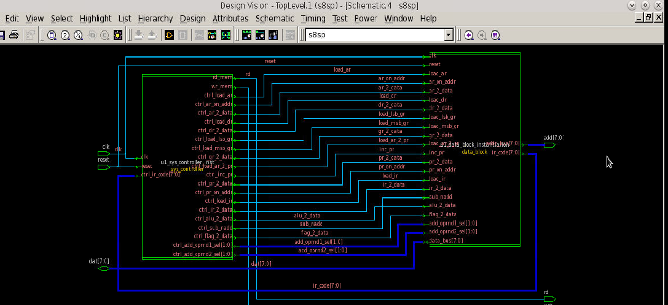

### C.4.2 Controller Schematic

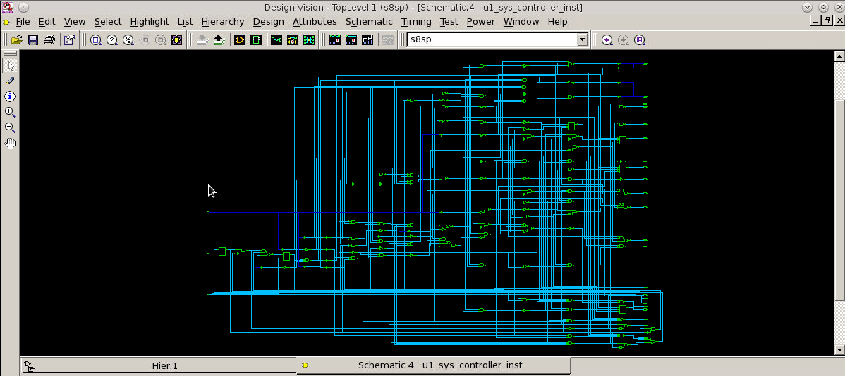

### C.4.3 Data_Block Schematic

