**SVKM'S NMIM’S Nilkamal School of Mathematics, Applied Statistics & Analytics**

**Master of Science (Data Science)**

**To configure Amazon Simple Storage Service (Amazon S3)**

**Writeup:**

**STORAGE AS A SERVICE S3:**

Storage as a Service (STaaS) is a cloud computing model that enables businesses and individuals to store, manage, and access data remotely over the internet. Instead of maintaining physical storage infrastructure on-premises, users can leverage third-party cloud service providers to store their data securely in off-site data centers.

**Key characteristics of Storage as a Service include:**

Scalability: STaaS offers scalable storage solutions, allowing users to increase or decrease storage capacity based on their needs without significant upfront investments in hardware or infrastructure.

Cost-Effectiveness: Users typically pay for STaaS on a subscription or pay-as-you-go basis, which can be more cost-effective than purchasing and maintaining on-premises storage infrastructure. This model eliminates the need for upfront capital expenditure and reduces operational costs associated with hardware maintenance and upgrades.

Accessibility: Data stored in the cloud can be accessed from anywhere with an internet connection, providing flexibility and enabling remote collaboration among users in different locations.

Reliability and Redundancy: Reputable STaaS providers often offer robust data redundancy and backup mechanisms to ensure data durability and availability. Data replication across multiple geographically dispersed data centers helps mitigate the risk of data loss due to hardware failures, disasters, or other unforeseen events.

Security: STaaS providers employ various security measures, including encryption, access controls, and compliance certifications, to protect sensitive data from unauthorized access, data breaches, and cyber threats.

Management and Maintenance: STaaS providers handle the management, maintenance, and upgrades of the underlying storage infrastructure, freeing users from the administrative burden of managing storage hardware and software.

Integration: Many STaaS solutions offer seamless integration with other cloud services, applications, and workflows, enabling users to leverage their existing tools and environments.

Overall, Storage as a Service offers a flexible, cost-effective, and reliable solution for storing and managing data in the cloud, making it an attractive option for businesses of all sizes looking to streamline their storage infrastructure and optimize resource utilization.

**USECASES:**

Static Content Hosting: Amazon S3 can host static website content, such as HTML, CSS, JavaScript files, images, and videos. Users can upload their website assets directly to an S3 bucket, making them accessible via unique URLs.

Cost-Effective: Hosting a static website on Amazon S3 is cost-effective, as users only pay for the storage used and data transfer out of the S3 bucket. There are no charges for requests made to the website, making it suitable for low-traffic websites or applications.

Scalability: S3 automatically scales to accommodate increasing traffic and storage requirements. Users do not need to worry about provisioning or managing servers; Amazon S3 handles the scalability aspects transparently.

High Availability and Durability: Amazon S3 provides high availability and durability for hosted content. S3 stores data across multiple data centers within a region, ensuring redundancy and fault tolerance. This means that static websites hosted on S3 benefit from reliable and consistent performance.

Content Delivery: Users can configure Amazon CloudFront, AWS's content delivery network (CDN), to distribute website content globally with low latency and high transfer speeds. By integrating S3 with CloudFront, users can deliver website assets efficiently to users worldwide.

Security: Amazon S3 offers various security features, including encryption at rest and in transit, access control policies, and integration with AWS Identity and Access Management (IAM). Users can secure their static websites and restrict access to specific users or groups.

Versioning and Lifecycle Policies: S3 supports versioning, allowing users to retain multiple versions of objects and recover them if needed. Additionally, users can define lifecycle policies to automatically transition or expire objects based on predefined rules, helping manage storage costs effectively.

**STEPS FOR S3:**

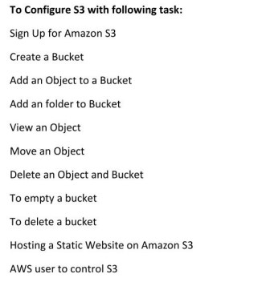

Step 1 : To create S3 bucket for storing objects that is files and folders.

Select Storage service and click on S3

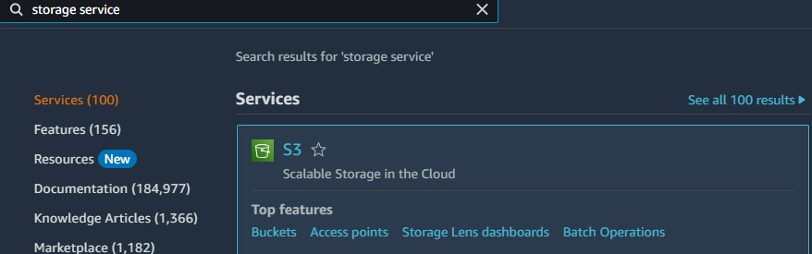



Do General configuration :

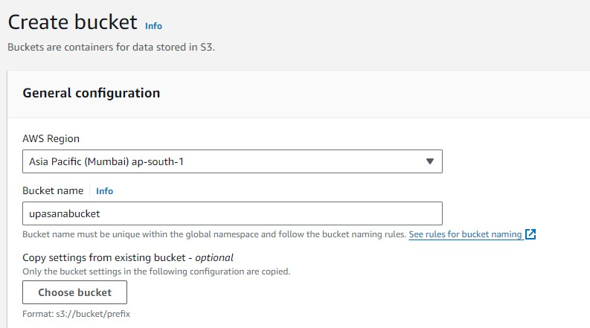

Rest keep same as follows:

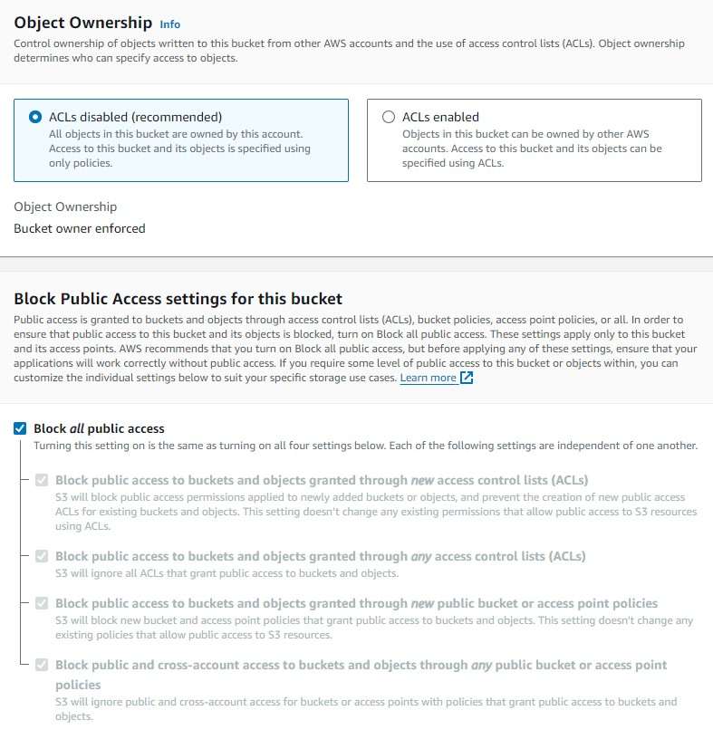

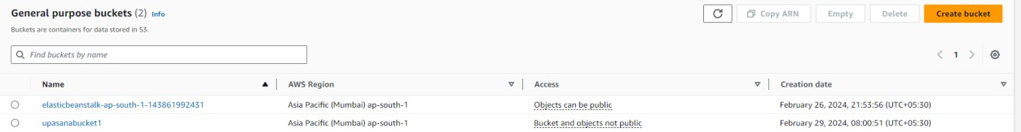

Select the upasanabucket1

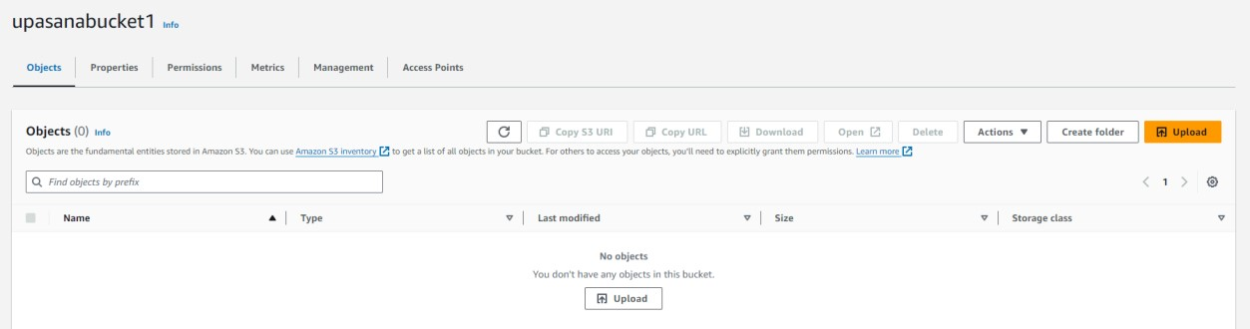

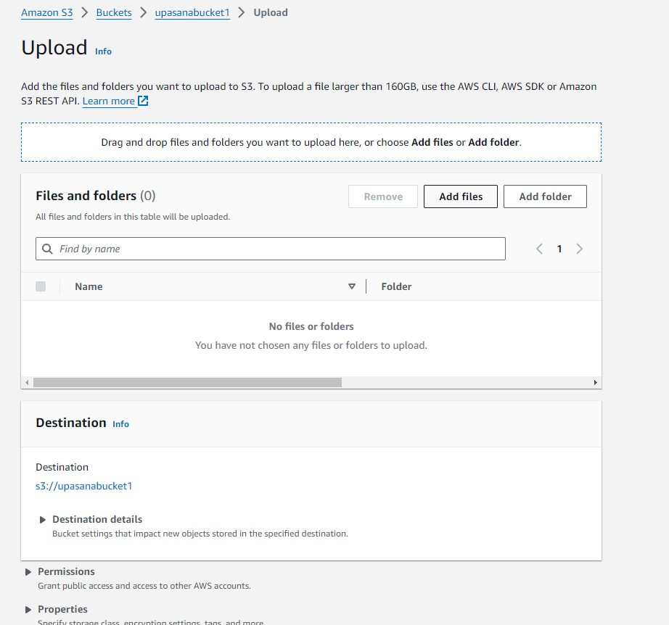

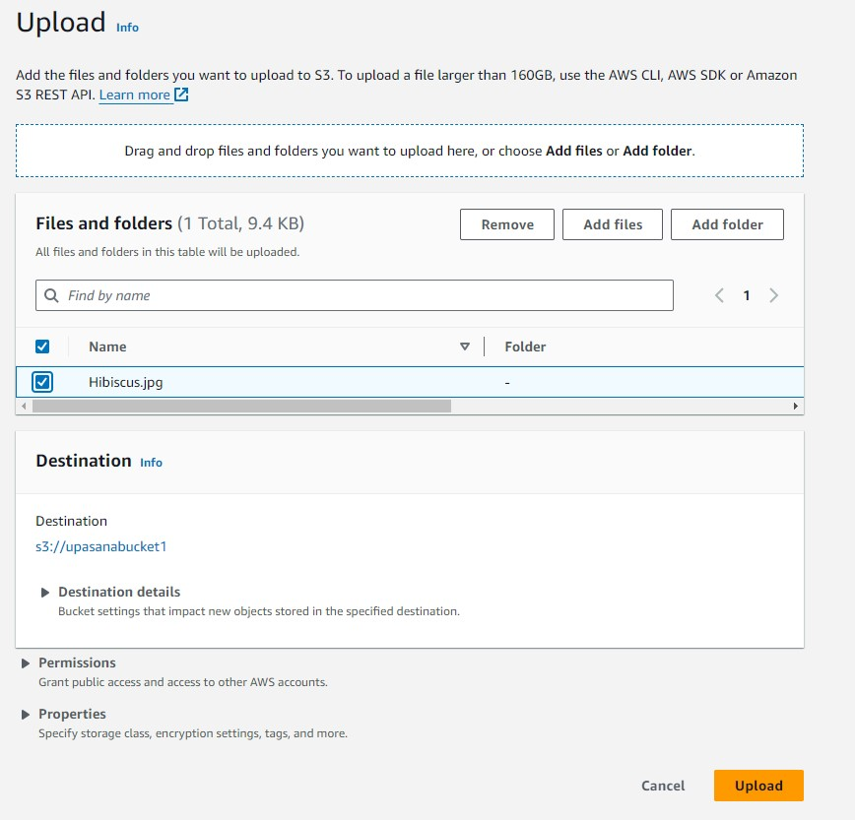



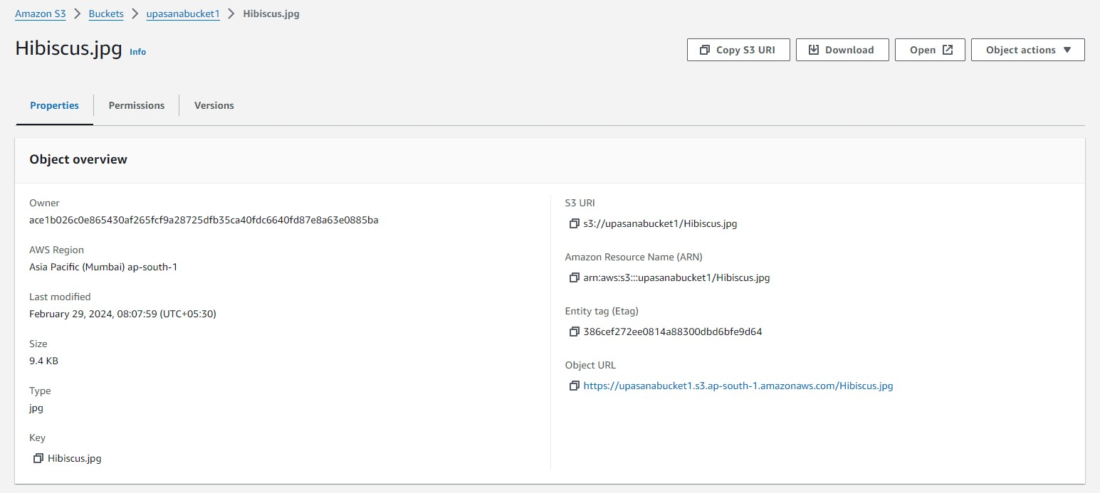

Click on Open button to see

To see the url



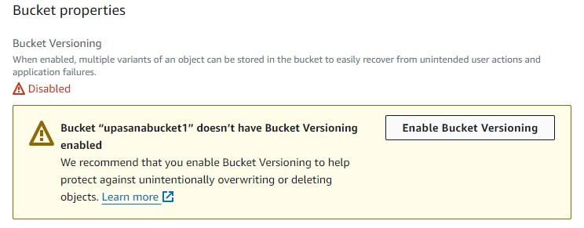

Enable Bucket Versioning

Go to permissions

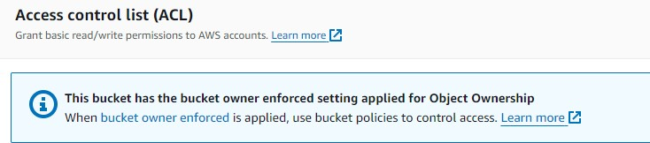

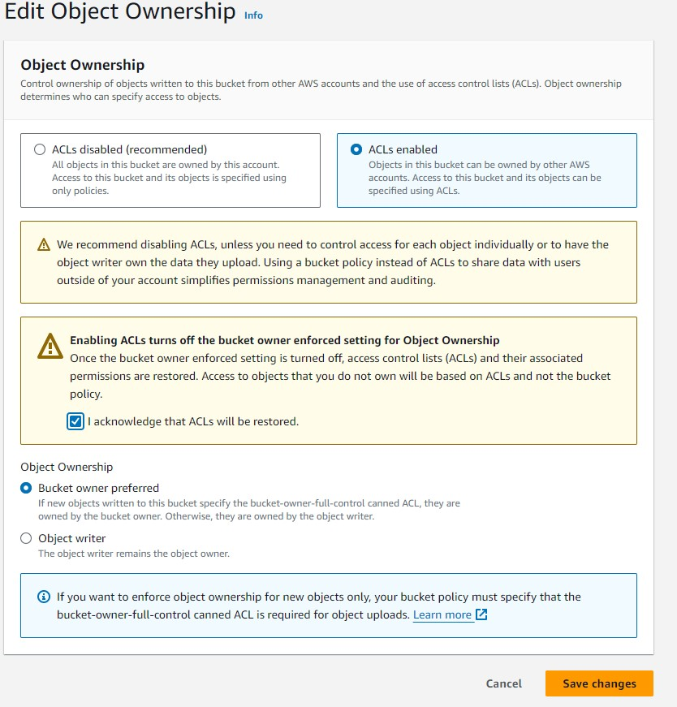

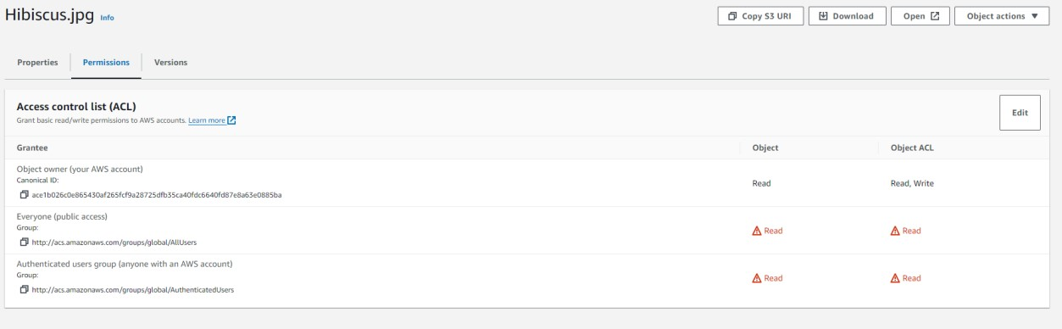



url : <https://upasanabucket1.s3.ap-south-1.amazonaws.com/Hibiscus.jpg>

**Static website**

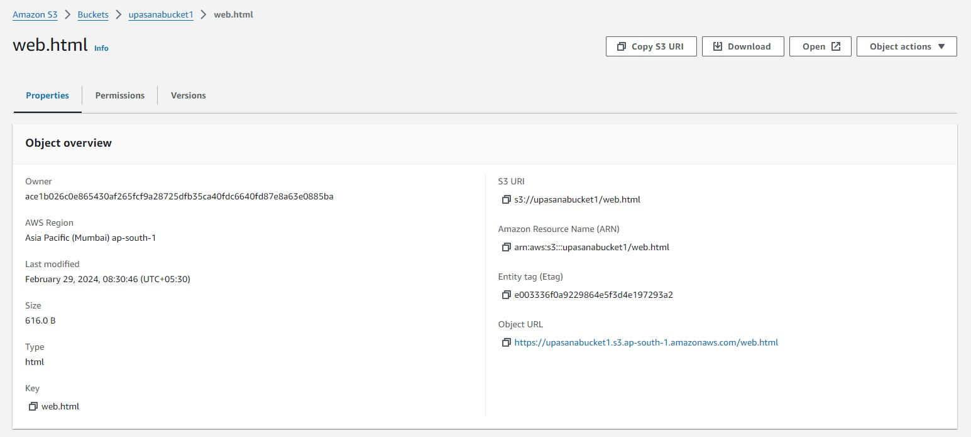



url : <https://upasanabucket1.s3.ap-south-1.amazonaws.com/web.html>

Go to google , bootstrap search buttons , and copy paste file in html

<html>

<div class="btn-group" role="group" aria-label="Basic radio toggle button group">

<input type="radio" class="btn-check" name="btnradio" id="btnradio1" autocomplete="off" checked>

<label class="btn btn-outline-primary" for="btnradio1">Radio 1</label>

<input type="radio" class="btn-check" name="btnradio" id="btnradio2" autocomplete="off">

<label class="btn btn-outline-primary" for="btnradio2">Radio 2</label>

<input type="radio" class="btn-check" name="btnradio" id="btnradio3" autocomplete="off">

<label class="btn btn-outline-primary" for="btnradio3">Radio 3</label> </div>

</html>