

TEACHTRACK

Project Report submitted in partial fulfillment of the requirements for the award of the degree of

**BACHELOR OF COMPUTER APPLICATIONS (BCA)**

*Submitted By*

**PAUL STEPHEN**

**21BCAD46**

Under the guidance of

**Dr. REVATHY V R**

**DEPARTMENT OF COMPUTER SCIENCE (UG) BCA PROGRAMME**

**KRISTU JAYANTI COLLEGE (Autonomous) K. Narayanapura, Kothanur P.O., Bengaluru – 560077**



**DEPARTMENT OF COMPUTER SCIENCE (UG)**

**CERTIFICATE OF COMPLETION**

This is to certify that the project entitled “**TEACHTRACK**” has been satisfactorily completed by **PAUL STEPHEN, 21BCAD46** in partial fulfillment of the award of the Bachelor of Computer Applications degree requirements prescribed by Kristu Jayanti College (Autonomous) Bengaluru (Affiliated to Bengaluru University) during the academic year 2023 – 24.

***Internal Guide Head of the Department***

***Valued by Examiners***

***1:*** ***Centre: Kristu Jayanti College***

***2:*** ***Date:***



**DECLARATION**

I, **PAUL STEPHEN (21BCAD46)** hereby declare that the project work entitled “**TEACHTRACK**” is an original project work carried out by me, under the guidance of **Dr. REVATHY V R.**

This project work has not been submitted earlier either to any University / Institution or any other body for the fulfillment of the requirement of a course of study.

Signature

PAUL STEPHEN 21BCAD46

Place: Bengaluru Date:

**ACKNOWLEDGEMENT**

*“The success is the result of preparation, hard work, and learning from failure*.”

It’s my duty to acknowledge and thank the individuals who has contributed to the successful completion of the project.

I take this opportunity to express my profound and wholehearted thanks to **Rev**. **Fr. Dr. Augustine George, Principal** and **Rev. Fr. Dr. Lijo P Thomas**, **Vice Principal** and **Chief Financial Officer, Kristu Jayanti College, Bangalore**.

I am deeply grateful for the invaluable support and encouragement provided by **Dean Dr. Calistus Jude AL** throughout this journey. His steadfast guidance has been instrumental in shaping my academic path, and I am sincerely appreciative of his contributions to my development. I also extend my heartfelt thanks to our beloved **Head of the Department, Prof. Sevuga Pandian A, and Programme Coordinator Dr. Sasikumar V R,** for their invaluable guidance and support. Additionally, I wish to express my deep gratitude to **Dr. Revathy V R**, my mentor and guide, whose mentorship and profound insights have greatly contributed to my growth and learning journey. Your willingness to share expertise and offer constructive feedback has enriched my learning experience immensely.

It is my duty to express my thanks to all Teaching and Non-Teaching Staff members of Computer science department who offered me help directly or indirectly by their suggestions. The successful completion of my project would not have been possible without my parent’s

Sacrifice, guidance, and prayers. I take this opportunity to thank everyone for their continuous Encouragement. I convey my thankfulness to all my friends who were with me to share my happiness and agony.

Last but not the least I thank almighty God for giving me strength and good health throughout my project and enabling me to complete it successfully.

**Table of Contents**

1. Project Synopsis 1-2
   1. Purpose 1
   2. Goals 1
   3. Intended Audience 2
2. Project Objectives 3
3. Project Outline 4
   1. Modules 4
   2. Flow Diagram 5-6
   3. Context Diagram………………………………………………………………………....6
4. Technologies Used 7-12
5. Screenshots 13-14
6. Project Features 15 -16
7. User Guide 17
8. Conclusion 18
9. References 19

# Project Synopsis

TeachTrack is a comprehensive mobile application designed to streamline the process of tracking teacher attendance in educational institutions. Developed using Kotlin programming language and Firebase backend, TeachTrack offers a user-friendly interface and robust functionality to effectively manage attendance records, facilitate communication, and enhance accountability among educators.

## Purpose:

**TeachTrack serves the following key purposes:**

Efficient Attendance Management: Simplifies the process of recording teacher attendance, saving time and reducing administrative burden.

Enhanced Communication: Facilitates seamless communication between teachers and administrative staff regarding attendance-related matters.

Accountability: Promotes accountability among educators by providing transparent access to attendance records and generating insightful reports.

Data Analysis: Enables educational institutions to analyze attendance trends and identify areas for improvement through comprehensive reports.

User Convenience: Offers a user-friendly interface and intuitive functionality to ensure ease of use for teachers and administrative personnel.

Modernization of Processes: Embraces mobile technology and cloud computing to modernize traditional attendance tracking methods, fostering efficiency and accuracy.

## Goals:

Automate Attendance Recording: Implement a system that automates the process of recording teacher attendance, reducing manual effort and minimizing errors.

Enhance User Experience: Develop a user-friendly interface that provides a seamless experience for teachers and administrative staff, promoting ease of use and efficiency.

Improve Communication: Foster better communication between teachers and administrative personnel regarding attendance-related matters, ensuring transparency and accountability.

Generate Insightful Reports: Create robust reporting functionality to analyze attendance trends, identify patterns, and make data-driven decisions to optimize organizational processes.

Ensure Data Security: Implement stringent security measures to protect sensitive attendance data, maintaining confidentiality and integrity throughout the system.

Facilitate Growth and Scalability: Design the application architecture to accommodate future growth and scalability, allowing for easy expansion and adaptation to changing needs.

Promote Adoption and Integration: Encourage widespread adoption of TeachTrack among educational institutions and seamlessly integrate it into existing workflows and systems.

Continuous Improvement: Commit to ongoing refinement and enhancement of TeachTrack based on user feedback, technological advancements, and evolving industry standards, ensuring its relevance and effectiveness over time.

## Intended Audience:

Educational Administrators: Principals, school administrators, and department heads who oversee teacher management and attendance tracking in educational institutions.

Teachers: Educators responsible for teaching classes and maintaining regular attendance, who will directly interact with TeachTrack to mark their attendance and access attendance records.

Administrative Staff: Personnel involved in administrative tasks such as managing teacher profiles, generating reports, and handling registration processes within educational institutions.

Technology Coordinators: Individuals responsible for implementing and managing technology solutions within educational institutions, who may oversee the deployment and maintenance of TeachTrack.

Educational Consultants: Professionals who provide guidance and support to educational institutions on improving processes and implementing technology solutions, including attendance management systems like TeachTrack.

Students (Indirect Audience): While not the primary users, students may indirectly benefit from TeachTrack as it ensures consistent teacher presence, which contributes to a conducive learning environment.

# Project Objectives

TeachTrack aims to revolutionize teacher attendance management in educational institutions by providing a comprehensive mobile application developed using Kotlin and Firebase backend. The project's objectives are diverse and focused on optimizing attendance tracking processes while ensuring user convenience, data security, and compliance with industry standards.

Automate Attendance Tracking: The project seeks to automate the process of recording teacher attendance, reducing manual effort and errors in attendance management.

Enhance Accessibility: With a user-friendly mobile interface, TeachTrack enables teachers to conveniently mark attendance and access records anytime, anywhere, using their smartphones.

Ensure Data Accuracy and Integrity: Measures are in place to maintain the accuracy and integrity of attendance data, ensuring reliability in reporting and decision-making.

Facilitate Communication: TeachTrack includes communication features to enable seamless interaction between teachers and administrative staff regarding attendance-related matters, fostering transparency and accountability.

Generate Comprehensive Reports: The application generates insightful reports on attendance trends, providing administrators with valuable insights for strategic decision-making and process optimization.

Ensure Security and Privacy: Robust security measures are implemented to protect sensitive attendance data, ensuring compliance with data privacy regulations and maintaining user privacy.

Promote User Adoption: Engaging features and comprehensive support services are provided to encourage widespread adoption of TeachTrack among teachers and administrative personnel.

Enable Scalability: The system is designed to accommodate varying user loads and scalability needs of educational institutions, ensuring seamless performance even with increased usage.

Ensure Compliance with Regulatory Requirements and Standards: TeachTrack adheres to relevant data privacy regulations and industry standards, ensuring legal compliance and user trust.

Commit to Continuous Improvement: The project is committed to continuous refinement and enhancement based on user feedback and technological advancements, ensuring the app remains relevant and effective over time.

# Project Outline

## MODULES

TeachTrack is a comprehensive mobile application designed to streamline teacher attendance management in educational institutions. Developed using Kotlin programming language and Firebase backend, TeachTrack offers a user-friendly interface and robust functionality to effectively manage attendance records, facilitate communication, and enhance accountability among educators.

The project comprises several key components:

Authentication Module: The application begins with a secure authentication module, ensuring only authorized users, namely teachers and administrative staff, can access the system. It includes features such as login, registration, and password recovery functionalities.

User Profile Management: TeachTrack provides personalized profiles for each user, allowing teachers to view and update their information. This module ensures accuracy in user data and facilitates communication by providing contact details and subject assignments.

Attendance Tracking: The core functionality of TeachTrack is its attendance tracking module, allowing teachers to mark their attendance conveniently through a mobile interface. The system records attendance with automatic timestamps and syncs data in real-time to the Firebase backend.

Communication Features: TeachTrack facilitates communication between teachers and administrative staff through built-in messaging or notification features. This allows for seamless communication regarding attendance-related matters, such as leave requests or inquiries.

Reporting and Analytics: The application includes robust reporting functionality to analyze attendance trends over time. Administrators can generate comprehensive reports and visualize data through graphical representations, enabling data-driven decision-making and identifying areas for improvement.

Security and Compliance: TeachTrack prioritizes the security and privacy of user data. It implements encryption protocols, access controls, and regular security audits to safeguard sensitive information. The application also ensures compliance with data privacy regulations such as GDPR and COPPA.

Scalability and Performance: The project is designed to be scalable to accommodate the varying needs of educational institutions of different sizes. The system architecture is optimized for performance, ensuring smooth operation even during peak usage periods.

User Support and Training: To promote user adoption and satisfaction, TeachTrack offers comprehensive support services and training materials. This includes user guides, tutorials, and responsive customer support channels to address any queries or issues users may encounter.

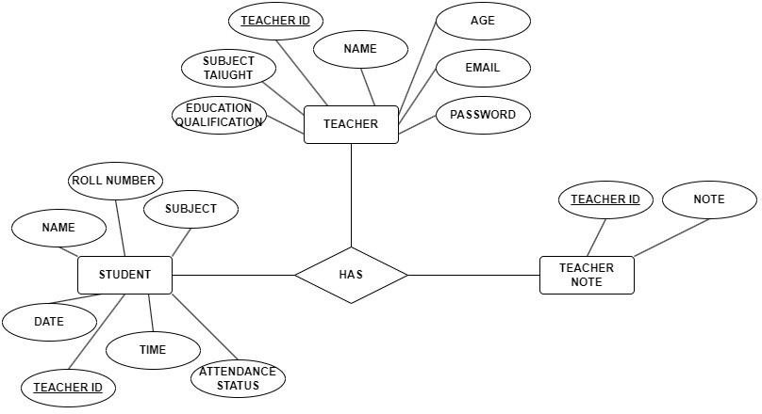

* 1. **Entity Relationship Diagram:**
  2. **Data Flow Diagram – Level 0:**

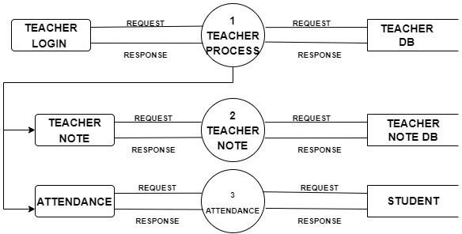

**Data Flow Diagram – Level 1:**

# Technologies Used

Programming Language: **Kotlin**

Development Platform: **Android Studio**

Database: **Firebase Realtime Database** Other Tools: **Firebase Authentication**

**Kotlin**

Kotlin, a statically typed language running on the Java Virtual Machine (JVM). It emerged in 2011 through JetBrains. With its stable release in 2016, Kotlin quickly gained traction, praised for its brevity, expressiveness, and compatibility with Java. This makes it particularly suitable for Android development, server-side applications, and various other projects.

* Firstly, Kotlin stands out for its concise syntax, reducing unnecessary code and enhancing readability. Type inference eliminates the need for explicit type declarations in many cases, streamlining the coding process.
* Secondly, Kotlin introduces null safety as a core feature, addressing common runtime errors associated with null pointers. By default, variables are non-nullable, minimizing the risk of unexpected crashes and improving program reliability.
* Thirdly, Kotlin embraces functional programming principles, offering support for first-class functions, lambda expressions, and higher-order functions. This enables developers to write more compact and expressive code, often leveraging functional constructs like map and filter for collection operations.

Kotlin maintains robust object-oriented capabilities akin to Java, with additional features like data classes for streamlined handling of immutable data structures. Kotlin seamlessly integrates with existing Java codebases, facilitating a smooth transition for developers. Extension functions and properties enable the augmentation of class functionality without altering their original source code, fostering code reuse and flexibility.

Furthermore, Kotlin introduces powerful asynchronous programming tools, notably coroutines, simplifying the management of concurrency and asynchronous operations.

Kotlin offers a modern, pragmatic approach to software development, empowering developers with concise syntax, null safety, functional and object-oriented programming support, seamless interoperability with Java, extension functions, and coroutines. These features collectively contribute to enhanced productivity and code quality across various application domains.

**Android Studio**

Android Studio, the official integrated development environment (IDE) for Android app development, was launched by Google in 2013. Built on the robust IntelliJ IDEA platform, Android Studio quickly emerged as the go-to toolkit for developers venturing into the dynamic realm of Android app creation. Boasting a comprehensive suite of features and tools, Android Studio empowers developers to navigate the intricacies of app development with confidence and efficiency.

At the heart of Android Studio lies its code editor, known for its advanced functionality and flexibility. Offering a rich array of features such as code completion, syntax highlighting, and refactoring capabilities, the code editor serves as the cornerstone of the development experience. It is highly customizable and developers can tailor their coding environment to their preferences with themes, keymaps, and plugins. Moreover, Android Studio provides robust support for Kotlin, Java, and C++ programming languages, allowing developers to wield their language of choice with ease and precision.

The layout editor in Android Studio stands as another pivotal feature, simplifying the creation of captivating user interfaces for Android apps. With its intuitive drag-and-drop interface and real-time preview pane, the layout editor enables developers to craft visually stunning layouts that adapt seamlessly to various screen sizes and orientations. Leveraging the power of ConstraintLayout, developers can effortlessly design intricate UIs that captivate and engage users.

Central to the Android Studio ecosystem is its Android Emulator, a versatile tool that facilitates comprehensive app testing on virtual Android devices. Offering plenty of device configurations, including diverse Android

versions, screen sizes, and hardware specifications, the emulator empowers developers to simulate real-world scenarios and optimize their apps for a broad spectrum of devices.

Android Studio seamlessly integrates with the Android Software Development Kit (SDK) and Google Play services, simplifying the development process and enhancing productivity. By automatically managing SDK components and offering built-in support for Google Play services, Android Studio equips developers with the resources they need to integrate essential features like Google Maps, Firebase, and AdMob seamlessly into their apps.

The IDE also offers robust debugging and profiling tools, enabling developers to identify and rectify issues with precision. From setting breakpoints and inspecting variables to gaining insights into app performance and memory usage, Android Studio empowers developers to deliver polished and optimized apps that resonate with users.

Android Studio boasts seamless version control integration with Git and GitHub, facilitating collaborative development and project management. Developers can effortlessly manage their projects, collaborate with team members, and track changes using version control tools directly within the IDE.

Android Studio also simplifies the app deployment process with support for building and deploying apps to various platforms, including Android devices, emulators, and the Google Play Store. With tools for generating signed APKs, managing app signing certificates, and publishing apps to the Google Play Store, Android Studio streamlines the app distribution process, empowering developers to reach their target audience with ease.

**Firebase Realtime Database**

Firebase’s Realtime Database is an integral component of the Firebase platform, offering developers a cloudhosted NoSQL solution that trumps traditional data storage methods. Developed by Google, Firebase Realtime Database provides a seamless solution for real-time data synchronization across multiple clients and devices.

At its core, Firebase Realtime Database revolutionizes the data storage landscape with its real-time synchronization capability. Changes made to the database propagate instantaneously across all connected clients, ensuring users are always presented with the latest data without the need for manual intervention. This real-time synchronization imbues applications with dynamic features such as live updates, real-time collaboration, and instantaneous messaging, fostering engaging user experiences that transcend conventional boundaries.

Central to Firebase Realtime Database's allure is its elegant JSON data model, which empowers developers to structure data hierarchically in a manner tailored to their application's unique requirements. Leveraging a flexible JSON structure, developers can effortlessly organize and retrieve data, even amidst the complexities of modern application architectures. Each data object is represented by a distinct URL-like path, facilitating seamless navigation and manipulation of data elements with unparalleled ease.

Moreover, Firebase Realtime Database offers robust offline support, a cornerstone feature that ensures uninterrupted functionality even in the absence of network connectivity. By seamlessly persisting data locally on devices, Firebase Realtime Database ensures applications remain operational regardless of network conditions. Upon reestablishing connectivity, the SDK orchestrates automatic synchronization of pending data changes with the server, ensuring data integrity and continuity.

Security is paramount in Firebase Realtime Database, with powerful security rules empowering developers to exert granular control over data access. Through Firebase Security Rules, developers can enforce authentication-based access controls, data validation, and user role-based permissions, safeguarding sensitive data against unauthorized access and tampering. These rules, enforced server-side, fortify applications with robust security mechanisms that instill confidence in users and stakeholders alike.

Furthermore, Firebase Realtime Database seamlessly integrates with an array of Firebase services, amplifying its utility and versatility. By leveraging services such as Firebase Authentication, Firebase Cloud Messaging, and Firebase Analytics, developers can augment their applications with advanced features like user authentication, push notifications, and comprehensive analytics tracking, all within the cohesive Firebase ecosystem.

Underpinning Firebase Realtime Database is a resilient and scalable infrastructure, engineered to deliver unparalleled reliability and performance. Automatic data replication and failover mechanisms ensure high availability and data durability, mitigating the impact of infrastructure failures and surges in demand. This resilient infrastructure provides a robust foundation upon which developers can build scalable and missioncritical applications with confidence.

**Firebase Authentication**

Firebase Authentication, a pivotal service within the Firebase platform, represents a cornerstone solution for user authentication and identity management across web and mobile applications. Developed by Google, Firebase Authentication empowers developers to seamlessly integrate robust authentication mechanisms into their applications, thereby ensuring secure access and personalized experiences for users.

At its core, Firebase Authentication boasts a rich array of authentication methods, providing developers with unparalleled flexibility in catering to diverse user preferences and needs. From traditional email/password authentication to innovative phone number authentication leveraging SMS verification, Firebase Authentication offers a plethora of options. Additionally, developers can harness the power of social media authentication through providers like Google, Facebook, Twitter, and GitHub, fostering frictionless sign-in experiences that resonate with modern users. Furthermore, custom authentication via OAuth providers offers developers unparalleled versatility in accommodating specialized authentication requirements.

Spearheading Firebase Authentication's appeal is its seamless integration with other Firebase services, facilitating cohesive user experiences that transcend individual authentication events. Once authenticated, users seamlessly navigate across Firebase services, accessing and managing their data with unparalleled ease and security. This seamless integration underscores Firebase Authentication's role as a linchpin in fostering holistic and cohesive application ecosystems.

A hallmark feature of Firebase Authentication is its steadfast commitment to security, safeguarding user accounts and sensitive data with robust encryption and authentication mechanisms. Leveraging token-based authentication with JSON Web Tokens (JWTs), Firebase Authentication ensures secure user authentication and authorization, mitigating the risk of unauthorized access and data breaches. Moreover, support for user roles and custom claims empowers developers to implement nuanced access control and authorization rules, thereby fortifying applications against potential security vulnerabilities.

Firebase Authentication streamlines account management processes with built-in support for essential features such as email verification, password reset, and account linking. Developers can effortlessly customize email templates and workflows to align with the branding and user experience of their applications, fostering cohesive and intuitive user interactions.

Underpinning Firebase Authentication is a scalable and reliable infrastructure engineered to deliver unparalleled performance and resilience. Automatic handling of user authentication requests, coupled with secure token generation and validation mechanisms, ensures swift and seamless authentication experiences for users across diverse platforms and scenarios. Additionally, monitoring and reporting tools empower developers to track user sign-in events, identify suspicious activity, and monitor system health and performance, thereby safeguarding the integrity and reliability of the authentication system.

# Screenshots

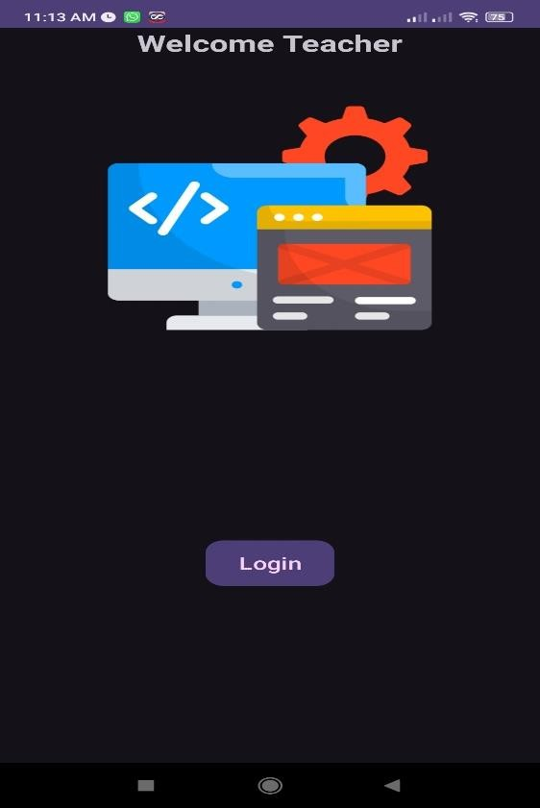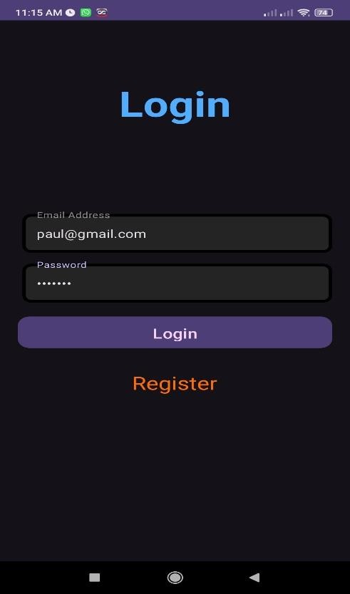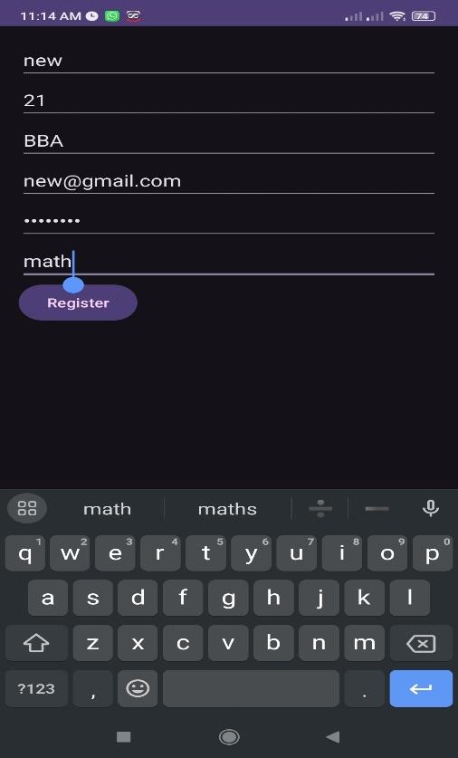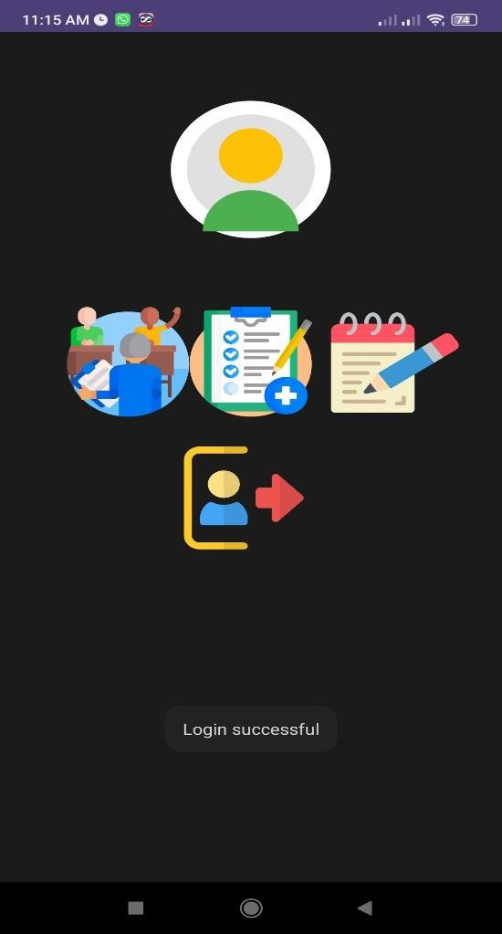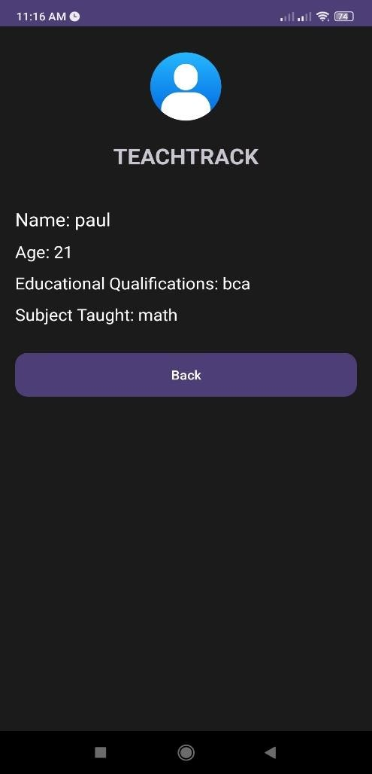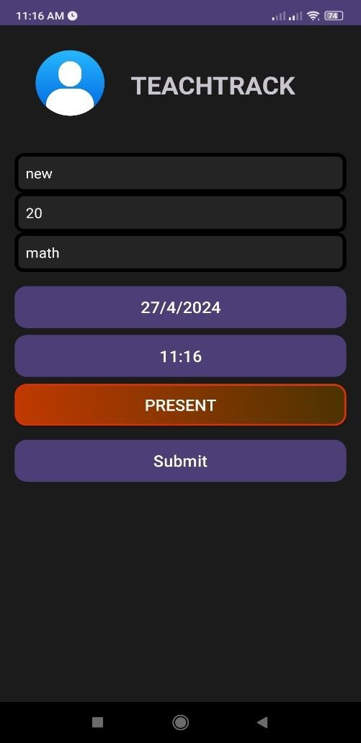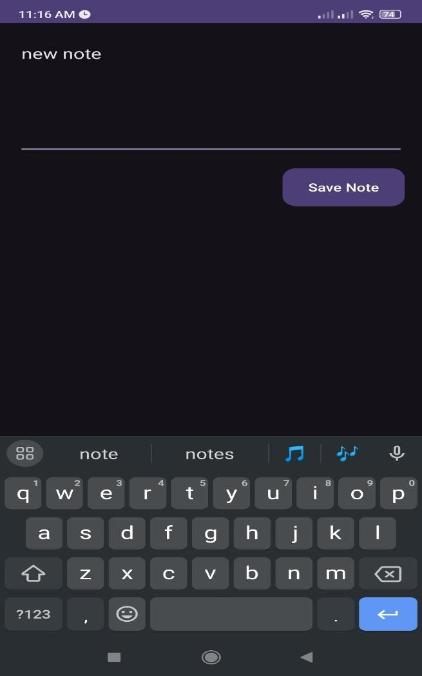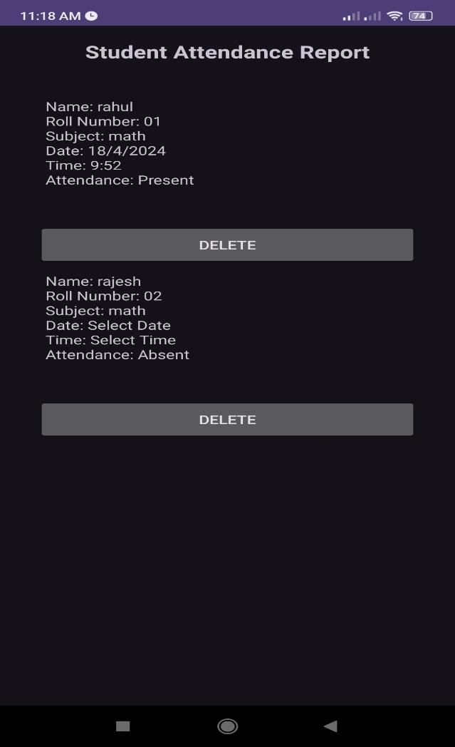

# Project Features

TeachTrack is a comprehensive mobile application that offers a wide array of features tailored to streamline teacher attendance management, facilitate communication, and ensure accountability within educational institutions. Let's delve into the rich feature set of TeachTrack:

Secure Authentication: TeachTrack employs a robust authentication system to ensure secure access for authorized users. Through encrypted login credentials, teachers and administrative staff can securely log in to the application. The registration process is also safeguarded, requiring verification mechanisms to authenticate new users and prevent unauthorized access.

User Profile Management: TeachTrack provides a centralized platform for managing user profiles, allowing teachers to personalize their information. Teachers can update their profiles with essential details such as contact information, subject assignments, and qualifications. Additionally, teachers can upload profile pictures, enhancing identification and personalization within the app.

Attendance Tracking: The core functionality of TeachTrack revolves around efficient attendance tracking. Teachers can conveniently mark their attendance using the mobile interface, eliminating the need for manual attendance registers. The system automatically timestamps each attendance entry, ensuring accuracy and reliability. Real-time synchronization with the Firebase backend ensures that attendance records are consistently updated and accessible to authorized users.

Communication Features: TeachTrack facilitates seamless communication between teachers and administrative staff. Built-in messaging features allow teachers to send inquiries, leave requests, or attendance-related notifications to administrators. This promotes efficient communication channels, enabling quick resolution of issues and fostering collaboration within the educational institution.

Reporting and Analytics: TeachTrack empowers administrators with powerful reporting and analytics tools to analyze attendance trends and make data-driven decisions. Administrators can generate comprehensive reports with customizable parameters, such as date range, teacher, or subject. Graphical representations provide visual insights into attendance patterns, enabling administrators to identify areas for improvement and implement targeted interventions.

Security and Compliance: Security is a paramount concern for TeachTrack, which employs stringent measures to safeguard sensitive data. Encryption protocols, access controls, and regular security audits ensure the

confidentiality and integrity of user information. TeachTrack also complies with data privacy regulations such as GDPR and COPPA, ensuring that user data is handled with the utmost care and compliance.

Scalability and Performance: TeachTrack is designed to scale seamlessly to meet the evolving needs of educational institutions. The system architecture is optimized for performance, ensuring smooth operation even during peak usage periods. As the user base grows, TeachTrack can accommodate increased demand without compromising performance or user experience.

User Support and Training: TeachTrack prioritizes user satisfaction by offering comprehensive support and training resources. User guides, tutorials, and responsive customer support channels are available to assist users with any queries or issues they may encounter. This commitment to user support ensures a positive experience with TeachTrack and promotes user adoption and satisfaction.

# User Guide

**Installation:**

I personally recommend using a physical Android 11+ phone to use the app rather than Android Studio’s Android Virtual Device or AVD, simply because it is not possible to create folders or move files in the AVD from your PC, and the process of getting hands on some .mp3 files from the within the AVD can be slightly tedious depending on well your PC can handle the emulation. The following are the steps to install my app from Android Studio onto a physical Android 11+ device:

1. Connect your phone to your PC via a USB-C cable and enable “USB Tethering” from your phone’s developer settings

(OR)

1. Make sure your phone and your PC are connected to the same WiFi network and enable “Wireless Tethering” in your phone’s developer settings
2. Now, you should be able to see the phone in place of the usual AVD’s name. You can now click the play titled “Run” next like you would normally do to the test the app on the AVD, except here you’re testing it on your phone.
3. The gradle build will start running, after which the app will have finished being installed on your phone.

# Conclusion

In conclusion, TeachTrack stands as a testament to the power of technology in revolutionizing teacher attendance management and communication within educational institutions. With its comprehensive feature set and user-friendly interface, TeachTrack addresses the diverse needs of teachers, administrators, and educational stakeholders, facilitating efficient attendance tracking, seamless communication, and data-driven decision- making.By automating attendance recording processes, TeachTrack saves valuable time and resources for educational institutions, enabling teachers to focus more on their core responsibilities of teaching and learning. The real-time synchronization with the Firebase backend ensures that attendance records are always up-to-date and accessible, promoting accuracy and reliability.Furthermore, TeachTrack fosters transparency and accountability through its communication features, allowing teachers to engage with administrative staff effortlessly. This streamlined communication enables quick resolution of attendance-related issues, enhances collaboration, and strengthens the overall efficiency of educational operations.The reporting and analytics capabilities of TeachTrack empower administrators with valuable insights into attendance trends, facilitating informed decision-making and targeted interventions to improve attendance rates and overall educational outcomes. Customizable reporting parameters and graphical representations provide administrators with a clear understanding of attendance patterns, enabling them to identify areas for improvement and implement proactive strategies.TeachTrack's commitment to security and compliance ensures that sensitive attendance data is protected with robust encryption protocols and stringent access controls, giving users peace of mind regarding the confidentiality and integrity of their data.In essence, TeachTrack represents a significant step forward in modernizing teacher attendance management processes, leveraging the latest technological advancements to streamline operations, enhance communication, and promote accountability within educational institutions. By empowering educators and administrators with powerful tools and insights, TeachTrack ultimately contributes to the advancement of education and the success of students.

# References

* Kotlin: <https://kotlinlang.org/docs/basic-syntax.html>
* Android Studio: <https://developer.android.com/studio>
* Firebase Realtime Database: <https://firebase.google.com/docs/database>
* Firebase Authentication: <https://firebase.google.com/docs/auth>