1. **PROJECT SYNOPSIS**

"Glow Up" is a mobile platform revolutionizing beauty parlour with streamlined appointment management, personalized services, and targeted marketing. Our goal is to empower salon owners to enhance customer experience, optimize operations, and grow their businesses. With user-friendly features like online booking, service customization, and virtual consultations, "Glow Up" caters to tech-savvy clients seeking convenience and quality.

"Glow Up" introduces a comprehensive beauty parlour booking system meticulously crafted to redefine salon management dynamics. At its core, our system integrates seamlessly into salon operations, facilitating effortless appointment scheduling, staff coordination, and client data management. Through a sleek and intuitive interface, salon owners gain unprecedented control over their schedules, enabling them to optimize resources and maximize productivity.

Beyond basic scheduling, "Glow Up" is engineered to enhance every aspect of the customer journey. Clients can effortlessly book appointments online, selecting from a range of personalized services tailored to their preferences. With virtual consultations available, they can engage with salon professionals remotely, receiving expert advice and recommendations before stepping foot in the salon.

Moreover, "Glow Up" empowers salon owners with robust marketing capabilities to drive client engagement and loyalty. Leveraging targeted promotions, loyalty programs, and real-time notifications, beauty parlours can effectively reach their target audience, fostering stronger connections and driving business growth. In essence, "Glow Up" transcends traditional booking systems, offering a holistic solution that not only streamlines operations but also elevates the salon experience for both owners and clients alike.

## 

## 1.1 Purpose:

The primary purpose of the "Glow Up" Beauty parlour Booking System is to revolutionize the way beauty parlour operate in today's digital landscape. Traditional salon management methods often face challenges in terms of efficiency, organization, and customer engagement. "Glow Up" seeks to address these challenges by providing a comprehensive platform that seamlessly integrates all aspects of salon operations into one user-friendly interface.

By centralizing appointment scheduling, staff management, and client communication, "Glow Up" simplifies the daily tasks of salon owners and staff, allowing them to focus more on delivering exceptional services to their clients. This streamlined approach not only saves time and resources but also ensures smoother operations and reduced chances of errors or double bookings.

Moreover, "Glow Up" places a strong emphasis on enhancing the overall customer experience. Through features such as online booking, service customization, and virtual consultations, clients are provided with greater flexibility and convenience in how they interact with the salon. This not only increases customer satisfaction but also fosters loyalty and repeat business.

Additionally, "Glow Up" empowers salon owners with powerful marketing tools to effectively promote their services and engage with their target audience. By offering features such as targeted promotions, loyalty programs, and real-time notifications, beauty parlours can attract new clients, retain existing ones, and stay top-of-mind in a competitive market.

In summary, the purpose of the "Glow Up" Beauty Parlour Booking System is to modernize salon operations, elevate the customer experience, and drive business success through efficient management, enhanced customer engagement, and strategic marketing initiatives.

Top of Form

## 

## 1.2 Goals:

The goals for the "Glow Up" Beauty Parlour Booking System are as follows:

1. **Efficient Salon Management:** Develop a user-friendly platform that streamlines salon operations by centralizing appointment scheduling, staff coordination, and client management, ultimately increasing efficiency and reducing administrative overhead.
2. **Enhanced Customer Experience:** Implement features such as online booking, service customization, and virtual consultations to provide clients with greater convenience, personalization, and accessibility, thereby elevating their overall salon experience.
3. **Effective Marketing Strategies:** Integrate robust marketing tools, including targeted promotions, loyalty programs, and real-time notifications, to help salon owners attract new clients, retain existing ones, and cultivate stronger relationships with their customer base, driving business growth and success Top of Form

## 1.3 Intended Audience:

The intended audience for the "Glow Up" Beauty Parlour Booking System includes:

1. **Salon Owners:** Independent salon owners and franchise operators seeking to modernize their operations, improve efficiency, and enhance customer experience.
2. **Salon Managers:** Managers responsible for overseeing day-to-day operations, staff scheduling, and client management within beauty parlours of varying sizes.
3. **Salon Staff:** Hairstylists, beauticians, and other salon professionals looking for a user-friendly platform to manage their schedules, appointments, and client interactions more effectively.
4. **Clients:** Tech-savvy individuals seeking convenience, flexibility, and personalized services when booking appointments and engaging with beauty parlours for their grooming needs.

Top of Form

# Project Objectives

**2.1 Develop a User-Friendly Platform:**

The primary objective is to design and build a platform that prioritizes ease of use and accessibility for both salon owners and clients. This involves creating a sleek and intuitive interface that allows salon staff to efficiently manage appointments, update schedules, and access client information with minimal effort. Additionally, the platform should offer a seamless booking experience for clients, enabling them to easily browse services, select appointment slots, and make reservations from any device.

**2.2 Enhance Customer Experience:**

A key focus is on enhancing the overall salon experience for clients by introducing features that cater to their preferences and expectations. This includes implementing online booking functionality to provide clients with the convenience of scheduling appointments at their convenience, even outside of salon operating hours. Moreover, offering service customization options allows clients to personalize their appointments based on their specific needs and preferences.

* 1. **Optimize Salon Operations:**

The system aims to streamline salon operations by centralizing administrative tasks and automating repetitive processes. This involves creating a centralized database for storing client information, appointment history, and staff schedules, making it easy for salon owners and staff to access and manage data efficiently. By automating appointment reminders, confirmations, and follow-ups, the system helps reduce no-shows and last-minute cancellations, optimizing appointment scheduling and resource allocation.

* 1. **Empower Marketing Initiatives:**

This involves integrating features such as targeted promotions, loyalty programs, and real-time notifications to engage with clients and incentivize repeat visits. By sending personalized offers and discounts based on client preferences and booking history, salon owners can effectively drive customer

# 3. Project Outline.

# 3.1 Modules

# 1.Sign up and Login

Sign-up and login are crucial steps in the user journey of a Glow up app. They allow users to create a personal account, enabling the app to provide a personalized experience. This process usually involves inputting an email and a unique password. To ensure security, it's important to implement measures like password strength checks and two-factor authentication.

**2.Registration**

## In the Glow Up Beauty, users can register by providing their basic information such as name, email

## address, and password. Upon registration, the system securely stores their credentials in a database, utilizing

## strong password hashing techniques for enhanced security. This registration process ensures that users can

## access personalized services, book appointments, and receive updates tailored to their preferences, fostering

## a seamless and engaging beauty parlour experience.

## 3.Services

## In the Glow Up app, the "Service" module encompasses a comprehensive range of beauty treatments and

## services tailored to meet clients' diverse needs and preferences. This module efficiently manages

## appointment scheduling, allowing users to book services such as haircuts, styling, manicures, pedicures,

## facials, massages, and more. It facilitates seamless communication between clients and beauticians, enabling

## clients to specify their desired services, preferred appointment times, and any special requests.

## 4. Facial

## In the Glow Up app, the facial module consists of types facials provided to the customers. It consists of milk

## facial, platinum facial, gold facial, oxygen facial etc. types of products to be used is also provided to the

## customer. The customer can select the type which they require.

## 5. Hair Treatment

## In the Glow Up app, the hair treatment module consists of types hair treatment provided to the customers. provides Like Hair cut, smoothing, coloring, styling, etc. types of products to be used is also provided to the customer. The customer can select the type which they require.

## 6. Manicure and Pedicure

## In the Glow Up app, the manicure module consists of types provided to the customers. It provides

## treatment for nails in hands and legs customer. The customer can choose the type which they require.

## The nail treatment consists of basic, acrylic, gel and French etc.

## 5. Bridal Package

## In the Glow Up app, the bridal package as a specialized feature catering to customers preparing for weddings or special occasions. This module provides a curated selection of services and treatments tailored specifically for brides-to-be, including hair styling, makeup, skincare treatments, and other beauty services. Users can browse through different package options, each offering a unique combination of services to suit their preferences and needs. The module also allows users to book appointments for their chosen package directly within the app, ensuring a seamless and convenient experience. Additionally, the module may integrate with our appointment booking system, allowing users to schedule their bridal appointments in advance and ensuring availability on their desired dates.

## 5. User Profile

## In the glow up app the user profile has the details of the customers i.e. user name, email address, phone

## number, password. The customer update or delete the account.

## 6. Appointment

## The appointment module in our glow up app streamlines the process of scheduling and managing appointments for our clients. This feature enables users to easily book appointments for various beauty services, including haircuts, manicures, facials, and more, directly from their mobile devices or computers. Users can view available time slots, select their preferred date and time, and choose specific services

**3.2 Flow Diagram**

**DATA FLOW DIAGRAM**

**LEVEL-0**

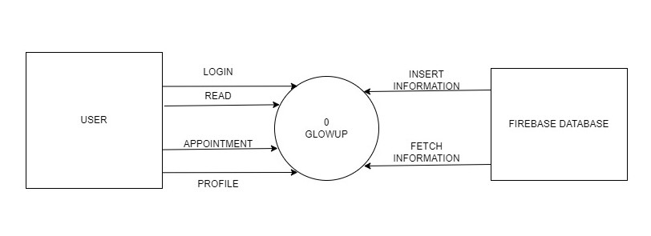

**LEVEL-1**

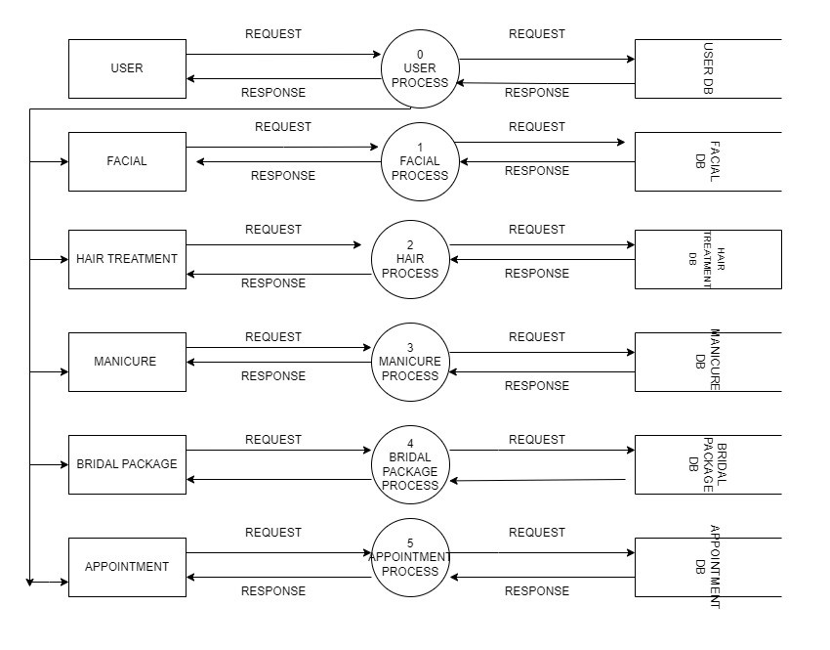

**ER DIAGRAM**

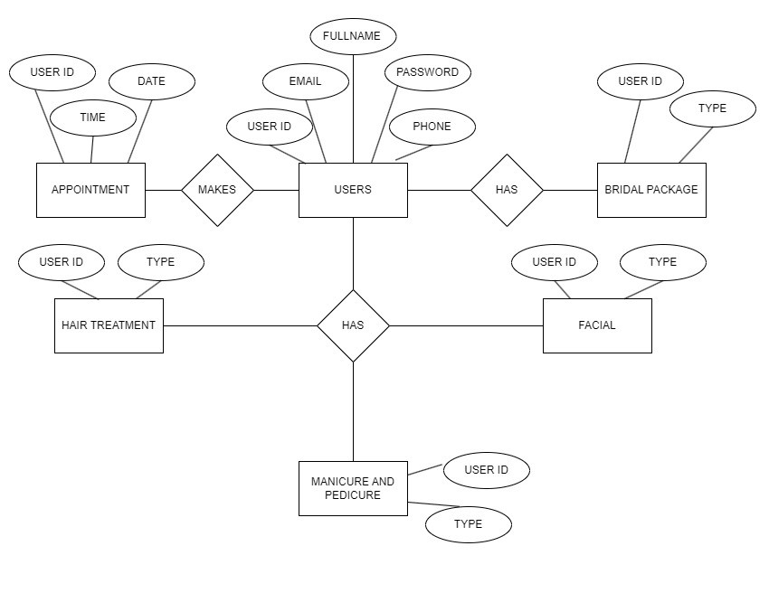

# 

# Screenshots

[Insert screenshots of the mobile application. Provide captions or annotations where necessary.]

[Screenshot 1]

[Screenshot 2]

# Project Features

[Describe the main features and functionalities of the mobile application.]

## 6.1 Feature 1: [Description]

## 6. 2 Feature 2: [Description]

## 6. 3 Feature 3: [Description]

# User Guide

[Provide instructions on how to use the mobile application.]

Installation Instructions:

Step 1: [Instruction]

Step 2: [Instruction]

Step 3: [Instruction]

User Interface Guide:

[Explain the various screens and interactions within the application.]

# Conclusion

[Summarize the overall experience of developing and working on the mobile project. Discuss any challenges faced and lessons learned.]

# References

[List any references, resources, or external materials used during the project development.]

[Reference 1]

[Reference 2]

[Reference 3]