**1. PROJECT SYNOPSIS**

"Glow Up" is a mobile platform revolutionizing beauty parlour with streamlined appointment management, personalized services, and targeted marketing. Our goal is to empower salon owners to enhance customer experience, optimize operations, and grow their businesses. With user-friendly features like online booking, service customization, and virtual consultations, "Glow Up" caters to tech-savvy clients seeking convenience and quality.

"Glow Up" introduces a comprehensive beauty parlour booking system meticulously crafted to redefine salon management dynamics. At its core, our system integrates seamlessly into salon operations, facilitating effortless appointment scheduling, staff coordination, and client data management. Through a sleek and intuitive interface, salon owners gain unprecedented control over their schedules, enabling them to optimize resources and maximize productivity.

Beyond basic scheduling, "Glow Up" is engineered to enhance every aspect of the customer journey. Clients can effortlessly book appointments online, selecting from a range of personalized services tailored to their preferences. With virtual consultations available, they can engage with salon professionals remotely, receiving expert advice and recommendations before stepping foot in the salon.

Moreover, "Glow Up" empowers salon owners with robust marketing capabilities to drive client engagement and loyalty. Leveraging targeted promotions, loyalty programs, and real-time notifications, glow up can effectively reach their target audience, fostering stronger connections and driving business growth. In essence, "Glow Up" transcends traditional booking systems, offering a holistic solution that not only streamlines operations but also elevates the salon experience for both owners and clients alike.

**1.1Purpose:**

The primary purpose of the "Glow Up" Beauty parlour Booking System is to revolutionize the way beauty parlour operate in today's digital landscape. Traditional salon management methods often face challenges in terms of efficiency, organization, and customer engagement. "Glow Up" seeks to address these challenges by providing a comprehensive platform that seamlessly integrates all aspects of salon operations into one userfriendly interface.

By centralizing appointment scheduling, staff management, and client communication, "Glow Up" simplifies the daily tasks of salon owners and staff, allowing them to focus more on delivering exceptional services to their clients. This streamlined approach not only saves time and resources but also ensures smoother operations and reduced chances of errors or double bookings.

Moreover, "Glow Up" places a strong emphasis on enhancing the overall customer experience. Through features such as online booking, service customization, and virtual consultations, clients are provided with greater flexibility and convenience in how they interact with the salon. This not only increases customer satisfaction but also fosters loyalty and repeat business.

Additionally, "Glow Up" empowers salon owners with powerful marketing tools to effectively promote their services and engage with their target audience. By offering features such as targeted promotions, loyalty programs, and real-time notifications, beauty parlours can attract new clients, retain existing ones, and stay topofmind in a competitive market.

In summary, the purpose of the "Glow Up" Beauty Parlour Booking System is to modernize salon operations, elevate the customer experience, and drive business success through efficient management, enhanced customer engagement, and strategic marketing initiatives.

**1.2 Goals:**

The goals for the "Glow Up" Beauty Parlour Booking System are as follows:

**1.Efficient Salon Management**: Develop a user-friendly platform that streamlines salon operations by centralizing appointment scheduling, staff coordination, and client management, ultimately increasing efficiency and reducing administrative overhead.

**2.Enhanced Customer Experience:** Implement features such as online booking, service customization, and virtual consultations to provide clients with greater convenience, personalization, and accessibility, thereby elevating their overall salon experience.

**3.Effective Marketing Strategies:** Integrate robust marketing tools, including targeted promotions, loyalty programs, and real-time notifications, to help salon owners attract new clients, retain existing ones, and cultivate stronger relationships with their customer base, driving business growth and success Top of Form

**1.3 Intended Audience:**

The intended audience for the "Glow Up" Beauty Parlour Booking System includes:

**Salon Owners:** Independent salon owners and franchise operators seeking to modernize their operations, improve efficiency, and enhance customer experience.

**Salon Managers:** Managers responsible for overseeing day-to-day operations, staff scheduling, and client management within beauty parlours of varying sizes.

**Salon Staff:** Hairstylists, beauticians, and other salon professionals looking for a user-friendly platform to manage their schedules, appointments, and client interactions more effectively.

**Clients:** Tech-savvy individuals seeking convenience, flexibility, and personalized services when booking appointments and engaging with beauty parlours for their grooming needs.

# 2. Project Objectives

**2.1 Develop a User-Friendly Platform:**

The primary objective is to design and build a platform that prioritizes ease of use and accessibility for both salon owners and clients. This involves creating a sleek and intuitive interface that allows salon staff to efficiently manage appointments, update schedules, and access client information with minimal effort. Additionally, the platform should offer a seamless booking experience for clients, enabling them to easily browse services, select appointment slots, and make reservations from any device.

**2.2 Enhance Customer Experience:**

A key focus is on enhancing the overall salon experience for clients by introducing features that cater to their preferences and expectations. This includes implementing online booking functionality to provide clients with the convenience of scheduling appointments at their convenience, even outside of salon operating hours. Moreover, offering service customization options allows clients to personalize their appointments based on their specific needs and preferences.

**2.3 Optimize Salon Operations:**

The system aims to streamline salon operations by centralizing administrative tasks and automating repetitive processes. This involves creating a centralized database for storing client information, appointment history, and staff schedules, making it easy for salon owners and staff to access and manage data efficiently. By automating appointment reminders, confirmations, and follow-ups, the system helps reduce no-shows and last-minute cancellations, optimizing appointment scheduling and resource allocation.

**2.4 Empower Marketing Initiatives:**

This involves integrating features such as targeted promotions, loyalty programs, and real-time notifications to engage with clients and incentivize repeat visits. By sending personalized offers and discounts based on client preferences and booking history, salon owners can effectively drive customer

**3. Project Outline.**

## 3.1 Modules

### 1.Sign up and Login

Sign-up and login are crucial steps in the user journey of a Glow up app. They allow users to create a personal account, enabling the app to provide a personalized experience. This process usually involves inputting an email and a unique password. To ensure security, it's important to implement measures like password strength checks and two-factor authentication.

### 2.Registration

In the Glow Up Beauty, users can register by providing their basic information such as name, email address, and password. Upon registration, the system securely stores their credentials in a database, utilizing strong password hashing techniques for enhanced security. This registration process ensures that users can access personalized services, book appointments, and receive updates tailored to their preferences, fostering a seamless and engaging beauty parlour experience.

### 3.Services

In the Glow Up app, the "Service" module encompasses a comprehensive range of beauty treatments and services tailored to meet clients' diverse needs and preferences. This module efficiently manages appointment scheduling, allowing users to book services such as haircuts, styling, manicures, pedicures, facials, massages, and more. It facilitates seamless communication between clients and beauticians, enabling clients to specify their desired services, preferred appointment times, and any special requests.

### 4. Facial

In the Glow Up app, the facial module consists of types facials provided to the customers. It consists of milk facial, platinum facial, gold facial, oxygen facial etc. types of products to be used is also provided to the customer.

The customer can select the type which they require.

### 5. Hair Treatment

In the Glow Up app, the hair treatment module consists of types hair treatment provided to the customers. provides Like Hair cut, smoothing, coloring, styling, etc. types of products to be used is also provided to the customer.

The customer can select the type which they require.

### 6. Manicure and Pedicure

In the Glow Up app, the manicure module consists of types provided to the customers. It provides treatment for nails in hands and legs customer. The customer can choose the type which they require. The nail treatment consists of basic, acrylic, gel and French etc.

### 5. Bridal Package

In the Glow Up app, the bridal package as a specialized feature catering to customers preparing for weddings or special occasions. This module provides a curated selection of services and treatments tailored specifically for brides-to-be, including hair styling, makeup, skincare treatments, and other beauty services. Users can browse through different package options, each offering a unique combination of services to suit their preferences and needs. The module also allows users to book appointments for their chosen package directly within the app, ensuring a seamless and convenient experience. Additionally, the module may integrate with our appointment booking system, allowing users to schedule their bridal appointments in advance and ensuring availability on their desired dates.

### 5. User Profile

In the glow up app the user profile has the details of the customers i.e. user name, email address, phone number, password. The customer update or delete the account.

### 6. Appointment

The appointment module in our glow up app streamlines the process of scheduling and managing appointments for our clients. This feature enables users to easily book appointments for various beauty services, including haircuts, manicures, facials, and more, directly from their mobile devices or computers. Users can view available time slots, select their preferred date and time, and choose specific services

## 3.2 Flow Diagram

### LEVEL-0

**CONTEXT DIAGRAM**

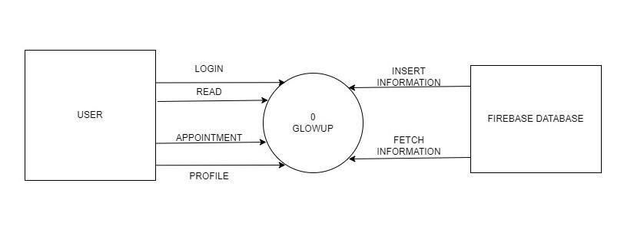

### 

**LEVEL-1**

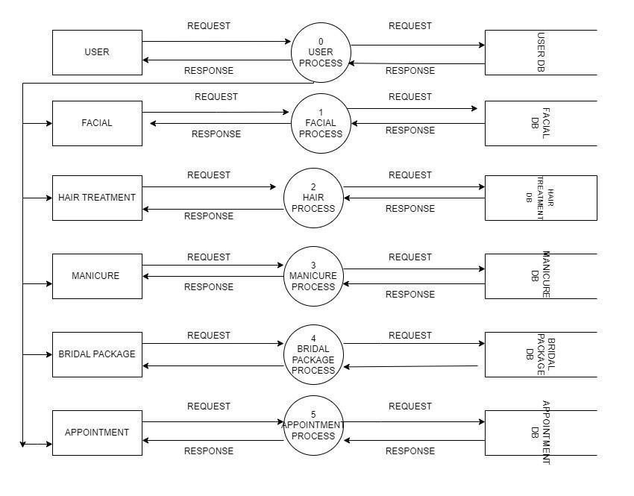

### ER DIAGRAM

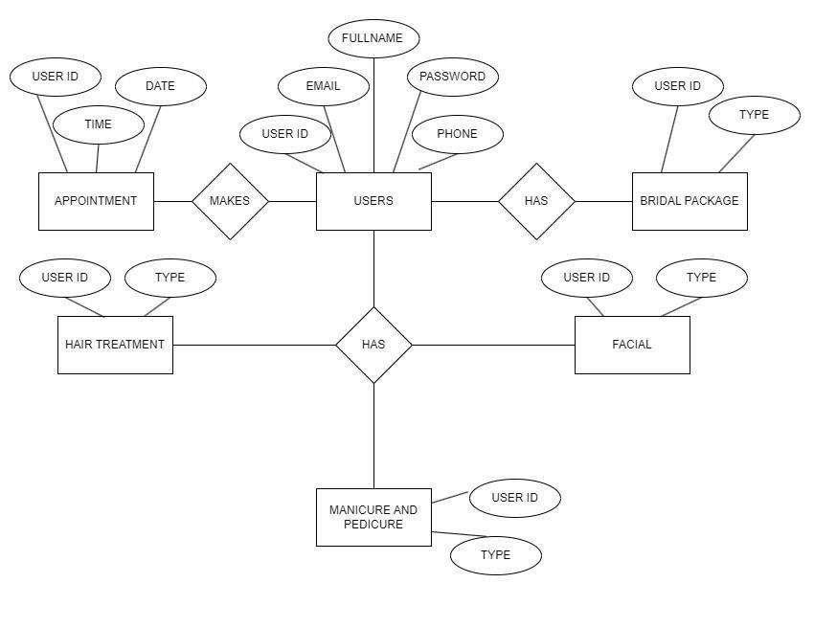

# 4.Technologies Used

## Programming Language: KOTLIN(XML)

Kotlin is a modern, statically-typed programming language developed by JetBrains. It is fully interoperable with Java, making it an excellent choice for Android app development. Kotlin is known for its concise syntax, null safety features, and functional programming capabilities.

## Development Platform:

## ANDROID STUDIO

Android Studio is the official integrated development environment (IDE) for Android app development. It provides a comprehensive set of tools for designing, building, testing, and debugging Android applications. Android Studio is based on IntelliJ IDEA and offers features specifically tailored for Android development, such as layout editors, a robust emulator, and integration with the Android SDK and Google services.

**Database:** FIREBASE(REAL TIME DATABASE,AUTHENTICATION,STORAGE)

Firebase is a comprehensive platform provided by Google for building mobile and web applications. It includes several services, such as Realtime Database, Authentication, and Storage, which are commonly used in Android app development. Realtime Database is a NoSQL cloud database that syncs data in real time, Authentication provides user authentication and management, and Storage offers cloud storage for usergenerated content like images and videos. Together, these services simplify backend development and enable developers to focus more on the frontend and user experience.

## Other Tools: NOTION

Notion is a versatile productivity tool that combines note-taking, project management, and collaboration features. It allows users to create custom databases, manage tasks and projects, take notes, and collaborate with others in real time. Notion's flexible interface and powerful features make it a popular choice for organizing information and workflows

# 5. Screenshots

 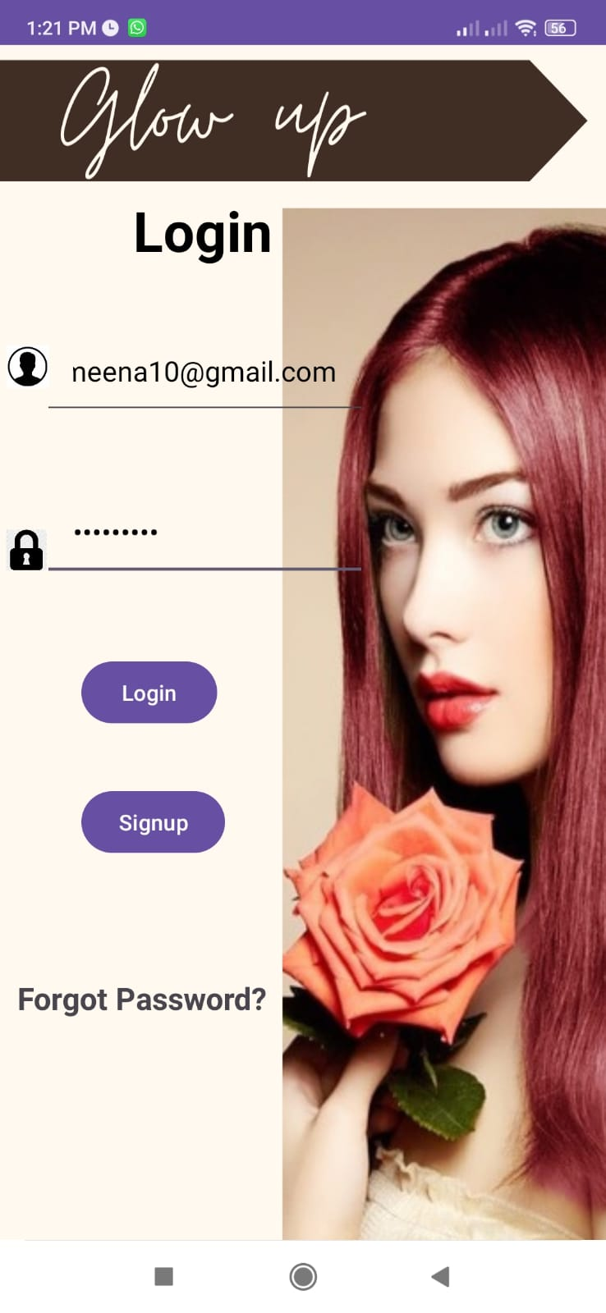

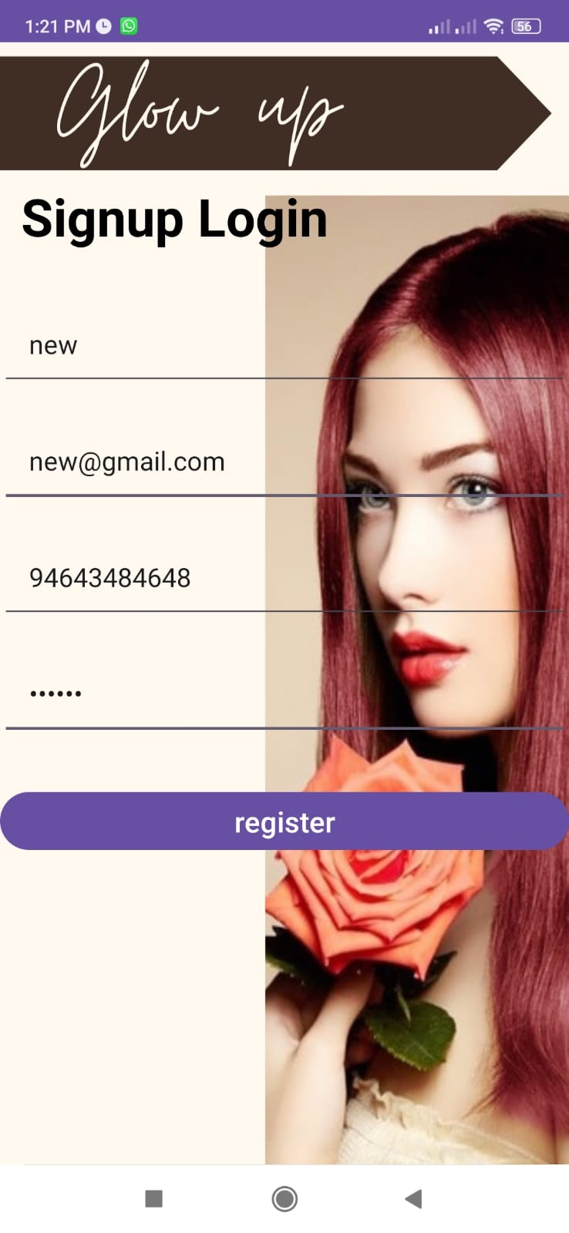 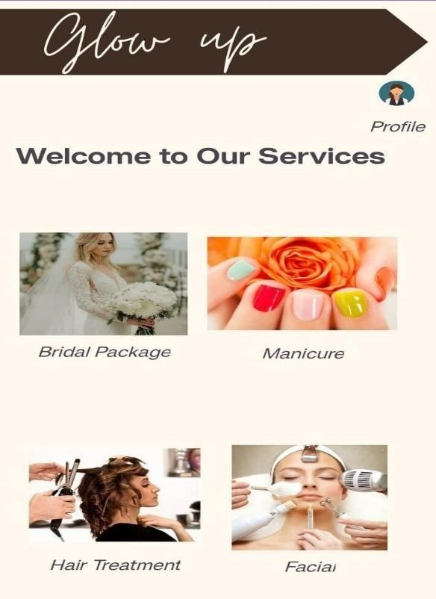

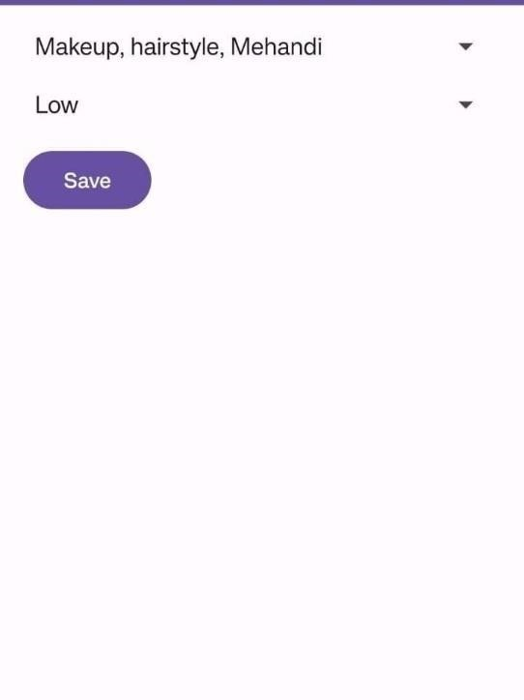 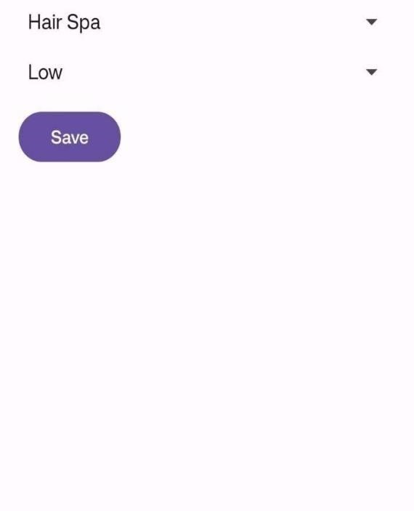

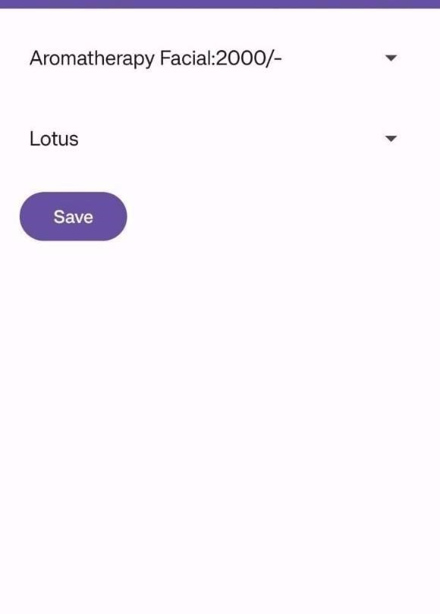 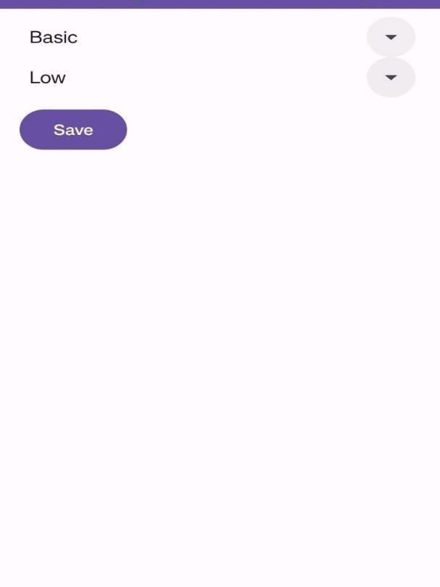

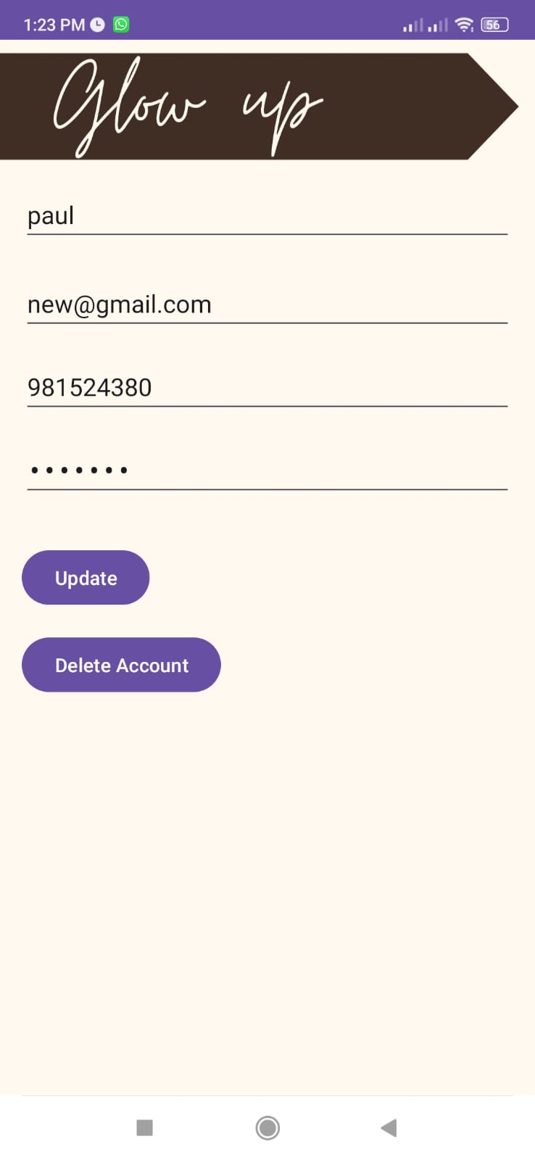 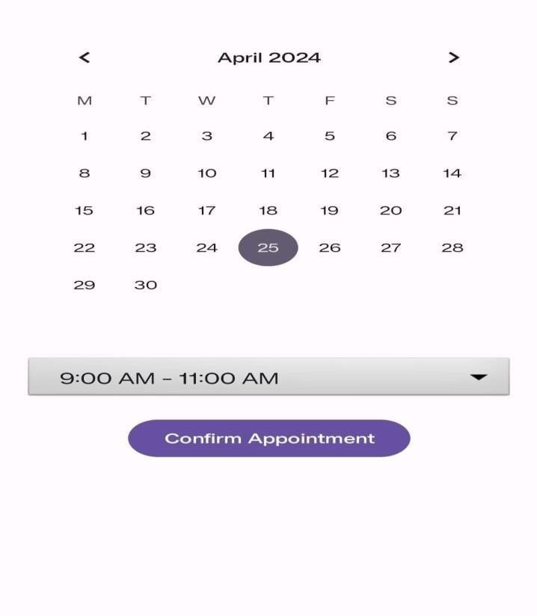

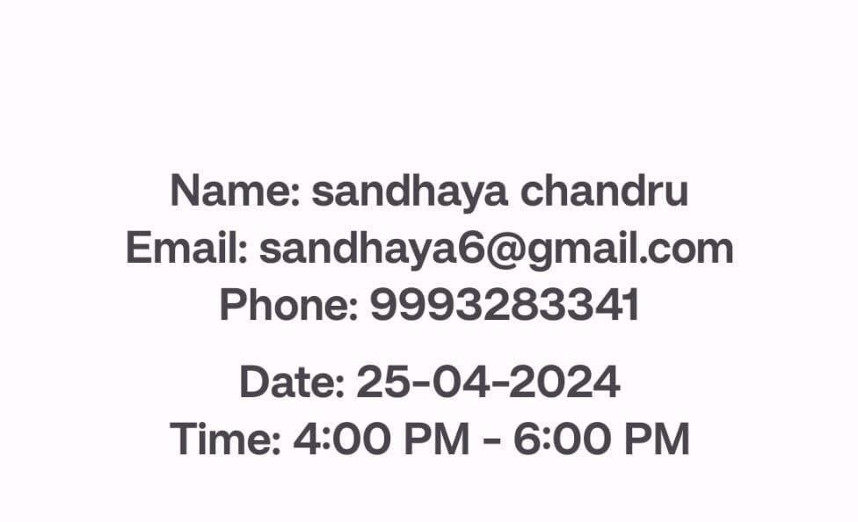

# 6. Project Features

## 6.1 User Authentication

Allow users to create accounts and log in securely to access the app's features. The truck transportation app includes robust user authentication mechanisms, enabling seamless account creation and secure login processes to grant users access to its full range of features and functionalities while prioritizing data security and privacy. The user authentication system employs industry-standard encryption protocols and multi-factor authentication options to safeguard user credentials and ensure the integrity of their accounts. Additionally, it provides a streamlined user experience with intuitive account creation workflows and password recovery mechanisms, fostering trust and confidence among users while minimizing the risk of unauthorized access or data breaches.

## 6.2 Unique ID

As a feature, the app generates a unique user ID for each registered user upon account creation. This user ID serves as a distinct identifier tied to the individual user within the app's database and ecosystem. The uniqueness of this ID ensures that each user's account and associated data are uniquely identifiable and distinguishable from others in the system. This unique user ID enhances the app's security measures by providing a non-sensitive identifier that is used for internal processes, reducing the risk of exposing personally identifiable information (PII) to unauthorized parties

## 6.3 Intuitive Navigation

The app is designed with a user-friendly interface and intuitive navigation pathways, allowing users to easily access various features and functionalities without confusion or unnecessary steps. Intuitive navigation in the app ensures that users can effortlessly find and access the features they need, enhancing overall usability and reducing the learning curve. Clear labeling, logical organization of menus, and consistent design elements contribute to intuitive navigation, allowing users to instinctively understand how to navigate the app.

## 6.4 User Profile Management

The profile section of a truck transportation app plays a critical role in personalizing the user experience. It stores user information like name, contact details, and shipment history. This section also keeps track of user preferences and feedback, helping the app to provide tailored services. Furthermore, a user profile aids in seamless transactions and fosters trust through transparent interactions. We can also update the profile according to the user.

# 7. User Guide

**7.1 Installation Instructions:**

Step 1: Install the "Glow up" app from the Google Play Store on your Android mobile phone to begin using the service.

Step 2: Open the app and sign up by providing your details such as name, email address, and password. This information will be used to create your account and manage your bookings.

Step 3: After signing up, log in to the app using your email and password to access your account.

Step 4: Once logged in, your user profile will be created and allows to create, delete and update by adding additional information such as your contact number, address, and any preferences you may have for bookings.

Step 5: Then you will be directed to the main page of the app, where you will find a list of available services like facial, hair treatment, manicure and pedicure and bridal package.

Step 6: Select the service that suits your requirements. Tap on the service option to proceed to the details field.

Step 7: In the details field, types facial, hair treatment, manicure and bridal package will be provide, select the type service you prefer after selecting the desired service it leads to the booking of the appointment.

Step 8: In the appointment field you can fix the date and time according to your convenient.

Step 9: After booking the appointment details, a report will be generated which displays all the relevant information about your booking, including the username, phone number, booking date, and time.

Step 10: If you need to make any changes to your booking or cancel it, you can do so through the app's booking management feature.

**7.2 User Interface Guide:**

* Splash Screen: Upon opening the app, you'll be greeted with a splash screen serving as a loading indicator. Be patient while the app initializes.

* Login Screen: Enter your email and password on the login screen. Once successfully logged in, you'll receive a confirmation message indicating successful login.

* Main Page: On the main page, you'll find a imagine buttons to easily locate types of services offered.

These fragments seamlessly navigate to different sections of the app.

* Smooth Fragment Navigation: All fragments within the app are designed to navigate smoothly between different sections, ensuring a seamless user experience.

* Search Functionality: Utilize the search bar to quickly find services based on your specific criteria.

Simply enter keywords or filters to refine your search results.

* Detailed information: The list of services is provided. Types of services with cost, type of product that should be used, you can fix the budget according to your convenience like low, high and premium.

* Functional Buttons: All buttons within the app are functional and responsive, providing easy navigation and interaction with various features.

* User-Friendly Design: The app is designed with a user-friendly interface, prioritizing ease of use and intuitive navigation to enhance your overall experience.

# 8. Conclusion

"Glow Up Beauty Parlor Booking System offers a seamless experience for customers seeking top-tier beauty services. With a range of offerings including facials, hair treatments, manicures, pedicures, and even bridal packages, Glow Up caters to diverse beauty needs. Its convenient appointment scheduling feature empowers customers to book their desired services at their own convenience, ensuring a delightful and stress-free experience from start to finish."

Glow Up Beauty Parlor Booking System revolutionizes the way individuals engage with beauty services. Through its user-friendly platform, customers gain access to a plethora of premium treatments, including rejuvenating facials, specialized hair treatments, exquisite manicures, pedicures, and comprehensive bridal packages.

Glow Up enables customers to schedule appointments effortlessly, eliminating the hassle of traditional booking methods. With just a few clicks, clients can select their preferred services, choose their preferred time slots, and secure their appointments, all from the comfort of their own homes. Glow Up prioritizes customer satisfaction by offering flexibility and convenience. Whether it's a quick touch-up or a luxurious pampering session, clients have the freedom to tailor their appointments according to their schedules and preferences. Glow Up emerges as a trusted companion on every individual's journey towards self-care and confidence.

The Glow Up Beauty Parlor has speciality like convenience the customers can book appointments anytime, anywhere, without the need to visit or call the beauty parlor. This flexibility caters to busy schedules and allows for spontaneous bookings. It is Time-saving has streamlining the booking process, Glow Up saves both customers and salon staff valuable time. Clients can quickly browse available slots and secure their appointments without prolonged waiting or back-and-forth communication.

The glow app allows customers to select specific services and tailor their appointments according to their preferences. Whether it's choosing a particular facial treatment or customizing a bridal package, clients have the freedom to personalize their beauty experience. With automated appointment scheduling and reminders, Glow Up reduces the risk of missed appointments and scheduling conflicts. This improves salon efficiency and ensures a smoother operation.

**9. References**

# GeeksforGeeks Android Studio Tutorial: A tutorial series on Android Studio for beginners.

# [Link](https://www.geeksforgeeks.org/android-studio-tutorial/)

# YouTube Tutorial on Android Development: A video tutorial on Android app development. [Link](https://www.youtube.com/watch?v=TRfDbqmhSDQ)

Custom ListView in Android Studio with Java: A tutorial on creating custom ListViews in

Android using Java. [Link](https://androidknowledge.com/custom-listview-android-studiojava)

Official Kotlin Documentation: Official documentation for the Kotlin programming language. [Link](https://developer.android.com/kotlin)

Android Developers Guide:

Official documentation for Android development. [Link](https://developer.android.com/guide)

Kotlin Documentation:

Official documentation for the Kotlin programming language. [Link](https://kotlinlang.org/docs/home.html)

Android Developers YouTube Channel:

Official YouTube channel for Android developers.

[Link](https://www.youtube.com/user/androiddevelopers)

GitHub: A platform for hosting and sharing code. [Link](https://github.com/)

# 