

# MINI PROJECT REPORT

*On*

## HYDRO REACH

*Submitted in partial fulfilment for the award of*

*degree Of*

**Master of Computer Applications**

*By*

**PRAVEENA PRAKASH**

## (MLM24MCA-2043)

Under the Guidance of

### Mr. Eldhose K Paul

(Associate Professor, Department of Computer Applications)



**DEPARTMENT OF COMPUTER APPLICATIONS**  **MANGALAM COLLEGE OF ENGINEERING, ETTUMANOOR**

***(Affiliated to APJ Abdul Kalam Technological University)***

# OCTOBER 2025

**MAPPING OF PO-PSO-SDG**

**1. MAPPING WITH PROGRAM OUTCOMES (POs):-**

|  |  |  |
| --- | --- | --- |
| **SL. NO** | **POs ADDRESSED** | **RELEVANCE TO PROJECT** |
| 1 | PO7- Environment and  Sustainability | The Hydro Reach project promotes environmental sustainability by enabling efficient water management, reducing wastage, and optimizing resource utilization for a greener future. |
| 2 | PO9-Individual and Team Work | The Hydro Reach project enhances individual and team skills by encouraging collaborative development, problem-solving, and coordination among team members to achieve efficient system implementation |

**LIST OF PROGRAM OUTCOMES (POs):**

**PO1 – Engineering Knowledge:** Apply knowledge of mathematics, science, engineering fundamentals, and an engineering specialization to solve complex engineering problems.

**PO2 – Problem Analysis**: Identify, formulate, research literature, and analyse complex engineering problems reaching substantiated conclusions using first principles of mathematics, natural sciences, and engineering sciences.

**PO3 – Design/Development of Solutions**: Design solutions for complex engineering problems and design systems, components, or processes that meet specified needs with appropriate consideration for public health and safety, cultural, societal, and environmental considerations.

**PO4 – Conduct Investigations of Complex Problems**: Use research-based knowledge and research methods including design of experiments, analysis, and interpretation of data, and synthesis of information to provide valid conclusions.

**PO5– Modern Tool Usage**: Create, select, and apply appropriate techniques, resources, and modern engineering and IT tools, including prediction and modeling, to complex engineering activities with an understanding of the limitations.

**PO6 – The Engineer and Society**: Apply reasoning informed by contextual knowledge to assess societal, health, safety, legal, and cultural issues and the consequent responsibilities relevant to professional engineering practice.

**PO7 – Environment and Sustainability**: Understand the impact of professional engineering solutions in societal and environmental contexts and demonstrate knowledge of, and need for sustainable development.

**PO8 – Ethics**: Apply ethical principles and commit to professional ethics and responsibilities and norms of engineering practice.

**PO9 – Individual and Team Work**: Function effectively as an individual, and as a member or leader in diverse teams, and in multidisciplinary settings.

**PO10 – Communication**: Communicate effectively on complex engineering activities with the engineering community and with society at large, such as being able to comprehend and write effective reports and design documentation, make effective presentations, and give and receive clear instructions. **PO11– Project Management and Finance**: Demonstrate knowledge and understanding of engineering and management principles and apply these to one’s own work, as a member and leader in a team, to manage projects and in multidisciplinary environments.

**PO12 – Lifelong Learning**: Recognize the need for, and have the ability to engage in independent and life-long learning in the broadest context of technological change.

1. **MAPPING WITH PROGRAM SPECIFIC OUTCOMES (PSOs):**

|  |  |  |
| --- | --- | --- |
| **SL.NO** | **PSOs ADDRESSED** | **RELEVANCE TO PROJECT** |
| 1 | PSO 2 | The Hydro Reach project applies computing principles to develop a sustainable solution for real-world water management challenges. |

**LIST OF PROGRAM SPECIFIC OUTCOMES (PSOs):**

**PSO 1**: Apply advanced technologies through innovations to enhance the efficiency of design development.

**PSO 2**: Apply the principles of computing to analyze, design and implement sustainable solutions for real world challenges.

1. **MAPPING WITH SUSTAINABLE DEVELOPMENT GOALS (SDGs):**

|  |  |  |
| --- | --- | --- |
| **SDG NO** | **SDGs ADDRESSED** | **RELEVANCE TO PROJECT** |
| SDG 6 | Clean Water and  Sanitation | The Hydro Reach project ensures sustainable water management and efficient delivery, supporting universal access to clean water. |
| SDG 15 | Life on Land | The Hydro Reach project promotes sustainable water use, helping to preserve terrestrial ecosystems and prevent land degradation. |

**SUSTAINABLE DEVELOPMENT GOALS (SDGs):**

**SDG 1 – No Poverty**-End poverty in all its forms everywhere.

**SDG 2 – Zero Hunger**-End hunger, achieve food security and improved nutrition, and promote sustainable agriculture.

**SDG 3 – Good Health and Well-Being**-Ensure healthy lives and promote well-being for all at all ages. **SDG 4 – Quality Education**-Ensure inclusive and equitable quality education and promote lifelong learning opportunities for all.

**SDG 5 – Gender Equality**-Achieve gender equality and empower all women and girls.

**SDG 6 – Clean Water and Sanitation**-Ensure availability and sustainable management of water and sanitation for all.

**SDG 7 – Affordable and Clean Energy**-Ensure access to affordable, reliable, sustainable, and modern energy for all.

**SDG 8 – Decent Work and Economic Growth**-Promote sustained, inclusive, and sustainable economic growth, full and productive employment, and decent work for all.

**SDG 9 – Industry, Innovation, and Infrastructure**-Build resilient infrastructure, promote inclusive and sustainable industrialization, and foster innovation.

**SDG 10 – Reduced Inequality**-Reduce inequality within and among countries.

**SDG 11 – Sustainable Cities and Communities**-Make cities and human settlements inclusive, safe, resilient, and sustainable.

**SDG 12 – Responsible Consumption and Production**-Ensure sustainable consumption and production patterns.

**SDG 13 – Climate Action**-Take urgent action to combat climate change and its impacts.

**SDG 14 – Life Below Water**-Conserve and sustainably use the oceans, seas, and marine resources. **SDG 15 – Life on Land** -Protect, restore, and promote sustainable use of terrestrial ecosystems, manage forests sustainably, combat desertification, halt and reverse land degradation, and halt biodiversity loss. **SDG 16 – Peace, Justice, and Strong Institutions**- Promote peaceful and inclusive societies, provide access to justice for all, and build effective, accountable, and inclusive institutions.

**SDG 17 – Partnerships for the Goals** -Strengthen the means of implementation and revitalize the global partnership for sustainable development.

## MANGALAM COLLEGE OF ENGINEERING, ETTUMANOOR DEPARTMENT OF COMPUTER APPLICATIONS OCTOBER 2025



### *DECLARATION*

*I hereby certify that the work which is being presented in the project entitled “HYDRO REACH” submitted in the* ***DEPARTMENT OF COMPUTER APPLICATIONS*** *is an authentic record of my own work carried under the supervision of* ***Mr.*** ***ELDHOSE K PAUL, ASSOCIATE PROFESSOR.*** *This study has not been submitted to any other institution or university for the award of any other degree. This report has been checked for plagiarism by the college and the similarity index is within permissible limits set by the college.*

*Name & Signature of Student*

*Date***:** PRAVEENA PRAKASH

*Place:*

## MANGALAM COLLEGE OF ENGINEERING, ETTUMANOOR DEPARTMENT OF COMPUTER APPLICATIONS OCTOBER 2025



### *CERTIFICATE*

*This is to certify that the Project titled “****HYDRO REACH****” is the bonafide record of the work done* ***by PRAVEENA PRAKSH (MLM24MCA-2043****) of Master of Computer Applications towards the partial fulfilment of the requirement for the award of the MASTER OF COMPUTER APPLICATIONS by* ***APJ ABDUL KALAM TECHNOLOGICAL UNIVERSITY****, during the academic year 2025-2026.*

**Internal Examiner Project Guide**

**Ms. Banu Sumayya S**

**Assistant Professor**

**Department of Computer Applications**

|  |  |
| --- | --- |
|  |  |
| **Project Guide** | **Head of the Department** |
| **Mr. Eldhose K Paul** | **Ms. Divya S B** |
| **Associate Professor** | **Associate Professor** |

**Department of Computer Applications**   **Department of Computer Applications**

# ACKNOWLEDGEMENT

I am greatly indebted to the authorities of Mangalam College of Engineering for providing the necessary facilities to successfully complete my Project on the topic “HYDRO REACH”.

I express my sincere thanks to **Dr. Vinodh P Vijayan**, Principal, Mangalam College of Engineering for providing the facilities to complete my Project successfully.

I thank and express my solicit gratitude to **Ms. Divya S B,** HOD, Department of Computer Applications, Mangalam College of Engineering, for her invaluable help and support which helped me a lot in successfully completing this Project work.

I express my gratitude to my Internal Guide, **Mr. Eldhose K Paul** Associate professor, Department of Computer Applications for the suggestions and encouragement which helped in the successful completion of my Project.

Furthermore, I would like to acknowledge with much appreciation the crucial role of the faculties especially Project coordinator, **Ms. Banu Sumayya S**, Department of Computer Applications, Mangalam College of Engineering, who gave the permission to use all the required equipment and the necessary resources to complete the presentation & report.

Finally, I would like to express my heartfelt thanks to my parents who were very supportive both financially and mentally and for their encouragement to achieve my goal.

**PRAVEENA PRAKASH**

**(MLM24MCA2043)**

# ABSTRACT

Hydro Reach is an innovative smart water delivery system designed to automate and streamline the entire water supply management process, addressing challenges such as delayed deliveries, inefficient scheduling, and manual errors. The system enables users to register securely and place water requests according to their requirements. Users can also check water availability in real time and make payments conveniently through an integrated payment gateway, ensuring a smooth and seamless experience.

On the administrative side, the system allows admins to verify user requests, approve payments, and efficiently assign delivery tasks to available tankers. This ensures optimal allocation of resources and timely delivery. Users receive real-time notifications and updates on the status of their requests and deliveries, improving transparency and reducing uncertainty.

The project is developed using Python and Django for robust backend operations, while HTML, CSS, and JavaScript are used to create an intuitive and responsive frontend interface. The system leverages a secure database to store user information, water requests, payment details, and delivery records, allowing for accurate tracking and reporting. HydroReach not only enhances operational efficiency and reduces manual intervention but also significantly improves user satisfaction.

Moreover, the system has the potential for future enhancements, including automated billing, predictive analytics for demand forecasting, and integration with IoT-based sensors for real-time water level monitoring and smart resource management. HydroReach represents a modern, technology-driven approach to water distribution, providing a reliable and user-friendly solution for urban and semi-urban water supply systems**.**

***Keywords: Smart Water Delivery System, User Registration, Water Availability, Payment Gateway, Admin, Delivery Tasks, Tankers, Notifications, Transparency, Python, Django, HTML, CSS.***

|  |  |
| --- | --- |
| **Mapping with Sustainable Development** | SDG 6-Clean Water and Sanitation  SDG 15 – Life on Land |

Department Of Computer Applications, MLMCE P a g e | **10**

## TABLE OF CONTENT

**CHAPTER TITLE PAGE**

**NO NO**

**List Of Figures I**

**List of Abbreviations II**

1. **INTRODUCTION 1** 
   1. Background **1**
   2. Introduction **2**
   3. Problem Statement **3**
   4. Motivation **4**
   5. Scope **5**
2. **LITERATURE REVIEW 6** 
   1. Applications of Smart Water Management System **6**
   2. Rural Drinking Water Supply in India **6**
   3. Demonstration of Real-Time Monitoring in Smart **7**

Graded Water Supply Grid

* 1. Implementation of an intelligence drinking water supply **8**

System using GIS mapping and smart metering for reliable water supply management

* 1. Machine Learning-Based Water Demand Forecasting in **9**

IoT-Enabled Distribution Networks

* 1. Comprehensive Review of Water Quality Indices **10**
  2. Smart Water Distribution and Leakage Detection Using **11**

IoT and Data Analytics

* 1. Supports Smart City Water Management **12**
  2. Machine Learning-Based Urban Water Demand **13**

Forecasting

* 1. IoT-Enabled Smart Water Metering Using Multi-Sensor **14**

Data

1. **PROPOSED SYSTEM 15** 
   1. Users **15**
   2. Registration **15**
   3. Login **15**
   4. Place Water Delivery Request **16**
   5. Notification For Request Status **16**
   6. Secure Online Payments **16**
   7. Real Time Delivery Tracking **17**
   8. Admin **17**
   9. Stock Management **17**
   10. Request Approval **18**
   11. Payment Verification **18**
   12. Driver Assignment **19**
   13. Driver **19**
   14. View Assigned Orders **19**
   15. Delivery Status **20**
   16. Live Tracking **20**
2. **METHODOLOGY 21**
3. **SYSTEM ARCHITECTURE 25** 
   1. Over View of System Architecture  **25**
   2. Presentation Layer  **26**
   3. Application Layer  **27**
   4. Database Layer **28**
   5. System Communication Flow **28**
   6. Security and Reliability **29**
4. **MODULES 31** 
   1. User Module **31**
   2. AdminModule **32**
   3. Driver Module **35**
   4. Payment Module **36**
   5. Notification And Tracking Module **37**
5. **DIAGRAMS 38** 
   1. Data Flow Diagrams  **38** 
      1. Context Level or LEVEL 0 DFD **38**
      2. Level 1 DFD **39**
      3. Level 2 DFD **40**
      4. Level 3 DFD **41**
   2. Class Diagram **42**
   3. Use Case Diagram **43**
   4. Sequence Diagram **44**
   5. Entity Relationship Diagram **45**

* 1. Activity Diagram **47**

1. **TESTING 49** 
   1. Testing **49**
   2. Unit Testing **51**
   3. Security Testing **52**
   4. Validation Testing **53**
   5. Regression Testing **53**
   6. Integration Testing **54**
2. **ADVANTAGES & DISADVANTAGES 55** 
   1. Advantages **55**
   2. Disadvantages **56**
3. **RESULTS 57**
4. **CONCLUSION & FUTURE SCOPE 60**

**APPENDICES 62**

**REFERENCES 66**

**CHAPTER-1**

## INTRODUCTION

### 1.1 Background

Water is one of the most essential resources for human life, and its availability plays a critical role in daily household activities, industries, and community services. Traditionally, water delivery and supply systems rely heavily on manual processes, which are often inefficient and prone to delays, errors, and miscommunication. These conventional systems also lack transparency, making it difficult for both administrators and users to track water distribution accurately. With the growing population, urbanization, and rising water demands, there is an increasing need for a smart, automated, and digital approach to water delivery management**.** Modern technology can play a crucial role in ensuring timely delivery, effective resource utilization, and improved customer satisfaction in the water supply sector. The Hydro Reach – Smart Water Delivery System has been developed as a web-based application using Python and Djangoto address these challenges. The system provides adigital platform that connects administrators, users, and drivers, allowing real-time monitoring, seamless coordination, and efficient management of water delivery operations. Hydro Reach is structured into five key modules Admin, User, Driver, Payment, and Live Tracking each focusing on specific aspects of the water delivery process. The Admin Module is responsible for overall system operations, including updating water stock, monitoring tanker availability, approving user requests, verifying payments, and assigning delivery personnel. The User Module enables customers to place water delivery requests online, make secure digital payments, and track their orders in real time. The Driver Module allows drivers to access assigned deliveries, view user information, update delivery status, and share live location details with administrators and users. The Payment Module integrates an online payment gateway to facilitate safe and transparent transactions, while the Live Tracking Module uses GPS technology to provide accurate, real-time location updates of delivery tankers. By integrating these modules, Hydro Reach minimizes manual intervention**,** reduces operational errors, and enhances transparency and accountability. The system ensures that water deliveries are executed on time while maintaining clear communication between users, drivers, and administrators. Additionally, the platform supports digital record-keeping and reporting, allowing administrators to make informed decisions based on real-time data. Beyond operational efficiency, Hydro Reach contributes to sustainable water resource management by optimizing deliveries, reducing wastage, and ensuring equitable access to water. The system also lays the groundwork for future technological enhancements, including AI-based route optimization, predictive demand forecasting, and advanced analytics for large-scale water management. Hydro Reach provides a modern, automated, and reliablesolution for the water supply sector. It demonstrates how integrating web technologies tracking, and online payment systems can transform conventional water distribution methods into a smart, efficient, and user-friendly service. The system not only improves operational performance and customer satisfaction but also promotes digital transformation, accountability, and sustainable management practices in water distribution, making it an essential tool for contemporary smart city initiatives.

### 1.2 Introduction

Water is one of the most vital resources for life, and its efficient distribution is essential for households, industries, and communities. With increasing urbanization, population growth, and industrial demand, managing water distribution effectively has become a significant challenge. Traditional water supply methods often rely on manual operations, which can lead to delays, mismanagement, lack of transparency, and inefficient resource allocation. These challenges highlight the need for a smart, automated, and digitally managed water deliverysystem that ensures timely, accurate, and transparent operations. The Hydro Reach Smart Water Delivery System is designed to address these challenges by providing a web- and mobile-based platform that connects administrators, users, and drivers in real time. The system automates water delivery processes, allowing users to request water online, make secure payments, and track delivery status. Administrators can efficiently manage stock, approve requests, assign drivers, and monitor deliveries, while drivers can access assigned orders, update delivery progress, and share live location details. Hydro Reach is structured into five key modules: Admin Module, User Module, Driver Module, Payment Module, and Live Tracking Module**.** Each module serves a specific function to streamline operations. The Admin Module manages system-wide activities such as stock updates, request approvals, payment verification, and driver assignments. The User Module enables customers to place requests, pay online, and track their deliveries in real time. The Driver Module allows delivery personnel to manage assigned orders and share location updates. The Payment Module integrates secure online payment gateways, and the Live Tracking Module provides GPS-based real-time delivery monitoring for both users and administrators. By integrating these modules into a cohesive platform, Hydro Reach reduces manual intervention, enhances transparency, ensures timely deliveries, and improves overall customer satisfaction. The system not only enhances operational efficiency but also promotes digital transformation and sustainable water resource management**.** With features like automated tracking, secure payments, and real-time updates, Hydro Reach provides **a** modern,intelligent, and user-friendlysolution for water delivery management, serving as a foundation for future enhancements such as predictive analytics, AI-based route optimization, and advanced reporting.

### 1.3 Problem Statement

Water is one of the most essential resources for human life, and timely access to clean water is critical for households, industries, and communities. Despite its importance, the traditional water delivery and supply systems are often inefficient and unreliable. Most existing systems rely heavily on manual operations**,** which create numerous challenges in managing water distribution effectively. These challenges include delays in water delivery, miscommunication between users and water suppliers, lack of transparency in operations, inefficient allocation of water tankers, and errors in tracking and payments. Users frequently face uncertainty regarding delivery schedules, while administrators often struggle to monitor tanker availability, approve requests efficiently, and maintain accurate records of stock and transactions. Drivers may also encounter difficulties due to unclear instructions or delayed updates, resulting in delays and reduced service quality.Another critical issue with conventional water distribution is the lack of real-time monitoring and tracking. Without a digital platform, users cannot track the status of their water deliveries, and administrators have no instant way to check whether requests have been fulfilled. This often leads to customer dissatisfaction and operational inefficiency. Payment collection in traditional systems is also problematic. Manual billing or offline payments are prone to errors, delays, and sometimes security issues, which reduce trust between customers and service providers. The absence of an automated system makes it difficult to maintain accountability, plan deliveries, and optimize resource usage effectively. In addition, resource wastage and non-optimized routes are common in traditional systems. Water tankers may travel inefficient routes, remain underutilized, or fail to reach the areas with urgent demand. This results in wastage of fuel, increased operational costs, and lower customer satisfaction. Furthermore, manual systems make it difficult to maintain records for reporting, analysis, and decision-making, limiting the ability to improve the overall water supply system over time. The Hydro Reach project aims to address all these issues by developing a smart, automated**,** and web-based water delivery system. By integrating administrators, users, and drivers into a single digital platform, the system enables real-time tracking, automated request approval, secure online payments, and efficient assignment of tankers. Users can easily place water delivery requests and monitor their status in real time. Administrators can manage stock, approve requests, assign deliveries, and track tanker locations, while drivers can access their assignments, update delivery progress, and share their live location. This reduces manual intervention, improves operational efficiency, ensures timely water delivery, and enhances transparency and customer satisfaction**.** By implementing Hydro Reach, the system not only solves the immediate challenges of traditional water distribution but also promotes digital transformation and sustainable management of water resources**.** It provides a platform that is scalable, secure, and capable of incorporating future enhancements such as AI-based route optimization, predictive demand forecasting, and advanced analytics for better decisionmaking. This ensures a reliable, efficient, and modern water delivery system that meets the growing needs of urban and semi-urban communities.

### 1.4 Motivation

Access to clean and timely water is a fundamental human need, yet many people still face delays, mismanagement, and lack of transparency in traditional water delivery systems. In many regions, users have to call suppliers manually, wait without confirmation, and often do not know when the water will arrive. There is no proper tracking, no clear communication, and no guarantee of fairness or efficiency. These real-life challenges motivated the need for a smart, automated, and user-friendly solution that simplifies the entire water delivery process. As technology advances, most services such as food delivery, transportation, and banking have already moved to digital platforms. However, water delivery services remain largelymanual, leading to poor customer experience and inefficient management. This gap between modern technology and basic water services inspired the development of Hydro Reach. The motivation behind this project is to bring digital transformation to the water supply sector, making it more efficient, reliable, and transparent. Hydro Reach is motivated by the goal of connecting users, drivers, and administrators onasingle platformto ensure smooth operations. Users should be able to place water requests easily, track deliveries in real time, and make secure online payments. Administrators should be able to monitor stock, approve requests, assign drivers, and ensure timely service. Drivers should receive clear delivery information and provide live updates. The motivation is to eliminate manual errors, reduce delays, and improve accountability. Further more, the project aims to support sustainable resource management by helping administrators track demand patterns and optimize delivery routes. By using automation, GPS tracking, and online transactions, Hydro Reach can significantly improve service quality and customer satisfaction. The motivation is not only to solve existing problems but also to build a smart water delivery system suitable for future smart cities and digital governance initiatives. In simple terms, Hydro Reach was motivated by the need to modernize water delivery, enhance convenience for users, improve efficiency for providers, and ensure transparency for everyone involved.

### 1.5 Scope

The scope of the Hydro Reach Smart Water Delivery System includes the development of a complete web-based platform that automates and manages the entire process of water delivery from user request to final delivery. The system focuses on integrating users, administrators, and drivers into a single platform to ensure efficient coordination, transparency, and real-time tracking. It enables users to register, place water requests, make secure online payments, and monitor their delivery status. Administrators can manage water stock, approve or reject user requests, verify payments, assign drivers, and monitor overall operations. Drivers can view assigned deliveries, access customer details, update delivery progress, and share their live location using GPS. The scope also covers the implementation of secure authentication, authorization, data validation, and automated notification features to improve usability and security. Report generation and data logs are included to support decision-making and system monitoring. The project further includes functional, performance, integration, and security testing to ensure reliability and real-world efficiency. Additionally, the system is designed to be scalable, allowing future enhancements such as AI-based route optimization, predictive demand forecasting, mobile app integration, and support for municipal water management. Overall, the scope of Hydro Reach is to digitalize and modernize water delivery services, reduce manual effort, increase accuracy, improve customer satisfaction, and promote sustainable resource management

**CHAPTER-2**

## LITERATURE REVIEW

### 2.1 Applications of Smart Water Management System. [Erico Soares Ascencao(2023)]

The paper *“*Applications of Smart Water Management Systems: A Literature Review” by Soares Ascenção et al. (2023) presents a comprehensive overview of modern technologies used in smart water supply and management systems. The study categorizes existing research into major application areas such as water monitoring, leak detection, data analytics, and distribution management. It highlights the growing adoption of IoT (Internet of Things), smart sensors, and cloud-based control systems to optimize water usage and ensure sustainable supply management.2 However, the review identifies a lack of integrated digital systems focusing on real-time tanker delivery, automated request approval, and user payment management. The authors conclude that while technical frameworks for sensing and analytics are well-established, more research is needed in end-to-end service delivery automation.

Key Aspects:

* Focus on Smart Technologies – Surveys IoT, sensor networks, and AI-based systems for efficient water management.
* Emphasis on Monitoring & Analytics – Discusses how data-driven insights improve leak detection and supply optimization.
* IoT Architecture Designs – Highlights NB-IoT and cloud-edge systems for real-time water data processing.
* Research Gap Identified – Notes the absence of comprehensive solutions that include delivery logistics and payment workflows.
* Sustainability and SDG-6 Alignment – Relates technological progress to global goals of clean water and sustainable management.

### 2.2 Rural Drinking Water Supply in India [Vidyadhara M. V (2024)]

This study provides a comprehensive overview of the challenges, progress, and policies related to rural drinking water supply in India. It highlights that despite decades of investment and government programs, less than half of India’s rural population has access to safely managed drinking water. The paper stresses that the main issues arise from chemical contamination (fluoride, arsenic), over-exploitation of groundwater, and lack of awareness about hygiene and sanitation.Vidyadhara emphasizes the evolution of water supply initiatives from the early postindependence schemes like the National Rural Drinking Water Programme (1969) and Rajiv Gandhi National Drinking Water Mission (1991), to modern reforms under Swajaldhara and Bharat Nirman. The article discusses the economic, environmental, and social dimensions of water scarcity, showing how water quality directly affects public health and rural development. It concludes that a sustainable, community-based, and participatory approach is essential for achieving long-term clean water accessibility in rural India Key Aspects:

* Water Resources: India has limited freshwater (4% of world’s supply) for a large population (16%).Most water is used for agriculture; only a small portion is for domestic use.Proper management is needed to ensure availability for rural areas.

* Rural Water Supply:700 million people live in rural India, making water supply a big challenge .Government programs like NDWM, RGNDWM, and Swajaldhara aim to improve access. Local bodies (PRIs) play a key role in managing rural water systems.

* Drinking Water: Less than 50% of rural households have safe drinking water. Fluoride and arsenic contamination is wide spread. water causes health problems, including waterborne disease

* Water Quality: Pollution comes from industries, farms, sewage, and natural events like floods. Water can be contaminated with bacteria, chemicals, and sediments. Community participation and proper hygiene are important to maintain safe water.

### 2.3 Demonstration of Real-Time Monitoring in Smart Graded-Water-Supply Grid

**[Shobhana Singh, Manoj Choudhary, Kim Sorensen. (2023)]**

This paper reports a case study of converting a 13 km water distribution network on the campus of Indian Institute of Technology (IIT) Jodhpur into a smart graded-water supply grid. The system serves 5,000 inhabitants. Sensors are deployed to measure flow and pressure; chlorine, pH, and temperature are monitored to check water quality. An IoT-enabled platform collects data in real time. The study consumption patterns (especially in student hostels), pressure vs. usage profiles, and water quality compliance. The goal is to illustrate how real-time monitoring and sensor data can help in planning, detecting anomalies, and ensuring water supply reliabilityKey Aspects:

* IoT-Based Monitoring System : Integration of Internet of Things (IoT) devices for real time measurement of water flow, pressure, and quality.
* Water Quality Tracking : Continuous monitoring of chlorine, pH, and temperature to maintain safe and reliable water supply standards.
* Data-Driven Decision Making : Utilization of real-time data to identify irregularities, leaks, or pressure drops in the supply network.
* Smart Dashboard Integration: Centralized digital platform to visualize and analyze live water distribution data.
* Optimized Resource Management: Helps authorities manage supply efficiently and respond quickly to system issues.
* Sustainability and Efficiency: Promotes smarter, energy-efficient, and data-supported operation of campus-scale water systems

### 2.4 Implementation of an intelligence drinking water supply system using GIS mapping and smart metering for reliable water supply management.[R. Brindha, A.Geetha, K.Ganesan(2024)]

This research from SRM Institute of Engineering and Technology (Tamil Nadu, India) describes the design and implementation of an intelligent drinking water supply system. The system combines GIS (Geographic Information System) mapping and smart metering to improve the reliability of water supply. Smart meters collect consumption data, and GIS mapping helps in visualising and managing the distribution network. The goal is to reduce supply unreliability, identify problematic zones in the distribution network, improve billing accuracy and reduce non-revenue water by better understanding where losses or inefficiencies occur. The study shows how integrating spatial data with metering improves decision-making for water managers**.**

Key Aspects:

* Smart Meter Deployment: Use of smart meters to capture real-time or frequent consumption data from households/users.
* GIS Mapping of Distribution Network: Spatial visualisation of pipelines, zones, problem areas, enabling managers to see geography-based issues.
* Reliability Improvement: Using the combined data (meter + spatial) to detect unreliable supply, uneven pressure or supply interruptions.
* Reduction in Non-Revenue Water: Identifying leakages or losses via mapping and metering so that the water that is produced but not billed / not used properly is minimised.
* Better Billing and Consumption Transparency: More accurate readings leads to fair billing; users and managers can trace consumption.

### 2.5 Machine Learning-Based Water Demand Forecasting in IoT-Enabled Distribution

**Networks [S. Narayanan and Deepa R.(2020)]**

This research presents a smart water management approach that uses machine learning and IoT technologies to accurately predict future water demand. In this model, IoT sensors are installed across the water distribution network to continuously collect real-time and historical water usage data from households, industries, and public areas. This large dataset is then processed and fed into different time-series machine learning algorithms such as LSTM (Long ShortTerm Memory), ANN (Artificial Neural Network), and ARIMA, which are used to analyze consumption patterns and forecast future demand. The study compares these algorithms and concludes that machine learning models offer higher prediction accuracy than traditional statistical methods.

Accurate forecasting enables authorities to plan and schedule water supply more efficiently, ensuring that the right amount of water is distributed at the right time. This helps to prevent shortages during peak usage periods and reduce wastage when demand is low. Additionally, the system supports smart city initiatives by enabling data-driven decision-making, improving operational efficiency, and promoting sustainable water resource management. Overall, this intelligent demand prediction model leads to optimized resource allocation, cost savings, and better service delivery in modern urban water systems.

Key Aspects:

* IoT sensors collect usage data
* Time-series machine learning models
* Better demand prediction accuracy
* Helps in planning and scheduling water supply

Reduces wastage and shortages

* Supports smart city water management

### 2.6 A Comprehensive Review of Water Quality Indices [S. Chidiac(2023)]

This study presents a detailed and comprehensive review of Water Quality Indices (WQIs), which are standardized tools used to evaluate and communicate the overall quality of water in a simplified manner. Instead of analyzing individual water parameters separately such as pH, dissolved oxygen, turbidity, nitrate levels, and microbial content WQIs combine multiple physical, chemical, and biological indicators into a single numerical score or rating. This makes it easier for government agencies, researchers, and the public to understand, compare, and monitor the health of water bodies.

The review examines the history and evolution of WQIs from their early development to modern advanced models. It compares different types of water quality indices used around the world, discussing methodologies, parameter selection, normalization techniques, weighting systems, and formula variations. The study also analyzes how WQIs are applied in various environments, including rivers, lakes, groundwater, reservoirs, and drinking water sources, showing their flexibility in different ecological and geographical contexts.

By summarizing existing research and case studies, the review highlights the importance of WQIs in water resource management, pollution control, environmental legislation, and public health protection. Furthermore, it identifies current challenges such as regional parameter differences, lack of standardization, and the need for real-time and AI-based WQI systems. The study concludes that while WQIs are a powerful decision-making tool, future improvements are needed to enhance accuracy, adaptability, and global applicability Key Aspects:

* Overview of Various WQIs Used Globally
* The review identifies and explains major WQIs employed worldwide, such as the National Sanitation Foundation Water Quality Index (NSF-WQI), Canadian Council of Ministers of the Environment Water Quality Index (CCME WQI), and others.
* It details the parameters included in each index, including pH, dissolved oxygen, turbidity, heavy metals, and microbial counts.
* Discussion on Advantages and Disadvantages of Selected Indices**:**

The study highlights the strengths of WQIs, including their ability to simplify complex water quality data and communicate results effectively to policymakers, researchers, and the public.

* Limitations are also discussed, such as loss of detailed information, regional variability, and challenges in selecting appropriate parameters for specific water bodies.
* Review of Water Quality Studies Worldwide Using WQIs:
* The paper surveys case studies from various countries that applied WQIs to evaluate rivers, lakes, and groundwater.
* It emphasizes how WQIs are used for tracking pollution trends, identifying contamination sources, and guiding water resource management.

### 2.7 Smart Water Distribution and Leakage Detection Using IoT and Data Analytics[R. Mehta & V. Singh, 2021]

This study presents an intelligent water distribution system that uses Internet of Things (IoT) sensors and data analytics to detect leakages and manage water supply more efficiently. Traditional water networks face major challenges such as undetected pipe bursts, illegal usage, and delayed repairs, which lead to huge water loss. To address this, the proposed model installs smart sensors across pipelines to continuously track flow rate, pressure, and usage data. The collected information is analyzed using anomaly detection algorithms that automatically identify unusual patterns indicating leakage or misuse. Once a fault is detected, the system sends instant alerts to authorities for quick action. A web-based dashboard is also provided for real-time monitoring and decision-making. Overall, this system supports sustainable water management, reduces wastage, and improves operational efficiency in smart cities.

Key Aspects:

* IoT Sensors Monitor Water Flow and Pressure: Smart sensors are installed in pipelines to collect real-time data about water movement, which helps in continuously tracking supply conditions.
* Real-Time Leakage and Anomaly Detection: The system immediately detects unusual drops in pressure or irregular flow, allowing early identification of water leaks or pipe bursts.

Data Analytics for Pattern Recognition: Advanced algorithms analyze sensor data to find hidden patterns or abnormalities that humans may not easily detect.

* Instant Alerts to Authorities: When a potential leakage or illegal connection is detected, the system automatically sends notifications to the concerned department for faster response.
* Dashboard for Visualization and Control: A digital interface displays live data, graphs, and alerts, helping officials monitor the entire water network easily and make decisions quickly.
* Reduces Water Wastage and Saves Resources: By detecting leaks early and preventing long-term losses, the system conserves water and reduces operational costs
* Supports Smart City Water Management Supports Smart City Water Management

### 2.8 Supports Smart City Water Management [P. Kumar & S. Bansal, (2020)]

This study proposes an IoT-enabled water quality monitoring system that continuously measures key water parameters such as pH, turbidity, temperature, and dissolved oxygen. Traditional water testing methods rely on manual sampling and laboratory analysis, which are time-consuming and cannot provide real-time results. To overcome this limitation, the proposed system uses low-cost sensors connected to microcontrollers and wireless networks to automatically collect water quality data and transmit it to a cloud platform. The data is then analyzed to detect any contamination or abnormal changes in water quality. The system also sends instant alerts to authorities and users when water becomes unsafe, enabling immediate action. Overall, this smart monitoring approach ensures reliable and continuous water quality assessment, supports environmental protection, and improves public health safety**.**

Key Aspects:

* Real-time water quality monitoring: Instead of periodic manual testing, the system continuously measures water parameters, providing up-to-date information every second or minute.
* Use of IoT sensors and cloud connectivity: Smart sensors collect data and send it to the cloud, enabling remote access and centralized monitoring from anywhere.
* Automatic detection of contamination: The system analyzes data to identify abnormal changes, such as poor pH levels or high turbidity, indicating pollution or health hazards.

Instant alerts and notifications: When unsafe water is detected, the system sends alerts to authorities or users through SMS, email, or dashboards for quick action.

* Reduces manual labor and testing delays: Automating the monitoring process saves time, reduces human error, and eliminates the need for frequent lab testing.
* Supports public health and environment safety: By identifying contamination early, the system helps prevent waterborne diseases and protects ecosystems.

**2.9 Machine Learning-Based Urban Water Demand Forecasting [A. Sharma & R.**

### Kulkarni, (2022)]

This study focuses on predicting urban water demand using machine learning (ML) techniques to improve water resource planning and supply management. Traditional methods of water demand estimation often rely on historical averages or manual calculations, which fail to account for dynamic consumption patterns and seasonal variations. In the proposed system, historical water usage data collected from smart meters and IoT sensors is fed into machine learning models such as Artificial Neural Networks (ANN), Random Forest (RF), and Long Short-Term Memory (LSTM) networks. The models analyze temporal patterns and provide accurate forecasts of daily, weekly, and monthly water demand. The results show that MLbased prediction significantly improves planning accuracy, helping authorities schedule supply, reduce shortages, and optimize distribution. The study emphasizes the role of data-driven models in enabling smart city water management and efficient resource utilization.

Key Aspects:

* Use of IoT and smart meter data**:**Sensors and smart meters provide real-time and historical water usage data, which forms the foundation for predictive modeling.
* Application of machine learning models: Algorithms like ANN, LSTM, and Random Forest analyze complex patterns in water consumption to forecast future demand.
* Improved demand prediction accuracy: ML models outperform traditional statistical methods, providing more reliable predictions and reducing forecasting errors**.**
* Helps in planning and scheduling supply: Accurate forecasts enable authorities to schedule water distribution efficiently, ensuring sufficient supply during peak periods.
* Reduces shortages and wastage: Better planning prevents water scarcity and minimizes excess supply that can go unused or lost.
* Supports smart city water management: Supports smart city water management

#### 2.10 IoT Enabled Smart Water Using Multi-Sensor Data [Jamadarkhani (2022)]

This study presents a non-intrusive and cost-effective method for monitoring water distribution systems (WDS) using IoT-enabled multi-sensor data. Traditional smart meters often require significant infrastructure investment and are challenging to implement in regions with intermittent water supply. The proposed approach overcomes these limitations by deploying multiple sensors that measure water flow and consumption without major modifications to existing pipelines. The collected sensor data is transmitted to a central system, enabling realtime monitoring, data analysis, and reporting. This solution is particularly useful for regions like India and other countries in the Global South, where water distribution networks face irregular supply and resource management challenges. The study demonstrates how this technique enhances the accuracy of water consumption tracking, improves operational efficiency, and reduces water wastage without the need for large-scale installation costs.

Key Aspects:

* Non-intrusive monitoring: Uses multi-sensor data to measure water consumption without modifying pipelines.
* Cost-effective solution: Reduces the need for expensive smart meters, making it suitable for developing regions.
* Real-time data collection: Enables continuous monitoring of water usage for better decision-making.
* Suitable for intermittent networks: Designed for areas with irregular water supply schedules.
* Efficiency and accuracy: Improves accuracy in tracking consumption and helps reduce wastage.
* Scalability: Can be deployed across urban and rural areas without major infrastructure changes.

**CHAPTER -3**

## PROPOSED SYSTEM

### 3.1 Users

Users are the primary stakeholders of the Hydro Reach system and interact with the platform through a user-friendly web interface. They begin by registering and creating an account, where their personal information is securely stored for future transactions. After registration, users can log in with authentication to access personalized features such as managing their profiles and viewing previous orders. They can browse available water packages, check tanker availability, and place water delivery requests based on their needs. Once a request is submitted, users can track the approval status from the admin and proceed with secure online payment if the request is accepted. After payment, the system provides real-time delivery tracking, allowing users to monitor the tanker’s live location until the water reaches their destination. Additionally, users can receive notifications, give feedback, and view their order history, making the overall experience convenient, transparent, and efficient

**3.2 Registration.**

The Registration module allows new users to create an account on the Hydro Reach platform by providing essential personal details such as name, contact number, email, address, and password. The system performs input validation to ensure data accuracy and prevents duplicate or invalid entries. Once the information is verified, the details are securely stored in the database using encryption techniques to protect user privacy. After successful registration, users can log in to the system, place water delivery requests, track orders, and make payments. This module ensures a smooth onboarding process and creates a personalized user profile for future service management.

**3.3 Login.**

The Login module allows users to securely access the Hydro Reach platform using their registered username and password. When users enter their credentials, the system performs authentication by verifying the information against the database to prevent unauthorized access. If the credentials are valid, the user is successfully logged in and redirected to their dashboard to manage requests, track deliveries, or make payments. In case of incorrect details, the system displays an error message and prompts the user to try again or recover their password. This module ensures secure access control and protects user accounts from unauthorized usage.

**3.4 Place Water Delivery Requests.**

The Place Water Delivery Requests module allows users to conveniently book water deliveries through the system. Users can specify important details such as the required water quantity, preferred delivery date and time, and exact delivery location to ensure accurate service. The system verifies the availability of stock and tanker capacity before accepting the request, helping to avoid delays or scheduling conflicts. Users can also view different water packages or pricing options and choose based on their needs. Once the request is submitted, it is sent to the admin for review and approval, and the user can monitor the status of the request in real time. This module simplifies the booking process, making water delivery fast, flexible, and user-friendly

**3.5 Notifications for Request Status.**

The Notifications for Request Status module ensures clear and timely communication between the system and the users. Once a user submits a water delivery request, the system continuously updates them about the approval, rejection, or pending status of their request. These notifications can be delivered through in-app alerts, SMS, or email, ensuring the user does not miss important updates. If a request is approved, the user is informed about the next steps, expected delivery time, and payment instructions. In case of rejection, the system provides a reason such as insufficient stock or tanker unavailability, allowing the user to modify or reschedule the request. This module improves transparency, user satisfaction, and trust, while also reducing confusion and unnecessary follow-ups, making the entire process smooth and efficient

**3.6 Secure Online Payments.**

The Secure Online Payments module ensures that users can pay for their water orders safely, quickly, and conveniently through integrated payment gateways. The system supports multiple payment options such as UPI, credit/debit cards, net banking, and digital wallets, making the process flexible and user-friendly. All transactions are encrypted and processed through secure payment APIs, protecting sensitive financial information and preventing unauthorized access or fraud. Once the payment is completed, the system automatically generates a digital receipt and updates the order status for both the user and the admin. This feature not only improves the reliability and transparency of financial transactions but also eliminates the need for cash handling**,** making the overall process faster, safer.

**3.7 Real-Time Delivery Tracking.**

The Real-Time Delivery Tracking feature allows users to monitor the live location and status of their water delivery using GPS technology. Once the delivery process begins, the system continuously updates the tanker’s route and displays it on the user dashboard or mobile interface. Users can view the driver’s current location, estimated arrival time, and delivery progress, ensuring full transparency and convenience. This feature reduces uncertainty, eliminates the need for constant follow-up calls, and improves trust between the service provider and the customer. Additionally, real-time tracking allows the admin to monitor driver movement, ensure timely deliveries, and handle any unexpected delays or route issues. Overall, this module enhances user satisfaction, operational visibility, and efficient delivery management.

### 3.8 Admin

The Admin module is the core control center of the HydroReach system, responsible for managing and coordinating all major operations to ensure smooth and efficient water delivery. The admin begins by managing user accounts and ensuring only verified users can access the platform. One of their key responsibilities is updating and monitoring water stock levels to ensure sufficient availability for incoming requests. When users place water delivery requests, the admin reviews, validates, and approves or rejects them based on stock availability, location, and priority. After approval, the admin verifies user payment status to confirm whether the transaction was successful before proceeding further. Once payment is confirmed, the admin assigns an available tanker and driver to the delivery request and schedules the service. The admin can also track delivery progress, handle delays, resolve user complaints, generate reports, and maintain system settings. By performing these tasks, the admin ensures transparency, timely service delivery, and overall system reliability.

**3.9 Stock Management.**

The Stock Management module enables the admin to maintain accurate records of available water supply and tanker availability to ensure uninterrupted service. The admin regularly updates water stock levels based on production, storage capacity, and previous deliveries. This helps in identifying the current availability, remaining quantity, and future demand.

Additionally, the admin monitors tanker status, including which tankers are in use, under maintenance, or free for new assignments. By keeping stock and tanker data up to date, the system avoids shortages, overbooking, and delivery delays. Proper stock management also allows the admin to plan refilling schedules, optimize resource utilization, and support timely approvals of user requests. Overall, this module plays a crucial role in maintaining operational efficiency, reliability, and customer satisfaction .

**3.10 Request Approval.**

The Request Approval process is a key function of the admin to ensure that each water delivery request can be fulfilled efficiently and accurately. When a user submits a request, the admin checks the current water stock levels, tanker availability, and delivery schedule capacity. If the required quantity of water is available and a tanker can be assigned within the requested time, the admin approves the request. In cases where stock is low, conflict in delivery timing exists, or capacity is exceeded, the admin may either reject the request or reschedule and notify the user. This step ensures proper resource management, avoids overbooking, and maintains smooth operations. Once a request is approved, it is moved forward to the payment verification and driver assignment stages, enabling a structured and efficient delivery workflow.

### 3.11 Payment Verification

The Payment Verification process is a crucial step in ensuring that water delivery requests are financially authenticated before services are provided. After a user completes the online payment, the system records the transaction details such as payment ID, transaction status, amount paid, and payment method. The admin reviews this information to confirm that the payment is successful and valid. This step helps prevent fraudulent or failed transactions and ensures that company resources are allocated only to confirmed orders. If the payment is verified, the request is approved for the next stage, where a tanker and driver are assigned for delivery. However, if the payment is incomplete or unsuccessful, the admin can reject or hold the request and notify the user for corrective action. This verification process ensures financial accuracy, operational transparency, and smooth delivery scheduling within the Hydro Reach system**.**

**3.12 Driver Assignment**.

Once a user’s water delivery request has been approved and the payment is successfully verified, the driver assignment process is initiated by the admin. In this stage, the admin selects an available driver based on factors such as location, tanker availability, delivery priority, and workload. The assigned driver receives complete delivery details, including the user’s name, contact information, delivery address, water quantity, and delivery schedule. This ensures smooth coordination and avoids delays or confusion during transportation. By assigning the right driver to the right task, the system ensures efficient resource utilization, timely delivery, and better overall service management.

### 3.13 Driver

Driver module plays a crucial role in ensuring timely and accurate water delivery to users. Once the admin assigns a delivery request, the driver receives complete delivery details, including the user’s name, address, contact information, and quantity of water required. Drivers are responsible for collecting the assigned tanker, following the scheduled route, and delivering the water safely and efficiently to the user’s location. During transit, the driver can update delivery status in real time, allowing users to track the live location of the tanker through the system. After completing the delivery, the driver confirms the service, submits delivery proof if required, and updates the system, which helps maintain transparency and accurate records. Additionally, drivers can communicate with users or the admin in case of delays, route issues, or emergencies, ensuring smooth and reliable operations**.**

**3.14 View Assigned Orders**.

The View Assigned Orders feature allows drivers to easily access and manage their delivery tasks in an organized manner. Through this module, drivers can view a complete list of delivery requests assigned by the admin, along with important information such as the customer’s name, contact number, delivery address, and the required water quantity. This helps drivers plan their route efficiently and prioritize deliveries based on schedule or location. Additionally, the module ensures clarity and transparency, reducing confusion and delays by providing all necessary details in one place. Drivers can also update the delivery status for each order, which keeps both the admin and user informed about the progress of the delivery.

**3.15 Delivery Status.**

The Update Delivery Status feature is a crucial component of the Hydro Reach system that enables drivers to communicate the progress of each assigned delivery in real time. As soon as a driver begins a delivery, they can mark the order as “In Transit”**,** which immediately notifies both the user and the admin, allowing them to monitor the delivery’s progress and estimated arrival time. This real-time visibility ensures that all stakeholders are informed, reduces uncertainty, and enhances trust in the delivery process.Once the delivery is completed successfully, the driver updates the status to **“**Delivered”**,** which finalizes the delivery record in the system and ensures accurate tracking of allcompleted orders**.** In cases where there are delays, route deviations, or other issues, the driver can provide additional status updates or remarks**,** keeping the admin and user informed about any changes or challenges. This functionality promotes accountability and transparency**,** allowing administrators to monitor driver performance and intervene if necessary to maintain service quality.By maintaining a continuous flow of status updates**,** this feature significantly improves coordination between drivers, admins, and users, reduces miscommunication, and ensures that water deliveries are managed efficiently. It enhances overall operational reliability, improves customer satisfaction, and supports effective management of delivery workflows within the Hydro Reach system.

### 3.16 Live Tracking

The Live Tracking feature is one of the most powerful and user-friendly components of the Hydro Reach system, enabling real-time monitoring of the tanker’s location using GPS technology. As soon as a driver begins the delivery, the system starts capturing their live location through the integrated GPS module and continuously updates the position on the map. This live data is then displayed to the user through the application interface, allowing them to see the current location of the tanker, the route being followed, and the estimated time of arrival (ETA). By knowing exactly where the delivery is and when it will arrive, users experience greater transparency, convenience, and peace of mind.In addition to users, the admin also has access to the live tracking panel, which allows them to monitor tanker movement in real time. This helps the admin ensure that deliveries are being carried out on schedule and allows them to identify delays, route deviations, or any unexpected issues during the delivery process. If necessary, the admin can contact the driver or reassign tasks to maintain efficient delivery operations.The Live Tracking feature significantly improves coordination and communication between users, drivers, and administrators. It enhances the overall reliability of the delivery.

**CHAPTER-4**

## METHODOLOGY

The methodology for the Hydro Reach Smart Water Delivery System follows a comprehensive, multi-stage approach designed to ensure efficiency, transparency, automation, and user satisfaction. The process begins with system planning and requirement analysis, where both functional and non-functional needs are identified. Functional needs include user registration, request placement, delivery tracking, payment processing, and admin-based approvals, while non-functional requirements involve security, scalability, performance, and reliability. During this stage, stakeholder inputs from users, administrators, drivers, and water suppliers are gathered to understand real-world challenges such as delayed deliveries, manual tracking, lack of transparency, and inefficient communication. The insights collected form the foundation of the system design, ensuring that Hydro Reach directly addresses existing water delivery problems and provides a smart digital solution.

The next step in the methodology is system design and architecture planning. A modular, layered architecture is adopted to separate responsibilities clearly and enhance maintainability. The system is divided into modules such as User, Admin, Driver, Payment, Notification, and Tracking. These modules interact seamlessly through a centralized database and logic layer. The front-end is designed for usability with responsive interfaces that work smoothly on both web and mobile devices. The back-end is developed using Python and Django to ensure robust performance, while the database stores all user profiles, orders, payment history, delivery logs, and stock availability. APIs are used for communication between modules, and GPS-based services are integrated to enable live tracking. This architecture ensures that each component of the system operates independently yet collaborates to achieve complete automation of the water delivery process.

Once the architecture is finalized, the implementation phase begins with user module development. The user workflow starts with secure registration where personal details are stored in an encrypted format. Users then log in through authentication mechanisms such as hashed passwords or OTP-based verification to prevent unauthorized access. After logging in, the system provides a personalized dashboard where users can view available water packages, check stock, select quantity, and place water requests by specifying the delivery address and preferred time. The request is then stored in the system and awaits admin approval. Users are provided a seamless experience with clear navigation, simple forms, and automated feedback messages to guide them through the process. The user module is built with high focus on convenience, accessibility, data privacy, and real-time interaction.

Following the user module, the admin module is implemented as the central control hub of the system. Admins have full access to all operational data and are responsible for managing stock levels, monitoring pending requests, verifying payments, and assigning drivers. When a user places a request, the system automatically checks water availability and tanker capacity, then forwards the request to the admin. The admin reviews the request details, validates feasibility, and either approves or rejects based on stock status, delivery schedules, and service region. Once approved, the admin ensures payment verification through integrated payment gateways. After successful payment confirmation, the admin assigns a driver along with delivery instructions and customer information. This structured workflow ensures accuracy, prevents overbooking, and avoids delays by allowing admins to make informed decisions using realtime data.

The methodology also includes the implementation of secure online payment integration. Users can make payments through multiple methods such as UPI, credit/debit cards, or digital wallets. The system uses encrypted payment gateways to protect sensitive information and ensure transaction reliability. Payment status is automatically captured and stored in the database, allowing admins to verify and approve only paid requests. In addition, automated receipts are generated for users and stored for future reference. This process eliminates manual cash handling, improves accountability, and enhances user trust. Payment failure handling is also implemented to notify users if a transaction is unsuccessful and redirect them to retry without losing request details.

An essential part of the methodology is GPS-enabled real-time tracking. Once a driver is assigned and the delivery begins, the system captures the driver’s live location using GPS technology. This location is continuously updated and displayed to both the admin and user for full transparency. The tracking feature increases user confidence by allowing them to see tanker movement in real time and estimate arrival times. Additionally, if any issue arises during the journey, the admin can contact the driver and provide alternate instructions. The use of realtime tracking not only improves operational efficiency but also builds user satisfaction and trust in the service.

The driver module is developed to support efficient delivery execution. After receiving assignments from the admin, drivers can view all required details such as customer name, address, contact number, and water quantity. They can update delivery status at each stage, including ‘On the way’, ‘Reached location’, and ‘Delivered’. These updates are instantly reflected to users and admins. The driver interface is kept simple to reduce complexity and allow them to focus on safe and timely delivery. Additionally, GPS tracking runs in the background, ensuring location visibility without manual input. This module ensures seamless coordination between admin, driver, and user, minimizing delays and miscommunication.

Another critical step in the methodology is notification and communication integration. The system sends automatic notifications through in-app alerts, SMS, or email at different stages such as request received, request approved/rejected, payment successful, driver assigned, delivery started, and delivery completed. These timely notifications keep users informed, reduce uncertainty, and eliminate the need for manual follow-up. Similarly, drivers receive alerts when new deliveries are assigned. Admins also get notifications when stock is low or a new request is waiting for approval. This multi-directional communication framework ensures that all stakeholders stay informed and aligned throughout the process.

Data management and database optimization also form part of the methodology. All data including user profiles, delivery history, payment records, stock levels, and feedback are stored securely in a centralized database. Data validation rules ensure accuracy, while indexing and optimization techniques improve query performance. Regular backups are scheduled to protect against data loss. The system also utilizes role-based access control to ensure that only authorized users can access specific data. For example, only admins can update stock or assign drivers, while users can only view their own orders. This structured approach enhances data security, prevents unauthorized access, and maintains the integrity of system operations.

Testing and quality assurance play a major role in the methodology. Multiple testing strategies are applied, including unit testing for individual components, integration testing for module interaction, system testing for complete workflows, and user acceptance testing to ensure usability. Functional testing verifies that each feature works as expected, while performance testing ensures the system can handle multiple users and requests simultaneously without slowdowns. Security testing checks for vulnerabilities, protecting against threats such as SQL injection, data theft, and unauthorized access. Issues detected during testing are fixed immediately to deliver a stable and reliable system.

Once the application is thoroughly tested, the deployment phase is executed on a secure web server. The system is configured with proper hosting, database connections, and API access. Before going live, beta testing is performed with real users to collect feedback and identify final improvements. Upon deployment, the system is monitored continuously to track performance, detect errors, and ensure high uptime. Logging and monitoring tools are implemented to capture system activity, making it easier to analyze issues and enhance system reliability.

The methodology also includes user training and support. Users are guided on how to place requests, make payments, and track deliveries. Admins and drivers receive training on handling approvals, managing stock, and updating statuses. Detailed documentation and help sections are provided to assist new users. In case of issues, support options such as helpdesk, FAQs, and contact forms are provided.

Finally, continuous improvement and maintenance ensure long-term success. Feedback from users, admins, and drivers is collected to identify problems and suggest enhancements. System updates are released regularly to improve performance, add new features, and increase scalability. Future enhancements may include AI-based demand forecasting, automated tanker scheduling, predictive maintenance, and integration with smart IoT water level sensors. This ongoing improvement cycle ensures that Hydro Reach evolves into a fully intelligent, automated, and future-ready water delivery ecosystem.

**CHAPTER-5**

## SYSTEM ARCHITECTURE

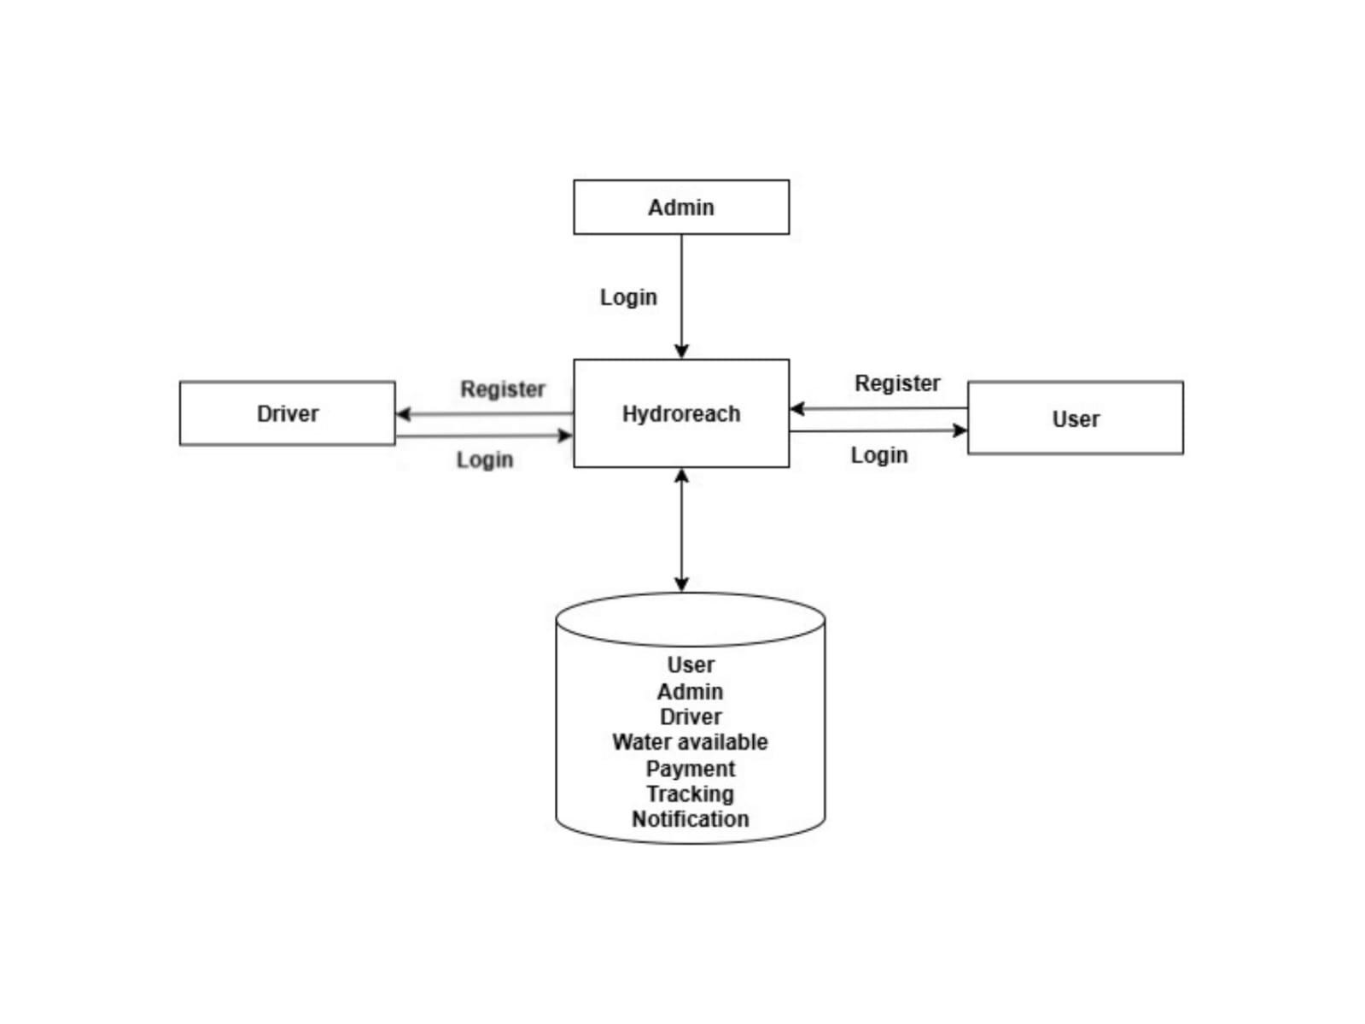

*FIGURE 5.1 SYSTEM ARCHITECTURE*

### 5.1 Overview of System Architectures

The Hydro Reach system follows a multi-tier architecture designed to efficiently manage smart water delivery operations. It consists of four primary layers: the User Interface Layer, which provides a responsive and intuitive interface for users, drivers, and administrators to register, log in, place water requests, track deliveries, and make payments; the Application Layer, which handles the core business logic such as request processing, delivery scheduling, notifications, payment verification, and authentication; the Database Layer, which securely stores all data including user profiles, delivery requests, driver details, payment records, and inventory information and the GPS & Payment Integration Layer, which enables real-time delivery tracking and secure online payment processing. All layers communicate through a centralized server, ensuring seamless data flow and interaction between modules. This architecture provides scalability, reliability, and efficiency, allowing Hydro Reach to deliver timely water services while maintaining secure and smooth system operations.

### 5.2 Presentation Layer (Frontend)

The Presentation Layer is the front-end interface of the Hydro Reach system and serves as the primary point of interaction for users, drivers, and administrators. It provides a visually intuitive and user-friendly environment where each type of user can easily perform their respective tasks. This layer is responsible for displaying information clearly, capturing user input, and sending it to the backend for processing. It ensures that the overall experience is smooth, responsive, and accessible across different devices such as desktops, tablets, and mobile phones.

For users, the Presentation Layer allows seamless registration and login through secure forms, followed by easy navigation to features such as placing water delivery requests, viewing available water packages, selecting quantity and location, tracking delivery progress in real time, and making secure online payments. The interface keeps users informed through alerts, status updates, and notifications.

For drivers, the frontend provides a simplified dashboard where they can view their assigned deliveries, check delivery details (customer information, location, quantity), and update the delivery status (Accepted, Out for Delivery, Delivered, or Delayed). This helps drivers stay organized and ensures transparency throughout the delivery process.

For administrators, the Presentation Layer offers powerful tools to monitor water stock, view and approve or reject user requests, assign tankers and drivers, manage delivery schedules, and track delivery status in real time. It also includes options to manage user and driver accounts, view transactions, and generate reports, enabling the admin to control the entire system from a single interface.

The interface is designed to be clean, responsive, and easy to navigate, ensuring a positive user experience for all roles. It uses HTML, CSS, and JavaScript for structure, styling, and interactivity, while frameworks like Bootstrap ensure mobile responsiveness. Optionally, advanced frontend frameworks such as ReactJS can be used to create dynamic, real-time, and interactive components for better performance and user engagement.

Overall, the Presentation Layer ensures that all interactions within Hydro Reach are efficient, visually appealing, and easy to use, making it a key component in delivering a smooth and reliable user experience across the entire system.

### 5.3 Application Layer (Backend)

The Application Layer serves as the backend of the Hydro Reach system, acting as the central hub where all core business logic and operational processes are executed. This layer is responsible for processing user requests, managing workflows, coordinating deliveries, verifying payments, and ensuring seamless communication between the frontend interface and the database. It acts as the intermediary that interprets frontend actions and translates them into secure, efficient operations that update the database and trigger appropriate notifications.

When a user places a water delivery request, the Application Layer processes the request, checks inventory availability, schedules delivery, and assigns a tanker and driver. It tracks delivery status in real time, ensuring that updates are communicated to users, drivers, and admins via notifications and alerts. The backend also handles payment verification, confirming successful transactions and updating records in the database while safeguarding sensitive financial information.In addition, the Application Layer manages secure authentication and authorization, ensuring that only authorized users, drivers, and administrators can access their respective functionalities. It maintains smooth interaction between the frontend and database, processing queries, performing validations, and handling errors to ensure reliable, uninterrupted system operation.

Technologies and Languages: The backend can be implemented using frameworks such as Python (Django/Flask), Node.js, Java, or PHP, depending on project requirements. It uses REST APIs or similar protocols to facilitate secure and efficient communication with the frontend. By executing business logic, coordinating workflows, and managing critical processes, the Application Layer ensures that Hydro Reach operates efficiently, securely, and reliably, providing a seamless experience for all users, drivers, and administrators.

### 5.4 Database Layer

The Database Layer forms the backbone of the Hydro Reach system, responsible for storing, managing, and securing all critical data required for smooth operations. It maintains structured and organized records of users, drivers, administrators, and delivery requests, ensuring that every transaction and action within the system is accurately recorded. This layer also stores payment details and transaction history, enabling secure financial tracking and accountability.

In addition, the Database Layer manages inventory and stock information, including the availability of water packages and tanker capacity, allowing the system to optimize resource allocation and ensure timely deliveries. It provides efficient data retrieval, reporting, and analytics capabilities, enabling administrators to generate detailed insights on delivery performance, stock utilization, user activity, and payment trends.

To maintain data integrity and consistency, the layer employs mechanisms for validation, error handling, and backup, ensuring that no critical information is lost and that the system remains reliable even in the event of failures. The database supports smooth communication with the backend, responding quickly to queries from the frontend or external modules such as payment gateways and GPS trackers.

Technologies and Languages: The Database Layer can be implemented using relational databases such as MySQL or SQLite, or non-relational databases depending on system requirements, with SQL used for querying and managing data efficiently. By centralizing all critical data and ensuring its accuracy, the Database Layer provides a robust foundation for the entire Hydro Reach system, supporting secure, reliable, and efficient operations across all modules.

### 5.5 System Communication Flow

The system communication flow in Hydro Reach is designed to enable smooth, real-time interactions between all components of the application, ensuring that users, drivers, and administrators experience a seamless and efficient service. The system architecture involves multiple layers, including the frontend interface, backend server, database, and external integration modules such as GPS tracking and payment gateways.Whenever a user, driver, or admin performs an action such as placing a water order, updating delivery status, or approving a request the frontend interface captures the input and sends it as a structured request to the backend server. The backend processes the request, performing necessary validations, executing business logic, and updating the database with the relevant information. The database responds with the requested data, such as order details, user information, or delivery status, which the backend then sends back to the frontend to display for the user.

In addition to database interactions, the backend communicates with external modules to enhance system functionality. For instance, it interacts with the GPS module to provide realtime tracking of deliveries, allowing both users and admins to monitor tanker locations accurately. Similarly, the payment gateway module ensures that transactions are securely processed and that payment confirmations are updated instantly in the system.

This structured communication flow guarantees that all components frontend, backend, database, and external integrations work in harmony, minimizing delays, preventing errors, and providing real-time updates. By maintaining efficient data exchange across layers, Hydro Reach ensures accurate, reliable, and timely operations, enhancing user satisfaction, improving delivery management, and supporting the overall robustness of the platform.

### 5.6 Security and Reliability

Security and reliability are foundational pillars of the Hydro Reach system, ensuring that users, drivers, and administrators can perform their tasks safely and without disruption. The system employs secure authentication protocols that require users to log in with verified credentials, along with strong password protection and data encryption, which safeguard sensitive information such as personal details and payment data from unauthorized access. Access control mechanisms further reinforce security by restricting system functions to authorized roles only users can place and track orders, drivers can update delivery statuses, and administrators can manage resources and approvals preventing any unauthorized operations or misuse of the platform.

Reliability is maintained through multiple layers of safeguards. The system includes error handling routines that detect and manage unexpected issues without causing failures, while backup mechanisms ensure that critical data, such as user profiles, delivery records, and payment transactions, is preserved even in case of hardware or software disruptions. Real-time monitoring tools continuously track system performance and operations, enabling prompt identification and resolution of potential issues before they affect users. Furthermore, the system performs regular validations and integrity checks on orders, payments, and delivery updates, ensuring that every process is executed accurately and consistently.

By combining robust security measures with reliable operational safeguards, Hydro Reach provides a trustworthy and dependable platform. Users can confidently register, place water delivery requests, make payments, and track orders, knowing that their data is secure and the service will remain uninterrupted. These comprehensive security and reliability practices not only protect the system against breaches and errors but also enhance overall user trust, contributing to a seamless and professional water delivery experience.

**CHAPTER-6**

## MODULES

### 6.1 User Module

The User Module is the core interface that enables customers to seamlessly access and utilize the services offered by the Hydro Reach system. The process begins with secure registration and login, which ensures that each user’s personal information is protected through authentication and encryption mechanisms. Once authenticated, users gain access to a personalized dashboard where they can manage and update their profile information, including contact details, delivery addresses, and service preferences. This feature ensures that the system can accurately process orders and provide a customized user experience.Users can place water delivery requests effortlessly by browsing the list of available water packages. Each package is clearly displayed along with its quantity options and pricing, allowing users to make informed decisions based on their specific requirements. After selecting the appropriate package, users can specify the desired delivery location and schedule, making the system flexible and convenient for diverse user needs. Once an order is placed, the module offers realtime tracking of the delivery process. Users are notified at each critical stage, including when the request is approved by the admin, when a tanker and driver are assigned, and when the delivery is out for dispatch. This transparency ensures users are always informed and can plan accordingly.To facilitate a smooth transaction, the

User Module integrates a secure online payment system, enabling users to pay for their deliveries safely through multiple payment options. The system confirms payment success and generates digital receipts, enhancing trust and accountability. Additionally, users receive timely notifications and alerts regarding the status of their orders, upcoming deliveries, or any changes in schedule, ensuring they are fully informed at all times.With its intuitive, interactive, and user-friendly interface, the User Module not only simplifies the process of placing and tracking water delivery requests but also enhances overall user satisfaction. By providing end-to-end control from profile management and package selection to real-time tracking and secure payment the module ensures that Hydro Reach delivers a reliable, transparent, and convenient service experience for all customers.

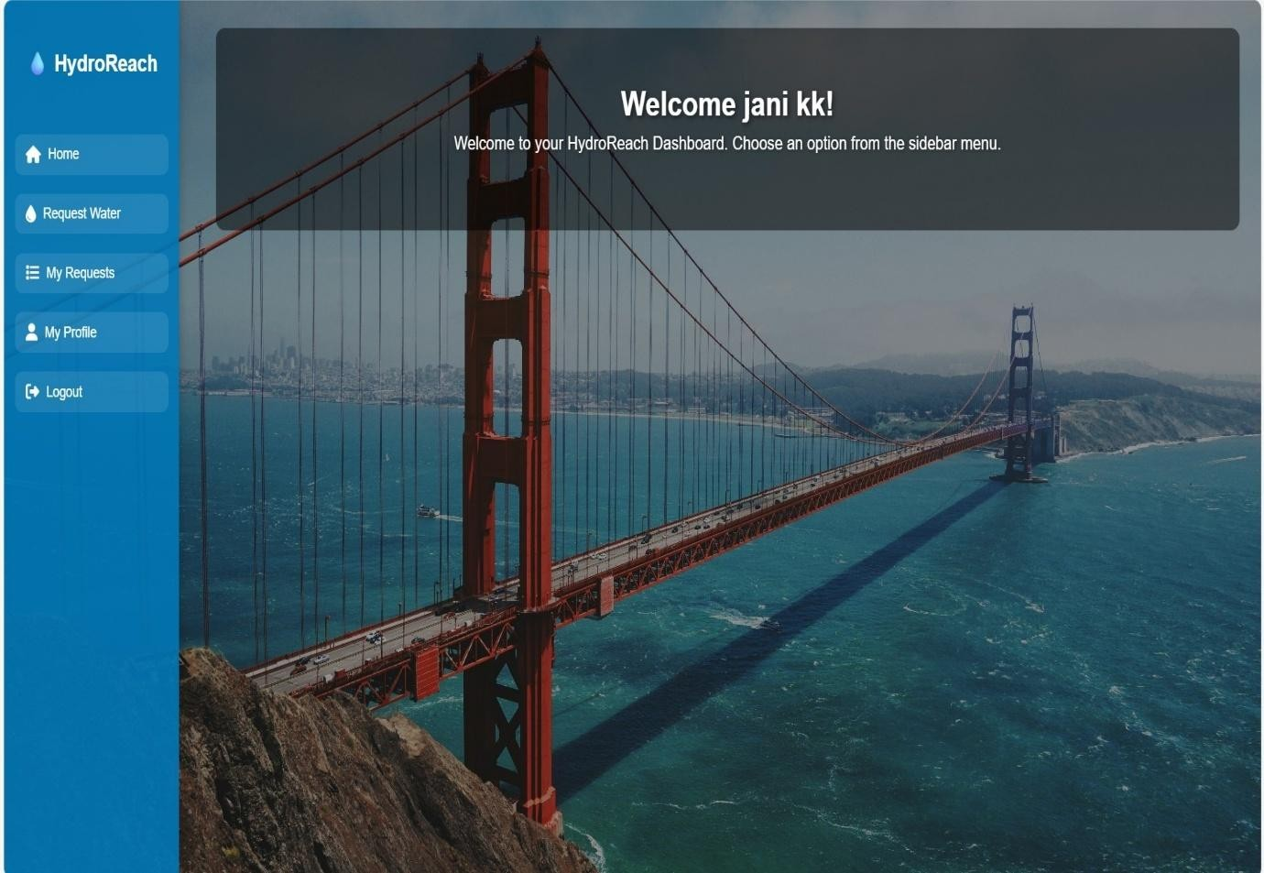

*FIGURE 6.1 USER MODULE*

### 6.2 Admin Module

The Admin Module is the core management component of the Hydro Reach Smart Water Delivery System, responsible for overseeing all operational, logistical, financial, and systemlevel activities to ensure a seamless and efficient water distribution process. The admin begins by managing user and driver accounts, where they verify new user registrations, authenticate identities, approve or reject driver applications, and control access by enabling, disabling, or modifying user roles and permissions. Through centralized profile and account management, the admin ensures platform security, prevents misuse, and maintains user authenticity.A major responsibility of the admin is water stock and resource management. This involves monitoring available water levels, updating stock after each delivery, managing tanker capacities, forecasting demand based on historical data, and scheduling refills to avoid shortages. When users place water delivery requests, the admin reviews, validates, and filters requests by checking water availability, delivery location, priority level, and system constraints. The admin then decides whether to approve or reject requests and provides appropriate feedback or reasons for rejection.

Once a request is approved, the admin oversees payment verification through the integrated online payment gateway. The admin ensures that transactions are successful, secure, and recorded properly in the system. After payment confirmation, the admin is responsible for tanker and driver assignment, where they match each delivery request with an available tanker and driver based on factors such as distance, delivery time, tanker capacity, fuel efficiency, and driver workload. The admin may also optimize delivery routes to reduce fuel usage and delivery time using route-planning techniques or GPS-based route mapping.

During the delivery process, the admin continuously monitors real-time delivery status through GPS tracking, ensuring that the driver follows the assigned route and timeline. The admin has the authority to update delivery status at each stage (Pending, Approved, Dispatched, Out-forDelivery, Delivered, or Cancelled). In case of any delays, traffic issues, emergencies, or customer requests for rescheduling, the admin can modify schedules, reassign drivers, reroute tankers, or reschedule deliveries, ensuring smooth service.Communication plays a vital role in the Admin Module. The admin can send automatic or manual notifications and alerts to users and drivers about approval status, tanker dispatch, payment confirmation, delivery schedules, delays, or feedback requests. Furthermore, the admin manages pricing structures, package creation, service areas, offer codes, delivery charges, and billing policies to maintain financial transparency and profitability.

To improve operational efficiency, the admin has access to an advanced analytics and reporting dashboard that compiles data about total requests, completed deliveries, pending orders, revenue streams, stock usage, payment history, tanker utilization, and driver performance. These insights allow the admin to make data-driven decisions, identify trends, reduce operational costs, and enhance service quality.

The admin also handles customer support and feedback management, addressing user complaints, resolving issues, enhancing satisfaction, and improving service policies based on feedback. They maintain system security by enforcing authentication, monitoring suspicious activities, safeguarding user data, and performing regular backups. In addition, the admin takes responsibility for system configuration, feature updates, maintenance, scalability planning, and performance optimization to ensure the application can support a growing number of users and deliveries.

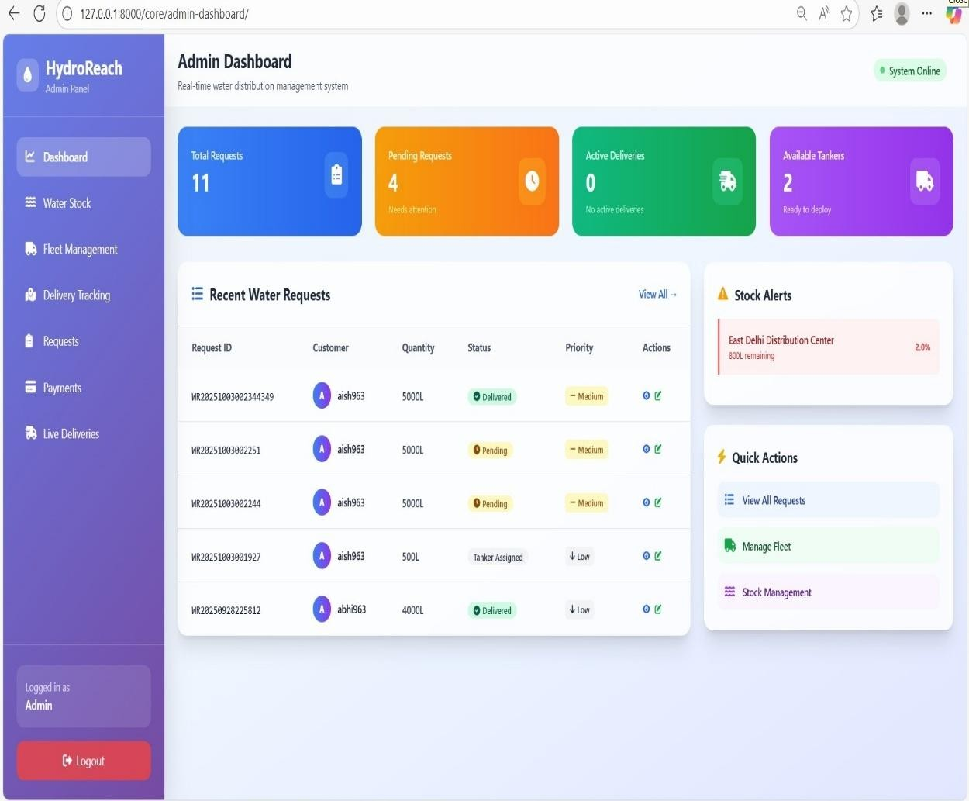

*FIGURE 6.2 ADMIN MODULE*

### 6.3 Driver Module

The Driver Module is a critical operational component of the Hydro Reach – Smart Water Delivery System, designed to empower delivery personnel with all the tools they need to efficiently transport water from the source to the customer doorstep. Drivers first register and log in to the system with secure authentication, after which their profiles are verified and approved by the admin. Once approved, drivers can view assigned tankers, check tanker details such as capacity, current water level, maintenance status, and upcoming delivery schedules. Each driver receives real-time delivery assignments once the admin approves customer requests and allocates a tanker. The driver can view full customer details, including name, contact number, address, delivery location pinned on a map, chosen water package, and preferred delivery time.Before starting the journey, the driver can accept or acknowledge the delivery task, and once confirmed, the system automatically updates the status to “Out for Delivery.” To assist in navigation, the module provides GPS-based route guidance, helping drivers follow the most optimized path to avoid traffic delays, reduce fuel consumption, and ensure timely delivery.

Throughout the process, the driver can update live delivery status, such as "On the Way," "Reached Location," "Delivery in Progress," and finally "Delivery Completed." These updates are instantly reflected in both the user and admin dashboards to maintain full transparency.In case of any issues such as route problems, tanker breakdowns, customer unavailability, or weather delays, the driver can immediately send alerts or request support from the admin. This feature enables quick problem resolution and helps avoid delivery cancellations. Additionally, drivers may have access to reschedule or reassign requests based on admin instructions.

After completing delivery, the driver confirms the water quantity delivered and can collect digital confirmation or e-signature from the customer if required.The Driver Module may also include performance monitoring tools, such as daily delivery history, total deliveries completed, customer feedback, and punctuality reports. This allows drivers to track their performance and maintain service quality. Moreover, drivers can manage their availability status (Available, On Duty, Off Duty), which helps admins in better driver allocation and workload balance. The module also supports in-app notifications, ensuring drivers receive instant updates on new tasks, changes in schedule, payment clearance, or tanker refilling instructions.

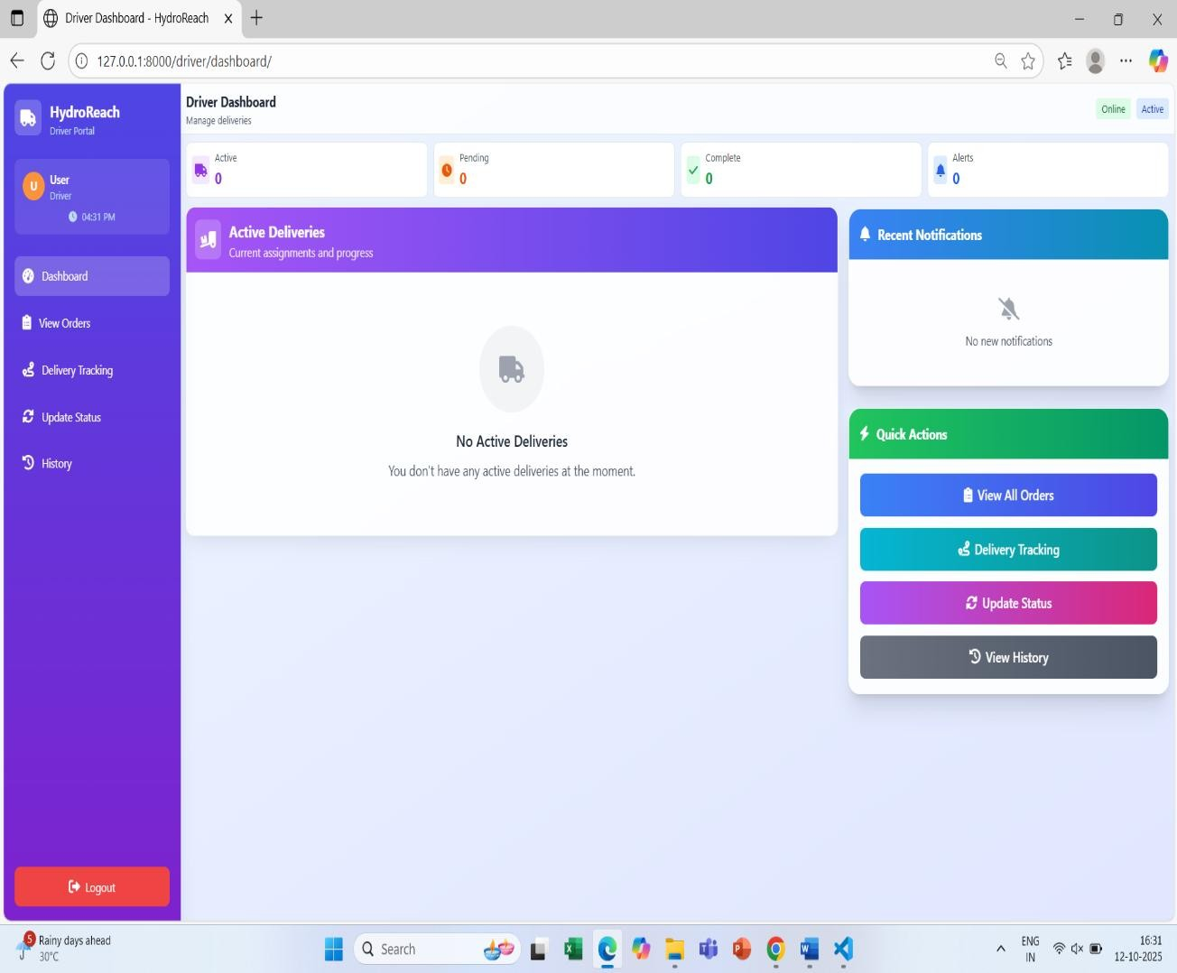

*FIGURE 6.3 DRIVER MODULE*

### 6.4 Payment Module

The Payment Module ensures secure and seamless financial transactions within the Hydro Reach system. Users can make online payments for water deliveries using integrated payment gateways, supporting multiple payment options such as credit/debit cards, UPI, and digital wallets. The module verifies payment status in real-time and updates the system to reflect successful or failed transactions. Administrators can also monitor all payment records, generate reports, and resolve discrepancies if any arise. By automating the payment process, this module enhances transparency, reduces manual errors, and ensures a smooth and trustworthy transaction experience for both users and the system administrators.

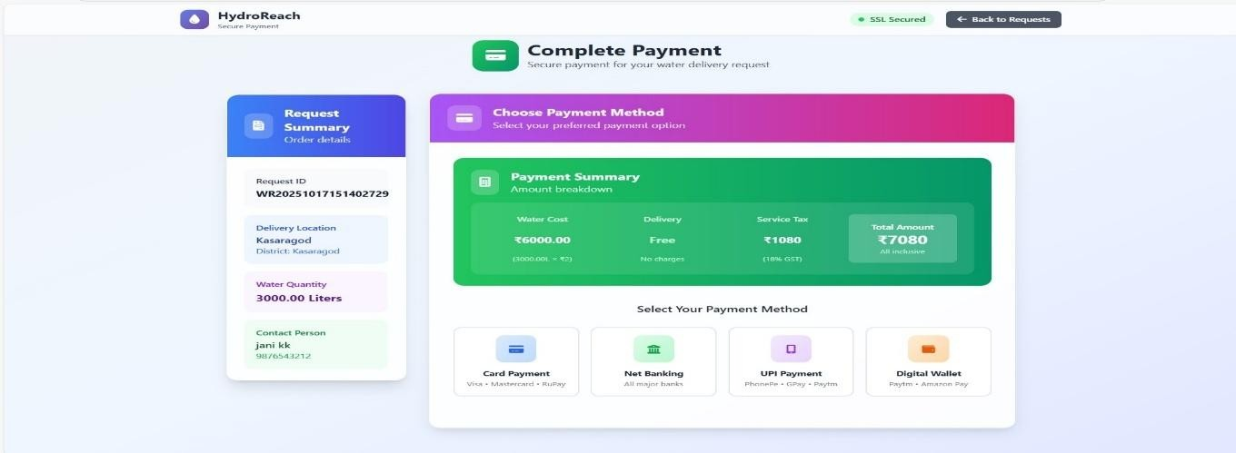

*FIGURE 6.4 PAYMENT MODULE*

### 6.5 Notification & Tracking Module

The Notification & Tracking Module enhances communication and transparency between the system, users, and drivers. Users receive real-time notifications regarding request approvals, delivery schedules, payment confirmations, and any changes to their orders. Drivers are informed of new assignments, route updates, and delivery priorities. Additionally, the system provides GPS-based tracking of water deliveries, allowing users and administrators to monitor the exact location and status of each order. This module ensures timely updates, improves operational efficiency, and builds user trust by keeping all stakeholders informed throughout the delivery process**.**

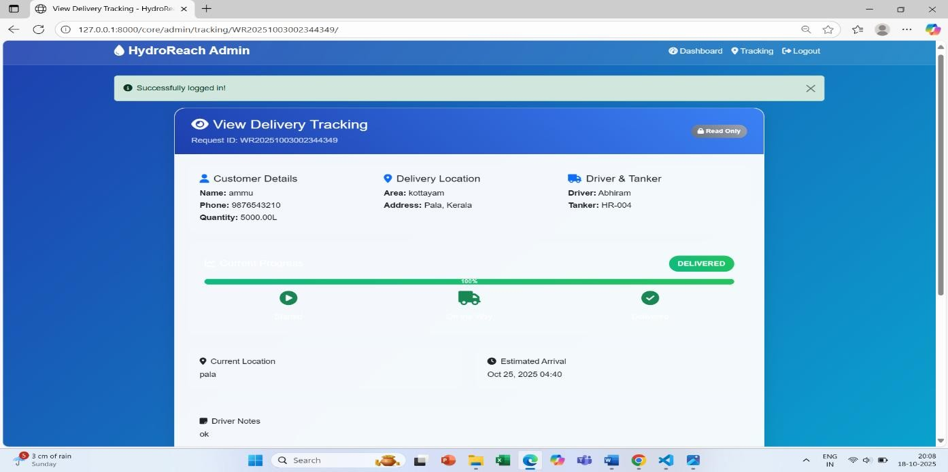

*FIGURE 6.5 NOTIFICATION &TRACKING*

**CHAPTER-7**

## DIAGRAMS

### 7.1 Data Flow Diagrams (DFD)

A DFD also known as a “bubble chart” has the purpose of clarifying system requirements and identifying major transformations that will become programs in system design. DFD consists of a series of bubbles joined by lines. The bubbles represent data transformations and the lines represents data flow in the system. A data flow diagram may be used to represent a system or software at any level of abstraction. DFD is a diagram that describes the flow of data and the processes that change or transform data throughout a system. It is a structured analysis and design tool that can be used or flowcharting in place of or in association with, information oriented and process-oriented system flowchart. When analyst prepare the DFD, they specify the user needs at a level of detail that virtually determines the information flow into and out of the system and the required data resources. This network is constructed by using a set of symbols that do not imply a physical implementation.

The DFD reviews the current physical system, prepare input and output specification, specifies the implementation plan etc. Data Flow Diagrams represent one of the most ingenious tools used for structured analysis. Data Flow Diagram or DFD as it is shortly called is also known as a bubble chart. It has the purpose of clarifying system requirements and identifying major transformations that will become programs in system design. It is the major starting point in the design phase that functionally decomposes the requirements specifications down to the lowest level of detail. DFD consists of a series of bubbles joined by lines. The bubble represents data transformation and lines represent data flow in the system.

#### 7.1.1 Context Level or Level 0 DFD

A Level 0 DFD is also called Context Diagram. It provides a high-level overview of the system or organization, illustrating the major processes and their interconnections. It represents thetop- level view of data flow without delving into the internal workings of individual processes. The main purpose of a Level 0 DFD is to provide a conceptual understanding of how data moves through the system. It's important to note that a Level 0 DFD is often the starting point for creating more detailed DFDs. As the analysis progresses, additional levels (such as Level 1, Level 2, and so on) can be developed to further decompose the main process into sub-processes and provide a more detailed representation of the system's functionality.

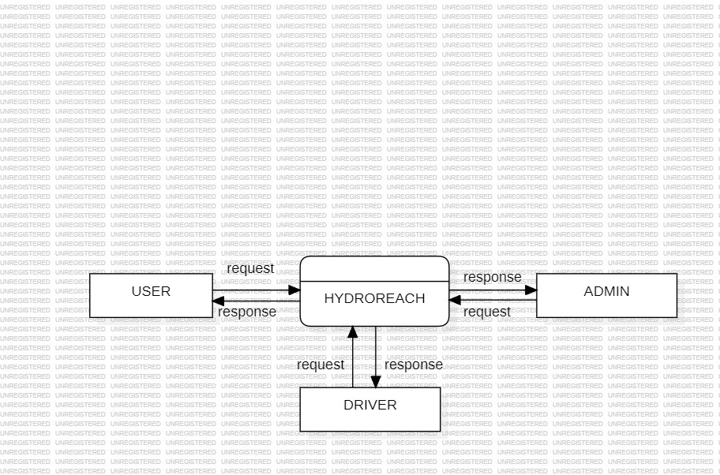

*FIGURE 7.1 LEVEL 0 DFD*

#### 7.1.2 Level 1 DFD

A Level 1 DFD provides a more detailed view of the system or organization compared to the Level 0 DFD. It decomposes the processes identified in the Level 0 DFD into sub-processes, showing the data flows between them. Here, the main functions carried out by the system are highlighted as we break into its sub-processes. The purpose of a Level 1 DFD is to provide a more granular understanding of how data moves and is processed within the system. Level 1

DFD can also be decomposed further into subsequent levels to provide an even more detailed view of the system's processes and data flows, depending on the complexity and requirements of the analysis.

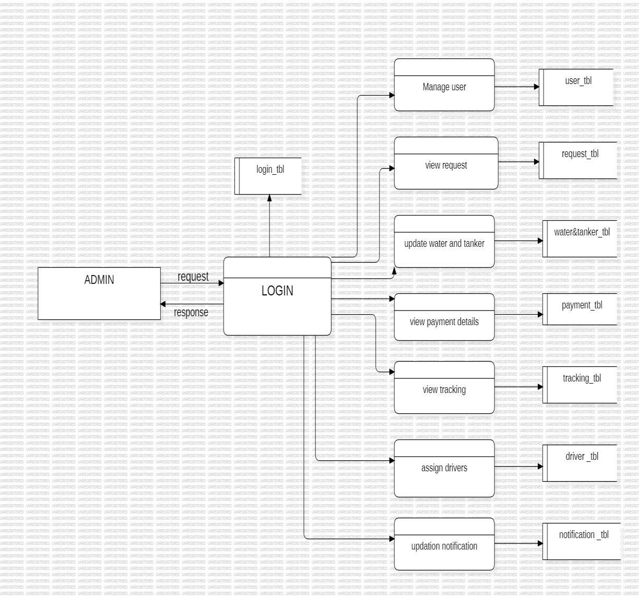

### *FIGURE 7.2 LEVEL 1 DFD*

#### 7.1.3 Level 2 DFD

The Level 2 DFD of the User Module provides a detailed view of how a user interacts with the HydroReach system. It shows sub-processes such as registration and login, placing water delivery requests, making payments, and receiving notifications. The diagram also illustrates data flows between the user, system processes, and databases, highlighting how information is stored, processed, and returned to the user. This detailed representation helps in understanding the internal workings of the User Module and ensures clarity in the system’s data processing.

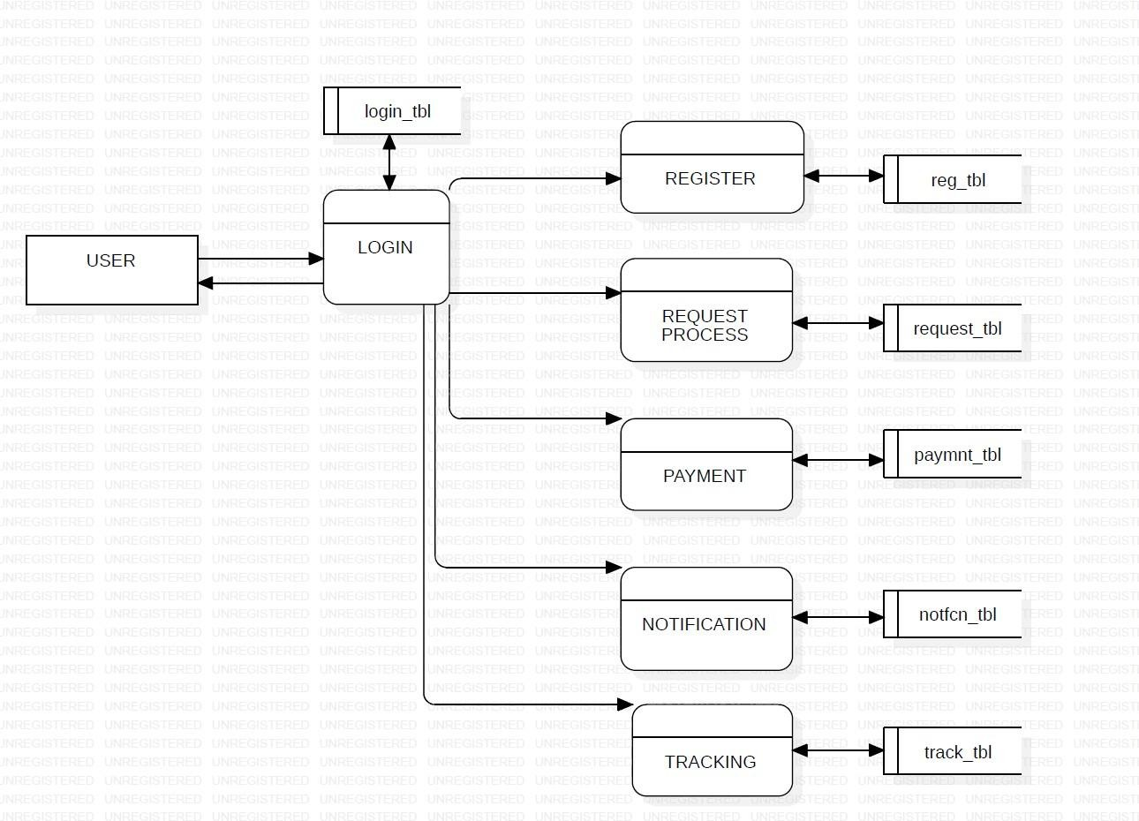

### *FIGURE 7.3 LEVEL 2*

#### 7.1.4 Level 3 DFD

The Level 3 DFD of the Driver Module provides a detailed breakdown of the processes involved in managing deliveries. It illustrates how drivers receive delivery assignments, access route information, update delivery status, and communicate with the system. The diagram also shows data flows between drivers, system processes, and relevant databases, highlighting how delivery information is tracked and updated in real-time. This detailed view helps in understanding the internal workings of the Driver Module and ensures smooth coordination between drivers, users, and administrators.

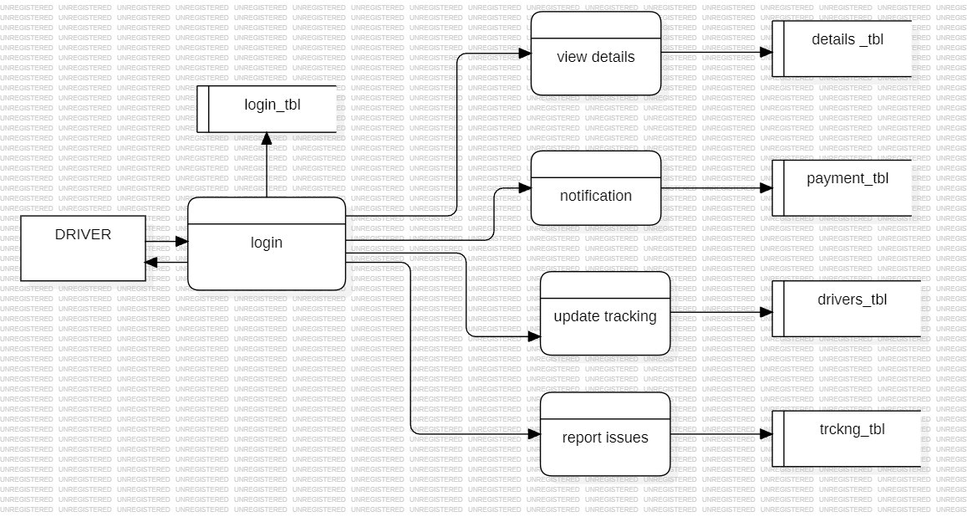

### *FIGURE 7.4 LEVEL 3*

**7.2 Class Diagram.**

The class diagram defines the main classes in the system, such as User, Admin, Driver, Water Request, Payment, and Delivery. It describes their attributes, methods, and how they are connected to each other through relationships. This helps in designing the structural blueprint of the entire system.

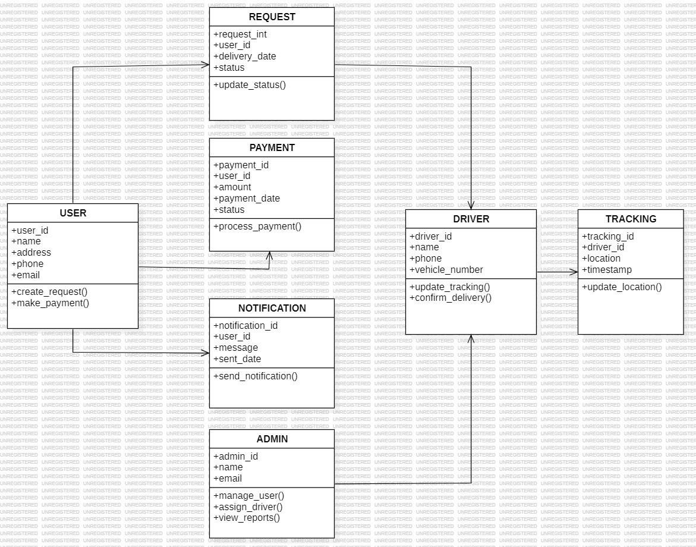

### *FIGURE 7.5 CLASS DIAGRAM*

#### 7.3 Use Case Diagram

The use case diagram represents how different actors such as Users, Admin, and Drivers interact with the Hydro Reach system. It clearly shows the key functions each actor can perform, such as placing requests, approving requests, assigning deliveries, and tracking status.

This helps in understanding the overall functionality from the user’s perspective.

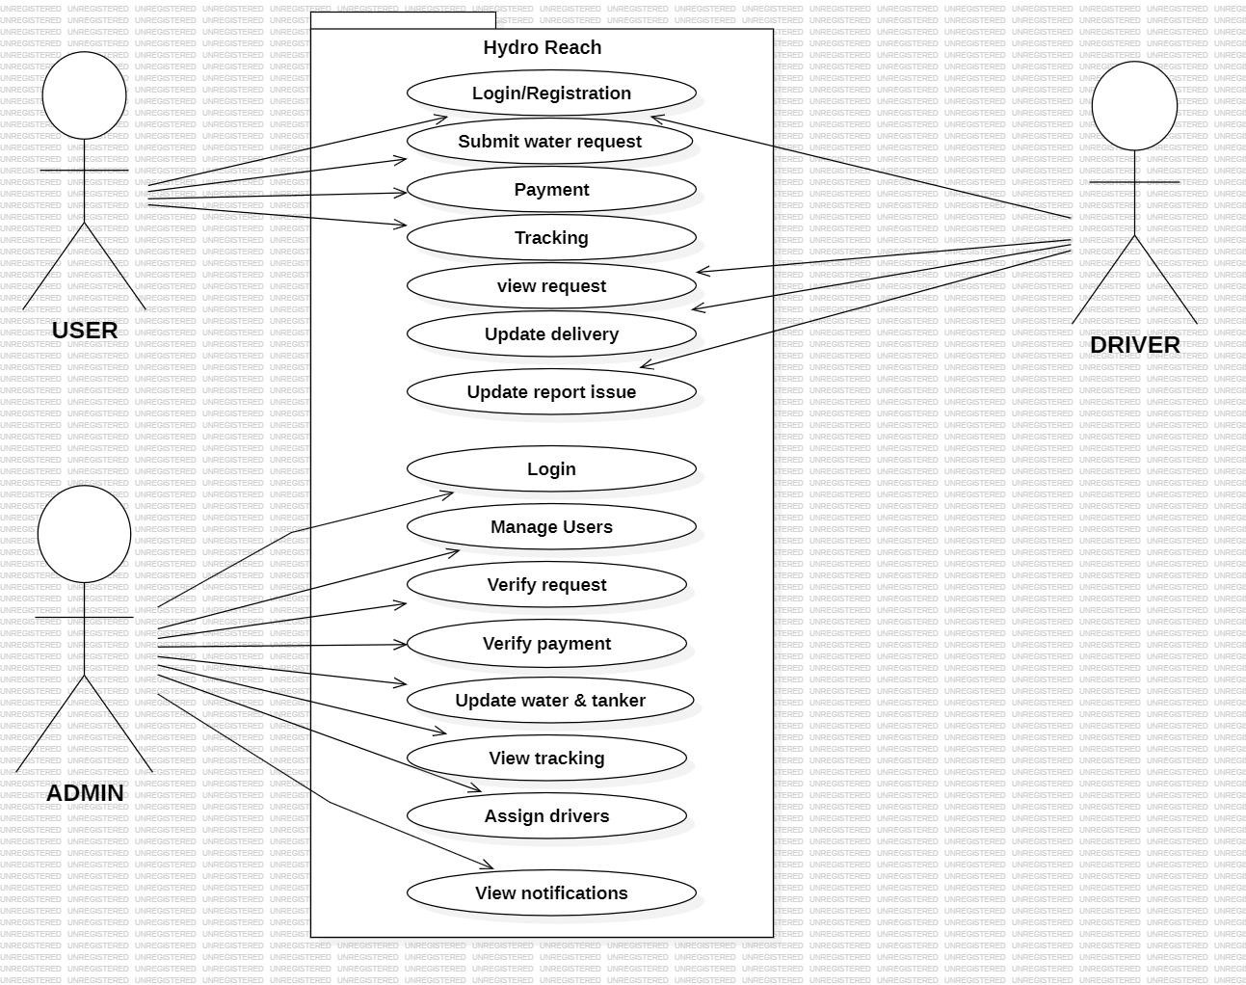

### *FIGURE7.6 USE CASE*

#### 7.4 Sequence Diagram

The sequence diagram explains the step-by-step flow of actions between system components over time. It shows how a user request is processed, approved by the admin, payment is verified, and delivery is assigned to the driver. This diagram highlights the order of communication and system behavior during operations**.**

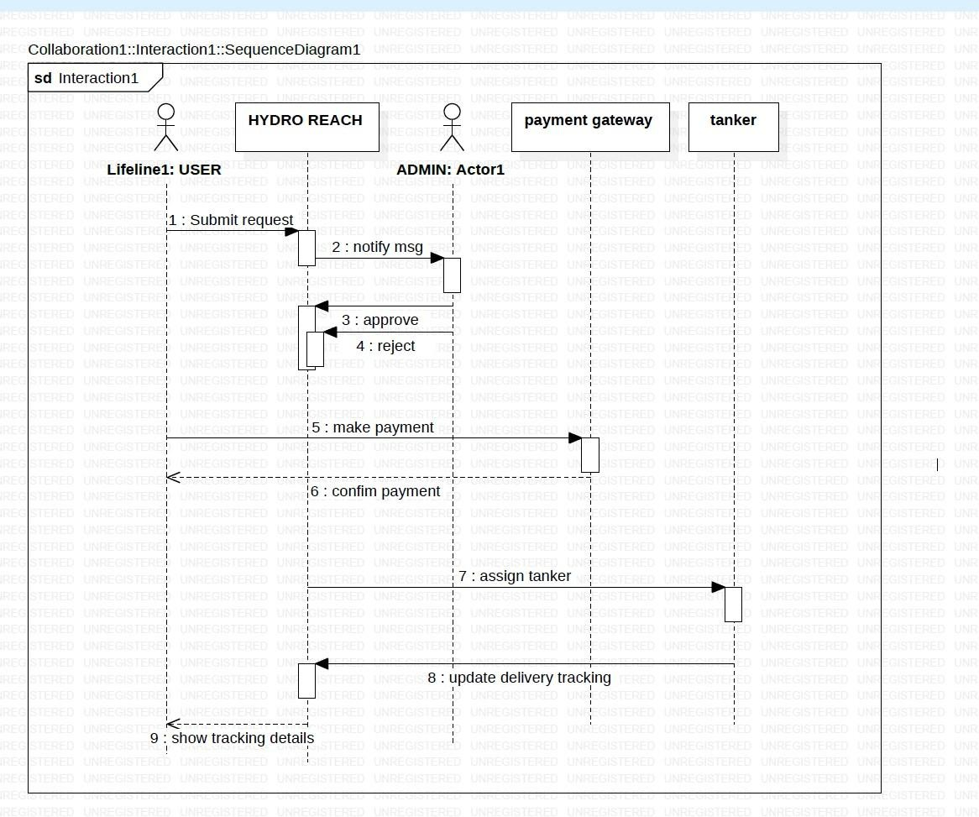

### *FIGURE 7.7 SEQUENCE DIAGRAM*

#### 7. 5 Entity Relationship Model (ER)

The Entity-Relationship (ER) Model is a conceptual framework used to design and represent the structure of a database. It helps identify the main entities, their attributes, and the relationships among them. In the context of a water delivery system, entities may include users, drivers, and water requests, each having specific attributes such as name, ID, or delivery status.

Relationships define how these entities interact—for example, a user places a water delivery request, and a driver fulfills it. ER diagrams provide a clear visual representation of the database, making it easier to plan, organize, and implement the system efficiently. This model ensures accurate data management and supports effective communication between developers and stakeholders

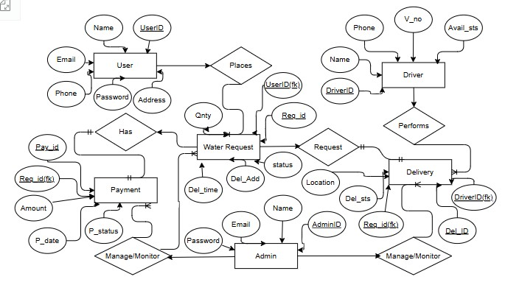

### *FIGURE 7.8 ENTITY RELATIONSHIP*

#### 7.6 Activity Diagram

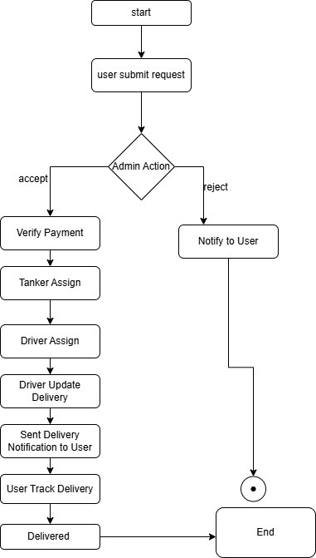

### *FIGURE:7.9 ACTIVITY DIAGRAM*

The Activity Diagram for the Hydro Reach system illustrates the complete workflow of water delivery, capturing the sequence of actions, decision points, and interactions among users, drivers, and administrators. It begins with the user logging into the system through secure authentication. After logging in, the user can browse available water packages, select the desired quantity, and place a delivery request. Once the order is submitted, the system proceeds to payment verification, where the payment status is checked. If the payment is successful, the request moves forward; otherwise, the user is notified to complete or correct the payment.

After payment confirmation, the admin reviews the request and assigns a tanker and driver to fulfill the delivery. The driver then collects the water from storage or depot and starts the delivery, updating the system with the current status, such as “In Transit.” Through the integrated Live Tracking feature, the user and admin can monitor the tanker’s real-time location and estimated arrival time. Upon reaching the destination, the driver delivers the water and updates the status to “Delivered”, completing the process.

The activity diagram also includes decision points and parallel activities, such as simultaneous payment verification and admin assignment, ensuring that the system operates efficiently. Optional remarks or status updates can be added by the driver in case of delays or issues, which helps maintain transparency and accountability. Overall, this diagram provides a clear visual overview of the end-to-end delivery process, showing how users, admins, and drivers interact, and how each activity is linked to decisions and notifications within the Hydro Reach system.

**CHAPTERS -8**

## TESTING

### 8.1 Testing

In the Hydro Reach system, testing is performed to verify that all modules operate correctly and efficiently. It ensures that the system is user-friendly, secure, and capable of handling multiple operations reliably under various conditions. Through testing, functional aspects such as user registration, water request placement, payment processing, and delivery tracking are validated. Additionally, usability, performance, security, and integration tests are conducted to identify potential errors and ensure smooth interaction between different system layers. This systematic testing process helps in detecting and resolving issues early, thereby enhancing the overall quality and reliability of the system before deployment.

In the Hydro Reach system, thorough testing is conducted to ensure that all modules function correctly, efficiently, and reliably. The testing process validates both the functional and nonfunctional aspects of the system, confirming that it is user-friendly, secure, and capable of handling multiple operations simultaneously under various scenarios. Functional testing focuses on core features such as user registration, profile management, water request placement, payment processing, tanker and driver assignment, and real-time delivery tracking, ensuring that each module performs as intended.

In addition to functional verification, the system undergoes usability testing to confirm that users, drivers, and administrators can navigate the interface intuitively and perform their tasks without confusion. Performance testing evaluates the system’s response time, scalability, and ability to manage concurrent requests, while security testing ensures that sensitive data, including personal information and payment details, is protected from unauthorized access. Integration testing is also performed to verify seamless communication between the frontend, backend, database, and external modules such as GPS and payment gateways.

By systematically executing these tests, the Hydro Reach system identifies and resolves potential errors or inconsistencies early in the development cycle. This process not only improves system stability and reliability but also enhances user satisfaction by delivering a robust, secure, and smooth water delivery experience. Ultimately, comprehensive testing ensures that the system is fully prepared for deployment and capable of maintaining high performance under real-world operating conditions.

**Testing principles are:**

* All tests should be traceable to customer requirements
* Testing should be planned long before the testing begins
* Testing should begin “in the small” and progress towards testing “in the large”.
* Exhaustive testing is not possible
* To be most effective, testing should be conducted by an independent third party.

**Testing objective are:**

* Testing is the process of executing a program within the intent of finding an error.
* A good test case is one that has high probability of finding an as yet undiscovered error.
* A successful test is one that un covers an as yet-undiscovered error

There are various testing strategies available to accommodate from low-level testing to high-level testing as discussed below.

### Test Plan

Testing is the major quality control measure employed during software development. In the project, the first test considered is the unit testing. In this unit testing, each module of the system is tested separately. This is carried out during programming stage itself. Each module should work satisfactory as regard from the module. After the entire module are checked independently and completed then the integration testing is performed to check whether there are any interface errors. Then those errors are verified and corrected and also the security test is performed to allow only authorized persons to this system. Finally the validation testing is performed to validate whether the customer requirements are stratified are not.

#### 8.2 Unit Testing

Unit testing is a software testing process in which individual modules or components of a software application are tested in isolation to ensure they function correctly according to the design specifications. The primary goal of unit testing is to verify the smallest parts of the software, such as functions, procedures, or classes, independently before integrating them into larger components or the complete system.

In this project, unit testing is carried out on the coding of each module. Each module is tested against the specifications produced during the design phase, ensuring that it meets the expected functionality. Testing begins with the lowest-level modules and proceeds gradually, focusing on one module at a time. During testing, specific test cases are created to examine all possible conditions, including boundary values, normal inputs, and edge cases, to ensure the module behaves correctly under all circumstances.

Unit testing emphasizes the verification of internal processing logic and data structures within the module boundary. It helps identify and fix logical errors, incorrect data handling, and unexpected behaviors at an early stage, reducing the likelihood of defects propagating to higher-level modules. The tests check individual functions, methods, and operations, validating both input processing and output generation.

This type of testing can be executed in parallel for multiple components, allowing different modules to be tested independently by separate testers or automated testing scripts. Unit testing is usually automated using frameworks or tools specific to the programming language, which improves efficiency, repeatability, and accuracy. Common unit testing frameworks include JUnit for Java, PyTest for Python, and NUnit for .NET applications.

The key advantages of unit testing include:

* Early detection of errors and bugs in the smallest units of code.
* Ensures that each module performs as intended before integration.
* Simplifies debugging by isolating issues within a single component.
* Improves code quality and reliability.
* Serves as documentation for developers to understand the expected behavior of modules.

In summary, unit testing is a critical verification step in software development, ensuring that each module or component is functionally correct, logically sound, and ready for integration into larger systems. It forms the foundation for higher-level testing, such as integration testing and system testing, by ensuring that the building blocks of the software are robust and reliable. **8.3 Security Testing**

Security testing is an essential phase of software testing aimed at ensuring that an application, system, or software component is protected from malicious attacks, unauthorized access, and potential vulnerabilities that could compromise sensitive data. The primary objective of security testing is to identify weaknesses in the system, evaluate the effectiveness of implemented security measures, and ensure that the principles of confidentiality, integrity, and availability (CIA) are maintained. This process involves examining various aspects of the system, such as authentication and authorization mechanisms, to ensure that only legitimate users can access the system and that each user has permissions corresponding to their role. Additionally, security testing verifies that sensitive information is securely stored and transmitted using encryption, preventing data leaks or interception during communication.A key part of security testing is the detection of potential vulnerabilities, including threats like SQL injection, cross-site scripting (XSS), buffer overflows, and session hijacking, which could allow attackers to manipulate or compromise the system. The testing process also evaluates session management, ensuring that user sessions are handled securely with proper timeouts, token validations, and protection against hijacking. Furthermore, error handling and logging are analyzed to confirm that system errors do not expose confidential data and that logs provide actionable insights for monitoring and investigating potential security incidents.

Security testing can be performed manually or automated using specialized tools such as OWASP ZAP, Burp Suite, Nessus, or Acunetix, which help identify vulnerabilities efficiently. Techniques like penetration testing, static and dynamic code analysis, and configuration compliance checks are commonly employed to simulate real-world attacks, review source code for flaws, and ensure that servers, databases, and networks are securely configured.The benefits of thorough security testing are significant. It protects sensitive user and organizational data, prevents financial losses and reputational damage, ensures compliance with legal and regulatory standards such as GDPR or HIPAA, and fosters user trust by demonstrating a secure and reliable system. In essence, security testing is not just a quality assurance measure—it is a critical safeguard that reinforces the robustness of the software, mitigates potential threats, and ensures that the system can operate securely in a real-world environment.

#### 8.4 Validation Testing

Validation testing is that validation succeeds when software functions in a manner that can be reasonably expected by the user. Validation testing begins after the culmination of integration testing, software is completely assembled as a package; interfacing errors have been uncovered and corrected.

The error detecting during this testing is

* Incorrect Function
* Input Condition Errors
* Database Error
* Performance Error
* Initialization and Interface Error

**8.5 Regression Testing.**

Regression testing is a software testing practice that ensures an application still functions as expected after any code changes, updates, or improvements. Regression testing is responsible for the overall stability and functionality of the existing features. Whenever a new modification is added to the code, regression testing is applied to guarantee that after each update, the system stays sustainable under continuous improvements. Changes in the code may involve dependencies, defects, or malfunctions. Regression testing targets to mitigate these risks, so that the previously developed and tested code remains operational after new changes. Generally, an application goes through multiple tests before the changes are integrated into the main development branch. Regression testing is the final step, as it verifies the product behaviour as a whole.

#### 8.6 Integration Testing

Integration testing in the Hydro Reach system focuses on verifying that all modules and layers work together seamlessly as a complete system. It ensures proper communication and data flow between the User Interface, Application Layer, Database, and GPS/Payment Integration Layer. For example, when a user places a water delivery request, the information must correctly pass from the front-end interface to the backend for processing, update the database, notify the driver, and reflect the delivery status in real time. Similarly, successful payment transactions must be accurately recorded in the database and trigger appropriate notifications to both the user and admin. Integration testing also validates hat updates from drivers, such as marking a delivery as completed, are synchronized across the system and displayed correctly to users and administrators. This testing helps identify any mismatches, delays, or failures in inter-module communication, ensuring that the Hydro Reach system operates reliably as a unified platform for smooth water delivery operations.

**CHAPTER-9**

## ADVANTAGES & DISADVANTAGES

### 9.1 Advantages

* Convenient Water Ordering: Users can easily place water delivery requests online without physically visiting shops, saving time and effort.
* Real-Time Delivery Tracking: GPS integration allows users to monitor the exact location and status of their water delivery in real time.
* Secure Online Payments: Integrated payment gateways enable safe and reliable transactions, minimizing the risk of fraud.
* Efficient Resource Management: Admins can effectively manage water stock, assign drivers, and track delivery schedules to ensure timely service.
* Timely Notifications: Users, drivers, and admins receive instant alerts for request approvals, payment confirmations, and delivery updates.
* User-Friendly Interface: The system provides an intuitive and accessible interface for users, drivers, and administrators, improving overall usability.
* Reduced Delivery Errors: Automated request processing and driver assignment minimize human errors and miscommunication.
* Enhanced Customer Satisfaction: Faster, reliable, and trackable water deliveries improve the overall user experience.
* Scalable System: The architecture allows for future expansion, such as adding more delivery zones or integrating advanced analytics.
* 24/7 Accessibility: Being a web-based system allows users to place orders or track deliveries anytime, increasing convenience and flexibility.
* Data-Driven Insights: Admins can generate reports and analyze delivery patterns to optimize routes, stock levels, and service efficiency.
* Improved Communication: Integrated notifications and status updates enhance communication between users, drivers, and administrators.
* Environmental Benefits: Optimized delivery routes and schedules reduce fuel consumption and carbon footprint.
* Role-Based Access Control: Different levels of access ensure security, giving users, drivers, and admins only the permissions they need.
* Emergency Handling: The system can quickly notify admins and reroute deliveries in case of emergencies or unexpected disruptions, maintaining service continuity.

### 9.2 Disadvantages

* Internet Dependency: The system requires an active internet connection, which may be a limitation in areas with poor connectivity.
* Initial Setup Cost: Setting up the system with GPS tracking, payment gateways, and server infrastructure can be expensive initially.
* Technical Issues: System failures, server downtime, or bugs may temporarily disrupt services and delay deliveries**.**
* Limited to Registered Users: Only users registered in the system can access services, which may exclude occasional customers.
* Privacy and Security Risks: Although secure, online systems are still vulnerable to hacking, data breaches, or unauthorized access if proper measures are not maintained.

**CHAPTER-10**

## RESULTS

The Hydro Reach Smart Water Delivery System successfully achieved its primary objective of digitalizing and automating the water delivery management process. The system provided a centralized platform that allowed users, admins, and drivers to collaborate seamlessly. During implementation and testing, the application demonstrated high reliability, accuracy, and improved service efficiency compared to traditional manual methods. The user interface was found to be intuitive, making it easy for users to register, log in, place water delivery requests, and track their orders without technical difficulty. The real-time tracking feature allowed customers to monitor the movement of the tanker, increasing transparency and trust in the service.

One of the key results of this project was the streamlined request and approval process. Previously, users had to contact suppliers through phone calls or physically visit water suppliers, leading to delays and miscommunication. With Hydro Reach, all requests were processed digitally, and the admin could view, validate, and approve them within seconds. This automation significantly reduced processing time and eliminated confusion or duplicate requests. Users also received notifications about their request status, ensuring clear communication and improved user experience.

The project also demonstrated a robust water stock and tanker management system. Admins were able to update the availability of water stock and tanker capacity in real-time, which helped in efficient resource allocation. This prevented overbooking, stock shortages, or delivery delays. The integration of secure online payment gateways ensured smooth and trustworthy transactions. After successful payment, the system automatically updated the order status, allowing the admin to verify the payment before tanker assignment. This greatly improved financial transparency and reduced the risk of fraud or manual errors.

Another important result was the efficient driver assignment and delivery tracking process. Once an order was approved and payment was verified, the admin could assign the delivery to a specific driver. The driver received complete details such as user name, delivery address, water quantity, and contact number, ensuring clarity and reducing miscommunication. During delivery, drivers could update the delivery status, which was visible to both admin and user. The real-time GPS tracking feature allowed users to view the live location of the tanker, enhancing trust and satisfaction.

The system proved to be scalable and flexible, allowing multiple users and requests to be handled simultaneously without performance issues. It was tested under different scenarios such as high request volume, delayed payments, and driver reassignment, and it operated smoothly. The modular design of the system made it easy to maintain and update individual components without affecting the entire application. This shows that Hydro Reach has strong potential for future expansion, such as integrating water quality reports, subscription plans, or IoT sensors.

From the admin perspective, the platform provided valuable analytics and insights. The admin could track total requests, approved or rejected orders, completed deliveries, available stock, and driver performance. These insights helped in making data-driven decisions and improving overall operational efficiency. Admins also appreciated the automation of repetitive tasks like verification, stock updates, and notifications, which saved time and reduced workload. As a result, the system greatly improved workflow efficiency and reduced manual dependency.

In terms of user satisfaction, the project received positive feedback during testing. Users appreciated the convenience of placing orders from home, choosing preferred delivery time, making secure payments, and tracking deliveries in real time. They no longer had to face uncertainty or delays, and the platform provided a modern, transparent, and reliable service experience. The ability to view past orders and payment history also helped users manage their consumption and expenses better.

The project also highlighted the importance of real-time communication among all stakeholders. By ensuring that every action whether request approval, payment confirmation, driver assignment, or delivery status was instantly updated and visible, the system eliminated confusion and increased coordination. This feature played a major role in improving service speed and accuracy. It also helped handle emergency or priority requests effectively.

Hydro Reach project successfully met its goals of digital transformation, operational efficiency, and user satisfaction. It provided a complete solution to the existing problems in water delivery systems, such as delays, mismanagement, lack of transparency, and manual processes. The results proved that technology-driven systems like Hydro Reach can significantly improve public utility services and can be adopted on a large scale. The project not only delivered functional success but also created a strong foundation for future enhancements like mobile app integration.

In conclusion, the implementation of Hydro Reach demonstrated that a well-planned and welldesigned web-based system can transform water delivery into a smart, automated, and usercentric service. The project provided clear outcomes in terms of faster request handling, accurate stock management, secure transactions, reliable tracking, and improved communication. These results make Hydro Reach a highly effective and scalable solution that has the potential to be deployed in urban and rural areas, benefiting both service providers and consumers.

**CHAPTER-11**

## CONCLUSION & FUTURE SCOPE

The Hydro Reach Smart Water Delivery System has been developed to provide a modern, efficient, and user-friendly solution for water distribution and delivery management. In today’s fast-paced world, the need for convenient, timely, and reliable access to essential resources like water is paramount. Traditional water supply systems often face challenges such as delays, mismanagement, lack of tracking, and inefficient allocation of resources. Hydro Reach addresses these issues by integrating digital technologies, automated workflows, and real-time monitoring, thereby significantly enhancing the overall water delivery experience for users.

The system is built on a multi-tier architecture, comprising the Presentation Layer (Frontend), Application Layer (Backend), Database Layer, and GPS/Payment Integration Layer. Each layer serves a specialized function to ensure seamless communication and reliable operations. The Presentation Layer provides an intuitive and responsive interface for users, drivers, and administrators, making it easy to register, place water requests, track deliveries, and process payments. The Application Layer efficiently handles core business logic, including request processing, driver assignment, payment verification, and notification management. The Database Layer stores and manages critical data, maintaining data integrity and supporting analytics for monitoring system performance. The GPS and Payment Integration Layer enables real-time tracking of deliveries and secure online payments, ensuring transparency and trust between users and service providers.

Throughout the development of HydroReach, various testing methodologies were employed to guarantee system functionality, usability, security, and reliability. Functional testing ensured that all modules, including user registration, water request placement, delivery tracking, and payment processing, worked as intended. Usability testing validated that the system interface was simple, intuitive, and accessible for all users. Performance testing confirmed that the system could handle multiple users and deliveries simultaneously without delays or crashes. Security testing safeguarded sensitive data such as user credentials and payment information, while integration testing ensured that all system layers and modules communicated effectively. Unit testing helped identify and fix potential issues at the earliest stage, ensuring each component worked independently before integration. The comprehensive testing process reinforced the system’s robustness, accuracy, and reliability, which are essential for a serviceoriented application. Although the current version of Hydro Reach fulfills its core objectives, there are numerous opportunities for future expansion to make the system more intelligent, automated, and scalable. One key enhancement is the integration of IoT-enabled smart sensors in water tankers to monitor water levels, quality, and delivery accuracy in real time. AI and Machine Learning can be used for demand forecasting, helping the admin predict future water requirements based on seasonal patterns and user behavior. A mobile application (Android/iOS) can be introduced to improve accessibility and allow users to place requests, track tankers using GPS, and receive push notifications instantly. The addition of multipayment gateways and UPI integration will further enhance convenience and financial transparency. Introducing route optimization algorithms can help assign the nearest drivers and reduce fuel consumption and delivery time. The system can also be extended to support government pipelines, rural communities, and emergency water supply management. Multilingual support and chatbot-based customer assistance will make the platform more userfriendly. In the long term, Hydro Reach can evolve into a fully automated smart water distribution ecosystem, integrated with smart meters, digital subsidies, and renewable energypowered delivery systems, thereby contributing to sustainability and smart city development.

**APPENDICES**

## Admin.py

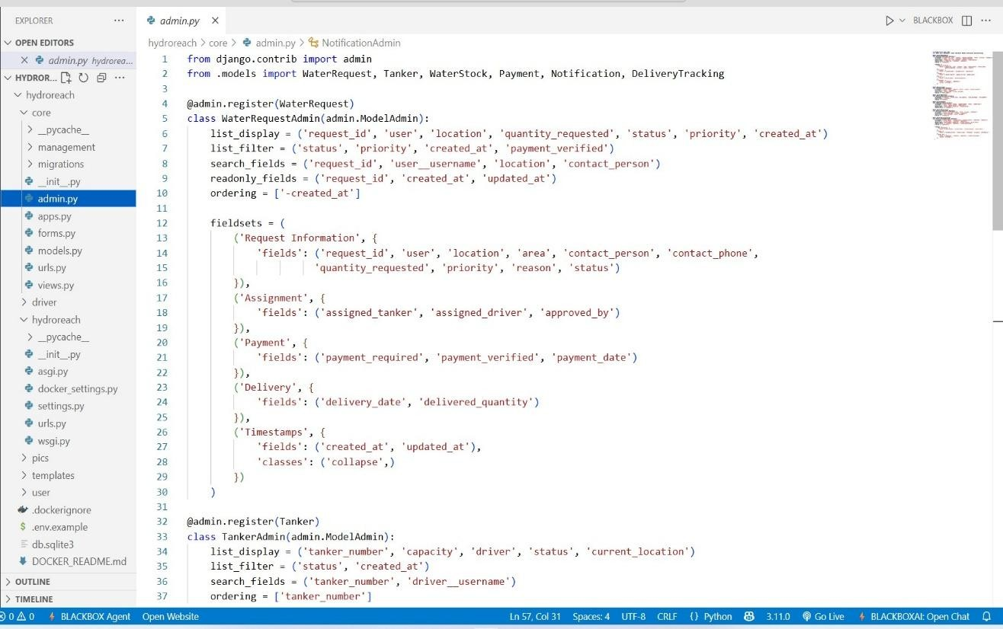

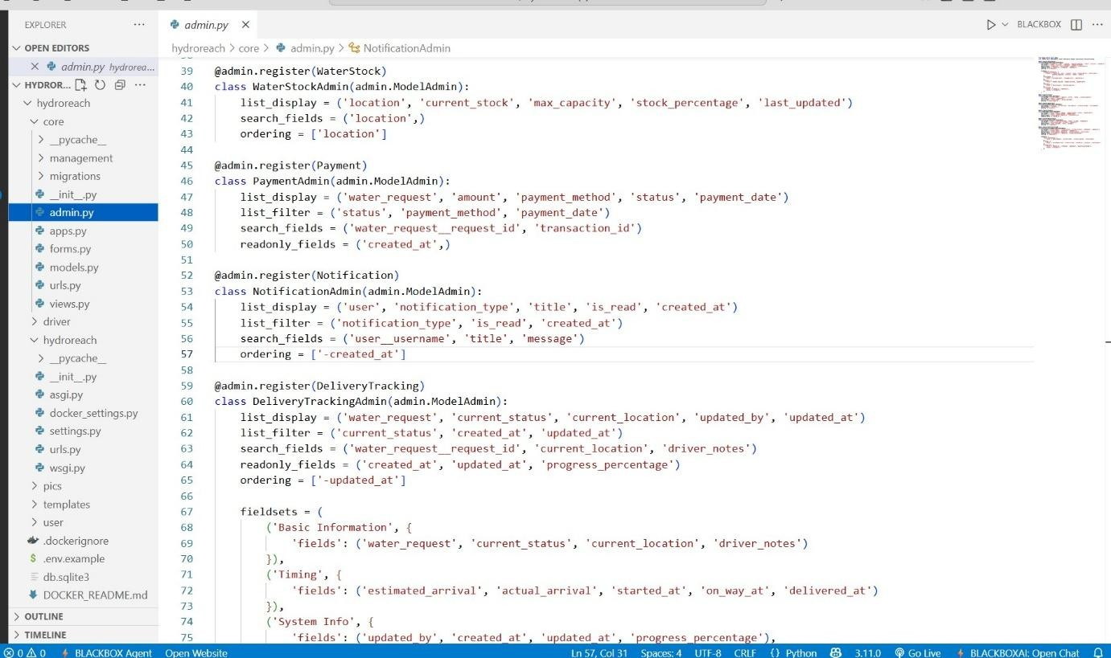

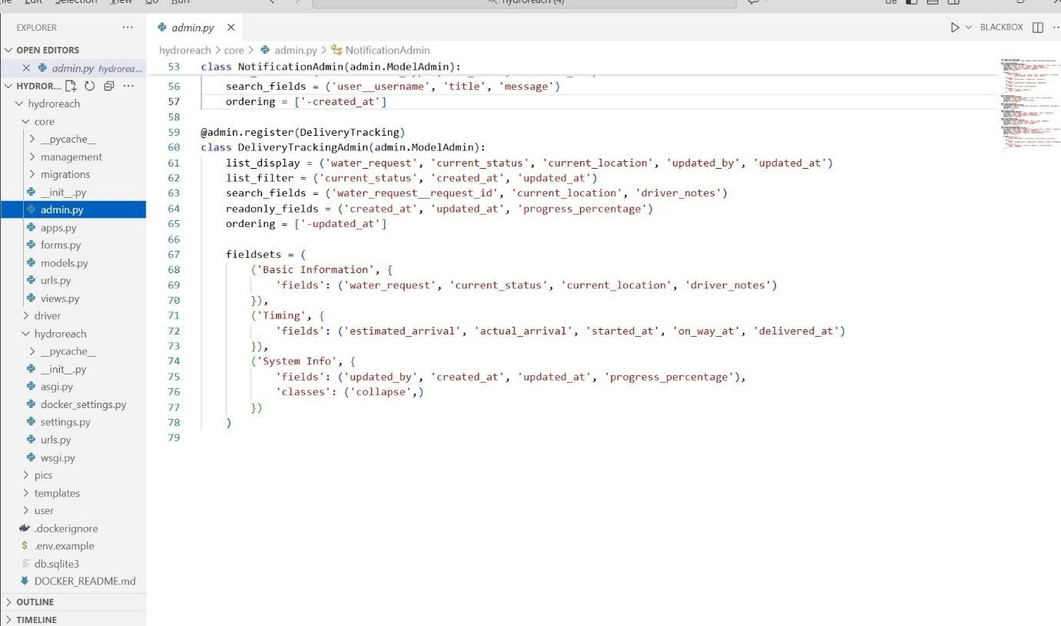

## Form.py

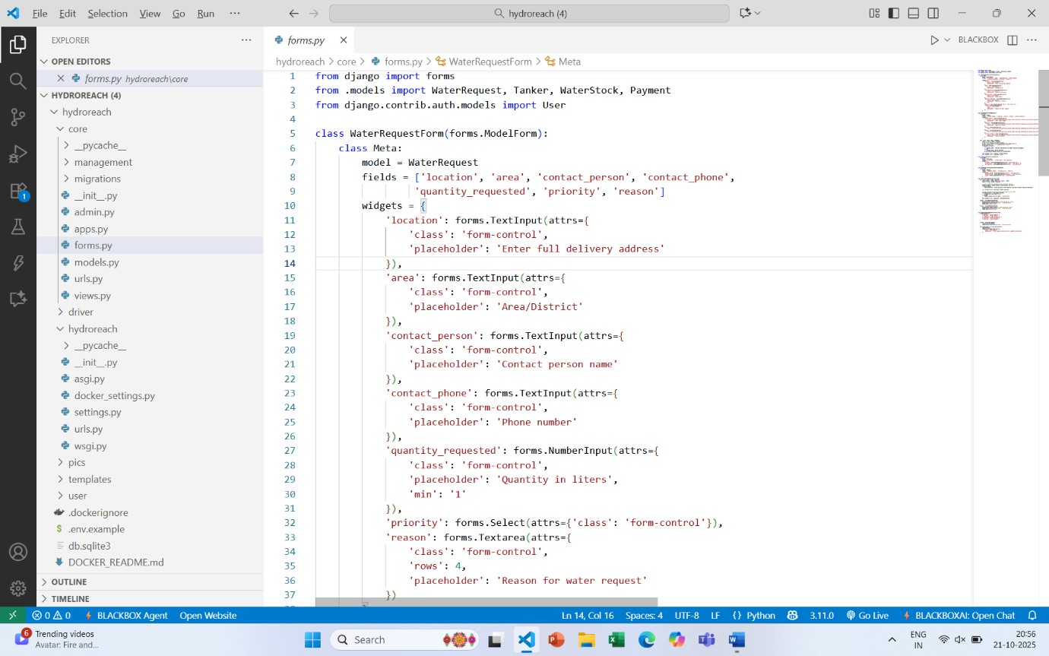

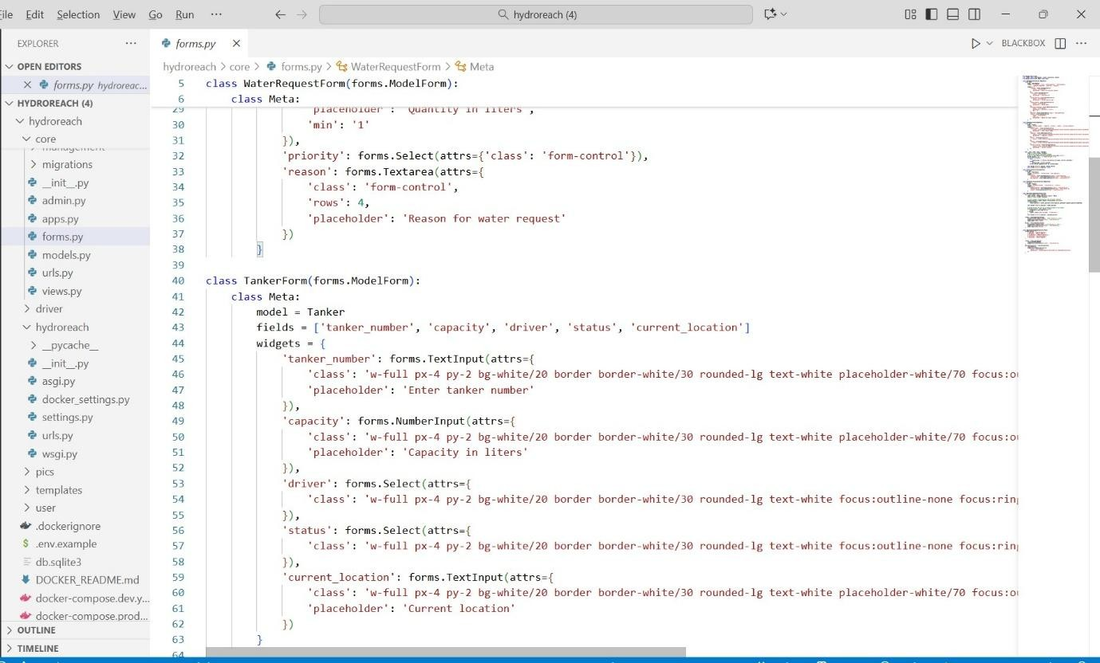

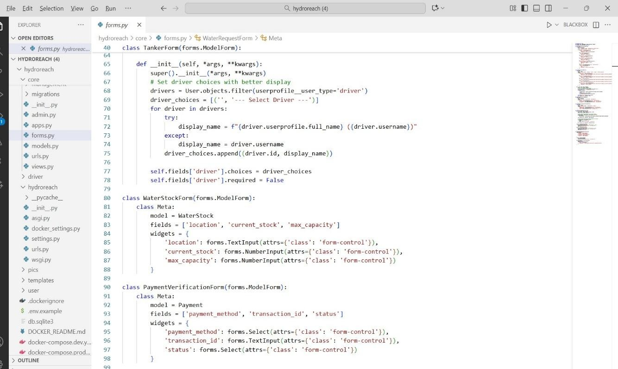

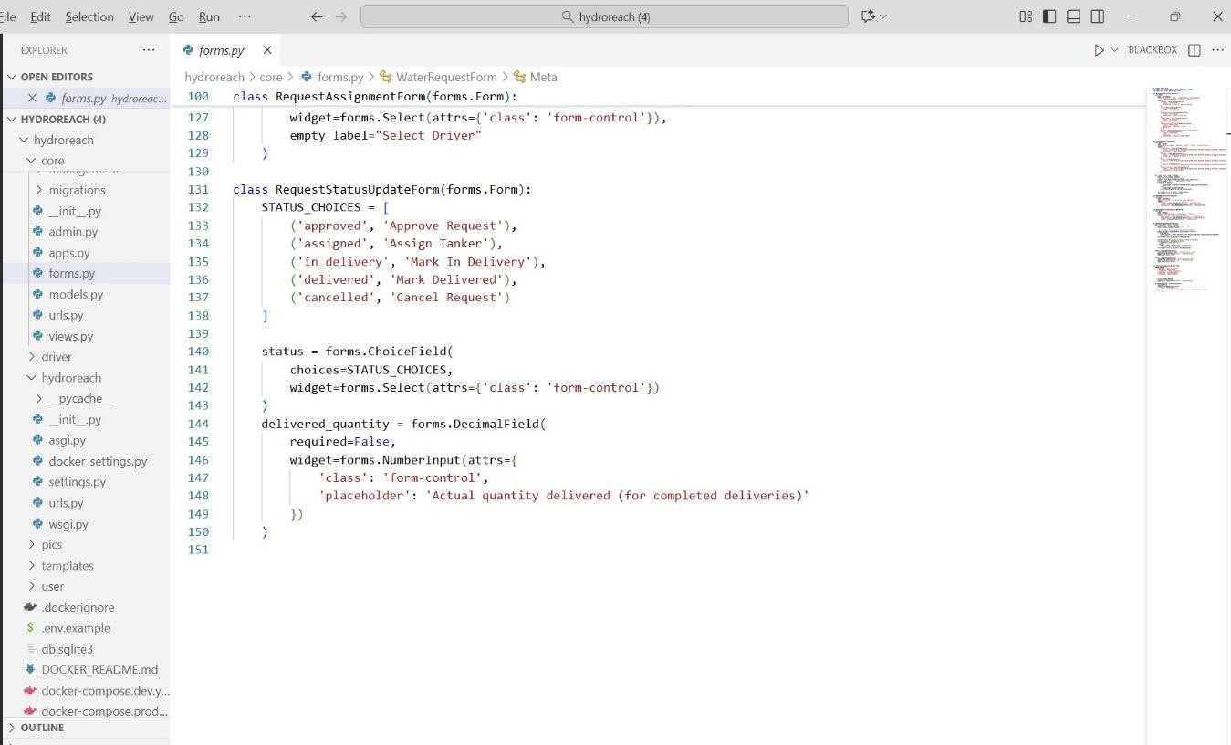

## REFERENCES

[1]¹ M. V. Vidyadhara, “Rural Drinking Water Supply in India – An Overview,” 2024.

[2]² S. Singh, M. Choudhary, and K. Sorensen, “Demonstration of Real-Time Monitoring in Smart Graded-Water Supply Grid,” 2023.

[3]³ R. Brindha, A. Geetha, and K. Ganesan, “Implementation of an Intelligent Drinking Water Supply System Using GIS Mapping and Smart Metering for Reliable Water Supply Management,” 2024.

[4]⁴ S. Narayanan and R. Deepa, “Machine Learning-Based Water Demand Forecasting in IoT-Enabled Distribution Networks,” 2020.

[5]⁵ S. Chidiac, “A Comprehensive Review of Water Quality Indices,” 2023.

[6]⁶ R. Mehta and V. Singh, “Smart Water Distribution and Leakage Detection Using IoT and Data Analytics,” 2021.

[7]⁷ P. Kumar and S. Bansal, “Supports Smart City Water Management,” 2020.

[8]⁸ A. Sharma and R. Kulkarni, “Machine Learning-Based Urban Water Demand Forecasting,” 2022.

[9]⁹ M. Jamadarkhani, “IoT-Enabled Smart Water Metering Using Multi-Sensor Data,” 2022.

[10]¹⁰ “Applications of Smart Water Management System,” (Technical Report / Conceptual Study).

1. R. Banerjee and S. Patel, “Machine Learning-Based Water Demand Forecasting for Smart Cities,” International Journal of Environmental Science and Technology, vol. 19, no. 4, pp. 2251–2262, 2022.
2. M. L. Fernandez and P. Gupta, “IoT-Enabled Water Quality Monitoring System for Urban and Rural Areas,” Journal of Smart Infrastructure and Water Systems, vol. 7, no. 3, pp. 78–87, 2021.
3. A. Kumar and S. R. Patel, “Automated Water Delivery and Scheduling System Using IoT,” International Journal of Innovative Research in Computer Science, vol. 15, no. 2, pp. 89–95, 2021.
4. N. Verma and P. Singh, “Secure Online Payment Integration in Web Applications,” International Journal of Computer Applications, vol. 182, no. 14, pp. 10–16, 2021.
5. T. Ramesh and D. K. Menon, “GPS-Based Real-Time Tracking System for Logistics and Delivery Services,” IEEE International Conference on Smart Technologies, pp. 245–250, 2020.
6. P. Lakshmi and B. Narayanan, “Role-Based Access Control in Web

Applications,” Journal of Information Security and Applications, vol. 26, no. 2, pp. 60–68, 2019.

1. S. Ahmed and R. K. Dash, “Scalable Architecture for Online Delivery Management Systems,” International Journal of Advanced Networking and Applications, vol. 13, no. 5, pp. 5123–5130, 2022.
2. D. Bose and K. Sen, “Admin Dashboard Design for Efficient System Monitoring,” International Journal of Human-Computer Interaction, vol. 9, no. 1, pp. 30–38, 2023.
3. M. R. Shaikh and V. D. Kulkarni, “Real-Time Notification System Using Firebase Cloud Messaging,” International Journal of Computer Science Trends and Technology, vol. 8, no. 6, pp. 15–21, 2020.
4. S. Thomas and J. Mathew, “Tanker Management and Resource Allocation in Water Delivery Systems,” Journal of Sustainable Water Engineering, vol. 5, no. 2, pp. 100–108, 2024.

 Page 1 of 75 - Cover Page Submission ID trn:oid:::10159:117161327

# Praverna Prakash

plagiarism

MINIPROJECT REPORT PLAGARISM CHECKING



**Document Details**

|  |
| --- |
| **63 Pages**  **18,110 Words**  **109,652 Characters** |

**Submission ID trn:oid:::10159:117161327**

**Submission Date**

**Oct 17, 2025, 3:42 PM GMT+5:30**

**Download Date**

**Oct 17, 2025, 3:44 PM GMT+5:30**

**File Name plagiarism.pdf**

**File Size**

**3.5 MB**

 Page 1 of 75 - Cover Page Submission ID trn:oid:::10159:117161327  Page 2 of 75 - Integrity Overview Submission ID trn:oid:::10159:117161327

## 18% Overall Similarity

The combined total of all matches, including overlapping sources, for each database.

**Match Groups**

**208**

Not Cited or Quoted

17

%



Matches with neither in-text citation nor quotation marks

**1**

Missing Quotations

%

0



Matches that are still very similar to source material

**2**

Missing Citation

%

0



Matches that have quotation marks, but no in-text citation

**1**

Cited and Quoted

0

%



Matches with in-text citation present, but no quotation marks

**Top Sources**

10

%



Internet sources

4

%



Publications

%

15



Submitted works (Student Papers)

 Page 2 of 75 - Integrity Overview Submission ID trn:oid:::10159:117161327