Praveena_Day2 Assignment screenshots

1.Alter Table

* Add new column

Alter Table employees ADD COLUMN linkedin_profile VARCHAR(80);

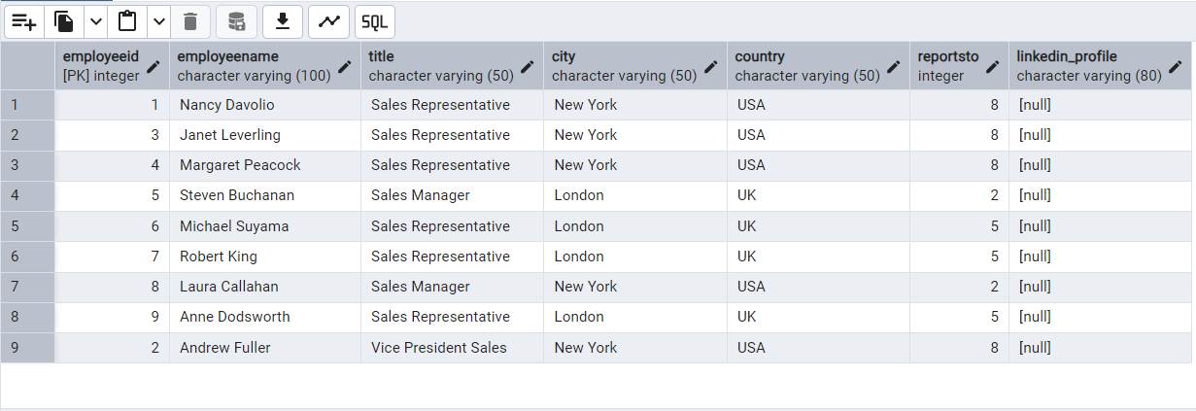

* Change the linkedin_profile column data type from VARCHAR to TEXT.

Alter Table employees

Alter COLUMN linkedin_profile

SET DATA TYPE text;

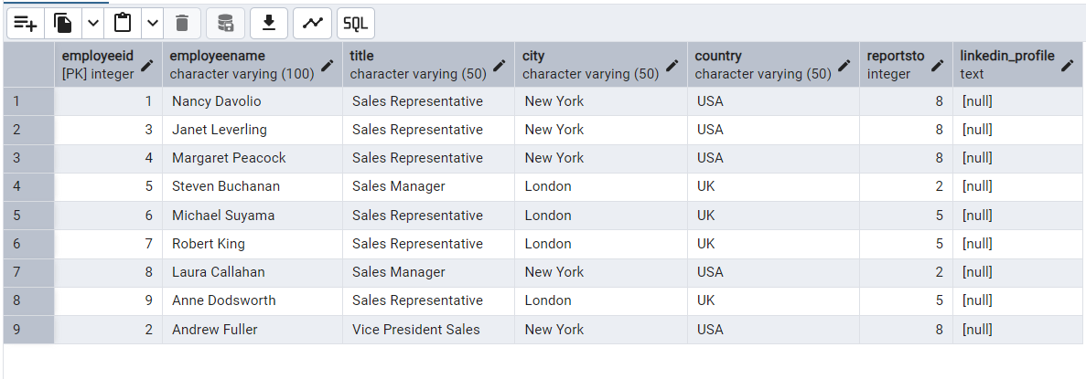

* Add unique, not null constraint to linkedin_profile

Updating values without Null

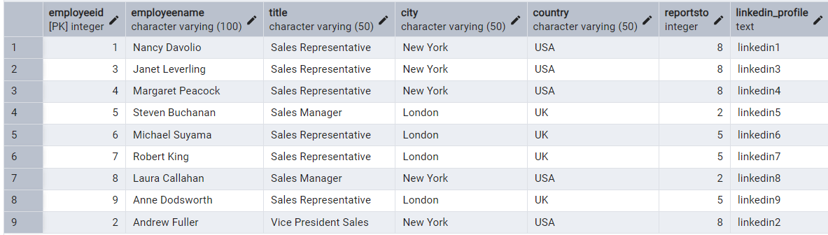

Now Adding Not null and Unique constraints

Alter Table Employees

ALTER COLUMN linkedin_profile SET NOT NULL,

ADD CONSTRAINT unique_linkedin UNIQUE(linkedin_profile)

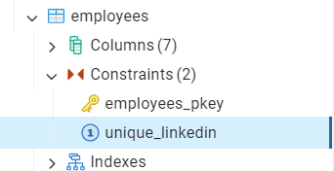

* Drop column linkedin_profile

ALTER TABLE employees

DROP COLUMN linkedin_profile;

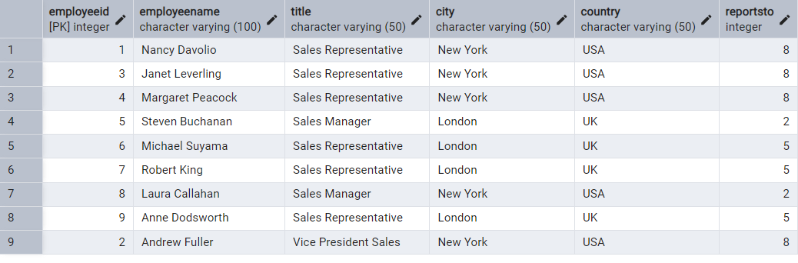

2.  Querying (Select)

* Retrieve the employee name and title of all employees

SELECT employeename, title FROM employees;

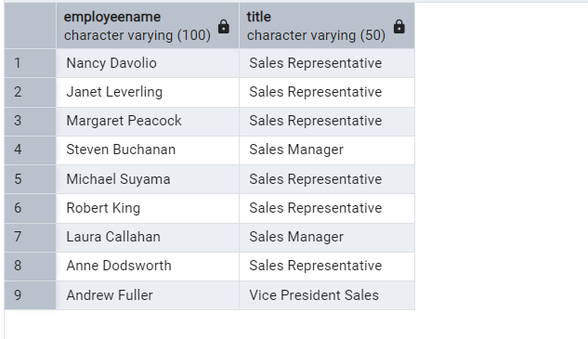

* Find all unique unit prices of products

SELECT DISTINCT unitprice FROM products;

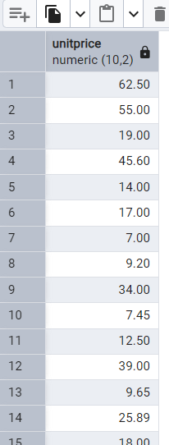

* List all customers sorted by company name in ascending order

SELECT * from customer ORDER BY companyname ASC

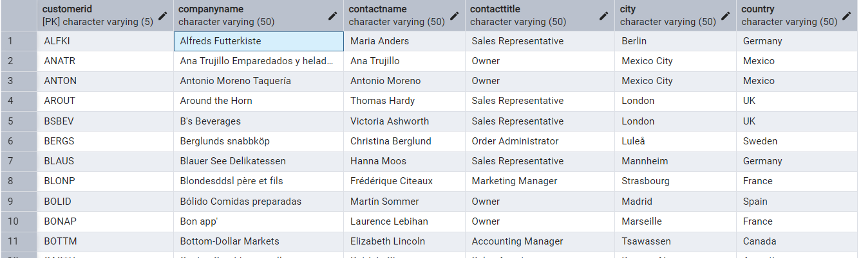

* Display product name and unit price, but rename the unit_price column as price_in_usd

Select productname,unitprice As price_in_usd from products

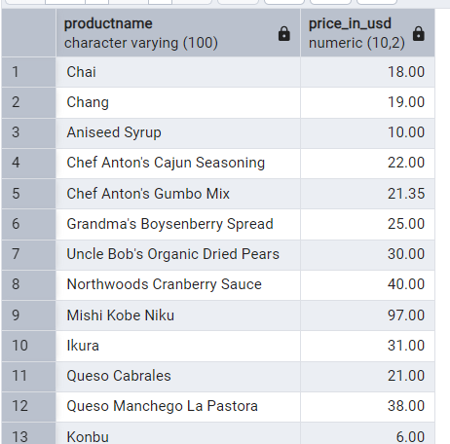

3.Filtering from customers and orders

* Get all customers from Germany

SELECT * from customer where country ='Germany';

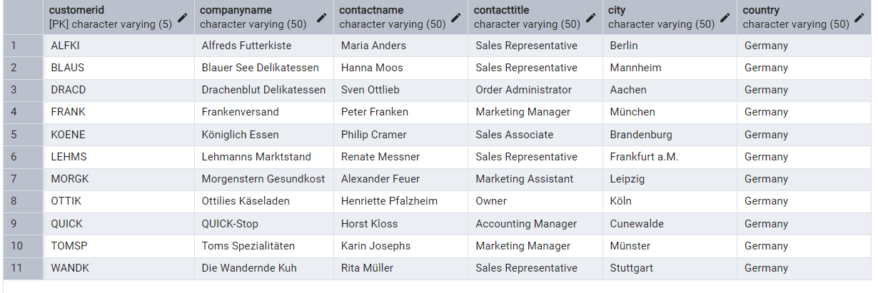

* Find all customers from France or Spain

SELECT * FROM customer WHERE country IN ('France', 'Spain');

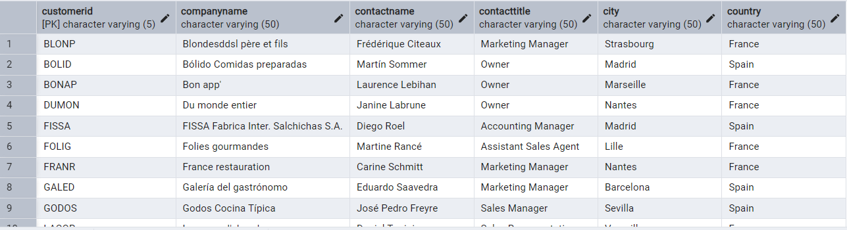

* Retrieve all orders placed in 2014(based on order_date), and either have freight greater than 50 or the shipped date available

SELECT * FROM orders WHERE EXTRACT(YEAR FROM orderDate) = 2014 AND (freight > 50 OR shippedDate IS NOT NULL);

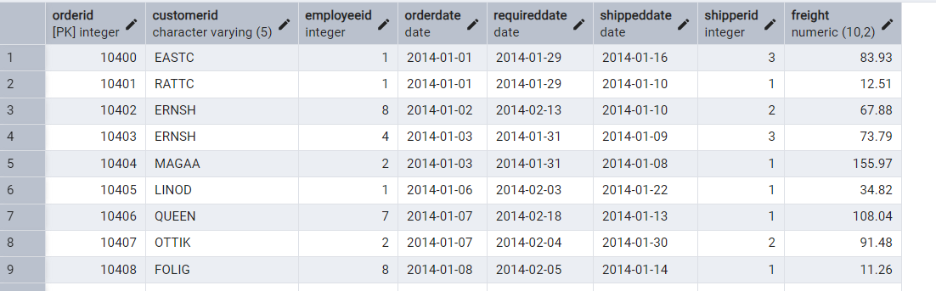

* 4.Products with unit price > 15

SELECT productID, productName, unitPrice FROM products WHERE unitPrice > 15;

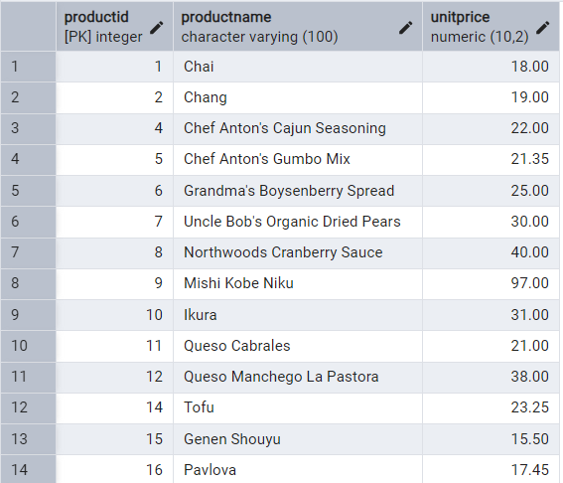

* -List all employees who are located in the USA and have the title "Sales Representative".

SELECT * FROM employees WHERE country = 'USA' AND title'SalesRepresentative';

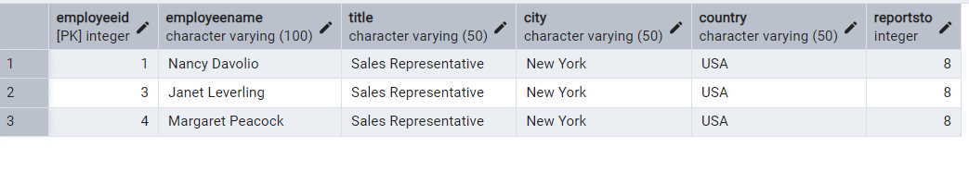

* Retrieve all products that are not discontinued and priced greater than 30

SELECT * FROM products WHERE discontinued = 0 AND unitPrice > 30;

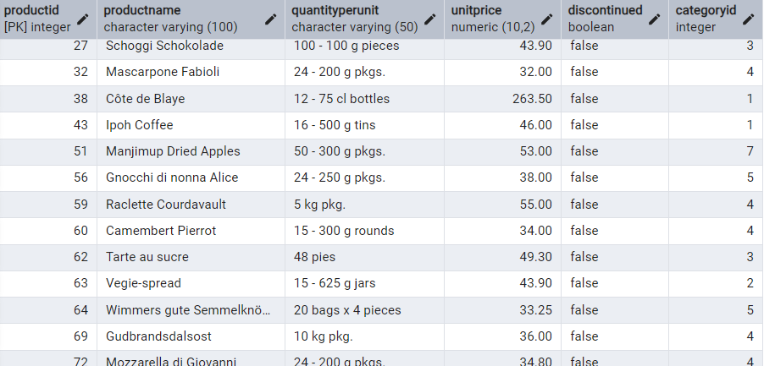

5.LIMIT/FETCH

--- Retrieve the first 10 orders from the orders table

SELECT * FROM orders ORDER BY orderID LIMIT 10;

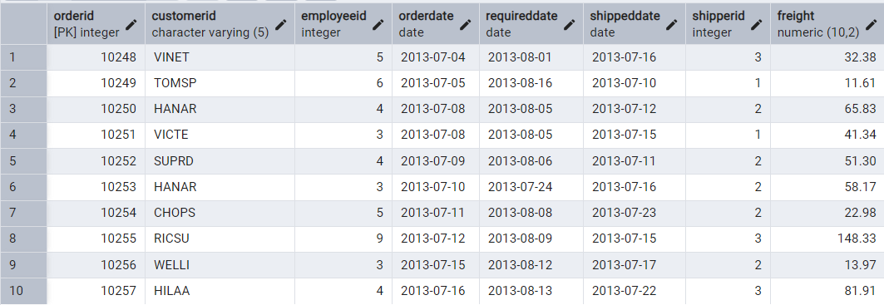

6.Filtering (IN, BETWEEN)

* List all customers who are either Sales Representative, Owner

SELECT * FROM customer WHERE contactTitle IN ('Sales Representative', 'Owner');

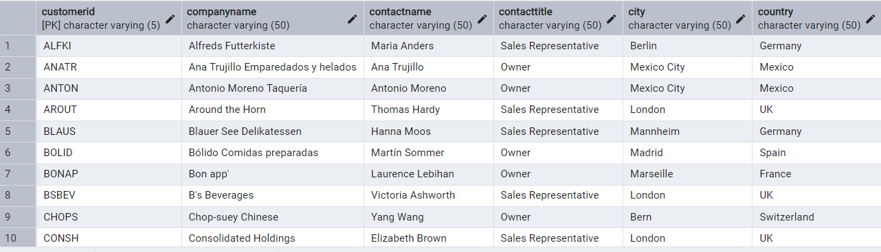

* Retrieve orders placed between January 1, 2013, and December 31, 2013

SELECT * FROM orders WHERE orderdate BETWEEN '2013-01-01' AND '2013-12-31';

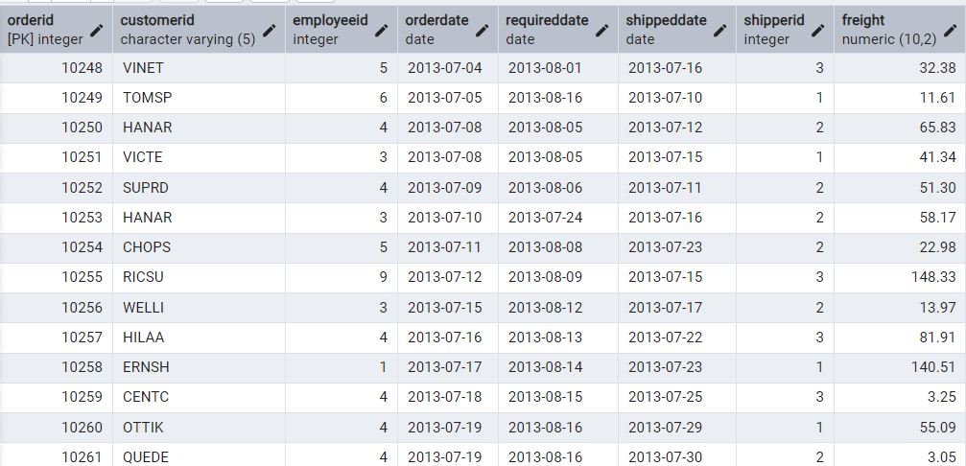

7.Filtering

* List all products whose category_id is not 1, 2, or 3.

SELECT * FROM products WHERE categoryID NOT IN (1, 2, 3);

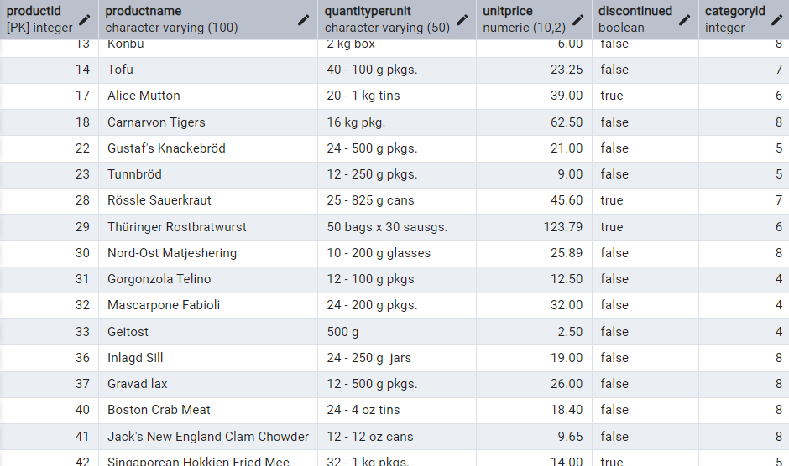

* Find customers whose company name starts with "A".

SELECT * FROM customer where companyname LIKE 'A%'

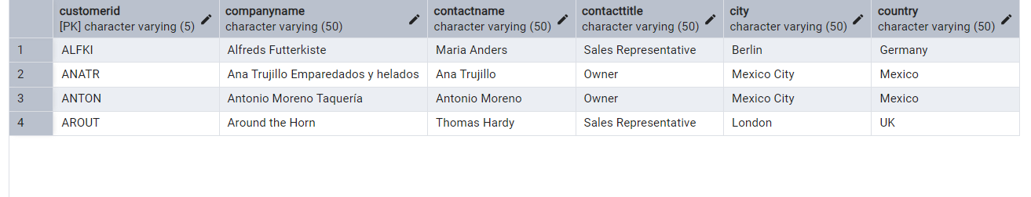

8. INSERT into orders table

* Add a new order

INSERT INTO orders (orderid,customerid,employeeid,orderdate,requireddate,shippeddate,shipperid,freight)

values(11078,'ALFKI',5,'2025-04-23','2025-04-30','2025-04-25',2,45.50);



9.Increase(Update) the unit price of all products in category_id =2

UPDATE products SET unitprice = unitprice * 1.10 WHERE categoryid = 2

Before

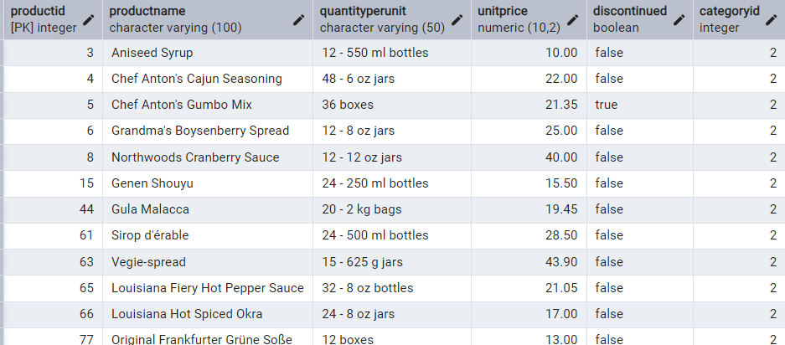

After unitprice = unitprice * 1.10

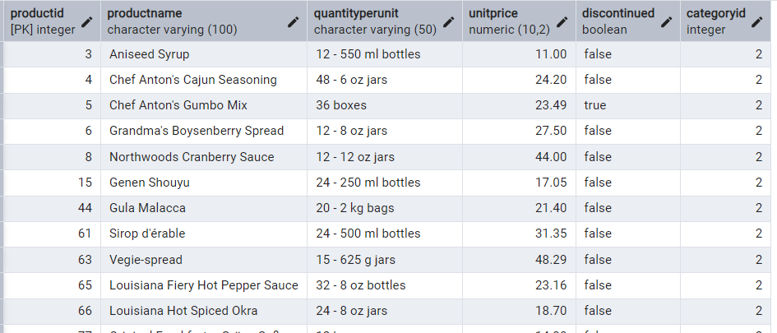

10. Sample Northwind database

