1. Update the categoryName From “Beverages” to "Drinks" in the categories table.

UPDATE category SET categoryname = 'Drinks' WHERE categoryname = 'Beverages';

Output:

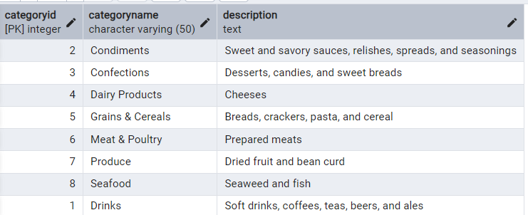

2. Insert into shipper new record (give any values) Delete that new record from shippers table.

* Insert INTO shippers(shipperid,companyname) values (4,'Express shipping')
* Output:

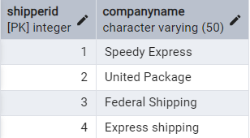

* DELETE FROM shippers WHERE shipperid=4;

Output:

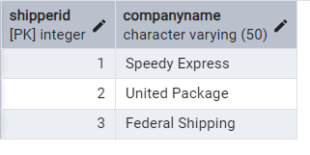

3. ON UPDATE CASCADE and ON DELETE CASCADE

* First dropping existing foreign key

ALTER TABLE products DROP CONSTRAINT products_categoryid_fkey;

Output:

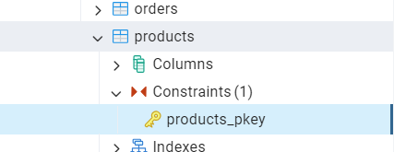

* Adding foriegn key on updated and delete cascade

ALTER TABLE products ADD CONSTRAINT products_categoryid_fkey FOREIGN KEY (categoryid) REFERENCES category(categoryid) ON UPDATE CASCADE

ON DELETE CASCADE;

Output:



* Updating categoryID=1 to categoryID=1001

UPDATE category SET categoryid=1001 WHERE categoryid=1;

In category Table

Output:

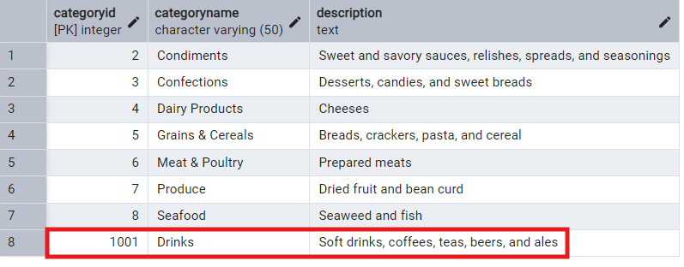

In Products table

Output:

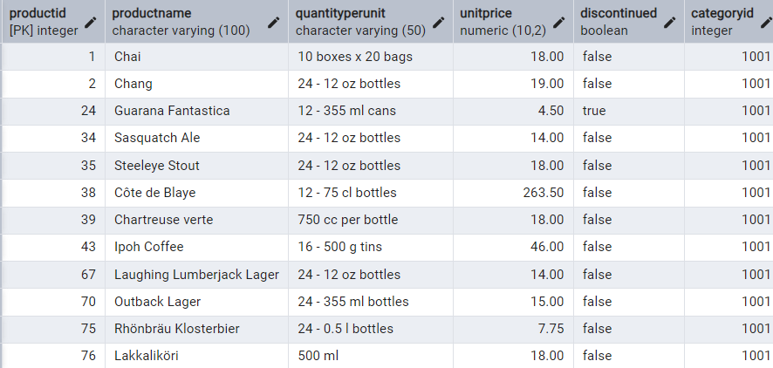

* Delete the categoryID= “3”  from categories. Verify that the corresponding records are deleted automatically from products.

ALTER TABLE orderdetails DROP CONSTRAINT orderdetails_productid_fkey;

ALTER TABLE orderdetails ADD CONSTRAINT orderdetails_productid_fkey

FOREIGN KEY (productid)

REFERENCES products(productid)

ON DELETE CASCADE;

--Deleting categoryid =3

DELETE FROM category WHERE categoryid =3;

SELECT * FROM category WHERE categoryid = 3;

SELECT * FROM products WHERE categoryid = 3;

Output:

Category Table:



Product Table:



4.Delete the customer = “VINET” from customers. Corresponding customers in orders table should be set to null

* Drop existing foreign key

ALTER TABLE orders DROP CONSTRAINT orders_customerid_fkey

* Set with ON DELETE SET NULL

ALTER TABLE orders

ADD CONSTRAINT orders_customerid_fkey

FOREIGN KEY (customerid) REFERENCES customer(customerid)

ON DELETE SET NULL;

* Deleting customerid = 'VINET'

DELETE FROM customer WHERE customerid = 'VINET'

SELECT * FROM orders WHERE customerid IS NULL

Output:

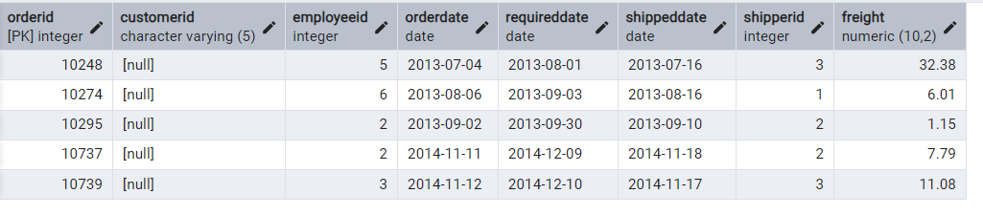

5. Insert the following data to Products using UPSERT

Record1:

INSERT INTO products(productid,productname,quantityperunit,unitprice,discontinued,categoryid)

values (100, 'White bread', 1, 13, FALSE, 5)

ON CONFLICT (productid)

DO UPDATE

SET quantityperunit = EXCLUDED.quantityperunit;

SELECT * FROM products WHERE productid = 100;

Output:

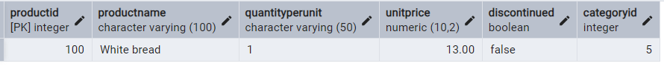

Record 2:

INSERT INTO products(productid,productname,quantityperunit,unitprice,discontinued,categoryid)

values (101, 'White bread', '5 boxes', 13, FALSE, 5)

ON CONFLICT (productid)

DO UPDATE

SET quantityperunit = EXCLUDED.quantityperunit;

SELECT * FROM products WHERE productid = 101;

Output:

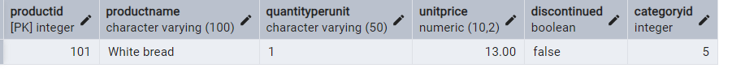

Record3:

INSERT INTO products (productid, productname, quantityperunit, unitprice, discontinued, categoryid)

VALUES (100, 'Wheat bread', '10 boxes', 13, FALSE, 3)

ON CONFLICT (productid)

DO UPDATE

SET quantityperunit = EXCLUDED.quantityperunit;

SELECT * FROM products WHERE productid = 100;

Output:

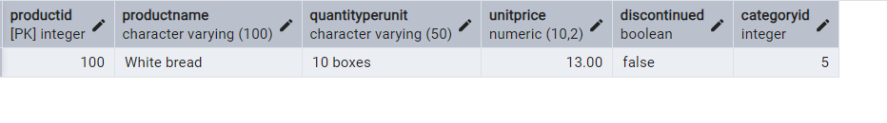

6. **MERGE query**

* **Creating Temp Table**

**CREATE TEMPORARY TABLE updated_product (**

**productid INTEGER,**

**productname VARCHAR(100),**

**quantityperunit VARCHAR(100),**

**unitprice DECIMAL(10,2),**

**discontinued INTEGER,**

**categoryid INTEGER**

**);**

INSERT INTO updated_product(productid, productname, quantityperunit, unitprice, discontinued, categoryid) VALUES

(100, 'Wheat bread', '10', 20, 1, 3),

(101, 'White bread', '5 boxes', 19.99, 0, 3),

(102, 'Midnight Mango Fizz', '24 - 12 oz bottles', 19, 0, 1001),

(103, 'Savory Fire Sauce', '12 - 550 ml bottles', 10, 0, 2);

SELECT * FROM updated_product;

Output:

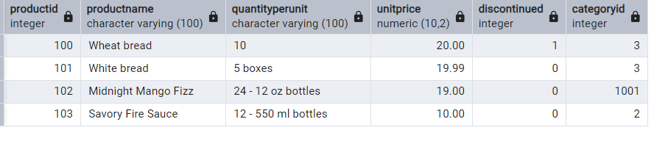

* UPDATE if match and not discontinued,DELETE if match and discontinued and INSERT if no match and not discontinued

MERGE INTO products p

USING updated_products u

ON p.productid = u.productid

WHEN MATCHED AND u.discontinued = 'FALSE' THEN

UPDATE SET

unitprice = u.unitprice,

discontinued = u.discontinued

WHEN MATCHED AND u.discontinued = 'TRUE' THEN

DELETE

WHEN NOT MATCHED AND u.discontinued = 'FALSE' THEN

INSERT (productid, productname, quantityperunit, unitprice, discontinued, categoryid)

VALUES (u.productid, u.productname, u.quantityperunit, u.unitprice, u.discontinued, u.categoryid);

SELECT * FROM products;

Output:

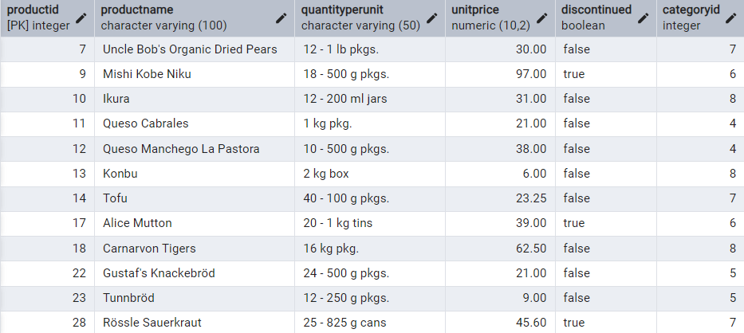

**USE NEW Northwind DB:**

 7. List all orders with employee full names. (Inner join)

SELECT o.order_id,

o.customer_id,

o.order_date,

e.first_name || ' ' || e.last_name AS employeefullname,

o.required_date,

o.shipped_date,

o.ship_via,

o.freight

FROM

orders o

INNER JOIN

employees e ON o.employee_id = e.employee_id;

Output:

