1. List all customers and the products they ordered with the order date. (Inner join)

Output:

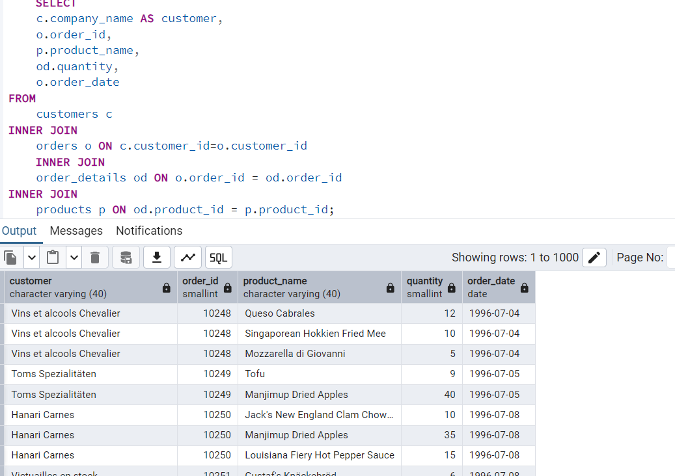

2.   Show each order with customer, employee, shipper, and product info — even if some parts are missing. (Left Join)

Output:

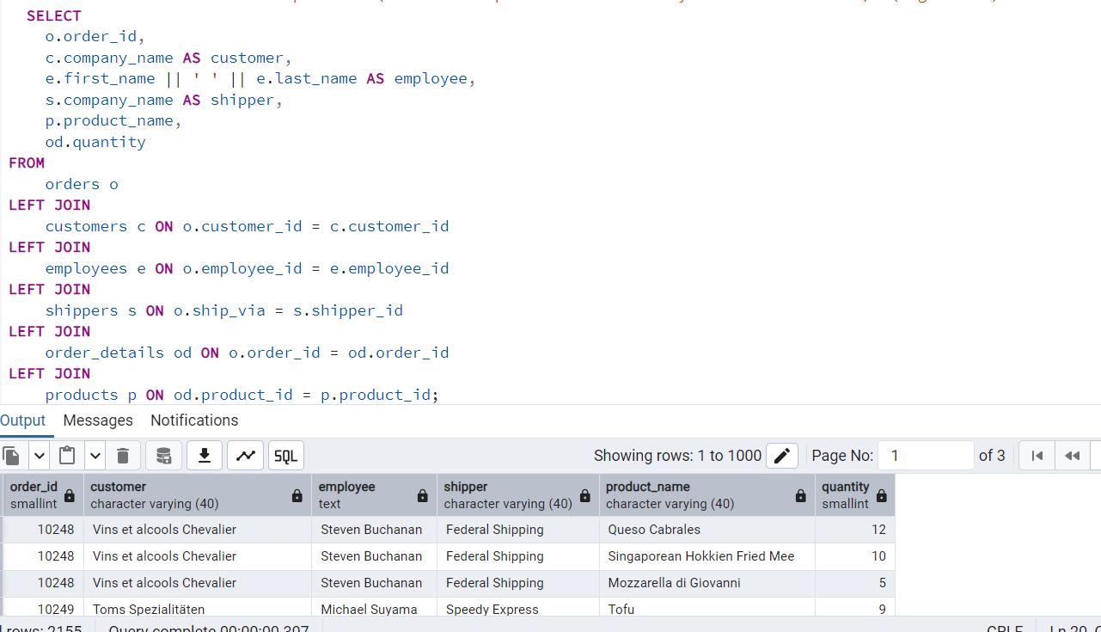

3. Show all order details and products (include all products even if they were never ordered). (Right Join)

Output:

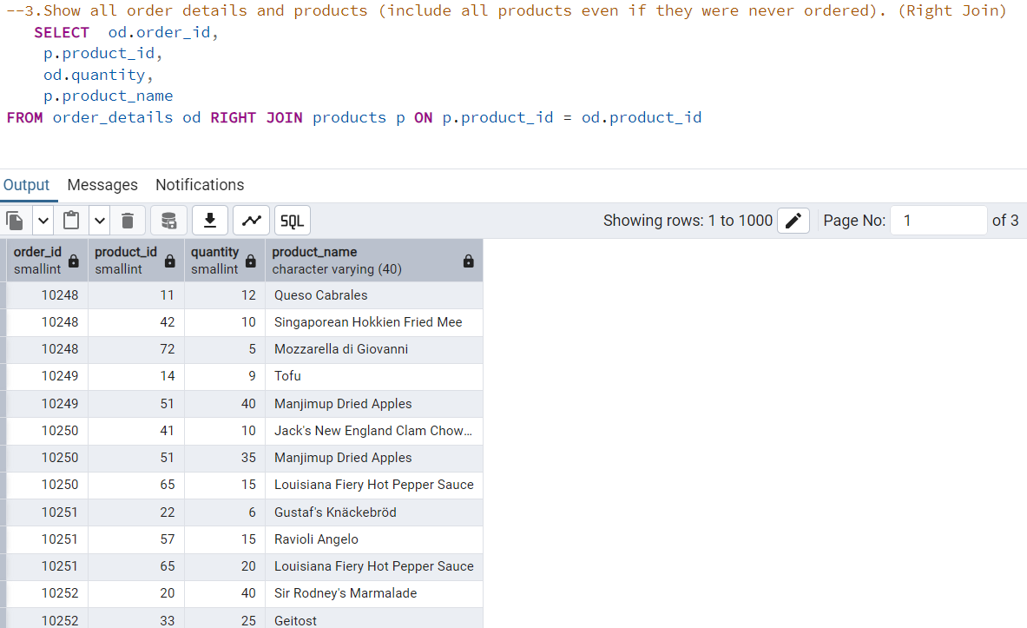

4. all product categories and their products — including categories that have no products, and products that are not assigned to any category.(Outer Join)

Output:

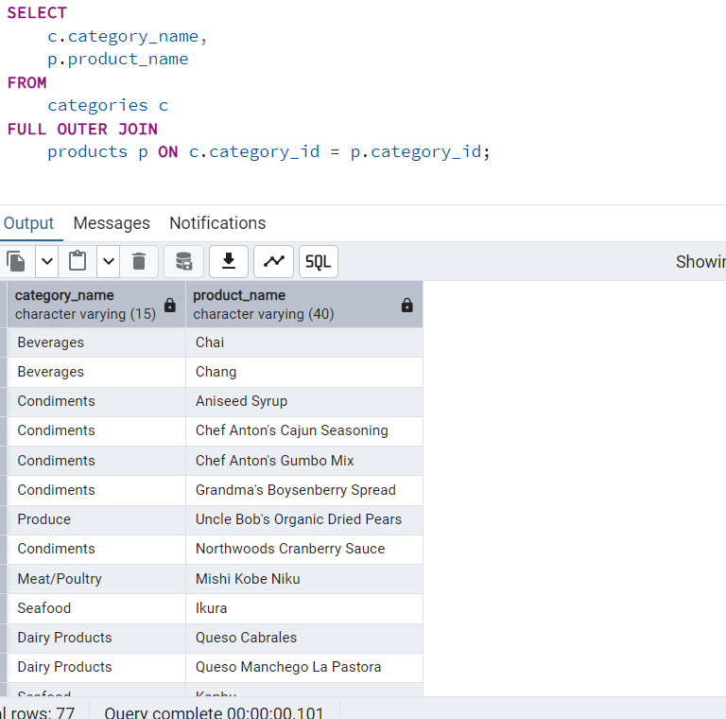

5. Show all possible product and category combinations (Cross join).

Output:

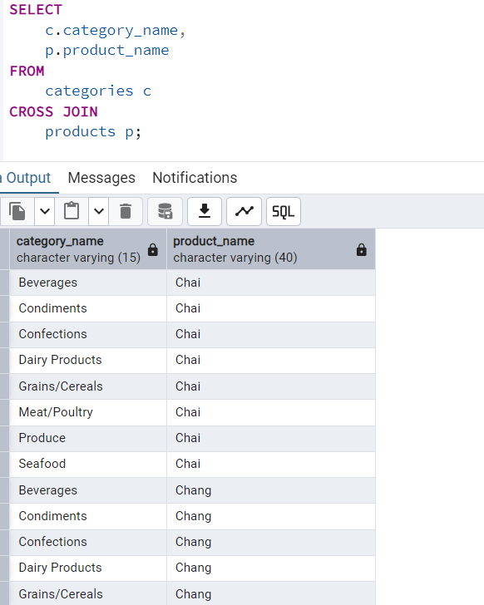

6. Show all employees and their manager(Self join(left join))

Output:

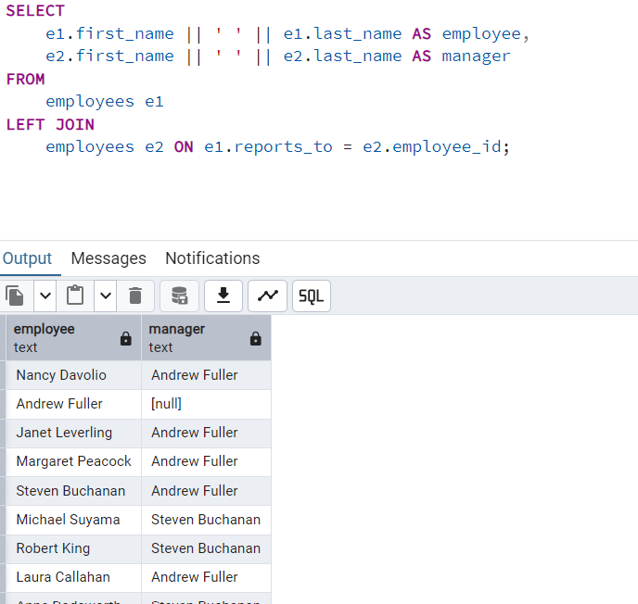

7. List all customers who have not selected a shipping method.

**Tables used:** customers, orders

**(Left Join, WHERE o.shipvia IS NULL)**

Output:

