**Day 5**

1.      GROUP BY with WHERE - Orders by Year and Quarter

Display, order year, quarter, order count, avg freight cost only for those orders where freight cost > 100

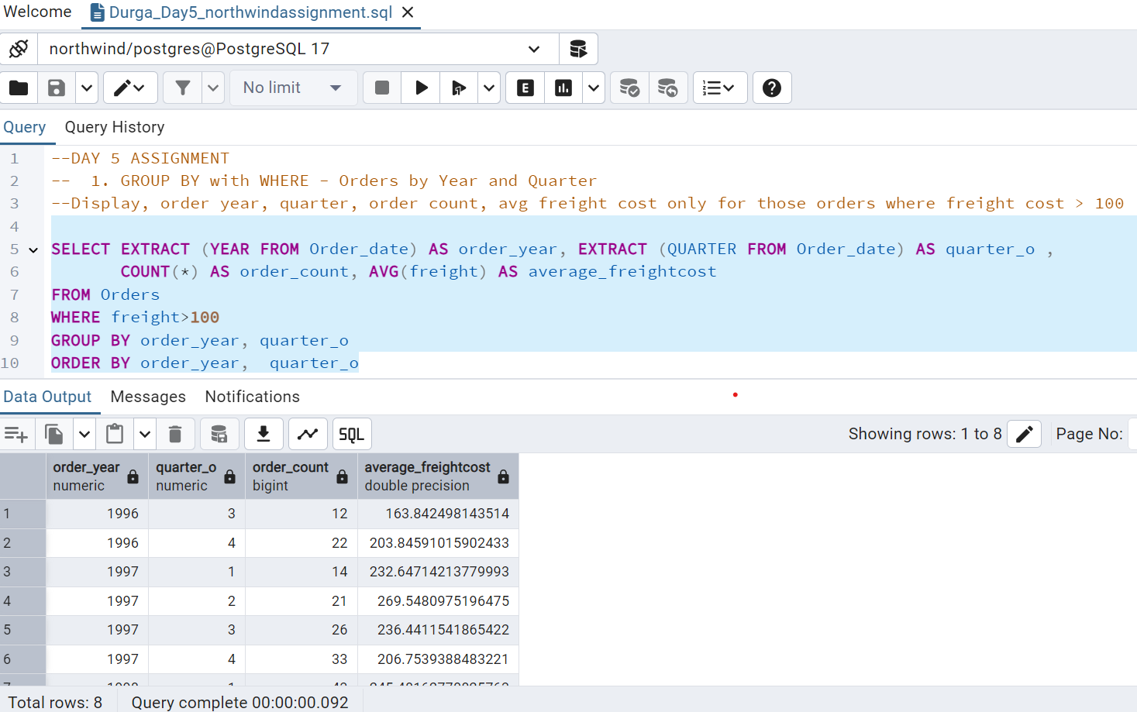

2.      GROUP BY with HAVING - High Volume Ship Regions

Display, ship region, no of orders in each region, min and max freight cost  
 Filter regions where no of orders >= 5

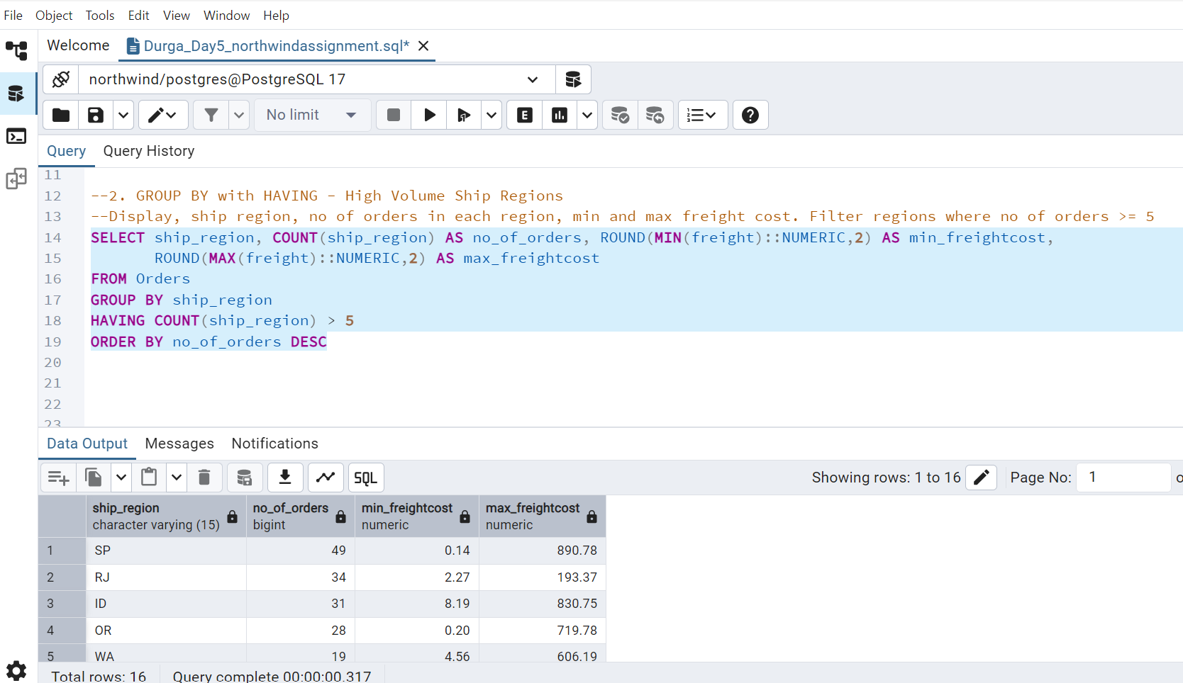

3.      Get all title designations across employees and customers ( Try UNION & UNION ALL)

UNION – Merge two results and removes duplicates

UNION ALL – Merge second result with the first and retains duplicates from the combined dataset

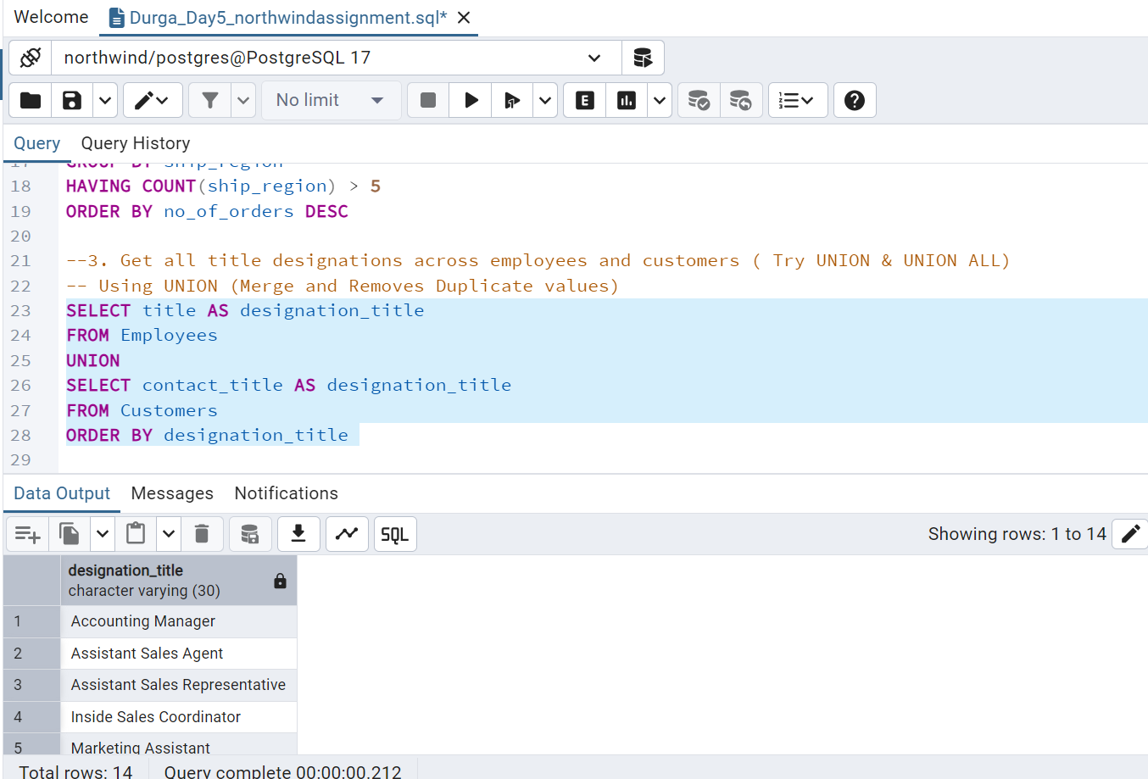

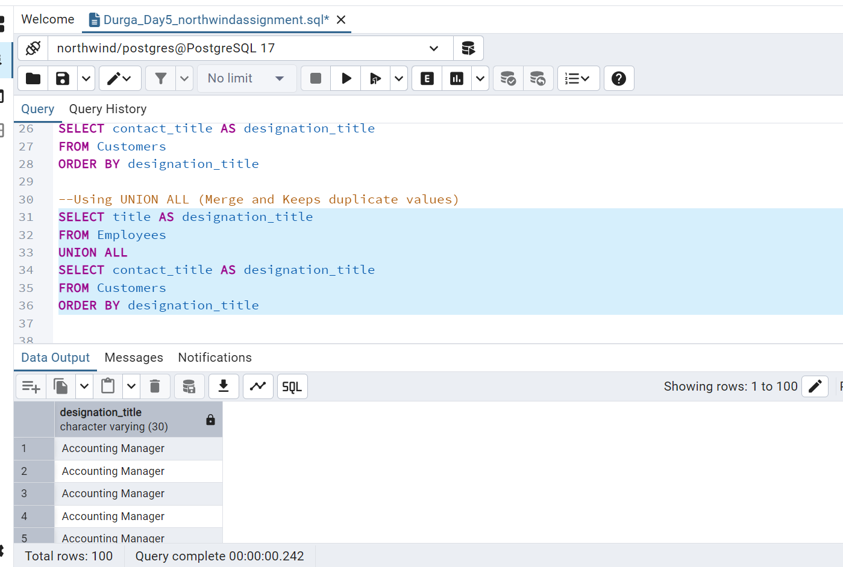

4.      Find categories that have both discontinued and in-stock products

(Display category_id, instock means units_in_stock > 0, Intersect)

The first part of the query will return every Category_id that has at least one discontinued product. The second part of query will return Category_id that has at least one product with units_in_stock>0. Intersect returns only those Category_id present in both the results(Category_id that have at least one discontinued and one in-stock product.)

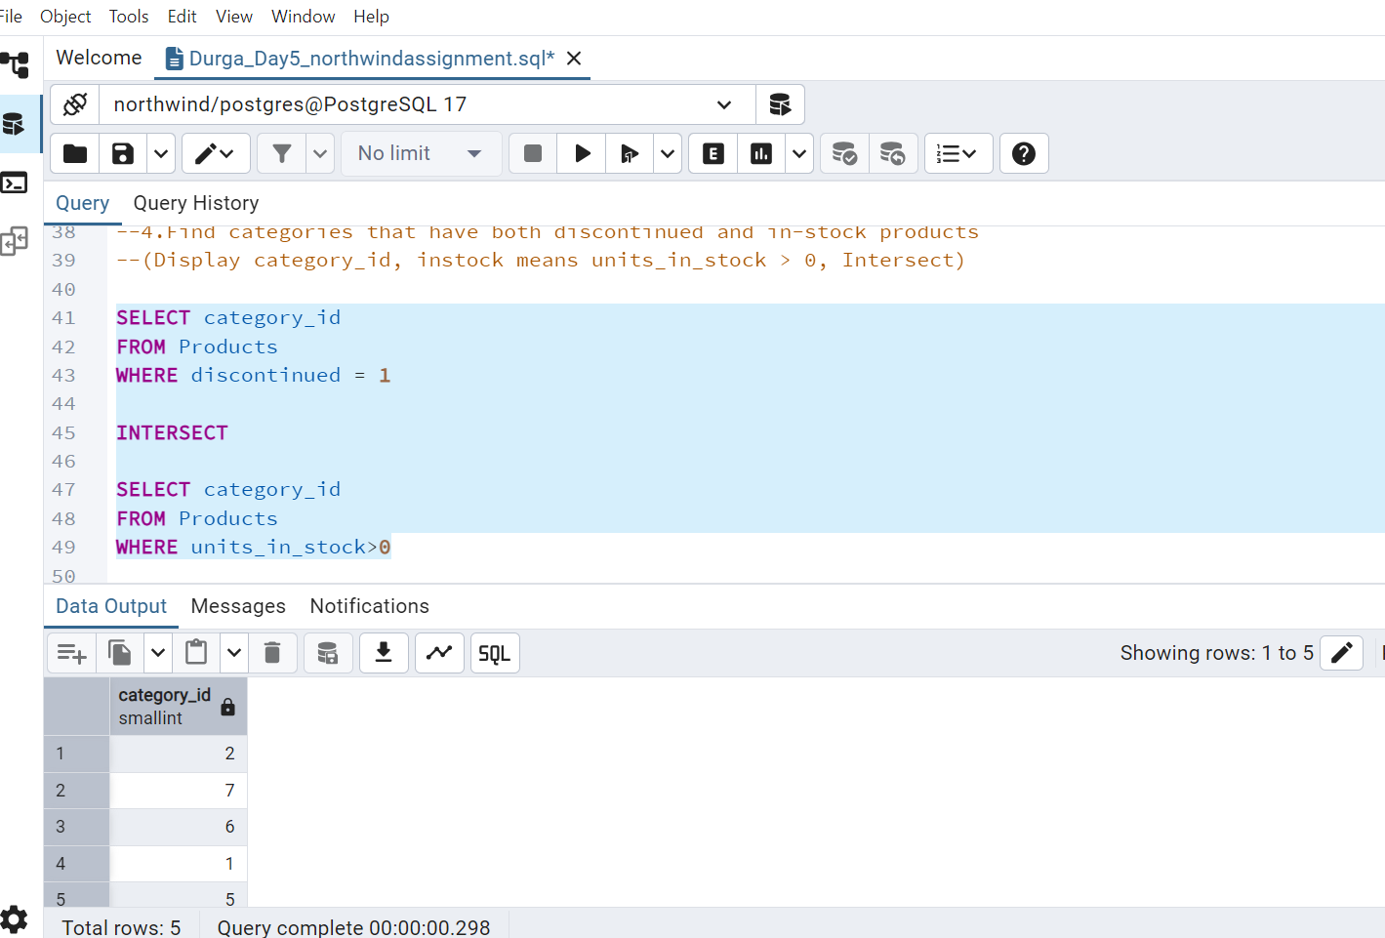

Intersect filter the duplicates and return only the distinct rows that are in common to both the left and right query. Inner join does not filter the duplicates. To make inner join behave as Intersect we should use DISTINCT.

5.      Find orders that have no discounted items (Display the  order_id, EXCEPT)

