1.      GROUP BY with WHERE - Orders by Year and Quarter

* Display, order year, quarter, order count, avg freight cost only for those orders where freight cost > 100

Output:

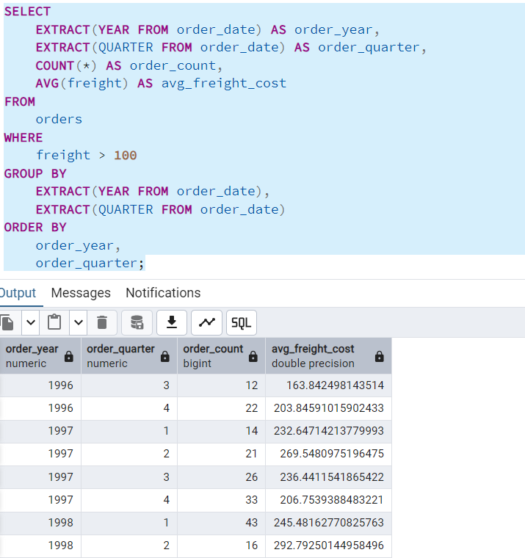

2.      GROUP BY with HAVING - High Volume Ship Regions

* Display, ship region, no of orders in each region, min and max freight cost  
   Filter regions where no of orders >= 5

Output:

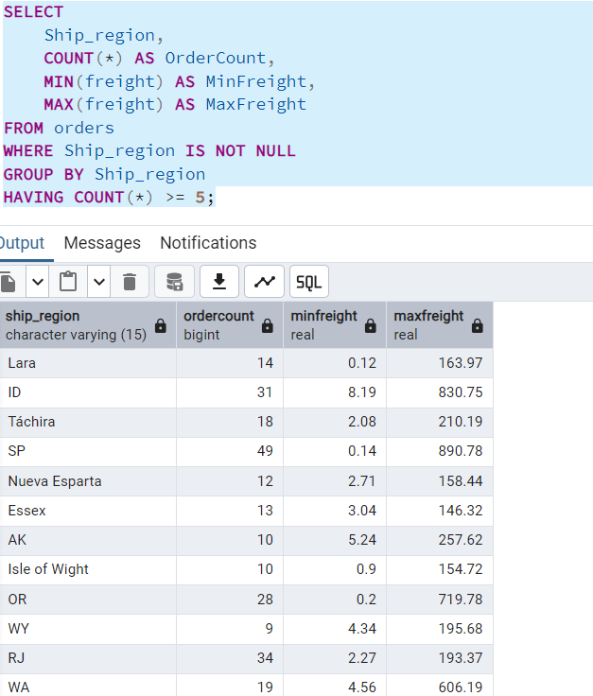

3.      Get all title designations across employees and customers ( Try UNION & UNION ALL)

* Using UNION (removes duplicates)

Output:

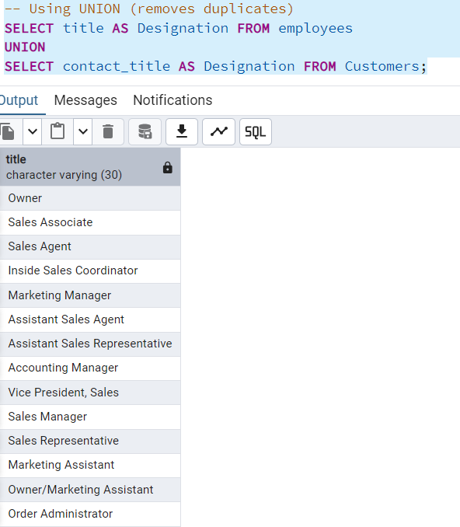

* Using UNION ALL (includes duplicates)

Output:

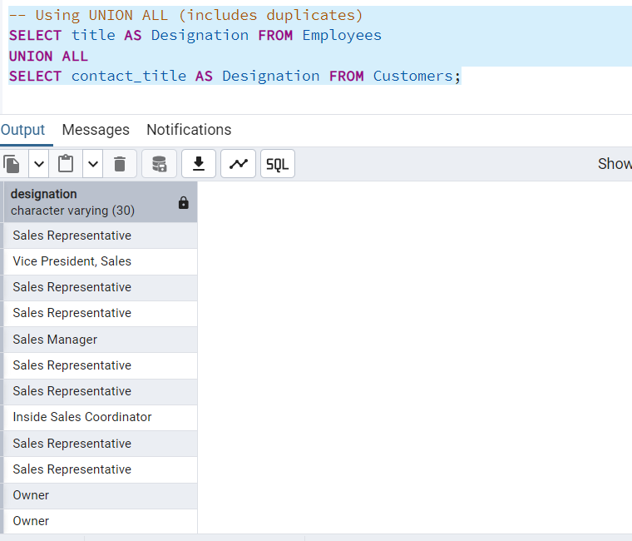

4.Find categories that have both discontinued and in-stock products

* (Display category_id, instock means units_in_stock > 0, Intersect)

Output:

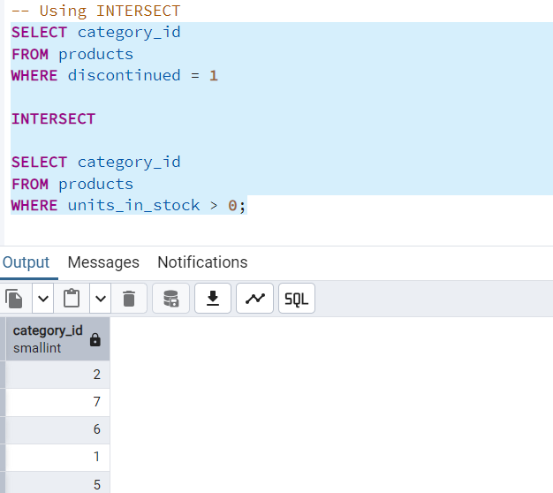

5.Find orders that have no discounted items (Display the order_id, EXCEPT)

Output:

