---1. Categorize products by stock status

(Display product_name, a new column stock_status whose values are based on below condition units_in_stock = 0  is 'Out of Stock',units_in_stock < 20  is 'Low Stock')

Output:

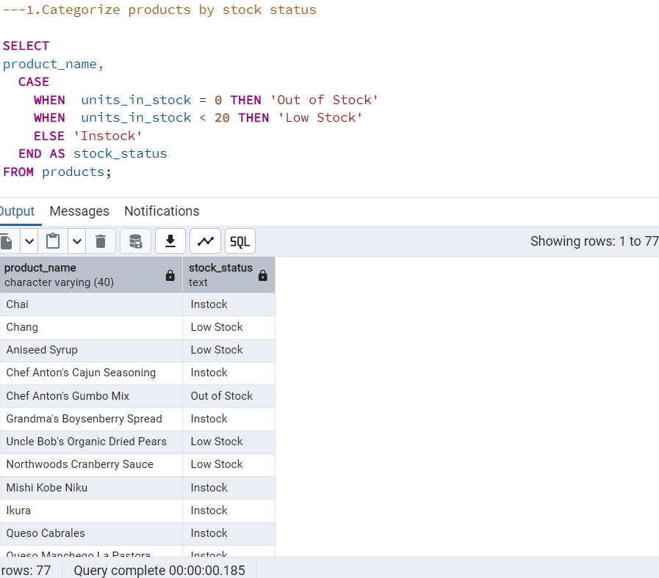

2. Find All Products in Beverages Category

(Subquery, Display product_name,unitprice)

Output:

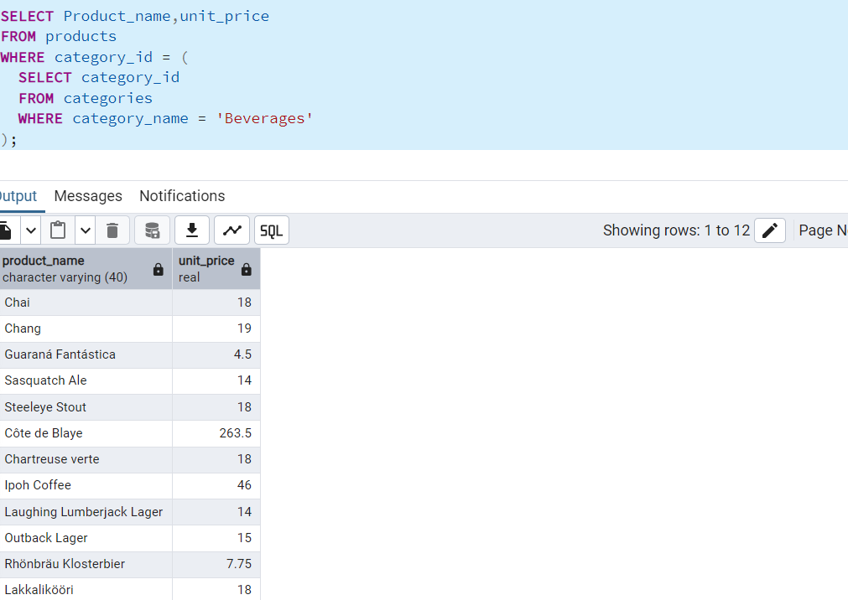

3.  Find Orders by Employee with Most Sales

(Display order_id,   order_date,  freight, employee_id.

Employee with Most Sales=Get the total no.of of orders for each employee then order by DESC and limit 1. Use Subquery)

Output:

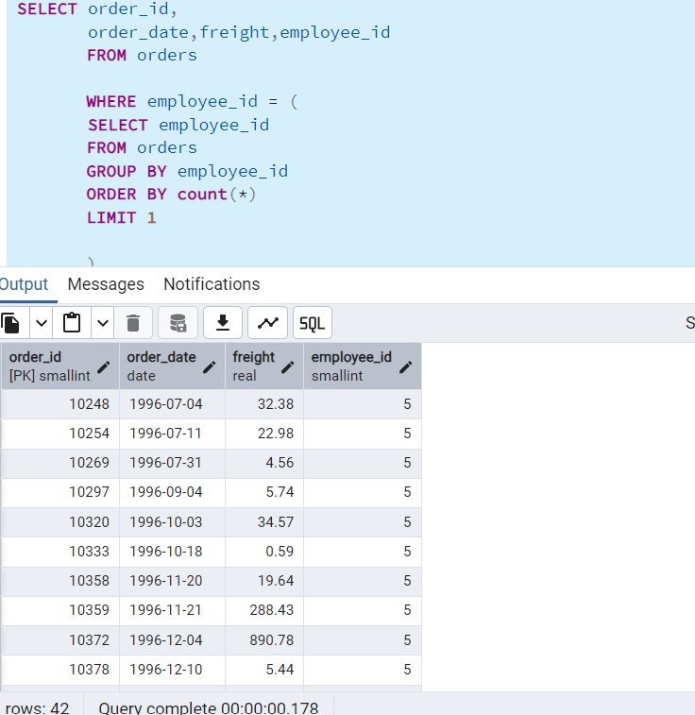

4. Find orders where for country!= ‘USA’ with freight costs higher than any order from USA.

* Subquery with ANY operator

Output:

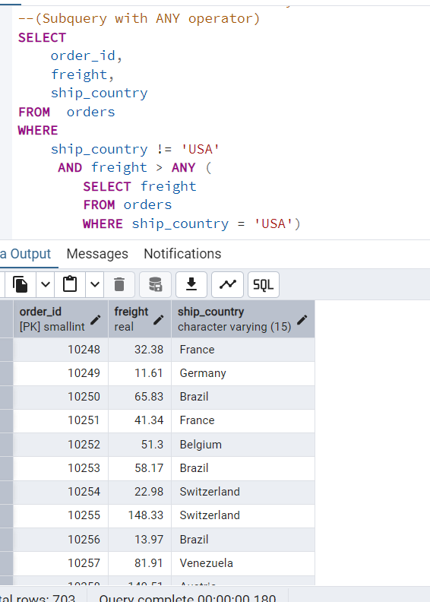

* Subquery with ALL operator

Output:

