**Assignment 7**

1.     Rank employees by their total sales

(Total sales = Total no of orders handled, JOIN employees and orders table)

SELECT

e.employee_id,

e.first_name || e.last_name AS employeename,

COUNT(o.order_id) AS total_sales,

RANK() OVER (ORDER BY COUNT(o.order_id) DESC) AS sales_rank

FROM

employees e

JOIN

orders o ON e.employee_id = o.employee_id

GROUP BY

e.employee_id, employeename

ORDER BY

total_sales DESC;

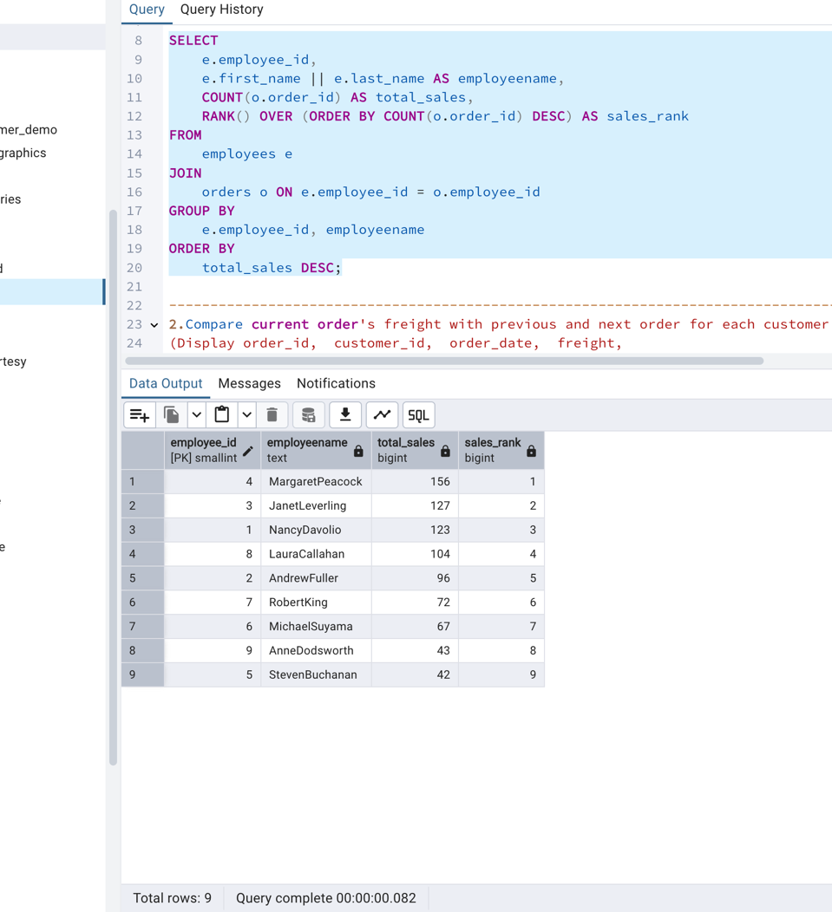

-----------------------------------------------------------------------------------------------------------------------------------------------------------------------------------------------------------

2.      Compare current order's freight with previous and next order for each customer.

(Display order_id,  customer_id,  order_date,  freight,

Use lead(freight) and lag(freight).

SELECT

order_id,

customer_id,

order_date,

freight,

LAG(freight) OVER (PARTITION BY customer_id ORDER BY order_date) AS previous_freight,

LEAD(freight) OVER (PARTITION BY customer_id ORDER BY order_date) AS next_freight

FROM

orders;

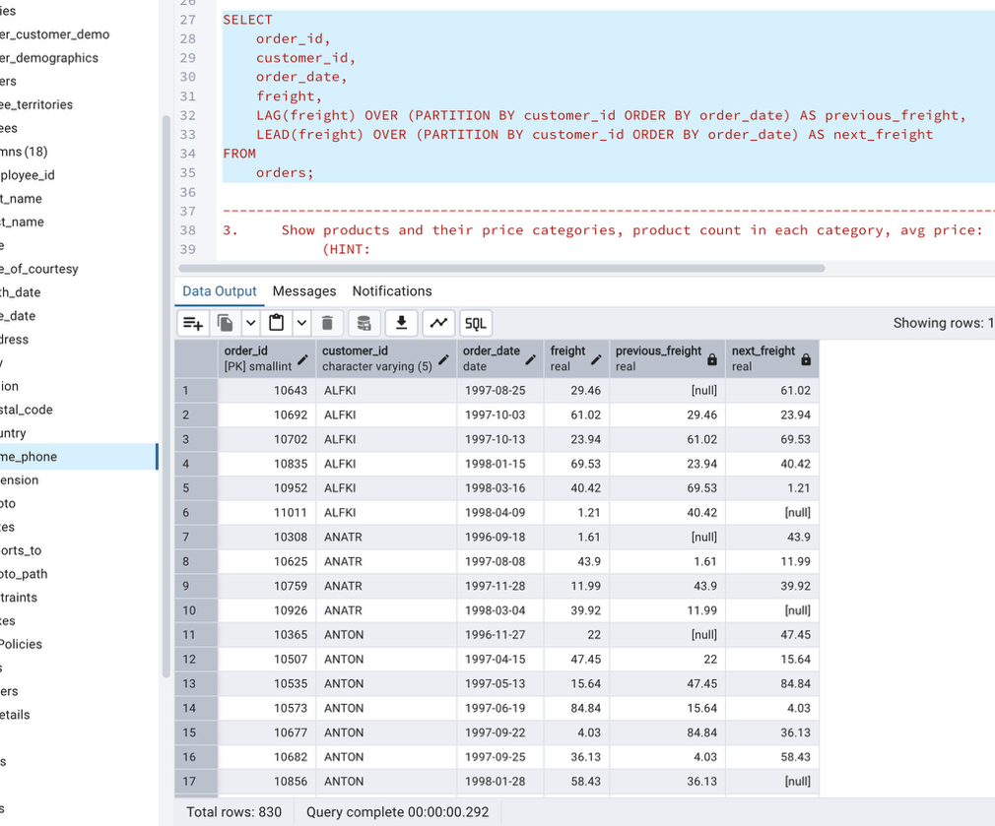

-----------------------------------------------------------------------------------------------------------------------------------------------------------------------------------------------------------

3.     Show products and their price categories, product count in each category, avg price:

         (HINT:

·  Create a CTE which should have price_category definition:

         WHEN unit_price < 20 THEN 'Low Price'

            WHEN unit_price < 50 THEN 'Medium Price'

            ELSE 'High Price'

·  In the main query display: price_category,  product_count in each price_category,  ROUND(AVG(unit_price)::numeric, 2) as avg_price

WITH price_categories AS (

SELECT

product_name,

unit_price,

CASE

WHEN unit_price < 20 THEN 'Low Price'

WHEN unit_price < 50 THEN 'Medium Price'

ELSE 'High Price'

END AS price_category

FROM

products

)

SELECT

price_category,

COUNT(*) AS product_count,

ROUND(AVG(unit_price)::numeric, 2) AS avg_price

FROM

price_categories

GROUP BY

price_category

ORDER BY

price_category;



